TMFC007 Service Order Management v2.1.0
Components and Canvas
In this deliverable:

Overview
Component Name | ID | Description | ODA Function Block
Service Order Management | TMFC007 | Service Order Management (SOM) component is the entry point to the Production Domain. It oversees delivery of Customer-Facing-Service (CFS) resources (network and service platform equipment). The SOM exposes the API ServiceOrder. It is triggered when the Product Order Delivery Orchestration And Management component calls this API to request CFS delivery. To achieve delivery of a CFS, the SOM orchestrates the CFS delivery process which identifies possible RFS and chooses one, using the catalog and technical inventory. It selects the resources (servers, equipment, etc.) and their instances, and requests the Resource Order Management (ROM) component to update selected resource instances to deliver CFS. Requests sent to the ROM contain the CFS and the list of configured resource instances to be updated. | Production

eTOM Processes, SID Data Entities and Functional Framework Functions

eTOM business activities
eTOM business activities this ODA Component is responsible for:
Identifier | Level | Business Activity Name | Description
1.4.5 | L2 | Service Configuration & Activation | Allocation, implementation, configuration, activation and testing of specific services to meet customer requirements.
1.4.5.1 | L3 | Design Solution | Develop an end-end specific service design which complies with a particular customer's requirement
1.4.5.2 | L3 | Allocate Specific Service Parameters to Services | Issue service identifiers for new services.
1.4.5.3 | L3 | Track & Manage Service Provisioning | Ensure service provisioning activities are assigned, managed and tracked efficiently.
1.4.5.4 | L3 | Implement, configure & activate service | Implement, configure and activate the specific services allocated against an issued service order.
1.4.5.6 | L3 | Issue Service Order | Issue correct and complete service orders
1.4.5.7 | L3 | Report service provisioning | Monitor the status of service orders, provide notifications of any changes and provide management reports.
1.4.5.8 | L3 | Close Service Order | Close a service order when the service provisioning activities have been completed
1.5.5 | L2 | Resource Order Management | Resource Order Management business process directs and controls ordering, scheduling, and allocation of resources (such as materials, equipment, and personnel) within the business.
1.5.5.6 | L3 | Manage Resource Order Capture | Manage Resource Order Capture is responsible for directing and controlling the capture and collection of resource orders from internal and external customers.
1.5.5.6.1 | L4 | Initiate Resource Order Capture | Initiate Resource Order Capture business activity is responsible for the initial activity of capturing and collecting resource orders from internal and external customers.
1.5.5.7 | L3 | Manage Resource Work Order | Manage Resource Order Work business activity directs and controls all work that are required to fulfill an approved resource order by ensuring the work related to the order is planned, executed and closed in a timely and efficient manner.
1.5.5.7.1 | L4 | Initiate Resource Work Order | Initiate Resource Work Order business activity starts a new work order for a specific resource along with all work orders tasks, roles and supporting resources that are need.

SID ABEs
SID ABEs this ODA Component is responsible for:
SID ABE Level 1 | SID ABE Level 2 (or set of BEs) | SID ABE L1 Definition | SID ABE L2 Definition
Service Order |  | The Service Order ABE contains entities that represent a type of Request that decomposes a Customer Order's products into the services associated with a ServiceOrder through which the products are realized. | *(no description available)*

eTOM L2 - SID ABEs links
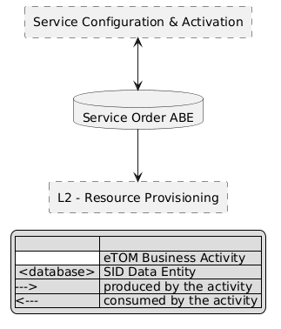
eTOM L2 - SID ABEs links diagram

Functional Framework Functions
Function ID | Function Name | Function Description | Aggregate Function Level 1 | Aggregate Function Level 2
584 | Service Activation Planning | Service Activation Planning provides planning of service activation to access, plan and gather additional information for service activation. | Service Order Management | Service Order Orchestration
588 | Service Orchestration Configuration | Service Orchestration Configuration function provides composition of a service configuration plan according to the required service actions and sent to Service Order Orchestration and/or Service Activation Management. | Service Order Management | Service Order Orchestration
591 | Service Parameters Allocation | Service Parameters Allocation provides allocation of the right service parameters to fulfill service orders. | Service Order Management | Service Order Orchestration
596 | Service Order Transfer Supervision | Oversees the transfer of Service Order Requests to appropriate resource providers. | Service Order Management | Service Order Orchestration
598 | Service Order Orchestration | The Service Order Orchestration function provides workflow and orchestration capabilities for a dedicated Service (CFS) Order. / Orchestration is needed when: / the technical solution includes the expansion of the operator Installed Resources or the purchase of a partner product (ex: local loop purchase) / a work order is necessary at the delivery address or somewhere in the operator network / part of the delivery process or checks needs to be delegated to another Service Order Manager / contributing or support systems must be informed / Example: to deliver a VOIP service, it will orchestrate actions on Access Network Factory, VOIP service platform and CPE. / Service Order Orchestration will also orchestrate and manage dependencies between related Service Order items of Service Order. | Service Order Management | Service Order Orchestration
733 | Service Order Decomposition | The Service Order Decomposition Function allows in the context of a Service Order to prepare Resource Order, Service Order which will be delegated to another system, Supplier Order, Stock Item Order or Work Order with the necessary information (the effective update in the order repositories will be supported by the corresponding Order Repository Management functions). / In the case of a Service associated with an existing Internal Resource Type, this function also allows to: / • Check if a corresponding Installed Resource is operational in the resource installed base, and determine the operation to be performed at Resource level (creation or modification) / • Eventually group in the same Resource order several ordered services, based on the same Customer Facing Service Specification (a.k.a. CFS specification), and/or identified to be delivered at the same time by the Service Order Delivery Orchestration. | Service Order Management | Service Order Delivery Preparation
734 | Service Data Collection | The Service Data Collection function gathers any needed service data to aid in the verification and issuance of a complete and valid service order as well as data necessary to address dependencies between service and/or resource orders. | Service Order Management | Service Order Orchestration
963 | Service Task Item Decomposition | Service Task Item Decomposition: By a request for an orchestration of a service the service needs to be analyzed and decomposed into the part-actions necessary to take to fulfill the requested orchestration. The Service may consist of several services and may use a number of Resources. It may also be controlled by several parameters for optional behaviors. This composition of the Service is given by configuration data available from Catalog applications and the Service Capability Orchestration application. | Service Order Management | Service Order Orchestration
968 | Service Work Item Sequence Execution | Service Work Item Sequence Execution function executes each individual item in sequence of the service orchestration to fulfill, or roll back according to a pre-defined configuration, and reports the sequence execution result. / Because of the “Service Decomposition” of an orchestration request the result may be several actions that needs to take place in a specific sequence. | Service Order Management | Service Order Orchestration
969 | Service Work Item Sequence Execution Configuration | The “Service Work Item Sequence Execution" function controls so that the sequence is fulfilled or rolled back. The rules for the sequence execution will set the conditions for the fulfillment, or roll-back, and for the reporting and notification. The “Service Task Item Sequence Carry Through configuration" is a management of the application function that defines how the execution of the orchestration sequence will be done. | Service Order Management | Service Order Orchestration
571 | Service Delivery Due Date Calculation | Service Delivery Due Date Calculation functions calculates the service delivery due date using network capacity, access provider selection and work center intelligence (including workload and capacity). | Service Order Management | Service Order Initialization
1061 | Service Order Initiation | Service Order Initiation function issues valid and complete service orders. / As part of order issuing/publication, additional data might be obtained or derived to support downstream functions that are not provided in the service order request. | Service Order Management | Service Order Initialization
595 | Service Order Completion | Completes the service order when all resource orders have been completed. | Service Order Management | Service Order Completion
600 | Service Order Validation | The Service Order Validation function validates the service order request based on contract, catalog, and provisioning rules. | Service Order Management | Service Order Completion
583 | Activation Notification | Activation Notification function provides notifications on successful activation and, in cases of exceptions send fallouts to Service Order Orchestration and manage rollbacks activities (if applicable). | Service Order Management | Service Order Repository Management
594 | Service Order Storage | Service order Storage function stores the service order into an appropriate data store. | Service Order Management | Service Order Repository Management
597 | Service Order Exposure | Service Order Exposure provides exposure of the status on the overall service order. | Fulfillment Integration Management | Service Fulfillment Access Management
599 | Service Order Tracking | The Service Order Tracking function tracks and manages the events and the lifecycle related to the Service (CFS) Order and to its items (e.g.: service order lines). / It gathers Service Order items delivery events from Service Order Orchestration and manages related Service Order lifecycle and Installed CFS lifecycle (via the Installed Service Management function). / Depending on the Service Order (or any of its elements) events, and on the implemented business rules, this function can decide to notify other systems (for example in case of delivery problems or delays) – via the business event publication function. | Service Order Management | Service Order Repository Management
735 | Access Provider Selection | Access Provider Selection function selects an access provider among identified available access providers or access technologies at the given location, based on business rules. | Service Order Management | Service Technical Solution Identification
341 | Service Activation | Service Activation function for services/products sold by affiliates. | Service Configuration & Activation | Service Activation
342 | Mass Service Pre-activation | Mass Service Pre-activation of services to prepare for a swift activation at sales. E.g., subsequent affiliate sales. | Service Configuration & Activation | Service Activation
570 | Solution Services Design Management | Solution Services Design Management function supports the end to end service design. It applies engineering rules to determine required network facilities, equipment configurations and the method and access path to the customer site or location of service termination. / This function also establishes and manages the detailed design tasks required to issue the work orders. | Service Configuration & Activation | Service Configuration
589 | Cross Services Dependencies Configuration | Cross Services Dependencies Configuration function provides support for appropriately considered cross service dependencies as part of the configuration activities to fulfill a service order. | Service Configuration & Activation | Service Configuration
590 | Service Configuration | The Service Configuration function is in charge of configuring the specific service and its parameters as appropriate for the fulfillment of a service order. | Service Configuration & Activation | Service Configuration
585 | Service Configuration Activation | Service Configuration Activation implements and activates the specific service configuration against the service configuration plan (including activation of CPE if part of the service). | Service Configuration & Activation | Service Activation
592 | Service Parameters Reservation | Service Parameters Reservation reserves the right service parameters based on service specification and service inventory for a service order. | Service Order Management | Service Availability
1219 | Service Order Request Consistency Check | The Service Order Request Consistency Check Function allows, when receiving a Service Order request prepared and transmitted by another system, to check its consistency. | Service Order Management | Service Order Initialization
1220 | Internal Service Order Initialization | The Internal Service Order Initialization Function permit to initialize Customer Facing Service Orders (a.k.a. CFS Orders) for operator internal needs, for example to change (part of) a technical solution and migrate operational Installed CFS on the new solution elements (ex: VOIP H323 -> VOIP SIP). | Service Order Management | Service Order Initialization
632 | Service Termination Points Determining | Service Termination Points Determining determines the termination points i.e. the appropriate service provider entry point to support the Customer's service request. | Service Order Management | Service Technical Solution Identification
1141 | Installed Resources Identification | Installed Resources Identification Function identifies the installed resources to update, as part of the chosen technical solution, to deliver the ordered service (CFS). / This information enriches the CFS order and the CFS. / This choice is based on service catalogue rules (between RFS specification and Resources specification) and it can be necessary to check the installed resources availability, occupancy, etc. via the Resource Availability function. / Cloud example: In case of a cloud service, the Service Order Delivery process only identifies the equipment in charge of the management of the cloud infrastructure and it will be informed of the ordered service characteristics. Depending on its own rules, the cloud infrastructure manager will decide or not to immediately allocate and configure all or part of the required resources. / So the first usage request of the cloud service can trigger the effective choice and configuration of the necessary resources and these resources can change between usages. In this case the end of the delivery process is assumed by the manager of the cloud infrastructure. / Note: This function is globally a part of the technical solution identification. | Service Order Management | Installed Resources Identification
1217 | Service Order Needs Identification | The Service Order Needs Identification Function allows in the context of a Service Order to query catalogues and installed bases to identify what needs to be delivered: resource specification and its configuration, service specification (CFSSpec), intervention (WorkSpec), supplier product, related to the ordered service. | Service Order Management | Service Order Delivery Preparation
16 | Fallout Automated Correction | Fallout Automated Correction function tries to automatically fix fallouts in workflows before they go to a human for handling. This includes a Fallout Rules Engine that provides the capability to handling various errors or error types based on built rules. These rules can facilitate autocorrection, correction assistance, placement of errors in the appropriate queues for manual handling, as well as access to various systems. | Fallout Management | Fallout Correction Management
17 | Fallout Correction Information Collection | Fallout Correction Information Collection collects relevant information for errors or situations that cannot be handled via Fallout Auto Correction. The intent is to reduce the time required by the technician in diagnosing and fixing the fallout. | Fallout Management | Fallout Correction Management
19 | Fallout Manual Correction Queuing | Fallout Manual Correction Queuing function provides the required functionality to place error fallout into appropriate queues to be handled via various staff or workgroups assigned to handle or fix the various types of fallout that occurs during the fulfillment process. This includes the ability to create and configure queues, route errors to the appropriate queues, as well as the ability for staff to access and address the various fallout instances within the queues. | Fallout Management | Fallout Correction Management
21 | Fallout Orchestration | The Fallout Orchestration function provides workflow and orchestration capability across Fallout Management. | Fallout Management | Fallout Correction Management
24 | Pre-populated Fallout Information Presentation | Pre-populated Fallout Information Presentation automatically position the analyzer on appropriate screens pre-populated with information about the order(s) that's subject for fallout handling. | Fallout Management | Fallout Correction Management
756 | Fallout Rule Based Error Correction | Fallout Rule Based Error Correction function provides the capability to handle various errors or error types based on pre-defined rules. These rules can facilitate autocorrection. | Fallout Management | Fallout Correction Management
18 | Fallout Management to Fulfillment Application Accessing | Fallout Management to Fulfillment Application Accessing function provides a variety of tools to facilitate Fallout Management access to other applications and repositories to facilitate proper Fallout Management. This can include various general access techniques such as messaging, publish and subscribe, etc. as well as specific APIs and contracts to perform specific queries or updates to various applications or repositories within the fulfillment domain. | Fallout Management | Fallout Repository Management
20 | Fallout Notification | Fallout Notification function provides the means to alert people or workgroups of some fallout situation. This can be done via a number of means, including email, paging, (Fallout management interface bus) etc. This function is done via business rules. | Fallout Management | Fallout Repository Management
22 | Fallout Reporting | Fallout Reporting provides various reports regarding Fallout Management, including statistics on fallout per various times periods (per hour, week, month, etc) as well as information about specific fallout. | Fallout Management | Fallout Repository Management
23 | Fallout Dashboard System Log-in Accessing | Fallout Dashboard System Log-in Accessing provides auto logon capability into various applications needed to analyze and fix fallout. | Fallout Management | Fallout Repository Management

TM Forum Open APIs & Events
The following part covers the APIs and Events; this part is split in 3:

List of Exposed APIs - This is the list of APIs available from this component.

List of Dependent APIs - In order to satisfy the provided API, the component could require the usage of this set of required APIs.

List of Events (generated & consumed) - The events which the component may generate are listed in this section along with a list of the events which it may consume. Since there is a possibility of multiple sources and receivers for each defined event.

API Context Diagram
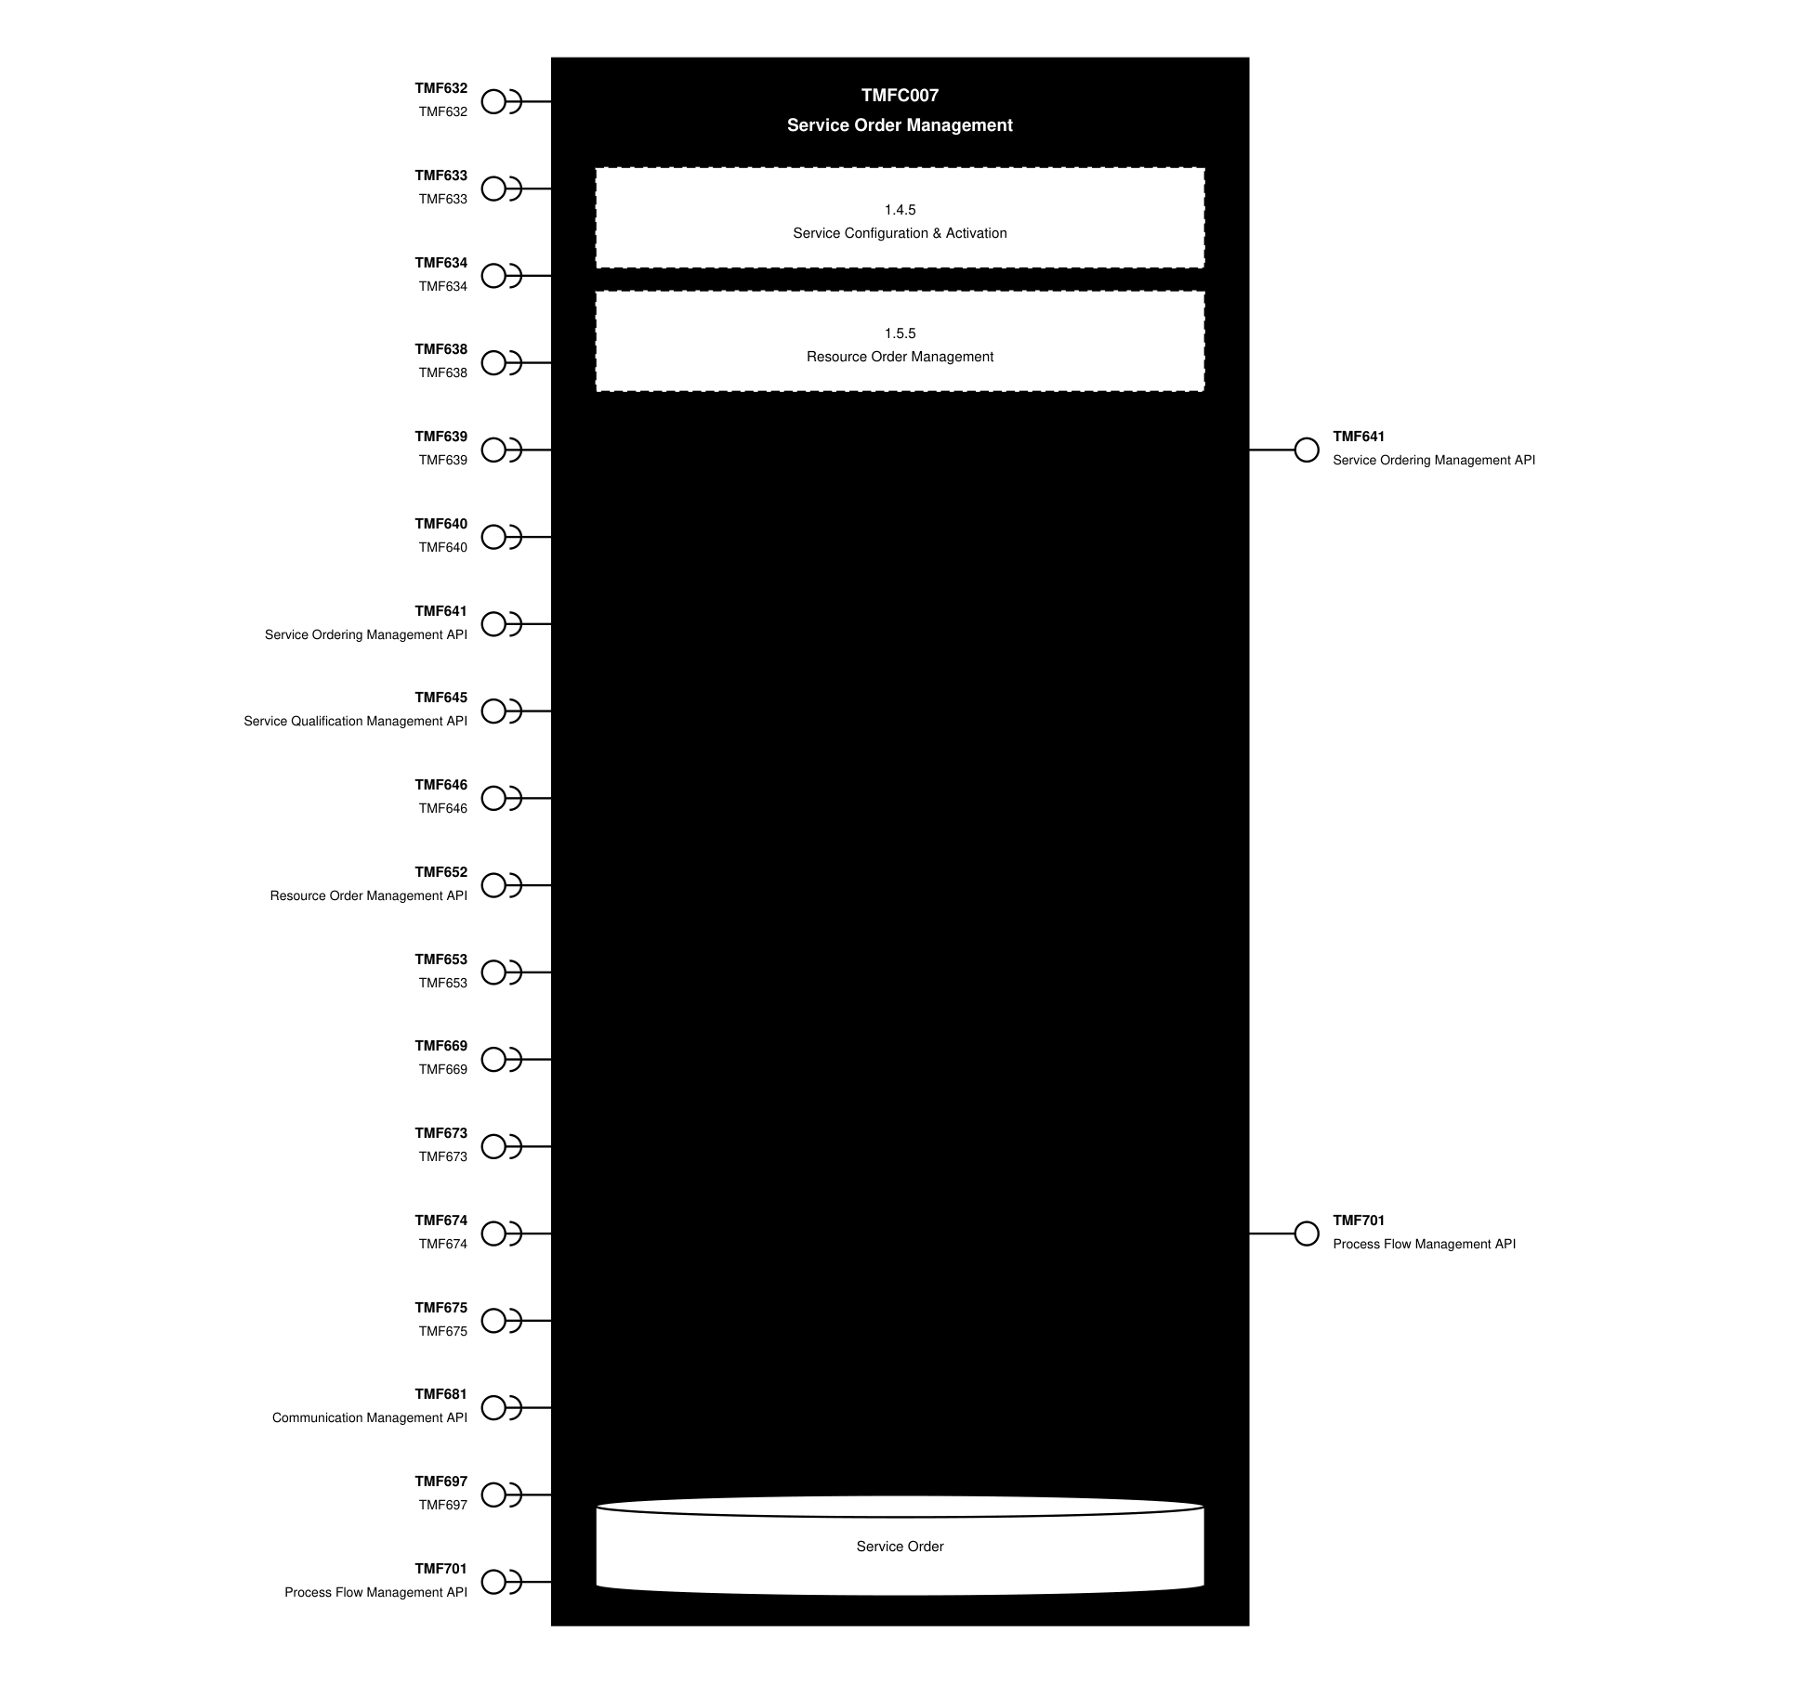
API Context diagram

Exposed APIs
API ID | API Name | Mandatory / Optional | API Version | Resource | Operations
TMF641 | Service Ordering Management API | Mandatory | 4 | serviceOrder  cancelServiceOrder | GET  GET /id  POST  PATCH  DELETE
TMF701 | Process Flow Management API | Optional | 4 | processFlow  taskFlow | GET  GET /id  POST  DELETE /id  PATCH /id

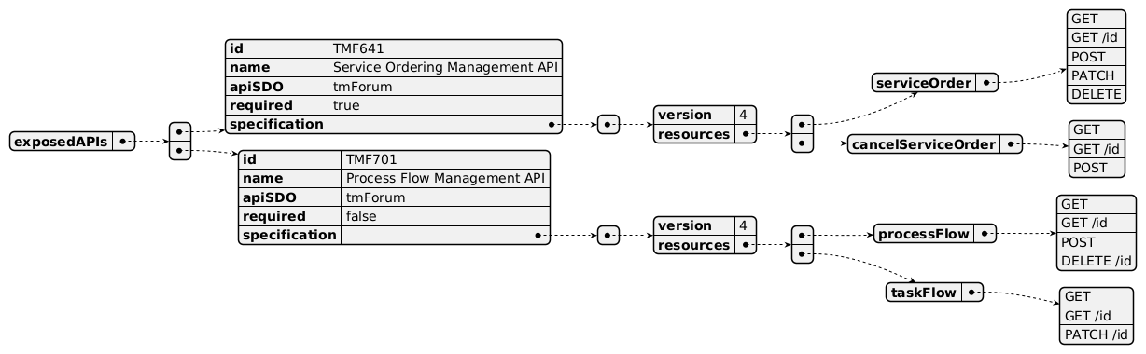
Exposed API diagram

Dependent APIs
API ID | API Name | API Version | Mandatory / Optional | Resource | Operations
TMF632 | TMF632 | 5 | Optional | individual  organization | GET  GET /id
TMF632 | TMF632 | 4 | Optional | individual  organization | GET  GET /id
TMF633 | TMF633 | 4 | Mandatory | serviceSpecification | GET  GET /id
TMF634 | TMF634 | 5 | Optional | resourceSpecification | GET  GET /id
TMF634 | TMF634 | 4 | Optional | resourceSpecification | GET  GET /id
TMF638 | TMF638 | 5 | Mandatory | service | GET  GET /id  POST  PATCH  DELETE
TMF638 | TMF638 | 4 | Mandatory | service | GET  GET /id  POST  PATCH  DELETE
TMF639 | TMF639 | 4 | Optional | resource | GET  GET /id
TMF640 | TMF640 | 4 | Optional | monitor | GET  GET /id
TMF641 | Service Ordering Management API | 4 | Optional | serviceOrder  cancelServiceOrder | GET  GET /id  POST  PATCH  DELETE
TMF645 | Service Qualification Management API | 5 | Optional | checkServiceQualification  queryServiceQualification | GET  GET /id  POST  PATCH
TMF645 | Service Qualification Management API | 4 | Optional | checkServiceQualification  queryServiceQualification | GET  GET /id  POST  PATCH
TMF646 | TMF646 | 4 | Optional | appointment  searchTimeSlot | GET  GET /id  POST  PATCH
TMF652 | Resource Order Management API | 4 | Optional | resourceOrder  cancelResourceOrder | GET  GET /id  POST  PATCH  DELETE
TMF653 | TMF653 | 4 | Optional | serviceTest  serviceTestSpecification | GET  GET /id
TMF669 | TMF669 | 5 | Optional | partyRole | GET  GET /id
TMF669 | TMF669 | 4 | Optional | partyRole | GET  GET /id
TMF673 | TMF673 | 4 | Optional | geographicAddress  geographicSubAddress  geographicAddressValidation | GET  GET /id  POST
TMF674 | TMF674 | 4 | Optional | geographicLocation | GET  GET /id
TMF675 | TMF675 | 4 | Optional | geographicSite | GET  GET /id
TMF681 | Communication Management API | 4 | Optional | communicationMessage | GET  GET /id
TMF697 | TMF697 | 4 | Optional | workOrder | GET  GET /id
TMF701 | Process Flow Management API | 4 | Optional | processFlow | POST  GET  GET /id  PATCH

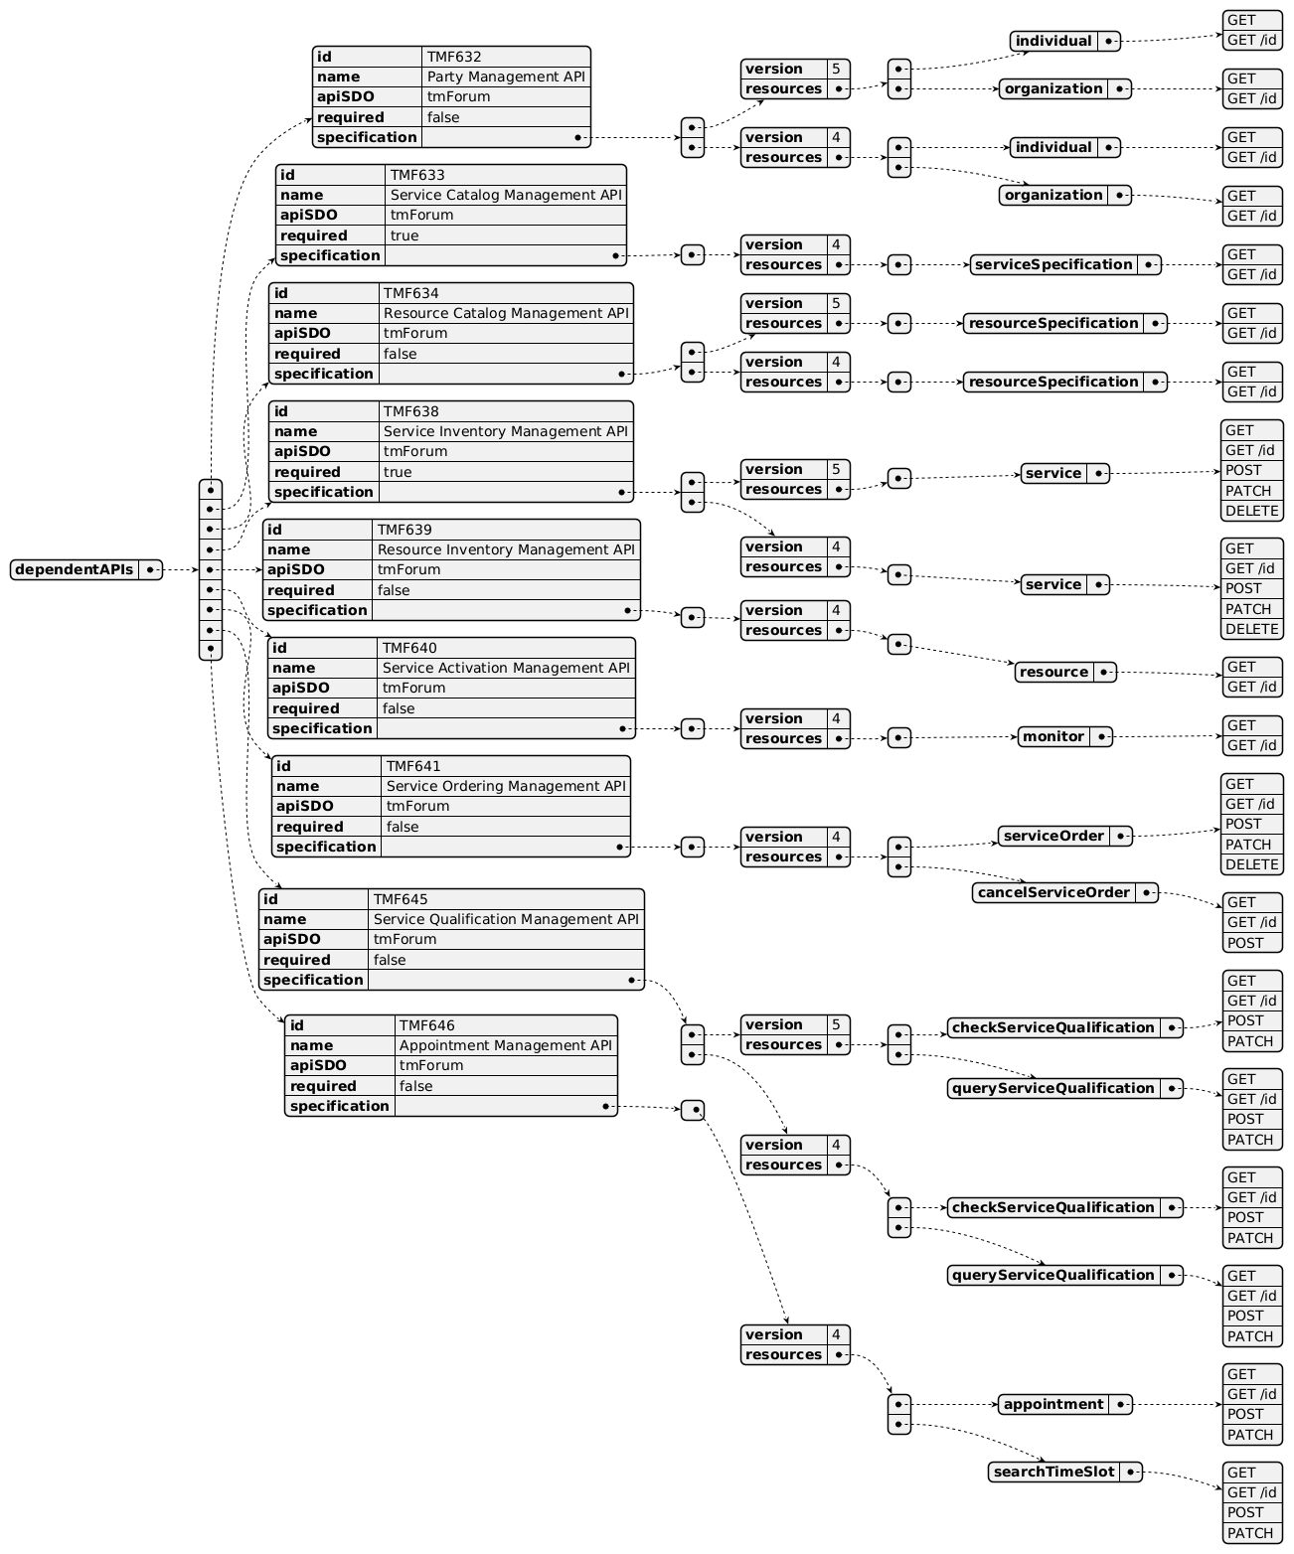
Dependent API diagram (1 of 2)
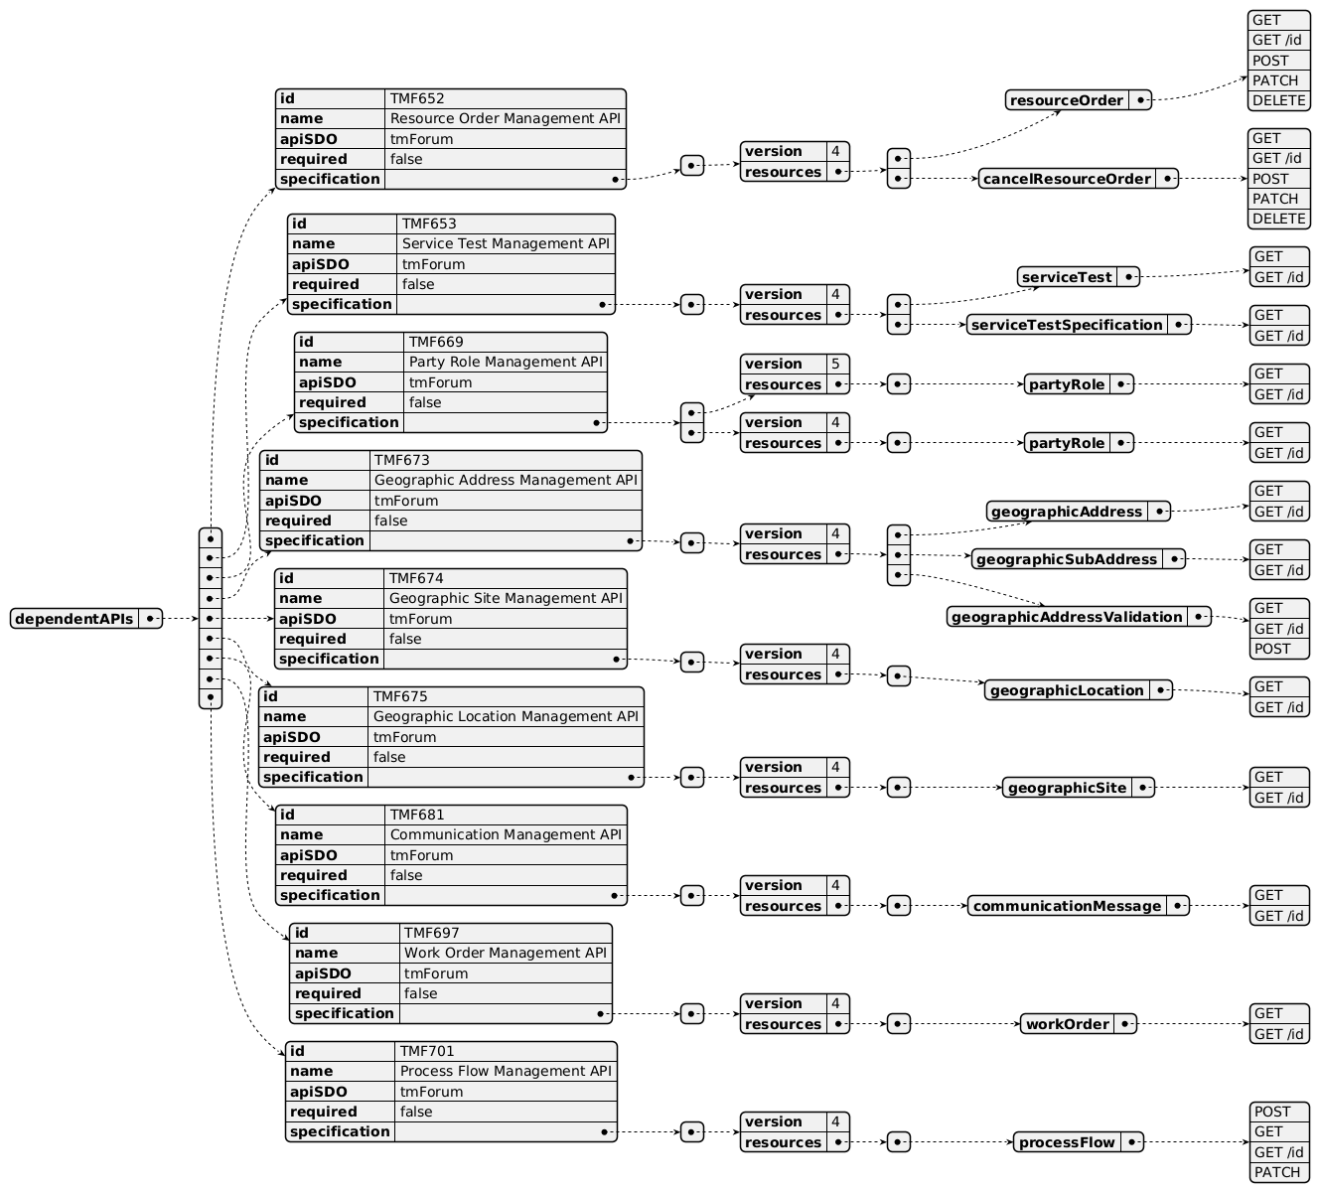
Dependent API diagram (2 of 2)

Events
The diagram illustrates the Events which the component may publish and the Events that the component may subscribe to and then may receive. Both lists are derived from the APIs listed in the preceding sections.

Published Events
API ID | API Name | Event Resources
TMF641 | Service Ordering Management API | serviceOrderCreateEvent  serviceOrderStateChangeEvent  serviceOrderDeleteEvent  serviceOrderAttributeValueChangeEvent  serviceOrderInformationRequiredEvent  serviceOrderMilestoneEvent  serviceOrderJeopardyEvent  cancelServiceOrderCreateEvent  cancelServiceOrderStateChangeEvent  cancelServiceOrderInformationRequiredEvent
TMF701 | Process Flow Management API | processFlowCreateEvent  processFlowStateChangeEvent  processFlowStateDeleteEvent  processFlowStateAttributeValueChangeEvent  taskFlowCreateEvent  taskFlowStateChangeEvent  taskFlowDeleteEvent  taskFlowAttributeValueChangeEvent  taskFlowInformationRequiredEvent

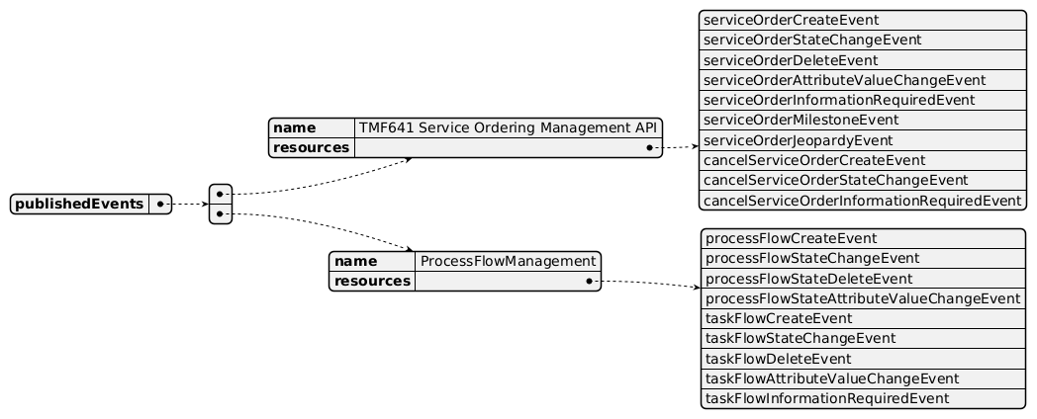
Published Events diagram

Subscribed Events
API ID | API Name | Event Resources
TMF652 | Resource Order Management API | resourceOrderStateChange  resourceOrderAttributeValueChangeEvent  resourceOrderInformationRequiredEvent  cancelResourceOrderStateChange  cancelResourceOrderInformationRequiredEvent
TMF645 | Service Qualification Management API | checkServiceQualificationStateChangeEvent  queryServiceQualificationStateChangeEvent
TMF681 | Communication Management API | communicationMessageStateChangeEvent
TMF697 | WorkOrder | workOrderStateChange
TMF681 | Communication Management API

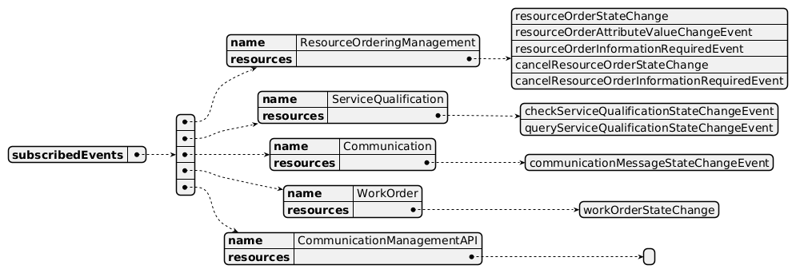
Subscribed Events diagram

Machine Readable Component Specification
Refer to the ODA Component Directory on the TM Forum website for the machine-readable component specification files for this component.

References

TMF Standards related versions
Standard | Version(s)
eTOM | v21.5, v26.0
SID | v25.0
Functional Framework | v21.5, v26.0

Jira References
No open Jira issues currently listed for this component.

Further resources
Service Order Management is used in the following IG1228 use cases:

TMFS004: Order Delivery - Fiber contract

TMFS007: B2B use-case re-using MEF

TMFS008: Service and Resource order management for postpaid mobile subscribers

TMFS009: Service and Resource order management for postpaid mobile subscribers with provisioning in 5G Core

TMFS010: ODA flow with NaaS Support

Administrative Appendix

Document History

Version History
Version Number | Date | Modified by | Description of changes
1.0.0 | 01-Oct-2021 | Goutham Babu | Final edits prior to publication
1.0.0 | 05-Aug-2022 | Goutham Babu | Final edits prior to publication
1.0.1 | 25-Jul-2023 | Ian Turkington | No content changed, simply a layout change to match template 3. Separated the YAML files to a managed repository.
1.0.1 | 15-Aug-2023 | Amaia White | Final edits prior to publication
1.1.1 | 01-Mar-2024 | Amaia White | Final edits prior to publication
1.2.1 | 25-Jun-2024 | Gaetano Biancardi | Updated for new ODA Component template; updated to ODF v23.5; removed TMF672 as mandatory dependent API; exposed API removed: TMF688 Event Mgmt, TMF672 User Roles and Permissions; dependent API removed: TMF688 Event Mgmt
1.2.2 | 08-Jul-2025 | Rosie Wilson | Update to Overview Diagram to remove TMF688 Event Management as requested by Sylvie Demarest to align with previous amendments; updates to description per agreed YAML updated on 03-Jun-2025
1.2.2 | 15-Jul-2025 | Rosie Wilson | Final edits prior to publication
2.1.0 | 02-Jun-2026 | Hugo Vaughan | Gen 5 API Updates
2.1.0 | 25-Jun-2026 | Sannah Sibaya | Final edits prior to publication

Release History
Release Status | Date Modified | Modified by | Description of changes
Pre-production | 01-Oct-2021 | Goutham Babu | Initial release of document
Pre-production | 05-Aug-2022 | Goutham Babu | Initial release of document
Pre-production | 15-Aug-2023 | Amaia White | New release 1.0.1
Production | 06-Oct-2023 | Adrienne Walcott | Updated to reflect TM Forum Approved status
Pre-production | 01-Mar-2024 | Amaia White | New release 1.1.1
Production | 26-Apr-2024 | Adrienne Walcott | Updated to reflect TM Forum Approved status
Pre-production | 02-Jul-2024 | Amaia White | New release 1.2.1
Production | 30-Aug-2024 | Adrienne Walcott | Updated to reflect TM Forum Approved status
Pre-production | 15-Jul-2025 | Rosie Wilson | New release 1.2.2
Production | 05-Sep-2025 | Adrienne Walcott | Updated to reflect TM Forum Approved status
Pre-production | 25-Jun-2026 | Sannah Sibaya | New release 2.1.0

Acknowledgements
This document was prepared by the members of the TM Forum ODA Components & Canvas team.
Team Member | Company | Role
Roland Leners | Satec | Reviewer
Sylvie Demarest | Orange | Editor
Abel Ruiz Huerta | Satec | Reviewer
Robert Ludovic | Orange | Reviewer
Cecile Ludwichowski | Orange | Reviewer
Ian Turkington | TM Forum | Additional Input
Hugo Vaughan (TM Forum) | TM Forum | Additional Input
Gaetano Biancardi | Accenture | Editor
Elisabeth Andersson | MATRIXX | Reviewer
Abinash Vishwakarma | Netcracker | Reviewer
Jose Macaluso | Xacria | Reviewer
Kamal Maghsoudlou | Ericsson | Reviewer
Milind Bhagwat | BT | Reviewer
Ritu Arora | BT | Reviewer
Matteo Destino | Accenture | Reviewer

