TMFC008 Service Inventory v1.3.0
Components and Canvas
In this deliverable:

Overview
Component Name | ID | Description | ODA Function Block
Service Inventory | TMFC008 | The Service Inventory component is responsible for storage and exposure of CFS (Customer Facing Services) that are associated to Product Inventory items. It is also responsible for RFS (Resource Facing Service) definition, mapping between CFS and RFS and mapping with infrastructure/network resources. The Service Inventory component has functionality that enables creation of inventory items, inventory organization, inventory search or filter, inventory monitoring and tracking, inventory control and inventory auditing. The minimum check to be performed at inventory item creation or update is for global consistency with the related Service Catalog information. | Production

eTOM Processes, SID Data Entities and Functional Framework Functions

eTOM business activities
eTOM business activities this ODA Component is responsible for:
Identifier | Level | Business Activity Name | Description
1.4.4 | L2 | Service Support Readiness | Manage service infrastructure, ensuring that the appropriate service capacity is available and ready to support the SM&O Fulfillment, Assurance and Billing processes.
1.4.4.1 | L3 | Manage Service Inventory | Establish, manage and administer the enterprise's service inventory, as embodied in the Service Inventory Database, and monitor and report on the usage and access to the service inventory, and the quality of the data maintained in it.

SID ABEs
SID ABEs this ODA Component is responsible for:
SID ABE Level 1 | SID ABE Level 2 (or set of BEs) | SID ABE L1 Definition | SID ABE L2 Definition
Service |  | A Service represents an instance of ServiceSpecification. The Service ABE contains entities that are used to represent both types of Services: CSP Know-Hows instances (a.k.a. Customer Facing Services or CFS) and Technical solution (a.k.a. Resource Facing Services or RFS). The Service carries the place where the Service is in use if relevant, as well as configuration characteristics, such as assigned telephone numbers and internet addresses. The Service also tracks the links to Product realized and/or Resources used. | *(no description available)*

eTOM L2 - SID ABEs links
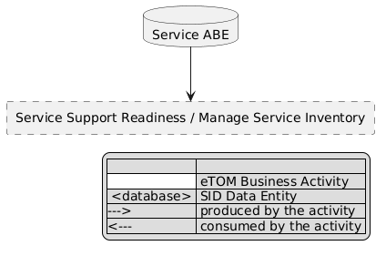
eTOM L2 - SID ABEs links diagram

Functional Framework Functions
Function ID | Function Name | Function Description | Aggregate Function Level 1 | Aggregate Function Level 2
576 | Service Data Retrieval | Service Data Retrieval provides retrieval of appropriate inventory data for example in the context of service end to end testing. | Service Management | Service / Repository Management
593 | Service Inventory Repository Updating | Service Repository Updating updates information in the service inventory according to the configuration of specific services | Service Management | Service Repository Management
628 | Service to Resource Relationship Management | Service to Resource Relationship Management provides Creation, Update and Deletion of the relations of stand-alone physical or logical resources whose assignment is critical to service's fulfillment, and whose tracking is critical to service operations, assurance, and billing, as well as, resources, which represent a larger resource structure supporting the service, often referred to as an Access Point. | Service Management | Service Repository Management
629 | Service to Resource Relationship Synchronization | Service to Resource Relationship Synchronization function entails reconciliation of the data in a Service Inventory Management system with inventory discovered from other sources and synchronizes mismatched service inventory records. | Service Management | Service Repository Management
630 | Service-Resource Relationship Management Notifications | Notification of Service-Resource Relationship Management actions to relevant stakeholders | Service Management | Service / Repository Management
964 | Onboarded Service Integration Configuration | Onboarded Service Integration Configuration function will configure the on boarded service and the relevant systems to establish integration automatically, when requested. There are several system services in the infrastructure that needs to be aware and integrated with the new service. | Service Management | Service / Repository Management
965 | Service Instance Lifecycle Management | Service Instance Lifecycle Management function will control the starting of new instances and closing of instances of a service as well as other activity states of the service instances. / Software based Services’ performance and availability may be controlled by managing multiple instances of the service with multiple states of activity. | Service Management | Service Repository Management
1344 | Service Topology Discovery | Service Topology Discovery function provides the required capability to discover how resources (e.g. network) are related to each other in providing a service. | Service Management | Service / Repository Management

TM Forum Open APIs & Events
The following part covers the APIs and Events; this part is split in 3:

List of Exposed APIs - This is the list of APIs available from this component.

List of Dependent APIs - In order to satisfy the provided API, the component could require the usage of this set of required APIs.

List of Events (generated & consumed) - The events which the component may generate are listed in this section along with a list of the events which it may consume. Since there is a possibility of multiple sources and receivers for each defined event.

API Context Diagram
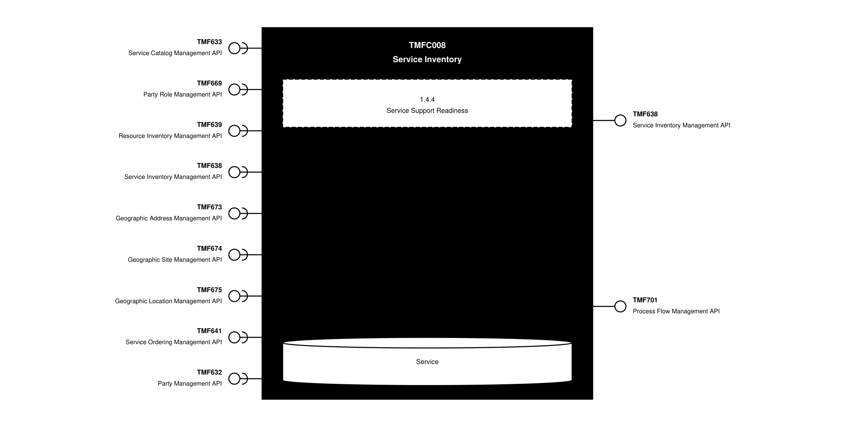
API Context diagram

Exposed APIs
API ID | API Name | Mandatory / Optional | API Version | Resource | Operations
TMF638 | Service Inventory Management API | Mandatory | 5 | service | GET  GET /id  POST  PATCH  DELETE
TMF638 | Service Inventory Management API | Mandatory | 4 | service | GET  GET /id  POST  PATCH  DELETE
TMF701 | Process Flow Management API | Optional | 4 | processFlow  taskFlow | POST  GET  GET /id  DELETE  PATCH

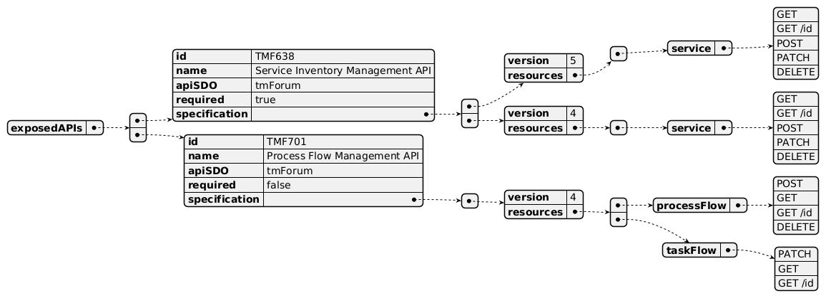
Exposed API diagram

Dependent APIs
API ID | API Name | API Version | Mandatory / Optional | Resource | Operations
TMF633 | Service Catalog Management API | 4 | Mandatory | serviceSpecification | GET  GET /id
TMF669 | Party Role Management API | 5 | Optional | partyRole | GET  GET /id
TMF669 | Party Role Management API | 4 | Optional | PartyRole | GET  GET /id
TMF639 | Resource Inventory Management API | 4 | Optional | resource | GET  GET /id
TMF638 | Service Inventory Management API | 5 | Optional | service | GET  GET /id
TMF638 | Service Inventory Management API | 4 | Optional | service | GET  GET /id
TMF673 | Geographic Address Management API | 4 | Optional | geographicAddress  geographicSubAddress | GET  GET /id
TMF674 | Geographic Site Management API | 4 | Optional | geographicSite | GET  GET /id
TMF675 | Geographic Location Management API | 4 | Optional | geographicLocation | GET  GET /id
TMF641 | Service Ordering Management API | 4 | Optional | serviceOrder | GET  GET /id
TMF632 | Party Management API | 5 | Optional | individual  organization | GET  GET /id
TMF632 | Party Management API | 4 | Optional | individual  organization | GET  GET /id

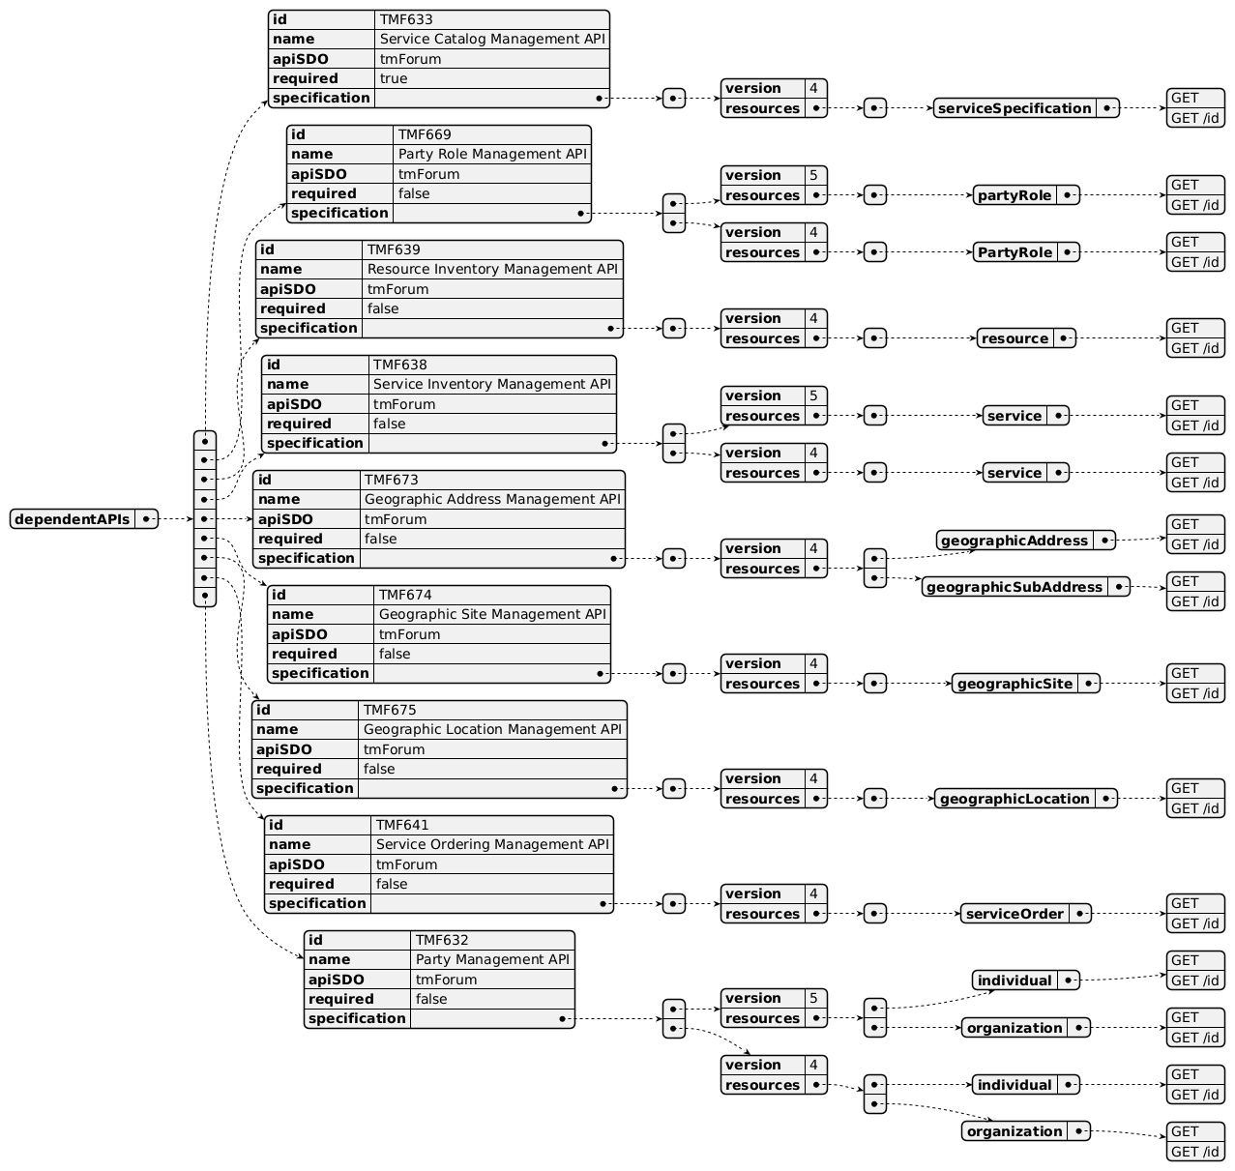
Dependent API diagram

Events
The diagram illustrates the Events which the component may publish and the Events that the component may subscribe to and then may receive. Both lists are derived from the APIs listed in the preceding sections.

Published Events
API ID | API Name | Event Resources
TMF638 | Service Inventory Management API | serviceCreateEvent  serviceAttributeValueChangeEvent  serviceStateChangeEvent  serviceDeleteEvent
TMF701 | Process Flow Management API | processFlowCreateEvent  processFlowStateChangeEvent  processFlowStateDeleteEvent  processFlowStateAttributeValueChangeEvent  taskFlowCreateEvent  taskFlowStateChangeEvent  taskFlowDeleteEvent  taskFlowAttributeValueChangeEvent  taskFlowInformationRequiredEvent

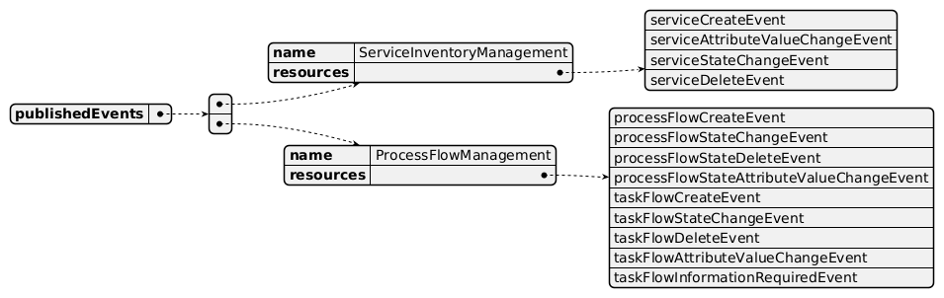
Published Events diagram

Subscribed Events
API ID | API Name | Event Resources
TMF639 | Resource Inventory Management API | resourceDeleteEvent
TMF638 | Service Inventory Management API | serviceCreateEvent  serviceAttributeValueChangeEvent  serviceStateChangeEvent  serviceDeleteEvent
TMF633 | Service Catalog Management API | serviceSpecificationDeleteEvent
TMF669 | Party Role Management API | partyRoleDeleteEvent
TMF674 | Geographic Site Management API | geographicSiteDeleteEvent
TMF675 | Geographic Location Management API | geographicLocationDeleteEvent
TMF632 | Party Management API | individualDeleteEvent  organizationDeleteEvent
TMF641 | Service Ordering Management API | serviceOrderDeleteEvent

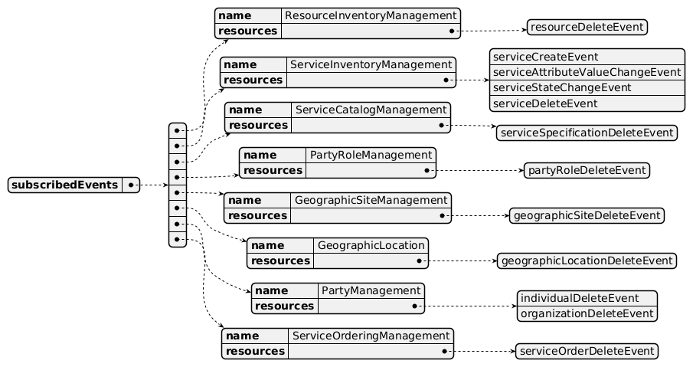
Subscribed Events diagram

Machine Readable Component Specification
Refer to the ODA Component Directory on the TM Forum website for the machine-readable component specification files for this component.

References

TMF Standards related versions
Standard | Version(s)
eTOM | v23.0
SID | v25.0
Functional Framework | v23.0

Jira References
Functional Framework

ISA-416 - Harmonize functions related to Product, Service and Resource Inventories (BACKLOG): harmonize as much as possible functions related to Product, Service and Resource Inventory (under review)

ISA-996 - Master Data Management has repurposed catalog related functions (BACKLOG): as part of reviewing the Product, Service and Resource Catalogs to align with the updates to the Functional Framework, a lot of functions have either been removed or re-purposed by Master Data Management, resulting in a decision to remove these functions from the Components:

Removed deleted unclassified functions (1, 2, 5, 7, 9, 10, 12, 14, 15)

Removed functions that used to be related to Catalog management but now have been re-purposed by Master Data Management (3, 4, 6, 11, 13)
Concern: catalog functions may be missing due to re-use of Master Data Management.

Further resources
1. IG1228: please refer to IG1228 for defined use cases with ODA components interactions.

Administrative Appendix

Document History

Version History
Version Number | Date | Modified by | Description of changes
1.0.0 | 31-May-2022 | Kamal Maghsoudlou, Sylvie Demarest | Initial release
1.0.1 | 27-Jul-2023 | Ian Turkington | No content changed, simply a layout change to match template 3.
1.0.1 | 15-Aug-2023 | Amaia White | Final updates before publication
1.1.0 | 14-May-2024 | Hugo Vaughan (TM Forum), Sylvie Demarest | Updated to latest template; aligned with 23.5 SID, eTOM and Functional Framework
1.1.0 | 12-Jul-2024 | Amaia White | Final updates before publication
1.2.0 | 12-Nov-2024 | Gaetano Biancardi | TMF688 removed from the core specification, moved to supporting functions; TMF672 removed from the core specification, moved to supporting functions; API version, only major version to be specified
1.2.0 | 26-Nov-2024 | Amaia White | Final updates before publication
1.2.1 | 08-Jul-2025 | Rosie Wilson | Updates to description per agreed YAML updated on 03-Jun-2025; final administrative updates prior to publication
1.3.0 | 05-Jun-2026 | Hugo Vaughan | Gen 5 API updates
1.3.0 | 05-Jun-2026 | Sannah Sibaya | Final edits prior to publication

Release History
Release Status | Date Modified | Modified by | Description of changes
Pre-production | 31-May-2022 | Goutham Babu | Initial release
Production | 22-Jul-2022 | Adrienne Walcott | Updated to reflect TM Forum Approved status
Pre-production | 15-Aug-2023 | Amaia White | New release v1.0.1
Production | 06-Oct-2023 | Adrienne Walcott | Updated to reflect TM Forum Approved status
Pre-production | 12-Jul-2024 | Amaia White | New release 1.1.0
Production | 30-Aug-2024 | Adrienne Walcott | Updated to reflect TM Forum Approved status
Pre-production | 26-Nov-2024 | Amaia White | New release 1.2.0
Production | 07-Mar-2025 | Adrienne Walcott | Updated to reflect TM Forum Approved status
Pre-production | 08-Jul-2025 | Rosie Wilson | New release 1.2.1
Production | 05-Sep-2026 | Adrienne Walcott | Updated to reflect TM Forum Approved status
Pre-production | 05-Jun-2026 | Sannah Sibaya | New release 1.3.0; final updates prior to publishing

Acknowledgements
This document was prepared by the members of the TM Forum ODA Components and Canvas team.
Team Member | Company | Role
Kamal Maghsoudlou | Ericsson | Editor
Sylvie Demarest | Orange | Additional Input
Ian Turkington | TM Forum | Additional Input
Hugo Vaughan (TM Forum) | TM Forum | Additional Input
Gaetano Biancardi | Accenture | Additional Input
Elisabeth Andersson | MATRIXX | Reviewer
Abinash Vishwakarma | Netcracker | Reviewer
Jose Macaluso | Xacria | Reviewer
Milind Bhagwat | BT | Reviewer
Ritu Arora | BT | Reviewer
Matteo Destino | Accenture | Reviewer

