TMFC009 Service Qualification Management v1.2.0
Components and Canvas
In this deliverable:

Overview
Component Name | ID | Description | ODA Function Block
Service Qualification Management | TMFC009 | The Service Qualification Management component is responsible for checking and validating the availability of a service according to specified and configured business rules. It must identify at least one technical solution (RFSspec) available to deliver the service (CFSspec) and check the availability of all the resources types involved in this technical solution. No resources are allocated during service qualification. The Service Qualification Management component has functionality that includes checking service feasibility status and publishing or reporting service qualification results, but also calculated service delivery due date and identified need of an appointment at the customer site. Service Qualification Management can also be responsible for the cost calculation of the technical solution identified, when it cannot be determined at catalog design time (complex B2B services). This information will be used as an input to price calculation. | Production

eTOM Processes, SID Data Entities and Functional Framework Functions

eTOM business activities
eTOM business activities this ODA Component is responsible for:
Identifier | Level | Business Activity Name | Description
1.4.5 | L2 | Service Configuration & Activation | Service Configuration & Activation processes encompass allocation, implementation, configuration, activation and testing of specific services to meet customer requirements, or in response to requests from other processes to alleviate specific service capacity shortfalls, availability concerns or failure conditions. Where included in the service provider offering, these processes extend to cover customer premises equipment. / Responsibilities of the Service Configuration & Activation processes include, but are not limited to: / • Verifying whether specific service designs sought by customers are feasible as part of pre-order feasibility checks; / • Allocating the appropriate specific service parameters to support service orders or requests from other processes; / • Reserving specific service parameters (if required by the business rules) for a given period of time until the initiating customer order is confirmed, or until the reservation period expires (if applicable); / • Implementing, configuring and activating specific services, as appropriate; / • Testing the specific services to ensure the service is working correctly; / • Recovery of specific services; / • Updating of the Service Inventory Database to reflect that the specific service has been allocated, modified or recovered; / • Assigning and tracking service provisioning activities; / • Managing service provisioning jeopardy conditions / • Reporting progress on service orders to other processes.

SID ABEs
SID ABEs this ODA Component is responsible for:
SID ABE Level 1 | SID ABE Level 2 (or set of BEs) | SID ABE L1 Definition | SID ABE L2 Definition
Service Configuration |  | The definition of how a Service operates or functions in terms of CharacteristicSpecification(s) and related ResourceSpec(s) and ServiceSpec(s) as well as a representation of how a Product operates or functions in terms of characteristics and related Resource(s) and Service(s). For more detail refer to Configuration & Profiling ABE in Common Domain | *(no description available)*

eTOM L2 - SID ABEs links
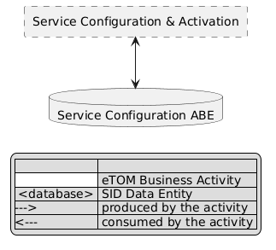
eTOM L2 - SID ABEs links diagram

Functional Framework Functions
Function ID | Function Name | Function Description | Aggregate Function Level 1 | Aggregate Function Level 2
319 | Service Feasibility Checking | Service Feasibility Checking provides checking based on the customer service location; service feasibility checks are done to assure the offering can actually be provided to the customer. This implies that the customer location is clearly established. Service feasibility checks are conducted via contract with the Service Order Management function. | Service Order Management | Service Availability
586 | Service Availability Validation | Service Availability Validation function validates that the service or services specified on the service order are available at the specified customer/service location and feasible from a network point of view. | Service Order Management | Service Availability
571 | Service Delivery Due Date Calculation | Service Delivery Due Date Calculation functions calculates the service delivery due date using network capacity, access provider selection and work center intelligence (including workload and capacity). | Service Order Management | Service Order Initialization

TM Forum Open APIs & Events
The following part covers the APIs and Events; this part is split in 3:

List of Exposed APIs - This is the list of APIs available from this component.

List of Dependent APIs - In order to satisfy the provided API, the component could require the usage of this set of required APIs.

List of Events (generated & consumed) - The events which the component may generate are listed in this section along with a list of the events which it may consume. Since there is a possibility of multiple sources and receivers for each defined event.

API Context Diagram
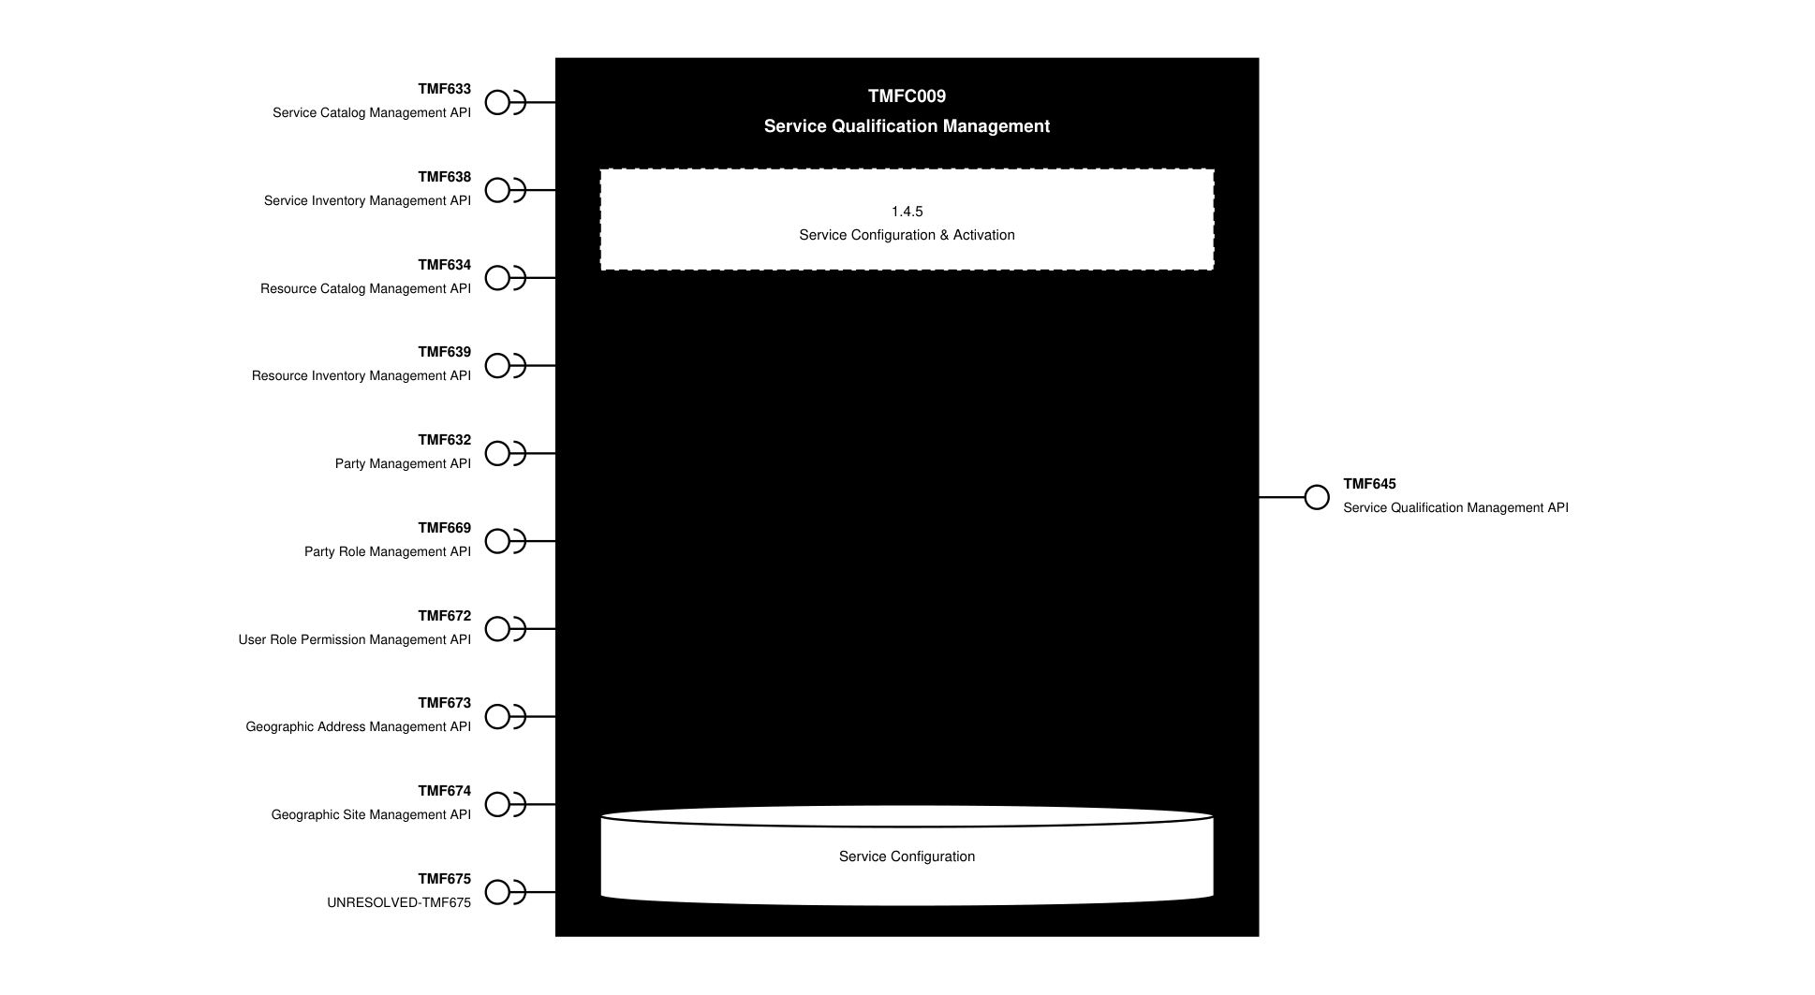
API Context diagram

Exposed APIs
API ID | API Name | Mandatory / Optional | API Version | Resource | Operations
TMF645 | Service Qualification Management API | Mandatory | 5 | checkServiceQualification  queryServiceQualification | GET  GET /id  POST  PATCH  DELETE
TMF645 | Service Qualification Management API | Mandatory | 4 | checkServiceQualification  queryServiceQualification | GET  GET /id  POST  PATCH  DELETE

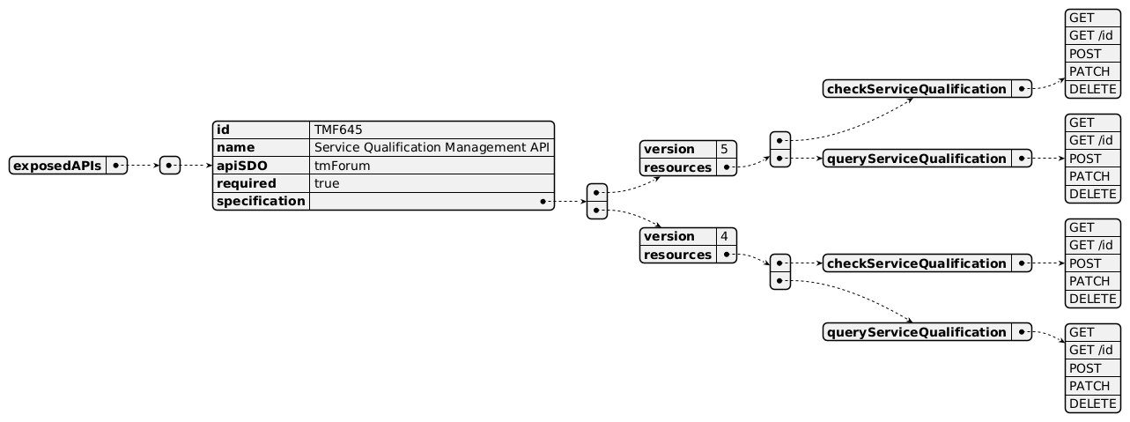
Exposed API diagram

Dependent APIs
API ID | API Name | API Version | Mandatory / Optional | Resource | Operations
TMF633 | Service Catalog Management API | 4 | Mandatory | serviceSpecification  serviceCategory | GET  GET /id
TMF638 | Service Inventory Management API | 5 | Optional | service | GET  GET /id
TMF638 | Service Inventory Management API | 4 | Optional | service | GET  GET /id
TMF634 | Resource Catalog Management API | 5 | Optional | resourceSpecification | GET  GET /id
TMF634 | Resource Catalog Management API | 4 | Optional | resourceSpecification | GET  GET /id
TMF639 | Resource Inventory Management API | 4 | Optional | resource | GET  GET /id
TMF632 | Party Management API | 5 | Optional | individual  organization | GET  GET /id
TMF632 | Party Management API | 4 | Optional | individual  organization | GET  GET /id
TMF669 | Party Role Management API | 5 | Optional | partyRole | GET  GET /id
TMF669 | Party Role Management API | 4 | Optional | partyRole | GET  GET /id
TMF672 | User Role Permission Management API | 5 | Optional | permission | GET  GET /id
TMF672 | User Role Permission Management API | 4 | Optional | permission | GET  GET /id
TMF673 | Geographic Address Management API | 4 | Optional | geographicAddress  geographicSubAddress | GET  GET /id
TMF674 | Geographic Site Management API | 4 | Optional | geographicSite | GET  GET /id
TMF675 | UNRESOLVED-TMF675 | 4 | Optional | geographicLocation | GET  GET /id

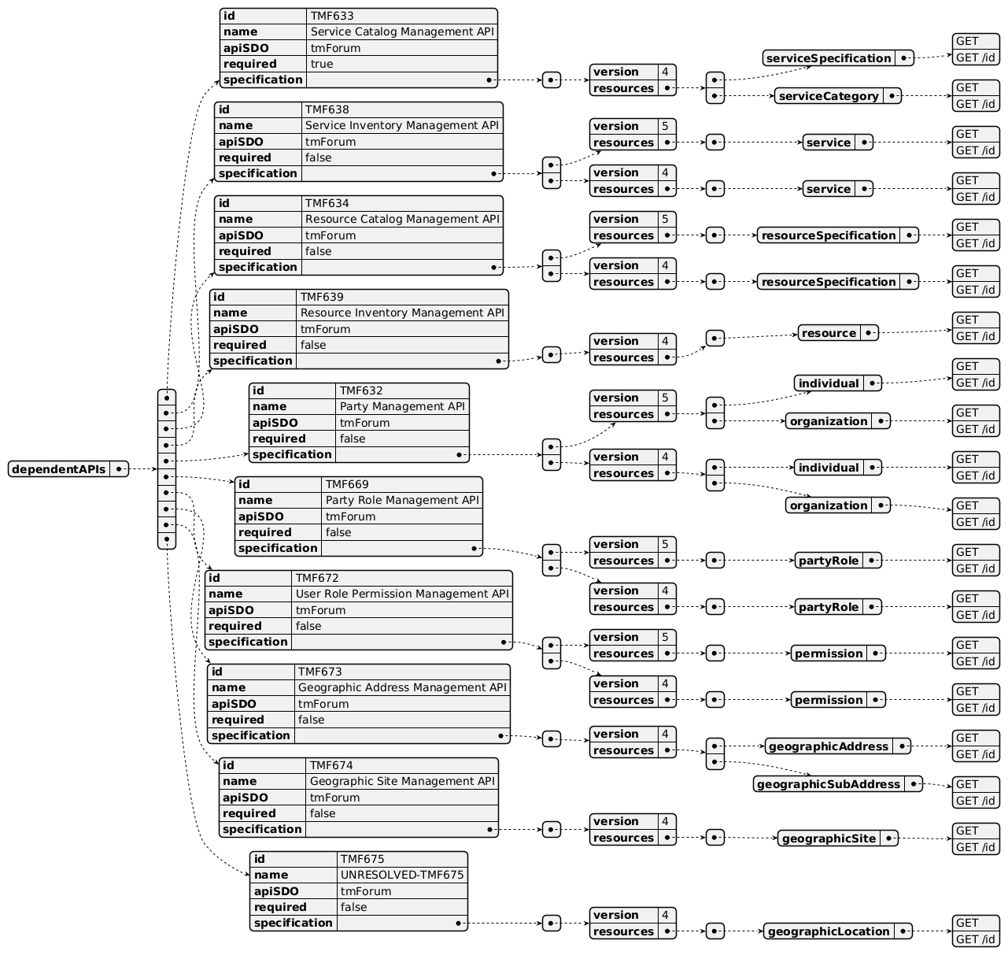
Dependent API diagram

Events
The diagram illustrates the Events which the component may publish and the Events that the component may subscribe to and then may receive. Both lists are derived from the APIs listed in the preceding sections.

Published Events
API ID | API Name | Event Resources
TMF645 | Service Qualification Management API | checkServiceQualificationCreateEvent  checkServiceQualificationStateChangeEvent  checkServiceQualificationInformationRequiredEvent  checkServiceQualificationAttributeValueChangeEvent  checkServiceQualificationDeleteEvent  queryServiceQualificationStateChangeEvent  queryServiceQualificationCreateEvent  queryServiceQualificationDeleteEvent

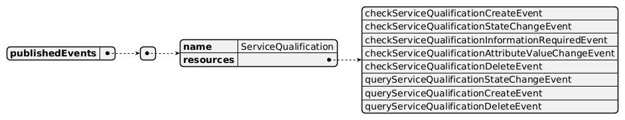
Published Events diagram

Subscribed Events
none listed in the component YAML

Subscribed Events diagram

Machine Readable Component Specification
Refer to the ODA Component Directory on the TM Forum website for the machine-readable component specification files for this component.

References

TMF Standards related versions
Standard | Version(s)
eTOM | v23.0.1
SID | v23.5.0
Functional Framework | v23.0

Jira References
eTOM

Identify a new Service Availability Check/Assessment activity at Service level, as part of L2 Service Configuration & Activation, able to provide all the expected results (feasibility status, service delivery due date, need of an appointment at customer site, and cost of the technical solution when needed)

Restore the Determine Resource Availability activity at Resource level. Initial definition: "This process investigates the ability to be able to satisfy specific service orders as a part of a feasibility check. Where the Allocate & Install Resource processes are requested by a pre-feasibility resource order, or by the Design Resources processes, these processes determine whether the requested resources are available."
SID

Identify a new Service Qualification BE (if we want to register the result of the Service Availability Check/Assessment)
Functional Framework

592 - Service Parameters Reservation should not be classified in Service Availability sub-domain level 2, but rather in Service Configuration & Activation / Service Configuration

571 - Service Delivery Due Date calculation should be classified in Service Availability sub-domain level 2 and not in Service Order Initialization

Add a function to calculate the cost of a technical solution, for complex cases when it cannot be done at catalog design time
API

TMF645 (AP-6200 - TMF645 - Add additional information in the response (DONE)) - Service Qualification API: be able to receive as an answer not only the qualification result but also the calculated due date, the need of an appointment, and the cost of the solution identified

Further resources
As listed in IG1214 - Mapping of ODA Components and ODA Use Cases, this component is involved in the following use cases described in IG1228 - How to Use ODA - Using Open APIs to Realize Use Cases: UC002, UC003, UC007, UC008 and UC010.

Administrative Appendix

Document History

Version History
Version Number | Date | Modified by | Description of changes
1.0.0 | 05-Aug-2022 | Goutham Babu | Final edits prior to publication
1.0.1 | 25-Jul-2023 | Ian Turkington | No content changed, simply a layout change to match template 3. Separated the YAML files to a managed repository.
1.1.0 | 13-May-2024 | Gaetano Biancardi | Component Template Update; ODF 23.5 update; TMF688 removed from exposed and dependent API
1.1.0 | 12-Jul-2024 | Amaia White | Final updates before publication
1.1.1 | 20-Jan-2026 | Rosie Wilson | Updates to description per agreed YAML updated on 03-Jun-2025; final administrative updates prior to publication
1.2.0 | 29-May-2026 | Hugo Vaughan | Gen 5 API Updates
1.2.0 | 25-Jun-2026 | Sannah Sibaya | Final edits prior to publication

Release History
Release Status | Date Modified | Modified by | Description of changes
Pre-production | 05-Aug-2022 | Goutham Babu | Initial release of document
Pre-production | 05-Sep-2022 | Adrienne Walcott | Updated to reflect TM Forum Member Evaluated status
Pre-production | 14-Aug-2023 | Amaia White | New release 1.0.1
Production | 06-Oct-2023 | Adrienne Walcott | Updated to reflect TM Forum Approved status
Pre-production | 12-Jul-2024 | Amaia White | New release 1.1.0
Production | 30-Aug-2024 | Adrienne Walcott | Updated to reflect TM Forum Approved status
Pre-production | 20-Jan-2026 | Rosie Wilson | New release 1.1.1
Production | 05-Sep-2025 | Adrienne Walcott | Updated to reflect TM Forum Approved status
Pre-production | 25-Jun-2026 | Sannah Sibaya | New release 1.2.0

Acknowledgements
This document was prepared by the members of the TM Forum ODA Components & Canvas team.
Team Member | Company | Role
Sylvie Demarest | Orange | Editor
Ian Turkington | TM Forum | Additional Input
Hugo Vaughan (TM Forum) | TM Forum | Additional Input
Rosie Wilson | TM Forum | Additional Input
Gaetano Biancardi | Accenture | Additional Input
Elisabeth Andersson | MATRIXX | Reviewer
Abinash Vishwakarma | Netcracker | Reviewer
Jose Macaluso | Xacria | Reviewer
Milind Bhagwat | BT | Reviewer
Ritu Arora | BT | Reviewer
Matteo Destino | Accenture | Reviewer

