TMFC010 Resource Catalog Management v1.4.2
Components and Canvas
In this deliverable:

Overview
Component Name | ID | Description | ODA Function Block
Resource Catalog Management | TMFC010 | The Resource Catalog Management component is responsible for organizing the collection of resource specifications that identify and define all requirements for a resource. The Resource Catalog Management component has the functionality that enables presentation of a customer-facing view, so users are able to browse and select resources they need, as well as a technical view to enable definition and setup of resources contained in the resource catalog. Additional functionalities include capturing new resource specifications, managing resources (registering assets and components and identifying and mapping connections/relationships), administering the lifecycle of resources, describing relationships between resources, reporting on resources and changes to their attributes, and facilitating easy access to identify and assign resources. | Production

eTOM Processes, SID Data Entities and Functional Framework Functions

eTOM business activities
eTOM business activities this ODA Component is responsible for:
Identifier | Level | Business Activity Name | Description
1.5.15 | L2 | Resource Catalog Lifecycle Management | Catalog Lifecycle Management business process covers a set of business activities that enable manage the lifecycle of an organizations catalog from design to build according to defined requirements. / Catalog Lifecycle Management proves the overarching governance to manage all the stages in the realization and operationalization of the Product/Service/Resource Catalog in support of the organizations business goals.
1.5.16 | L2 | Resource Catalog Operational Readiness Management | Resource Catalog Operational Readiness Management business process establishes and administers the support needed to operationalize Resource catalogs for ongoing day-to-day business needs. / These business activities implement the Resource Catalog through Release and Deploy business activities.
1.5.17 | L2 | Resource Catalog Content Management | Resource Catalog Content Management business process define and provide the business activities that support the day-to-day operations of Resource Catalogs in order to realize the business operations goals. / Resource Catalog Content Management business processes include administering the Resource Catalog instance in production, maintaining catalog entries, assuring catalogs, managing catalog access, managing entry lifecycle through versioning, handling catalog entity entry and changes, supporting distribution of catalogs as needed, and supporting user-facing activities.
1.5.18 | L2 | Resource Catalog Planning Management | Resource Catalog Planning Management business process covers a set of business activities that understand and enable establish the plan to define, design and operationalize a catalog in order to meet the needs and objectives of Resource cataloging. / The Resource Catalog Planning Management business process ensure that the organization is able to identify the most appropriate scheme and goal for it catalog. It includes designing the Catalog plan and developing the specification according to Resource management requirement.
1.5.19 | L2 | Resource Specification Management | Resource Specification Management business process leverages captured resource requirements to develop, master, analyze, and update documented standard conditions that must be satisfied by a resource design and/or delivery. / Resource Specifications Management can result in establishing in a centralized way, technical (know-how) standards. Such standards provide the organization with a means to control and approve the values and inputs of specification through structure, review, approval and distribution processes to stakeholders and suppliers.
1.5.3 | L2 | Resource Specification Development & Retirement | Resource Specification Development & Retirement processes develop new, or enhance existing technologies and associated resource types, so that new Products are available to be sold to customers. They use the capability definition or requirements defined by Resource Strategy & Planning They also decide whether to acquire resources from outside, taking into account the overall business policy in that respect. These processes also retire or remove technology and associated resource types, which are no longer required by the enterprise. / Resource types may be built, or in some cases leased from other parties. To ensure the most efficient and effective solution can be used, negotiations on network level agreements with other parties are paramount for both building and leasing. / These processes interact strongly with Product and Engaged Party Development processes.
1.5.3.4 | L3 | Develop Detailed Resource Specifications | The Develop Detailed Resource Specifications processes develop and document the detailed resource-related technical, performance and operational specifications, and manuals. These processes develop and document the required resource features, the specific technology requirements and selections, the specific operational, performance and quality requirements and support activities, any resource specific data required for the systems and network infrastructure. The Develop Detailed Resource Specifications processes provide input to these specifications. The processes ensure that all detailed specifications are produced and appropriately documented. Additionally, the processes ensure that the documentation is captured in an appropriate enterprise repository.

SID ABEs
SID ABEs this ODA Component is responsible for:
SID ABE Level 1 | SID ABE Level 2 (or set of BEs) | SID ABE L1 Definition | SID ABE L2 Definition
Resource Specification |  | The Resource Specification ABE contains entities that define the shared characteristics and behavior of each of the three types of Resource entities. This enables multiple instances to be derived from a single specification entity. In this derivation, each instance will use the shared characteristics and behavior defined in its associated template. A ResourceSpecification might be Physical such as a handset, Logical such as an IP address or Compound i.e. composed of Logical and / or Physical Resources such as a Box with its firmware. | *(no description available)*
Resource Performance | ResourcePerformanceSpecification | The Resource Performance ABE collects information used to correlate, consolidate, and validate various performance statistics and other operational characteristics of Resources. Each of these entities also enables network performance assessment against planned goals, performs various aspects of trend analysis, including error rate and cause analysis and Resource degradation. Entities in this ABE also includes statistics defining Resource loading, and traffic trend analysis. | A measure of the manner in which a Resource is functioning.
Resource Usage | ResourceUsageSpec | The Resource Usage ABE represents the specification of Resource Usage types and collects Resource Usage records with their characteristics (a.k.a. consumption data). The entities in this ABE provide physical, logical, and network usage information. | This Entity defines the attributes that are common to all resources that make up a Product or used to configure a Service or to support an enterprise infrastructure.
Resource Configuration | ResourceConfigSpec | The Resource Configuration ABE represents the specification of the different possible Resource configurations as well as the Resource Configurations instantiated for a Resource. | The definition of how a Resource operates or functions in terms of CharacteristicSpecification(s) and related ResourceSpec(s).

eTOM L2 - SID ABEs links
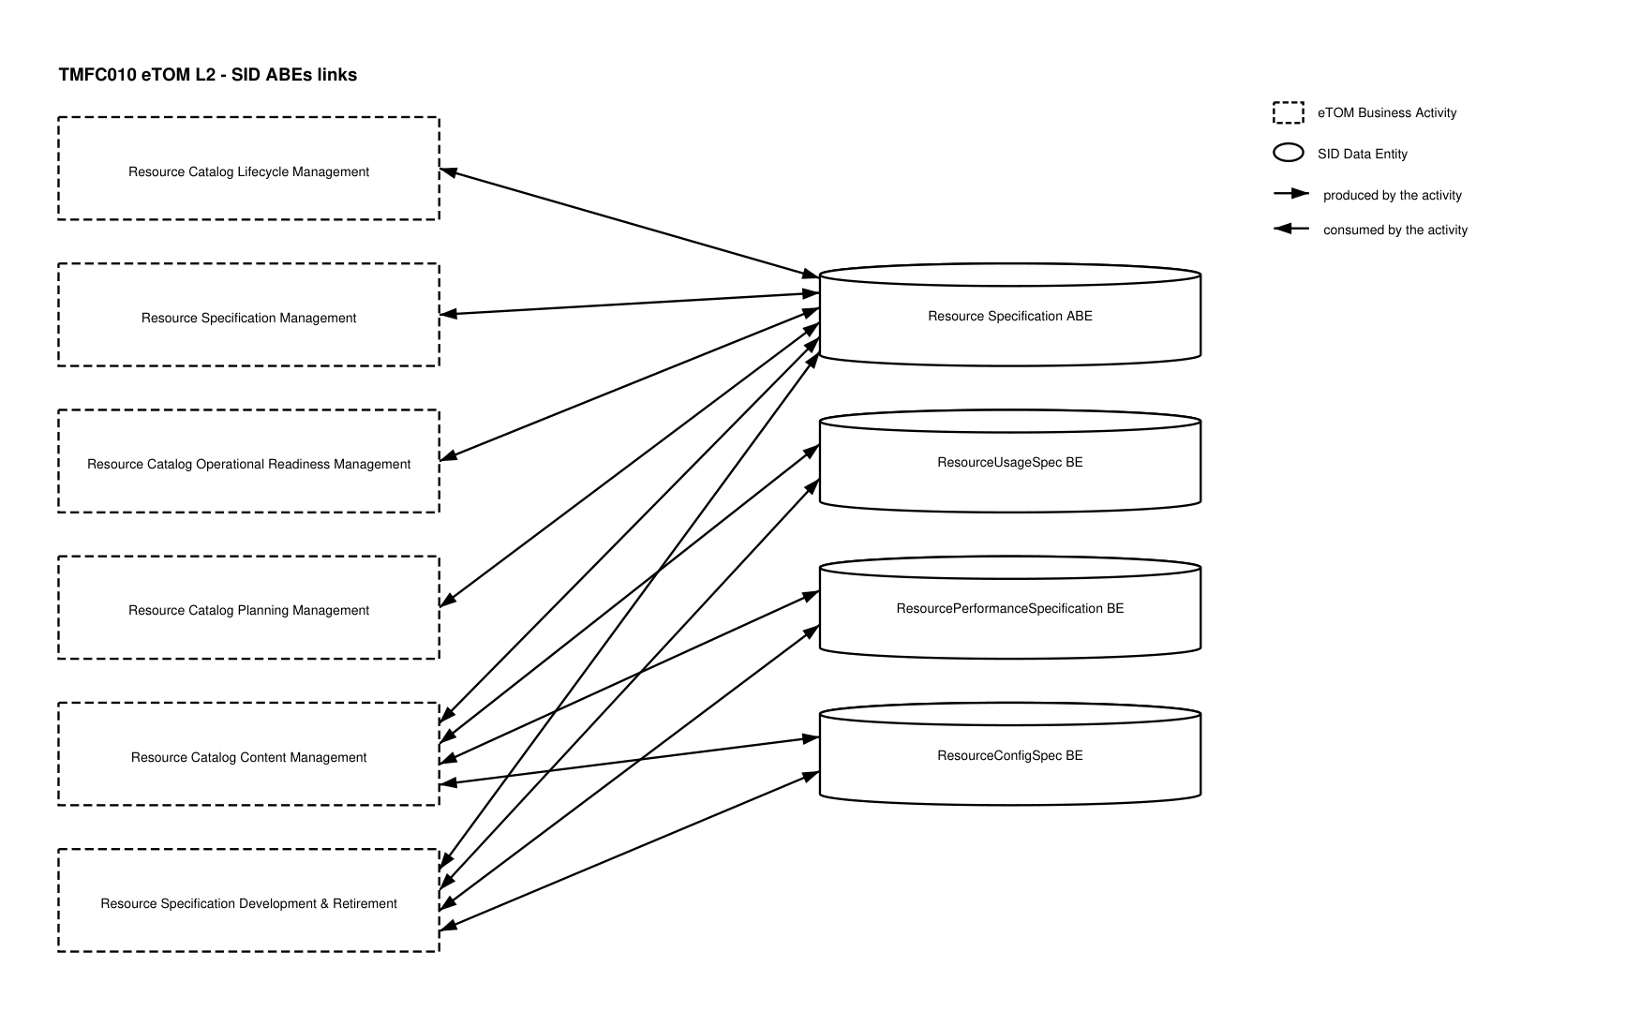
eTOM L2 - SID ABEs links diagram

Functional Framework Functions
Function ID | Function Name | Function Description | Aggregate Function Level 1 | Aggregate Function Level 2
737 | Resource Capability Specification Management | This function involves the creation, editing, storage and retrieval of capability specifications. The capability specifications represent the general, common and invariant characteristics of resource that may be realized in more than one type of specific resource. Examples of capability are Layer2, Data, radio and Transport. | Resource Capability Management | Resource Specification Capability Development
467 | Resource Data Transformation/Parsing Rules Configuration | Resource Data Transformation/Parsing Rules Configuration provides tools to set up and maintain resource data parsing rules. | Resource Specification Management | Resource Specification Development
951 | Resource Catalog Entities Management | Resource Catalog Entities Management identifies resource entities in a common Catalog Management from the Common Domain, or identifies a specific instance of a Catalog Management for resource entities. | Resource Specification Management | Resource Specification Development
996 | Resource Task Item Policy Control Configuration | Defines and configures the policies which will be implemented during the Resource task item lifecycle. | Resource Specification Management | Resource Specification Development
1083 | Resource Specification Repository Management | Resource Specification Repository Management is able to create, modify and delete Resource Specification. / This includes the ability to manage the state of an entity during its lifecycle (e.g. planned, deployed, in operation, replaced by locked). / It includes Resource Specifications retrieval, integrity rules check and versioning management. / It also provides Product Specification and Offering views adapted to the different roles. | Resource Specification Management | Resource Specification Development
1088 | Resource Specification to Supplier Product Specification Relationship Design | Resource Specification to Supplier Product Specification Relationship Design identifies, when it corresponds to equipment rented to a Supplier (devices, network equipments, hardware & software, etc). | Resource Specification Management | Resource Specification Development
1089 | Resource Specification Action Skill Design | Resource Specification Action Skill Design manages the links to the Skill catalog to identify for each type of resource, or of Action on a resource, which type of skill is necessary to make the intervention. | Resource Specification Management | Resource Specification Development
1082 | Resource Specification Change Auditing | Resource Specification Change Auditing manages the implications of Resource Specifications changes to determine the consequences of any given change. Resource Specifications changes may impact other Resource Specifications and Resource Facing Service Specit supports / The function logs Resource Specifications changes and supports the analysis of relationships between Resource Specifications. / In addition, it tracks the history of changes in an easy and accessible manner. | Resource Specification Management | Resource Specification Development
1064 | Logical and Software Resources Designing | Logical and Software Resources Designing supports physical, logical, and software design of resources including definition of configuration variables and initial parameters. | Resource Specification Management | Resource Specification Development
1087 | Resource Specification Design | Resource Specification Design manages Resource Specifications including constraints, characteristics and type of usages. / It specifies Physical, Logical and Compound Resource Specifications. / It includes resource types that as a Service Provider we don't own or commercialize (ex: mobile phones used by our customers). | Resource Specification Management | Resource Specification Development

TM Forum Open APIs & Events
The following part covers the APIs and Events; this part is split in 3:

List of Exposed APIs - This is the list of APIs available from this component.

List of Dependent APIs - In order to satisfy the provided API, the component could require the usage of this set of required APIs.

List of Events (generated & consumed) - The events which the component may generate are listed in this section along with a list of the events which it may consume. Since there is a possibility of multiple sources and receivers for each defined event.

API Context Diagram
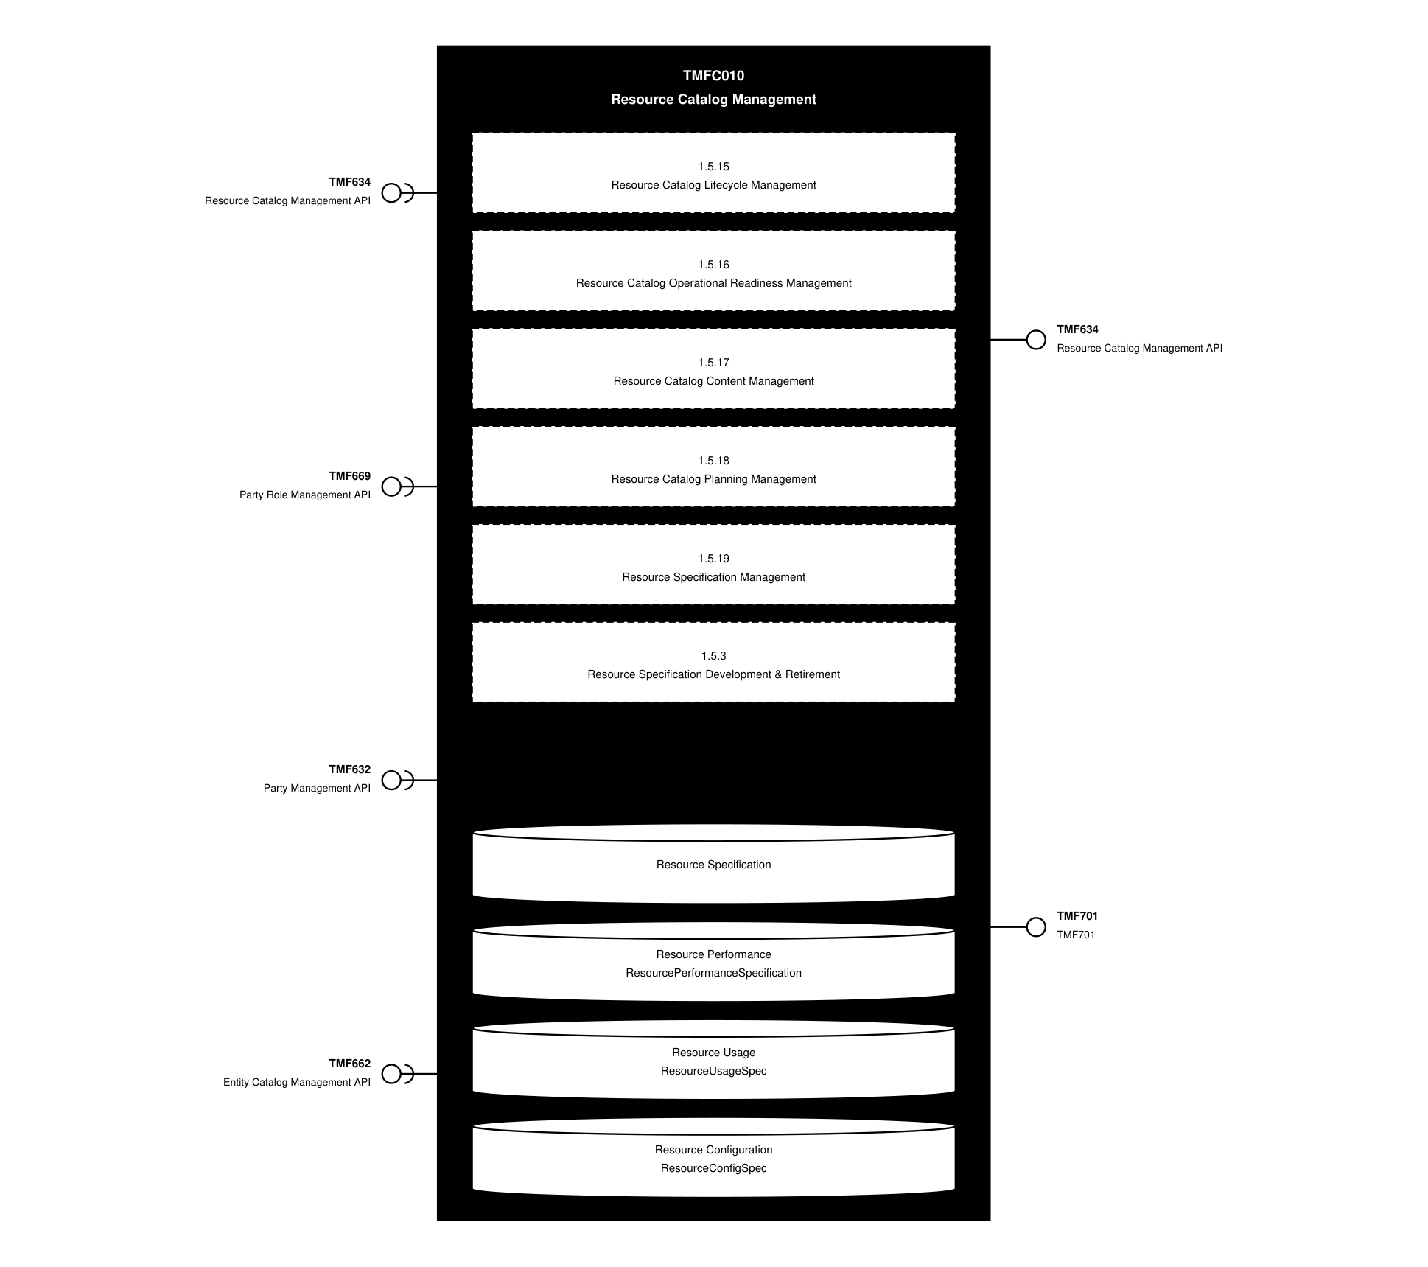
API Context diagram

Exposed APIs
API ID | API Name | Mandatory / Optional | API Version | Resource | Operations
TMF634 | Resource Catalog Management API | Mandatory | 5 | exportJob  importJob  resourceCandidate  resourceCatalog  resourceCategory  resourceSpecification | GET  GET /id  POST  DELETE  PATCH
TMF634 | Resource Catalog Management API | Mandatory | 4 | resourceCatalog  resourceCategory  resourceSpecification  resourceCandidate  exportJob  importJob | GET  GET /id  POST  PATCH  DELETE
TMF701 | TMF701 | Optional | 4 | processFlow  taskFlow | POST  GET  GET /id  DELETE  PATCH

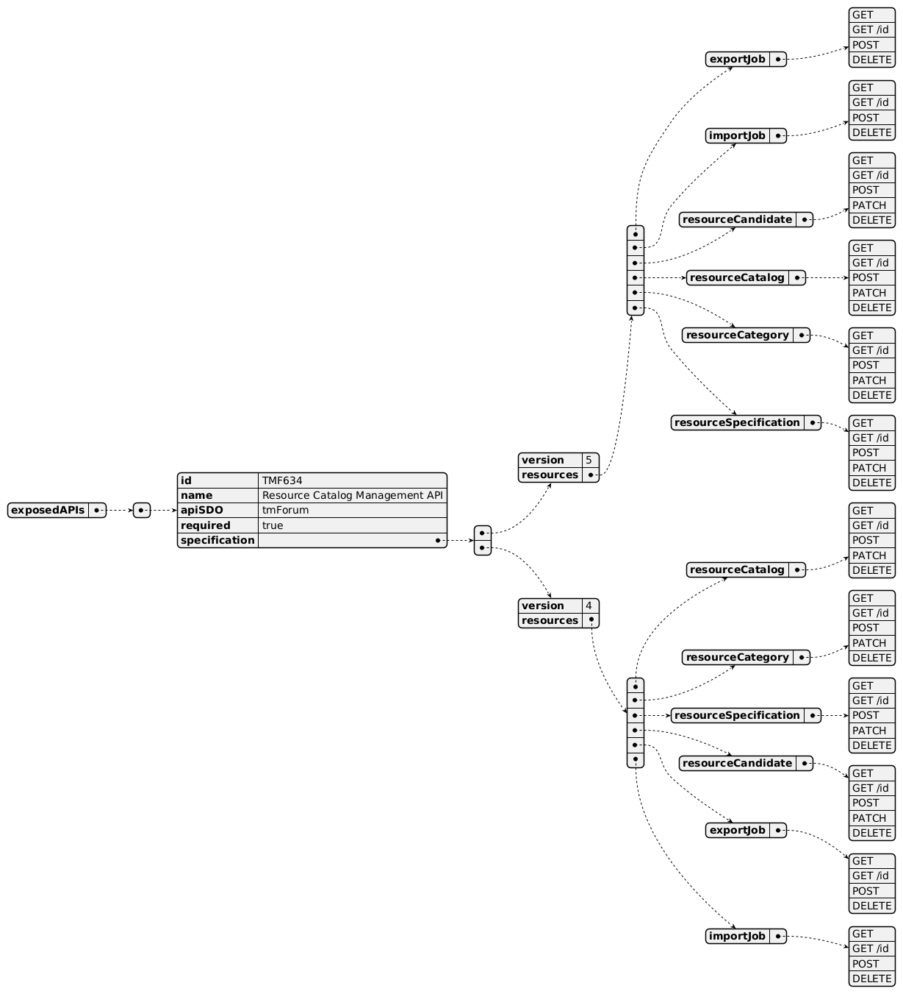
Exposed API diagram (1 of 2)
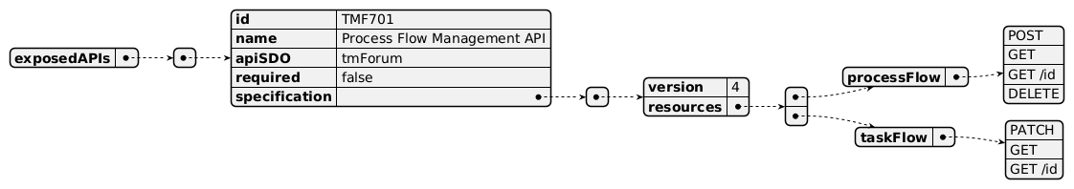
Exposed API diagram (2 of 2)

Dependent APIs
API ID | API Name | API Version | Mandatory / Optional | Resource | Operations
TMF634 | Resource Catalog Management API | 5 | Optional | exportJob  importJob  resourceCandidate  resourceCatalog  resourceCategory  resourceSpecification | GET  POST  DELETE  GET /id  PATCH
TMF634 | Resource Catalog Management API | 4 | Optional | resourceCatalog  resourceCategory  resourceSpecification  resourceCandidate  exportJob  importJob | GET  GET /id  POST  PATCH  DELETE
TMF669 | Party Role Management API | 5 | Optional | partyRole | GET  GET /id
TMF669 | Party Role Management API | 4 | Optional | partyRole | GET  GET /id
TMF632 | Party Management API | 5 | Optional | individual  organization | GET  GET /id
TMF632 | Party Management API | 4 | Optional | individual  organization | GET  GET /id
TMF662 | Entity Catalog Management API | 4 | Optional | entitySpecification  associationSpecification | GET  GET /id

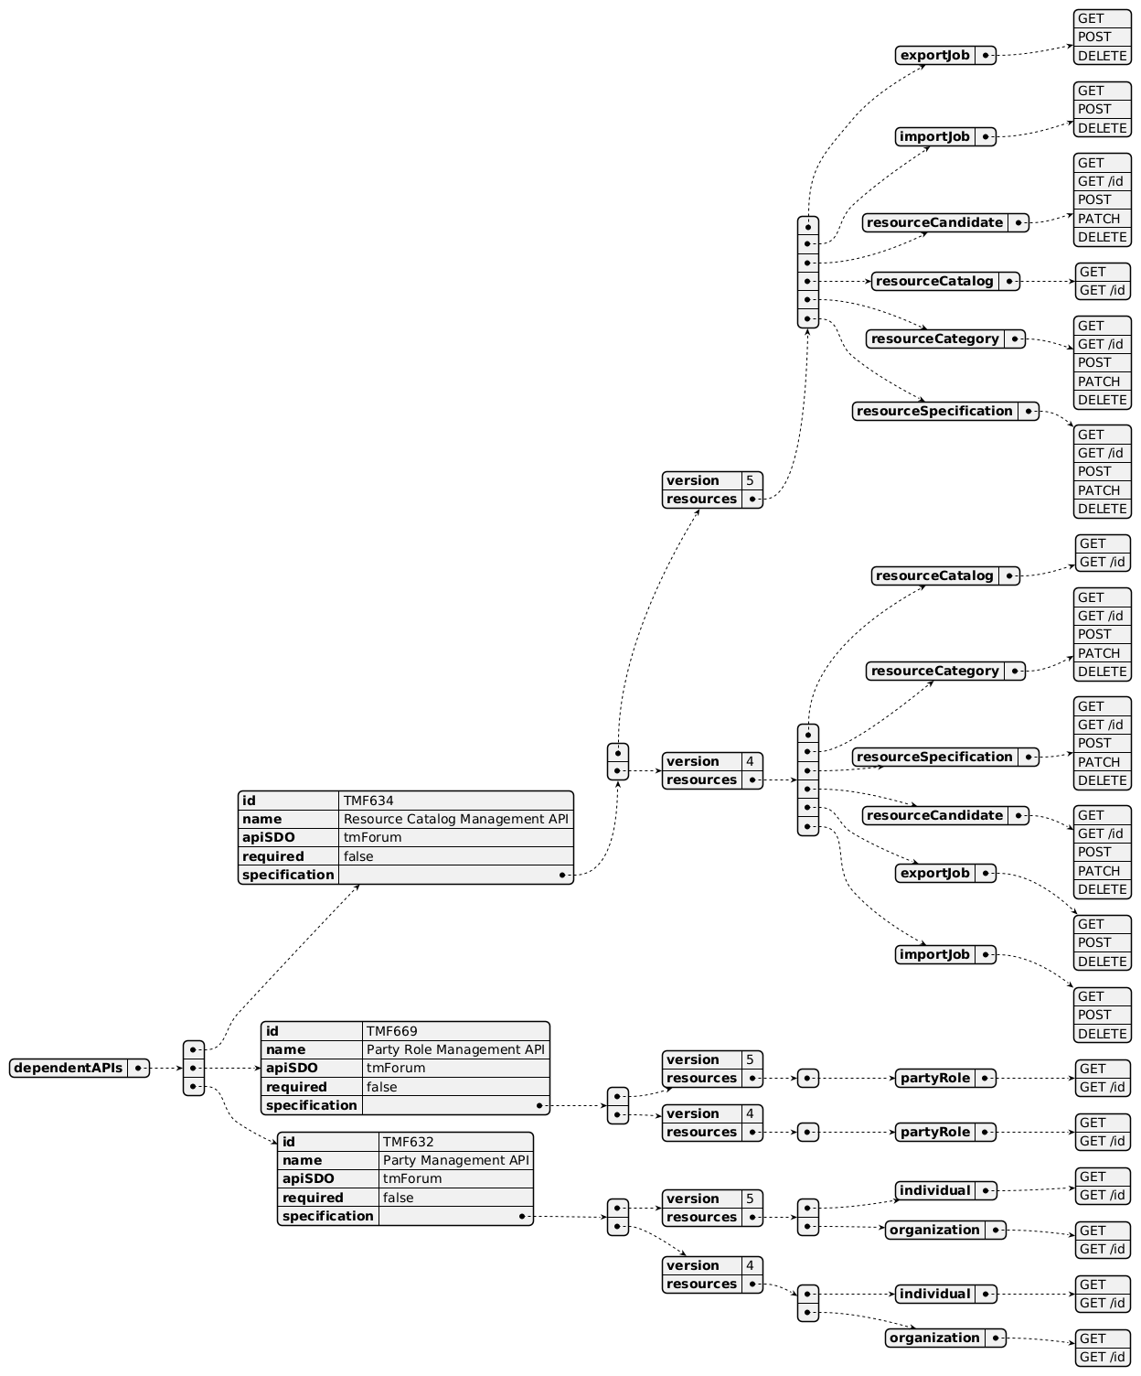
Dependent API diagram (1 of 2)
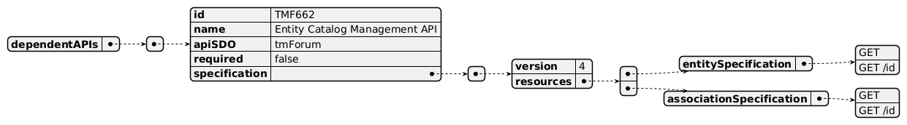
Dependent API diagram (2 of 2)

Events
The diagram illustrates the Events which the component may publish and the Events that the component may subscribe to and then may receive. Both lists are derived from the APIs listed in the preceding sections.

Published Events
API ID | API Name | Event Resources
TMF634 | Resource Catalog Management API | resourceCatalogCreateEvent  resourceCatalogChangeEvent  resourceCatalogDeleteEvent  resourceCategoryCreateEvent  resourceCategoryChangeEvent  resourceCategoryDeleteEvent  resourceCandidateCreateEvent  resourceCandidateChangeEvent  resourceCandidateDeleteEvent  resourceSpecificationCreateEvent  resourceSpecificationChangeEvent  resourceSpecificationDeleteEvent  importJobCreateEvent  exportJobCreateEvent  exportJobStateChangeEvent
TMF701 | ProcessFlowManagement | processFlowCreateEvent  processFlowStateChangeEvent  processFlowStateDeleteEvent  processFlowStateAttributeValueChangeEvent  taskFlowCreateEvent  taskFlowStateChangeEvent  taskFlowDeleteEvent  taskFlowAttributeValueChangeEvent  taskFlowInformationRequiredEvent

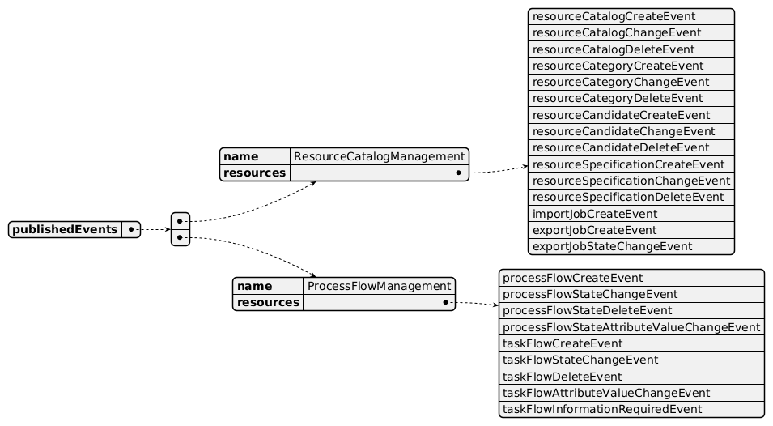
Published Events diagram

Subscribed Events
API ID | API Name | Event Resources
TMF662 | Entity Catalog Management API | entitySpecificationCreateEvent  entitySpecificationAttributeValueChangeEvent  entitySpecificationStateChangeEvent  entitySpecificationDeleteEvent
TMF669 | Party Role Management API | partyRoleDeleteEvent
TMF632 | Party Management API | individualDeleteEvent  organizationDeleteEvent

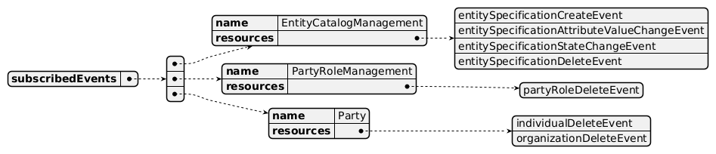
Subscribed Events diagram

Machine Readable Component Specification
Refer to the ODA Component Directory on the TM Forum website for the machine-readable component specification files for this component.

References

TMF Standards related versions
Standard | Version(s)
eTOM | v23.0
SID | v25.0
Functional Framework | v23.0

Jira References
Open API

AP-4088 - Assess the addition of a ResourceUsage API with both ResourceUsage & ResourceUsageSpecification (DONE). The UsageSpecification is described in the Catalog Management components — at product, service, and resource levels. As part of the Resource Catalog Component specification, the question has arisen around the need to assess the addition of a ResourceUsage API with both ResourceUsage & ResourceUsageSpecification (feedback from Ludovic Robert and Kamal Maghsoudlou). This will be similar to the resource level like TMF727 (ServiceUsage) is for the service level. This is consistent with the SID ABE (resourceUsage & resourceUsageSpec).
Functional Framework

ISA-996 - Master Data Management has repurposed catalog related functions (BACKLOG). As part of reviewing the Product, Service and Resource Catalogs to align with the updates to the Functional Framework, we realized that a lot of functions have either been removed or been re-purposed by Master Data Management. Due to this, we had to make a decision to remove all these functions from the Components: removed deleted unclassified functions (1, 2, 5, 7, 9, 10, 12, 14, 15); removed functions that used to be related to Catalog management but now have been re-purposed by Master Data Management (3, 4, 6, 11, 13). Our concern is that we may be missing functions for the catalog due to re-use of Master Data Management.

Further resources
1. IG1228: please refer to IG1228 for defined use cases with ODA components interactions.

Administrative Appendix

Document History

Version History
Version Number | Date | Modified by | Description of changes
1.0.0 | 05-Aug-2022 | Kamal Maghsoudlou, Gaetano Biancardi, Sylvie Demarest | Final edits prior to publication
1.1.0 | 06-Oct-2022 | Elisabeth Andersson | Added support for federated catalogs and minor fixes.
1.1.1 | 27-Jul-2023 | Ian Turkington | No content changed, simply a layout change to match template 3. Separated the YAML files to a managed repository.
1.1.1 | 14-Aug-2023 | Amaia White | Final edits prior to publication
1.2.0 | 19-Apr-2024 | Elisabeth Andersson | Update to latest template; aligned with 23.5 SID and eTOM (removed Resource Test specification BE and process, now managed by Resource Test Mgt); updated with Functional Frameworks 23.5 — added new functions under lvl2 Resource Specification Development (1064, 1082, 1083, 1087, 1088, 1089), updated the description of function 996, removed deleted unclassified functions (1, 2, 5, 7, 9, 10, 12, 14, 15), removed functions re-purposed by Master Data Management (3, 4, 6, 11, 13)
1.2.0 | 30-Apr-2024 | Amaia White | Final edits prior to publication
1.3.0 | 26-Nov-2024 | Elisabeth Andersson | TMF688 removed from the core specification, moved to supporting functions; TMF672 removed from the core specification, moved to supporting functions; removed the minor versions of all APIs as per template
1.3.0 | 24-Dec-2024 | Rosie Wilson | Final edits prior to publication
1.3.1 | 08-Jul-2025 | Rosie Wilson | Updates to description per agreed YAML updated on 03 Jun 2025
1.3.1 | 15-Jul-2025 | Rosie Wilson | Final edits prior to publication
1.3.2 | 13-Oct-2025 | Gaetano Biancardi | Corrected naming format (without spaces) from "Resource Performance Specification BE" to "ResourcePerformanceSpecification BE"
1.3.2 | 19-Nov-2025 | Rosie Wilson | Final edits prior to publication
1.4.0 | 05-Jun-2026 | Hugo Vaughan (TM Forum) | Gen 5 API inclusion
1.4.0 | 25-Jun-2026 | Sannah Sibaya | Final edits prior to publication

Release History
Release Status | Date Modified | Modified by | Description of changes
Pre-production | 05-Aug-2022 | Goutham Babu | Initial release
Pre-production | 07-Oct-2022 | Alan Pope | Version 1.1.0
Pre-production | 14-Aug-2023 | Amaia White | Version 1.1.1
Production | 06-Oct-2023 | Adrienne Walcott | Updated to reflect TM Forum Approved status
Pre-production | 30-Apr-2024 | Amaia White | Version 1.2.0
Production | 28-Jun-2024 | Adrienne Walcott | Updated to reflect TM Forum Approved status
Pre-production | 24-Dec-2024 | Rosie Wilson | Version 1.3.0
Production | 07-Mar-2025 | Adrienne Walcott | Updated to reflect TM Forum Approved status
Pre-production | 15-Jul-2025 | Rosie Wilson | Version 1.3.1
Production | 05-Sep-2025 | Adrienne Walcott | Updated to reflect TM Forum Approved status
Pre-production | 19-Nov-2025 | Rosie Wilson | Version 1.3.2
Production | 16-Jan-2026 | Adrienne Walcott | Updated to reflect TM Forum Approved status
Pre-production | 25-Jun-2026 | Sannah Sibaya | Version 1.4.0

Acknowledgements
This document was prepared by the members of the TM Forum Component and Canvas project team:
Team Member | Company | Role
Elisabeth Andersson | MATRIXX | Editor
Hugo Vaughan (TM Forum) | TM Forum | Additional Input
Ian Turkington | TM Forum | Additional Input
Gaetano Biancardi | Accenture | Additional Input / Reviewer
Abinash Vishwakarma | Netcracker | Reviewer
Jose Macaluso | Xacria | Reviewer
Kamal Maghsoudlou | Ericsson | Reviewer
Milind Bhagwat | BT | Reviewer
Ritu Arora | BT | Reviewer
Matteo Destino | Accenture | Reviewer
julien rouland | Orange | Additional Input / Reviewer

