TMFC011 Resource Order Management v1.3.0
Components and Canvas
In this deliverable:

Overview
Component Name | ID | Description | ODA Function Block
Resource Order Management | TMFC011 | The Resource Order Management Component manages the end-to-end lifecycle of a resource order request. This includes validating resource availability as well as the resource order request. Other functionality includes resource order assurance, resource order decomposition and resource order tracking, along with orchestrating activation and the test and turn-up processes. | Production

eTOM Processes, SID Data Entities and Functional Framework Functions

eTOM business activities
eTOM business activities this ODA Component is responsible for:
Identifier | Level | Business Activity Name | Description
1.5.5 | L2 | Resource Order Management | Resource Order Management business process directs and controls ordering, scheduling, and allocation of resources (such as materials, equipment, and personnel) within the business. / Resource Order Management includes managing the capture of resource orders, scheduling works to support the resource order, managing the fulfillment of resource orders, picking/packing, shipping, tracking and closing orders.
1.5.5.6 | L3 | Manage Resource Order Capture | Manage Resource Order Capture is responsible for directing and controlling the capture and collection of resource orders from internal and external customers. / / The business activity begins with the receipt of an order for resource(s), checks orders for completeness and accuracy, and ensures missing or incorrect information is requested from the customer.
1.5.5.7 | L3 | Manage Resource Work Order | Manage Resource Order Work business activity directs and controls all work that are required to fulfill an approved resource order by ensuring the work related to the order is planned, executed and closed in a timely and efficient manner. / Manage Resource Order Work business activity includes activities to "Initiate Resource Work Order", "Create Resource Work Order", "Review Resource Work Order", "Plan Resource Work Order", "Close Resource Work Order", "Analyze Resource Work Order" and "Report Resource Work Order".
1.5.5.8 | L3 | Manage Resource Order Fulfilment | Manage Resource Order Fulfillment business activity directs and controls activities that ensure that resource orders are described, internally satisfied and delivered accordingly. / / Manage Resource Order Fulfillment business activity will coordinate with various business processes, such as inventory management, purchasing and logistics to ensure that resources are readily available and can be shipped to the customer in a timely manner.
1.5.5.9 | L3 | Manage Resource Order Picking/Packing | Manage Resource Order Picking/Packing business activity directs and controls the preparation of resources for delivery to the customer. / / Manage Resource Order Picking/Packing business activity will select the resources from inventory, package them accordingly for delivery (based on the shipment method of the resource order), applying the right mark/label/designation.
1.5.5.12 | L3 | Manage Resource Order Tracking | Manage Resource Order Tracking business activity directs and controls the monitoring of resource order status from the time the order is placed to the time is confirmed delivered. / Manage Resource Order Tracking business activity tracks the status of the resource order, provides updates to all related parties, and ensures that issues are escalated and managed promptly.
1.5.5.13 | L3 | Manage Resource Order Closure | Manage Resource Order Closure business activity directs and controls the closure of an order and finalizing all supporting business activities. / / Manage Resource Order Closure business activity will support order invoicing, order payment processing, and updating the resource order status based on completion status of the order.

SID ABEs
SID ABEs this ODA Component is responsible for:
SID ABE Level 1 | SID ABE Level 2 (or set of BEs) | SID ABE L1 Definition | SID ABE L2 Definition
Resource Order |  | The Resource Order ABE contains entities related to a request to provide / update / remove Resources. | *(no description available)*

eTOM L2 - SID ABEs links
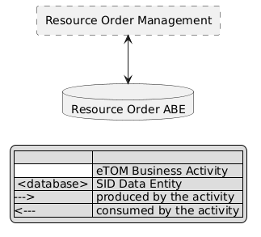
eTOM L2 - SID ABEs links diagram

Functional Framework Functions
Function ID | Function Name | Function Description | Aggregate Function Level 1 | Aggregate Function Level 2
490 | Resource Order Data Collection | Resource Order Data Collection function gathers any needed resource data to aid in the verification and issuance of a complete and valid resource order. | Resource Order Management | Resource Order Completion
491 | Resource Order Initiation | Resource Order Initiation function issues valid and complete resource orders, and stores the order into an appropriate data store. As part of order publication, additional data might be obtained or derived to support downstream functions that are not provided in the resource order request. | Resource Order Management | Resource Order Completion
495 | Resource Order Completion | Resource Order Completion completes the resource order when all activities have been completed. | Resource Order Management | Resource Order Completion
503 | Resource Order Validation | The Resource Order Validation function validates the resource order request based on contract, catalog, and provisioning rules. | Resource Order Management | Resource Order Completion
452 | Resource Commissioning | Resource Commissioning supports the commissioning process of a resource and ensuring that operational status' are configured. | Resource Order Management | Resource Order Orchestration
492 | Resource Order Management | This function provides workflow and orchestration capability for the Resource order fulfillment. | Resource Order Management | Resource Order Orchestration
493 | Resource Order Dependency Management | Manages dependencies across resource orders by triggering and follow up as needed. | Resource Order Management | Resource Order Orchestration
494 | Resource Order Jeopardy Tracking | Raises jeopardies as appropriate if specified dates and workflow milestones are not met, and escalates jeopardies to appropriate management levels. | Resource Order Management | Resource Order Orchestration
529 | Tactical Resource Planning | Detailed design of resources against the existing networked resource at all technology layers, ensuring that the designed resource is actually deployed and for accurately recording the resultant inventory. | Resource Order Management | Resource Order Orchestration
958 | Resource Task Decomposition | By request for an orchestration of a resource the Task Item needs to be analyzed and decomposed into the part-actions necessary to take to fulfill the requested resource orchestration. The resource task item may consist of several resource tasks and may use a number of Resources. It may also be controlled by several parameters for optional behaviors. This composition of the Resource is given by configuration data available from Catalog applications and the Resource Capability Orchestration application. | Resource Order Management | Resource Order Orchestration
961 | Resource Work Item Sequence Execution | Because of the “Resource Task Item Decomposition” of an orchestration request the result may be several actions that needs to take place in a specific sequence. The “Resource Work Item Sequence Execution” function executes each individual item in sequence to fulfill, or roll back according to a pre-defined configuration, and reports the sequence carry through result. | Resource Order Management | Resource Order Orchestration
496 | Resource Order Tracking | Resource Order Tracking tracks the various resource orders until completed. | Resource Order Management | Resource Order Tracking & Business Value Development
497 | Resource Order Status Reporting | Resource Order Status Reporting provides status reports on the resource order. | Resource Order Management | Resource Order Tracking & Business Value Development
488 | Resource Parameter Allocation | Resource Parameters Allocation allocates the right resource parameters to fulfill resource orders. | Resource Management | Resource Allocation
487 | Resource Parameter Reservation | Resource Parameters Reservation reserves the right resource parameters based on resource specification and resource inventory. | Resource Management | Resource Allocation
16 | Fallout Automated Correction | Fallout Automated Correction function tries to automatically fix fallouts in workflows before they go to a human for handling. This includes a Fallout Rules Engine that provides the capability to handling various errors or error types based on built rules. These rules can facilitate autocorrection, correction assistance, placement of errors in the appropriate queues for manual handling, as well as access to various systems. | Fallout Management | Fallout Correction Management
17 | Fallout Correction Information Collection | Fallout Correction Information Collection collects relevant information for errors or situations that cannot be handled via Fallout Auto Correction. The intent is to reduce the time required by the technician in diagnosing and fixing the fallout. | Fallout Management | Fallout Correction Management
19 | Fallout Manual Correction Queuing | Fallout Manual Correction Queuing function provides the required functionality to place error fallout into appropriate queues to be handled via various staff or workgroups assigned to handle or fix the various types of fallout that occurs during the fulfillment process. This includes the ability to create and configure queues, route errors to the appropriate queues, as well as the ability for staff to access and address the various fallout instances within the queues. | Fallout Management | Fallout Correction Management
21 | Fallout Orchestration | The Fallout Orchestration function provides workflow and orchestration capability across Fallout Management. | Fallout Management | Fallout Correction Management
24 | Pre-populated Fallout Information Presentation | Pre-populated Fallout Information Presentation automatically position the analyzer on appropriate screens pre-populated with information about the order(s) that's subject for fallout handling. | Fallout Management | Fallout Correction Management
756 | Fallout Rule Based Error Correction | Fallout Rule Based Error Correction function provides the capability to handle various errors or error types based on pre-defined rules. These rules can facilitate autocorrection. | Fallout Management | Fallout Correction Management
18 | Fallout Management to Fulfillment Application Accessing | Fallout Management to Fulfillment Application Accessing function provides a variety of tools to facilitate Fallout Management access to other applications and repositories to facilitate proper Fallout Management. This can include various general access techniques such as messaging, publish and subscribe, etc. as well as specific APIs and contracts to perform specific queries or updates to various applications or repositories within the fulfillment domain. | Fallout Management | Fallout Repository Management
20 | Fallout Notification | Fallout Notification function provides the means to alert people or workgroups of some fallout situation. This can be done via a number of means, including email, paging, (Fallout management interface bus) etc. This function is done via business rules. | Fallout Management | Fallout Repository Management
22 | Fallout Reporting | Fallout Reporting provides various reports regarding Fallout Management, including statistics on fallout per various times periods (per hour, week, month, etc) as well as information about specific fallout. | Fallout Management | Fallout Repository Management
23 | Fallout Dashboard System Log-in Accessing | Fallout Dashboard System Log-in Accessing provides auto logon capability into various applications needed to analyze and fix fallout. | Fallout Management | Fallout Repository Management

TM Forum Open APIs & Events
The following part covers the APIs and Events; this part is split in 3:

List of Exposed APIs - This is the list of APIs available from this component.

List of Dependent APIs - In order to satisfy the provided API, the component could require the usage of this set of required APIs.

List of Events (generated & consumed) - The events which the component may generate are listed in this section along with a list of the events which it may consume. Since there is a possibility of multiple sources and receivers for each defined event.

API Context Diagram
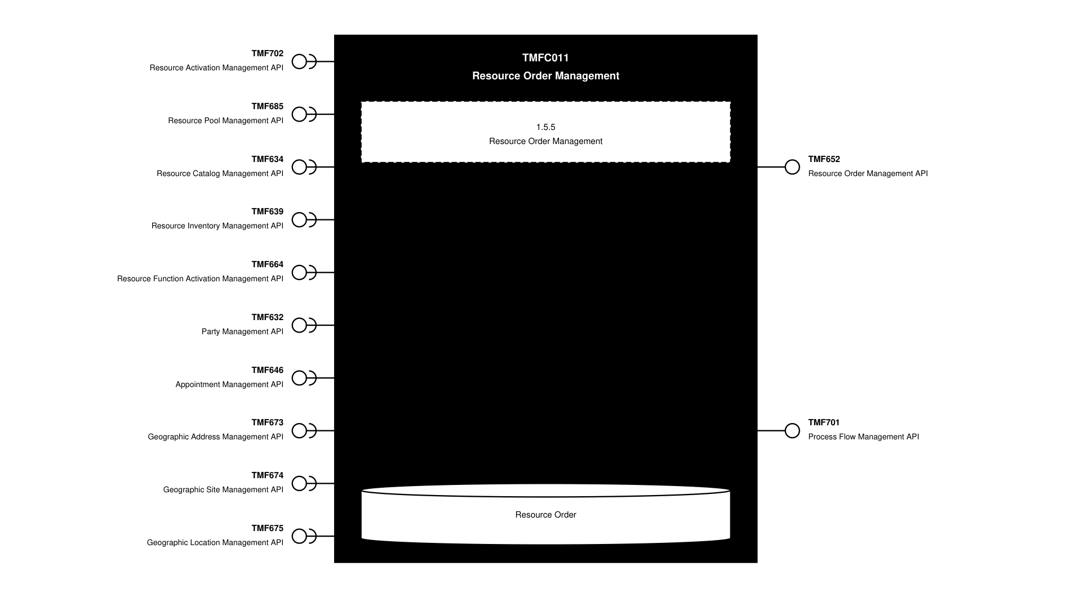
API Context diagram

Exposed APIs
API ID | API Name | Mandatory / Optional | API Version | Resource | Operations
TMF652 | Resource Order Management API | Mandatory | 4 | resourceOrder  cancelResourceOrder | GET  GET /id  POST  PATCH  DELETE
TMF701 | Process Flow Management API | Optional | 4 | processFlow  taskFlow | POST  GET  GET /id  DELETE  PATCH

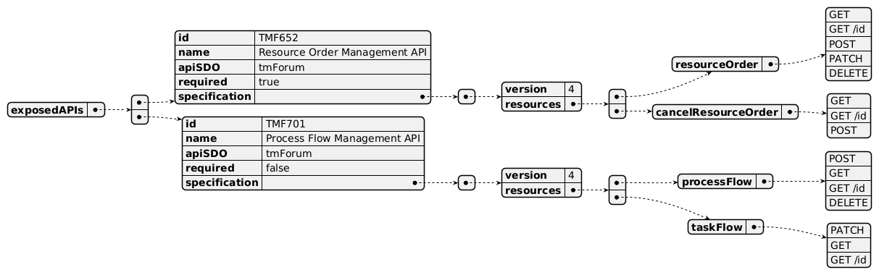
Exposed API diagram

Dependent APIs
API ID | API Name | API Version | Mandatory / Optional | Resource | Operations
TMF702 | Resource Activation Management API | 4 | Optional | resource  monitor | GET  GET /id  POST  PATCH  DELETE
TMF685 | Resource Pool Management API | 5 | Optional | resourcePool  availabilityCheck | GET  GET /id  POST  PATCH  DELETE
TMF634 | Resource Catalog Management API | 5 | Mandatory | resourceSpecification | GET  GET /id  POST  PATCH  DELETE
TMF634 | Resource Catalog Management API | 4 | Mandatory | resourceSpecification | GET  GET /id  POST  PATCH  DELETE
TMF639 | Resource Inventory Management API | 4 | Mandatory | resource | GET  GET /id  POST  PATCH  DELETE
TMF664 | Resource Function Activation Management API | 4 | Optional | resourceFunction | GET  GET /id  POST  PATCH  DELETE
TMF632 | Party Management API | 5 | Optional | individual  organization | GET  GET /id
TMF632 | Party Management API | 4 | Optional | individual  organization | GET  GET /id
TMF646 | Appointment Management API | 4 | Optional | workOrder | GET  GET /id
TMF673 | Geographic Address Management API | 4 | Optional | geographicAddress | GET  GET /id
TMF674 | Geographic Site Management API | 4 | Optional | geographicSite | GET  GET /id
TMF675 | Geographic Location Management API | 4 | Optional | geographicLocation | GET  GET /id

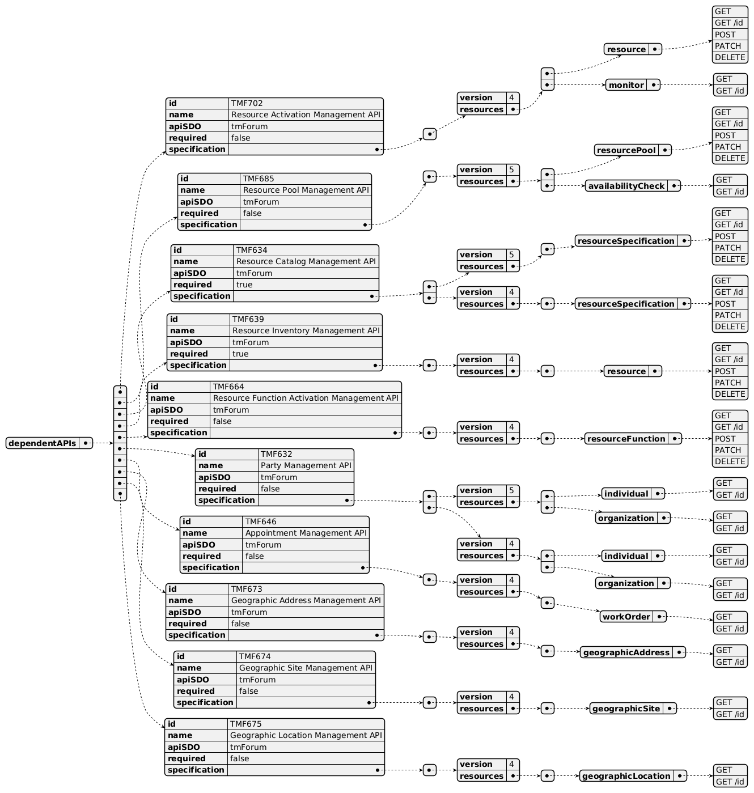
Dependent API diagram

Events
The diagram illustrates the Events which the component may publish and the Events that the component may subscribe to and then may receive. Both lists are derived from the APIs listed in the preceding sections.

Published Events
API ID | API Name | Event Resources
TMF652 | Resource Order Management API | CancelResourceOrderInformationRequiredEvent  CancelResourceOrderInformationRequiredEventPayload  CancelResourceOrderStateChangeEvent  CancelResourceOrderStateChangeEventPayload  ResourceOrderAttributeValueChangeEvent  ResourceOrderAttributeValueChangeEventPayload  ResourceOrderCreateEvent  ResourceOrderCreateEventPayload  ResourceOrderDeleteEvent  ResourceOrderDeleteEventPayload  ResourceOrderInformationRequiredEvent  ResourceOrderInformationRequiredEventPayload  ResourceOrderStateChangeEvent  ResourceOrderStateChangeEventPayload
TMF701 | Process Flow Management API | processFlowCreateEvent  processFlowStateChangeEvent  processFlowStateDeleteEvent  processFlowStateAttributeValueChangeEvent  taskFlowCreateEvent  taskFlowStateChangeEvent  taskFlowDeleteEvent  taskFlowAttributeValueChangeEvent  taskFlowInformationRequiredEvent

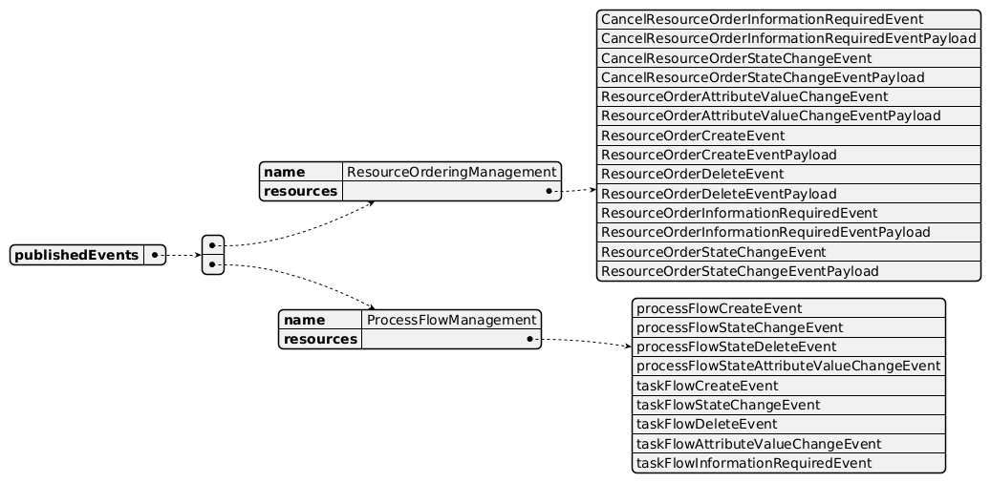
Published Events diagram

Subscribed Events
API ID | API Name | Event Resources
TMF664 | Resource Function Activation Management API | resourceFunctionCreateEvent  resourceFunctionChangeEvent  monitorStatechangeEvent  healStatechangeEvent  scaleStatechangeEvent  migrateStatechangeEvent
TMF702 | Resource Activation Management API | resourceChangeEvent  monitorCreateEvent  monitorStatechangeEvent

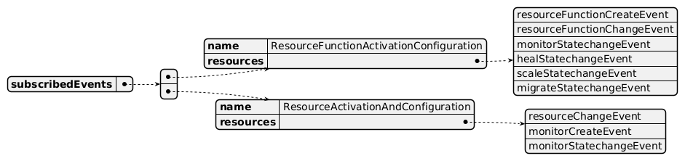
Subscribed Events diagram

Machine Readable Component Specification
Refer to the ODA Component Directory on the TM Forum website for the machine-readable component specification files for this component.

References

TMF Standards related versions
Standard | Version(s)
eTOM | v23.0
SID | v25.0
Functional Framework | v23.0

Jira References

TAC-1217

Further resources
none currently listed

Administrative Appendix

Document History

Version History
Version Number | Date | Modified by | Description of changes
1.0.0 | 01-Mar-2024 | Amaia White | Final edits prior to publication
1.1.0 | 27-Aug-2024 | Gaetano Biancardi | Component update: applied new ODA Component template; exposed API removed TMF688 Event Management API; dependent API removed TMF688 Event Management API
1.1.0 | 06-Sep-2024 | Amaia White | Final edits prior to publication
1.1.1 | 18-Nov-2024 | Gaetano Biancardi | API version, only major version to be specified
1.1.1 | 24-Dec-2024 | Rosie Wilson | Final edits prior to publication
1.1.2 | 10-Jul-2025 | Rosie Wilson | Updates to description per agreed YAML updated on 03-Jun-2025; updated TMF697 in Overview Diagram from TMF679 as requested by Sylvie
1.1.2 | 15-Jul-2025 | Rosie Wilson | Final edits prior to publication
1.2.0 | 13-Oct-2025 | Gaetano Biancardi | Overview diagram: corrected TMF Open API typo for Work Order Mgt API Id in the overview picture (replaced TMF679 with TMF697); team agreed the following updates during the call on 07-Jan-2025 (Hugo Vaughan and Gaetano Biancardi to update in the next revision of the functional specification and YAML file): TMF702 - Resource Activation Management API - Optional; TMF634 - Resource Catalog Management API - Mandatory; TMF664 - Resource Function Activation Management API - Optional; TMF639 - Resource Inventory Management API - Mandatory
1.2.0 | 19-Nov-2025 | Rosie Wilson | Final edits prior to publication
1.3.0 | 29-Jan-2026 | Julien Rouland | Component update: added TMF685 ResourcePool to the dependent API; removed from functional framework 448, 568 and 569 as more related to qualification activity than a resource order
1.3.0 | 05-Jun-2026 | Hugo Vaughan | Gen 5 API updates
1.3.0 | 25-Jun-2026 | Sannah Sibaya | Final edits prior to publication

Release History
Release Status | Date Modified | Modified by | Description of changes
Pre-production | 01-Mar-2024 | Amaia White | Release of version 1.0.0
Production | 26-Apr-2024 | Adrienne Walcott | Updated to reflect TM Forum Approved status
Pre-production | 06-Sep-2024 | Amaia White | Release of version 1.1.0
Production | 01-Nov-2024 | Adrienne Walcott | Updated to reflect TM Forum Approved status
Pre-production | 24-Dec-2024 | Rosie Wilson | Release of version 1.1.1
Production | 07-Mar-2025 | Adrienne Walcott | Updated to reflect TM Forum Approved status
Pre-production | 15-Jul-2025 | Rosie Wilson | Release of version 1.1.2
Production | 05-Sep-2025 | Adrienne Walcott | Updated to reflect TM Forum Approved status
Pre-production | 19-Nov-2025 | Rosie Wilson | Release of version 1.2.0
Production | 16-Jan-2026 | Adrienne Walcott | Updated to reflect TM Forum Approved status
Pre-production | 25-Jun-2026 | Sannah Sibaya | Release of version 1.3.0

Acknowledgements
This document was prepared by the members of the TM Forum Component and Canvas project team.
Team Member | Company | Role
Anastasios Sarantis | CityFibre | Author
Gaetano Biancardi | Accenture | Author
Sylvie Demarest | Orange | Key Contributor
Koen Peeters | Ciminko | Key Contributor
Abinash Vishwakarma | Netcracker | Reviewer
Jose Macaluso | Xacria | Reviewer
Kamal Maghsoudlou | Ericsson | Reviewer
Milind Bhagwat | BT | Reviewer
Ritu Arora | BT | Reviewer
Matteo Destino | Accenture | Reviewer
Elisabeth Andersson | MATRIXX | Reviewer
Julien Rouland | Orange | Reviewer

