TMFC012 Resource Inventory v2.3.0
Components and Canvas
In this deliverable:

Overview
Component Name | ID | Description | ODA Function Block
Resource Inventory | TMFC012 | The Resource Inventory component owns accounting for resources (all inputs - including stock, parts, assets, production components etc.) that are owned and/or held for allocation and/or use by the organization. The Resource Inventory component has functionality that includes inventory item creation, inventory organization, inventory search or filter, inventory monitoring and tracking, inventory control (organization, re-stock management etc.) and inventory auditing. The minimum check to be performed at inventory item creation or update is for global consistency with related Resource Catalog information. | Production

eTOM Processes, SID Data Entities and Functional Framework Functions

eTOM business activities
eTOM business activities this ODA Component is responsible for:
Identifier | Level | Business Activity Name | Description
1.5.4 | L2 | Resource Readiness & Support | Manage resource infrastructure to ensure that appropriate application, computing and network resources are available and ready to support the Fulfillment, Assurance and Billing processes in instantiating and managing resource instances, and for monitoring and reporting on the capabilities and costs of the individual FAB processes.
1.5.4.5 | L3 | Manage Resource Inventory | Establish, manage and administer the enterprise's resource inventory, as embodied in the Resource Inventory Database, and monitor and report on the usage and access to the resource inventory, and the quality of the data maintained in it.

SID ABEs
SID ABEs this ODA Component is responsible for:
SID ABE Level 1 | SID ABE Level 2 (or set of BEs) | SID ABE L1 Definition | SID ABE L2 Definition
Resource |  | A Resource represents an instance of ResourceSpecification. The Resource ABE contains entities that are used to represent the three types of Resources: Logical, Physical and Compound Resources. The Resource carries the place where the Resource is installed, as well as configuration characteristics, such as assigned telephone numbers and internet addresses. The Resource also tracks the links to Product and/or Service realized. | *(no description available)*

eTOM L2 - SID ABEs links
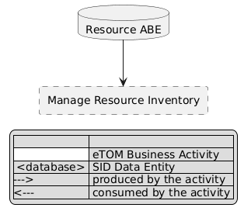
eTOM L2 - SID ABEs links diagram

Functional Framework Functions
Function ID | Function Name | Function Description | Aggregate Function Level 1 | Aggregate Function Level 2
426 | Physical Implementation Information Capturing | Physical Implementation Information Capturing provide levels of implementation details that tactical planning does not need to specify, such as duct routes and the frame appearances of device ports. | Resource Management | Resource Repository Management
442 | Network Overviews Presentation | Network Overviews Presentation provides a more generalized view of the network than found in resource management. | Resource Management | Resource Repository Management
453 | Resource Configuration Change Logging | Resource Configuration Change Logging - Collects and Records the history of configuration changes | Resource Management | Resource Repository Management
454 | Resource Configuration Management | Resource Configuration Management provides configuration database and management of the configurations of the individual resources. | Resource Management | Resource Repository Management
456 | Resource Topology Verification | Resource Topology Verification works with the Inventory Management functions to ensure that the topology reflected in its database is in sync with that in the Inventory Management Systems. | Resource Management | Resource Repository Management
468 | Resource Information Model Creation | Resource Information Model creation function allows Service Providers to create information base in the resource inventory of the managed resources along its attributes. This function uses the standardized information model (e.g. TM Forum Information Framework) for the resources to be managed. The specific details will depend on the particular resources (e.g., particular types of managed elements and equipments) and associated technologies. | Resource Management | Resource Repository Management
470 | Resource Repository Retrieval | This function allows for client operations support (service assurance and billing systems) to retrieve part or all of the resource inventory known to the target OSS. This feature may allow the following selection criteria: / • retrieval of a specified set of one or more sub-trees / • exclusion or inclusion of specified object types from the selected sub-tree / • further filtering based on attribute matching / • retrieval of only the object instances that have been modified after a provided date and time / • For the selected objects, this feature may allow the client operations support (service assurance and billing systems) to specify what specific attributes and relationships shall be returned. This (the attributes and relationships to be returned) would be the same for all objects of the same type. | Resource Management | Resource Repository Management
471 | Resource Repository Updating | Resource Repository Updating function entails update of the resource Repository based on a provided collection of updates. The expectation is that the Repository is updated as requested, but no other side effects are expected (e.g., creating a Sub Network Connection (SNC) in the network). This is a key point concerning this capability. The Repository update request can involve addition (new object), modification (change to an existing object) or deletion (removal of an object). | Resource Management | Resource Repository Management
472 | Resource Repository Update Notification | Resource Inventory Update Notification function entails the generation of inventory update notifications based on changes to the inventory: Notifications concerning object creation, object deletion and attribute value changes to other systems. / • Single Entity Notifications – in this variation of the feature, each notification pertains to only one entity, e.g., an equipment instance / • Multi-entity Notifications – in this variation of the feature, a single notification may report on inventory changes for multiple entities. / • Notification Suppression – in this variation of the feature, each notification pertains to only one entity. | Resource Management | Resource Repository Management
562 | Voucher Reporting | Voucher Reporting function for querying and reporting of voucher related data | Resource Management | Resource Repository Management
564 | Voucher Life Cycle Management | Voucher Life Cycle Management including activation, locking, expiration and maintenance of purchased vouchers. | Resource Management | Resource Repository Management
738 | Resource Data Inventory Synchronization | Resource Data Inventory Synchronization is the function that ensure OSS Inventory data generated in each function is available to other functions as required. | Resource Management | Resource Repository Management
436 | Number Aging | Manages the aging of numbers before they can be re-assigned. | Resource Management | Regulated Logical Resources Management
437 | Number Assigning | Number Assigning manages the assignment of numbers for usage. | Resource Management | Regulated Logical Resources Management
439 | Number Searching | Number Searching provides the means to search the number inventory. | Resource Management | Regulated Logical Resources Management
440 | Number Tracking and Reporting | Provides functionality to track numbers and perform number reporting. | Resource Management | Regulated Logical Resources Management
743 | Number Portability Orchestration | Number Portability Orchestration is a communication mechanism that ensures the Resource Number orders activation according to a criteria set, allowing in this way the correct execution of orders. | Resource Management | Regulated Logical Resources Management
744 | Number Portability Risk & Effectiveness Management | Number Portability Risk & Effectiveness Management for determine of threats, risks and control of fulfillment, in order to comply with the execution of all Resource Number Portability orders. | Resource Management | Regulated Logical Resources Management
745 | Number Portability Validation | Number Portability Validation can perform calculations that determine whether the information received is reliable, safe and contains the minimum information required during implementation, enabling with this the Resource Number Portability orders rejection for those who do not comply with the defined criteria. | Resource Management | Regulated Logical Resources Management
1062 | Number Acquisition | Number Acquisition manages the capturing of numbers for the number inventory. | Resource Management | Regulated Logical Resources Management
1249 | Number Porting | Number Porting implements the changes to transfer the management of a number from one Service Provider to another, and on request provides status on the implementation of the changes. | Resource Management | Regulated Logical Resources Management
438 | Number Reservation | Provides the functionality to manage the reservation of numbers. | Resource Management | Regulated Logical Resources Management
435 | Number Inventory Establishing | Number Inventory Establishing manages the establishment of a number inventory. | Resource Management | Regulated Logical Resources Management

TM Forum Open APIs & Events
The following part covers the APIs and Events; this part is split in 3:

List of Exposed APIs - This is the list of APIs available from this component.

List of Dependent APIs - In order to satisfy the provided API, the component could require the usage of this set of required APIs.

List of Events (generated & consumed) - The events which the component may generate are listed in this section along with a list of the events which it may consume. Since there is a possibility of multiple sources and receivers for each defined event.

API Context Diagram
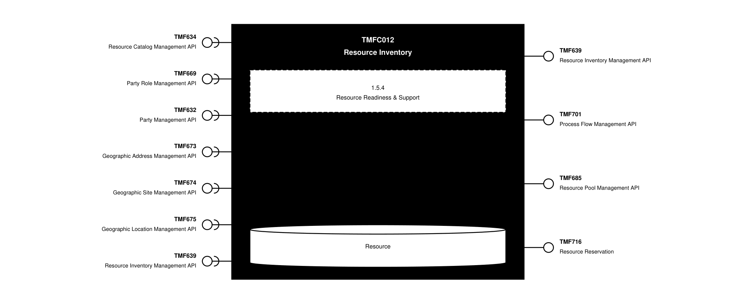
API Context diagram

Exposed APIs
API ID | API Name | Mandatory / Optional | API Version | Resource | Operations
TMF639 | Resource Inventory Management API | Mandatory | 4 | resource | GET  GET /id  POST  PATCH  DELETE
TMF701 | Process Flow Management API | Optional | 4 | processFlow  taskFlow | POST  GET  GET /id  DELETE  PATCH
TMF685 | Resource Pool Management API | Optional | 5 | capacitySpecification  resourcePoolSpecification  resourcePool  resourcePoolSpecification  availabilityCheck  push  extract | POST  GET  GET /id  PATCH  DELETE
TMF716 | Resource Reservation | Optional | 4 | resourceReservation  cancelResourceReservation | POST  GET  GET /id  PATCH  DELETE

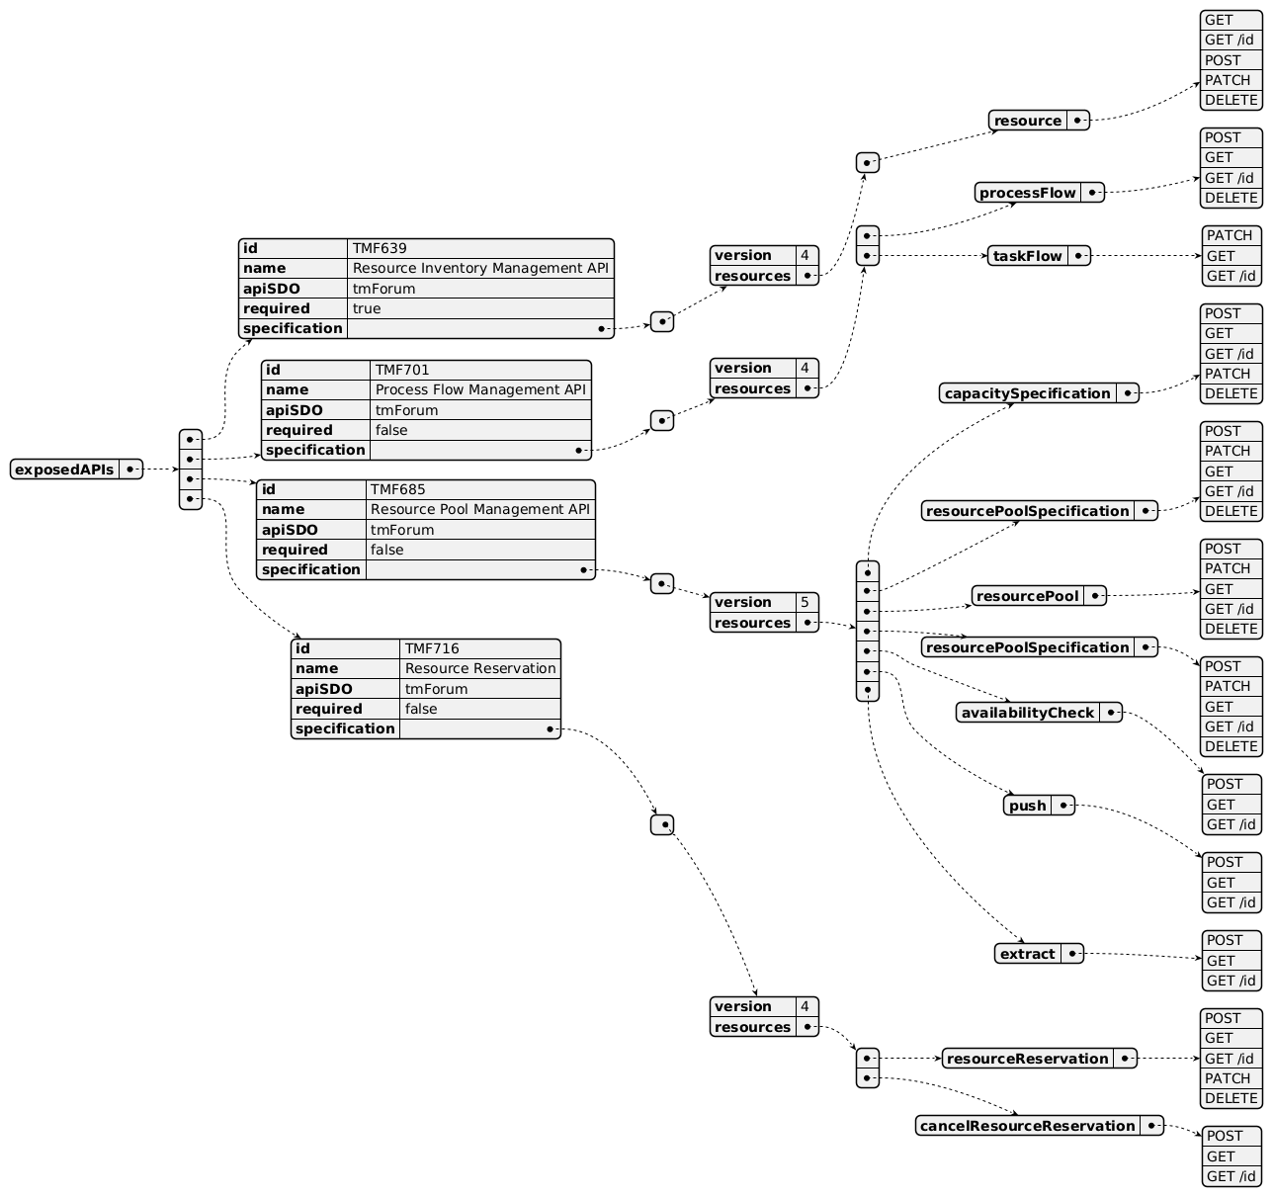
Exposed API diagram

Dependent APIs
API ID | API Name | API Version | Mandatory / Optional | Resource | Operations
TMF634 | Resource Catalog Management API | 5 | Mandatory | resourceSpecification | GET  GET /id
TMF634 | Resource Catalog Management API | 4 | Mandatory | resourceSpecification | GET  GET /id
TMF669 | Party Role Management API | 5 | Optional | partyRole | GET  GET /id
TMF669 | Party Role Management API | 4 | Optional | partyRole | GET  GET /id
TMF632 | Party Management API | 5 | Optional | individual  organization | GET  GET /id
TMF632 | Party Management API | 4 | Optional | individual  organization | GET  GET /id
TMF673 | Geographic Address Management API | 4 | Optional | geographicAddress  geographicSubAddress | GET  GET /id
TMF674 | Geographic Site Management API | 4 | Optional | geographicSite | GET  GET /id
TMF675 | Geographic Location Management API | 4 | Optional | geographicLocation | GET  GET /id
TMF639 | Resource Inventory Management API | 4 | Optional | resource | GET  GET /id  POST  PATCH  DELETE

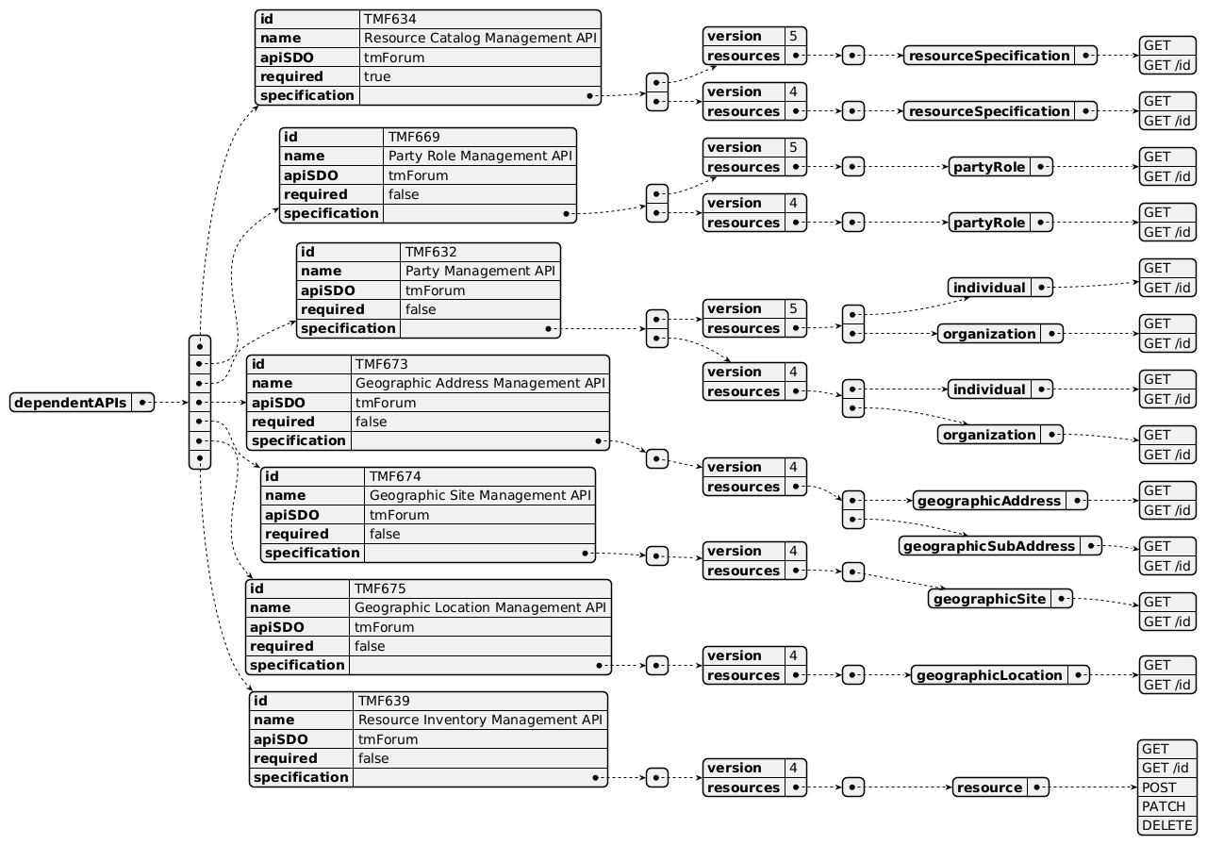
Dependent API diagram

Events
The diagram illustrates the Events which the component may publish and the Events that the component may subscribe to and then may receive. Both lists are derived from the APIs listed in the preceding sections.

Published Events
API ID | API Name | Event Resources
TMF639 | Resource Inventory Management API | resourceCreateEvent  resourceChangeEvent  resourceDeleteEvent  resourceAttributeValueChangeEvent
TMF701 | Process Flow Management API | processFlowCreateEvent  processFlowStateChangeEvent  processFlowStateDeleteEvent  processFlowStateAttributeValueChangeEvent  taskFlowCreateEvent  taskFlowStateChangeEvent  taskFlowDeleteEvent  taskFlowAttributeValueChangeEvent  taskFlowInformationRequiredEvent

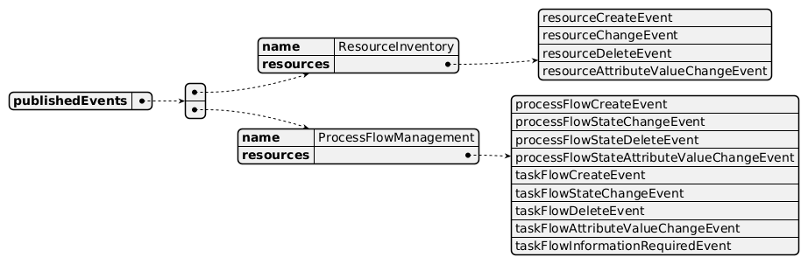
Published Events diagram

Subscribed Events
API ID | API Name | Event Resources
TMF634 | Resource Catalog Management API | resourceCatalogCreateEvent  resourceCatalogChangeEvent  resourceCatalogDeleteEvent  resourceCategoryCreateEvent  resourceCategoryChangeEvent  resourceCategoryDeleteEvent  resourceCandidateCreateEvent  resourceCandidateChangeEvent  resourceCandidateDeleteEvent  resourceSpecificationCreateEvent  resourceSpecificationChangeEvent  resourceSpecificationDeleteEvent  importJobCreateEvent  exportJobCreateEvent  exportJobStateChangeEvent
TMF639 | Resource Inventory Management API | resourceCreateEvent  resourceChangeEvent  resourceDeleteEvent  resourceAttributeValueChangeEvent
TMF669 | Party Role Management API | PartyRoleCreateEvent  PartyRoleAttributeValueChangeEvent  PartyRoleStateChangeEvent  PartyRoleDeleteEvent
TMF674 | Geographic Site Management API | geographicSiteDeleteEvent
TMF675 | Geographic Location Management API | geographicLocationDeleteEvent
TMF632 | Party Management API | individualDeleteEvent  organizationDeleteEvent

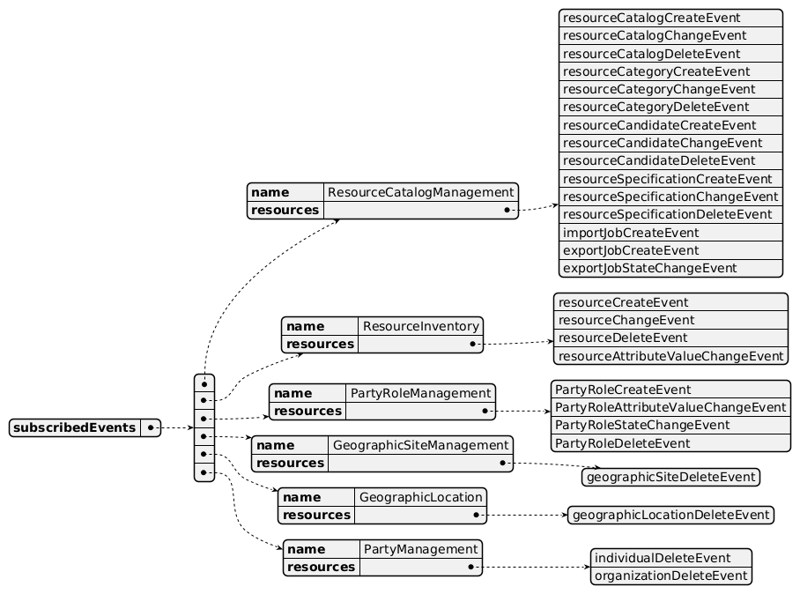
Subscribed Events diagram

Machine Readable Component Specification
Refer to the ODA Component Directory on the TM Forum website for the machine-readable component specification files for this component.

References

TMF Standards related versions
Standard | Version(s)
eTOM | v23.0.1
SID | v25.0
Functional Framework | v23.0

Jira References
Functional Framework

ISA-416 - Harmonize functions related to Product, Service and Resource Inventories (BACKLOG). Harmonize as much as possible functions related to Product, Service and Resource Inventory.

ISA-417 - Review Resource Inventory Mgt sub-domain functions (BACKLOG). Review functions 465, 466 and 564 in Resource Inventory Mgt sub-domains as they are not related to such an inventory.
API

https://projects.tmforum.org/jira/browse/AP-1401
ODA Components

TAC-342 - Create and Publish: TMFCxxx: Add a Resource Topology Mgt component to the component inventory (BACKLOG). Add a new Resource Topology Management component in the component inventory.

Further resources
This component is involved in the following use cases described in IG1228 How to use ODA - Using Open APIs to realize Use Cases.

Administrative Appendix

Document History

Version History
Version Number | Date | Modified by | Description of changes
1.0.0 | 31-May-2022 | Kamal Maghsoudlou, Sylvie Demarest | Initial release
1.0.1 | 25-Jul-2023 | Ian Turkington | No content changed, simply a layout change to match template 3. Separated the YAML files to a managed repository.
1.0.1 | 14-Aug-2023 | Amaia White | Final edits prior to publication
2.0.0 | 30-Apr-2024 | Gaetano Biancardi | Updated Component Template; removed Resource Pool Management API from exposed list; aligned to Frameworks 23.5; removed TMF688 Event Management (from exposed and dependent API); removed TMF672 User Roles and Permissions from dependent API
2.0.0 | 12-Jul-2024 | Amaia White | Final edits prior to publication
2.1.0 | 18-Nov-2024 | Gaetano Biancardi | API version, only major version to be specified; Dependant API, following APIs moved from mandatory to optional (correction of diagram typo): TMF673, TMF674
2.1.0 | 24-Dec-2024 | Rosie Wilson | Final edits prior to publication
2.1.1 | 28-Feb-2025 | Rosie Wilson | Versioning updated ahead of update
2.1.1 | 09-Jul-2025 | Rosie Wilson | Updates to description per agreed YAML updated on 03 Jun 2025
2.1.1 | 15-Jul-2025 | Rosie Wilson | Final edits prior to publication
2.2.0 | 29-Jan-2026 | julien rouland | Component Update: add exposed APIs TMF685 resourcePool; add exposed APIs TMF716 resource reservation; update functional framework (remove duplicated 471, update title and description of 472)
2.2.0 | 05-Jun-2026 | Hugo Vaughan | Gen 5 API updates
2.2.0 | 25-Jun-2026 | Sannah Sibaya | Final edits prior to publication

Release History
Release Status | Date Modified | Modified by | Description of changes
Pre-production | 31-May-2022 | Goutham Babu | Initial release
Production | 22-Jul-2022 | Adrienne Walcott | Updated to reflect TM Forum Approved status
Pre-production | 14-Aug-2023 | Amaia White | New release v1.0.1
Production | 06-Oct-2023 | Adrienne Walcott | Updated to reflect TM Forum Approved status
Pre-production | 12-Jul-2024 | Amaia White | New release v2.0.0
Production | 30-Aug-2024 | Adrienne Walcott | Updated to reflect TM Forum Approved status
Pre-production | 24-Dec-2024 | Rosie Wilson | New release v2.1.0
Production | 07-Mar-2025 | Adrienne Walcott | Updated to reflect TM Forum Approved status
Pre-production | 15-Jul-2025 | Rosie Wilson | New release v2.1.1
Production | 05-Sep-2025 | Adrienne Walcott | Updated to reflect TM Forum Approved status
Pre-production | 25-Jun-2026 | Sannah Sibaya | New release v2.2.0

Acknowledgements
This document was prepared by the members of the TM Forum ODA Components & Canvas team.
Team Member | Company | Role
Kamal Maghsoudlou | Ericsson | Editor
Sylvie Demarest | Orange | Reviewer
Hugo Vaughan (TM Forum) | TM Forum | Additional Input
Ian Turkington | TM Forum | Additional Input
Gaetano Biancardi | Accenture | Additional Input
Abinash Vishwakarma | Netcracker | Reviewer
Jose Macaluso | Xacria | Reviewer
Milind Bhagwat | BT | Reviewer
Ritu Arora | BT | Reviewer
Matteo Destino | Accenture | Reviewer
Elisabeth Andersson | MATRIXX | Reviewer

