TMFC014 Location Management v1.3.1
Components and Canvas
In this deliverable:

Overview
Component Name | ID | Description | ODA Function Block
Location Management | TMFC014 | The Location Management component allows easy reference to geographic places important to other entities, where a geographic place is an entity that can answer the question "where?" This component could be a facade tool for GIS systems, address sytems, BIM systems, mapping systems ... (eg. Google Maps). | Production

eTOM Processes, SID Data Entities and Functional Framework Functions

eTOM business activities
eTOM business activities this ODA Component is responsible for:
none listed in the component YAML

SID ABEs
SID ABEs this ODA Component is responsible for:
SID ABE Level 1 | SID ABE Level 2 (or set of BEs) | SID ABE L1 Definition | SID ABE L2 Definition
Location | Geographic Place | The Location ABE represents the site or position of something, such as a customer's address, the site of equipment where there is a fault and where is the nearest person who could repair the equipment, and so forth. Locations can take the form of coordinates and/or addresses and/or physical representations. Disclaimer This Location model is complex and has a number of subtleties. It provides a high level framework, explains broad concepts and gives illustrative examples. Actual solutions for particular requirements will be dependent factors such as country address standards state/ country / province map standards Service Provider addressing standards Equipment vendor equipment naming & addressing conventions whether textual only or graphical representations will be provided It is expected that when this model is used in NGOSS Catalyst projects, the feedback will clarify its application & usage in particular situations. There is obviously a limit to the amount of detail that can be included in a document like this. Those wishing to delve into more detail should consult the references used as the basis for this document. Introduction At the most fundamental level [Zachman], [Coad-Archetypes] the world can be thought of as comprising of entities that answer the 5 fundamental questions. (see below Figure L.00 - Showing how Location Fits in) | A group of entities that are used to define a geographic location and enable it to be marked it on a map or given an address.
Location | Geographic Location | The Location ABE represents the site or position of something, such as a customer's address, the site of equipment where there is a fault and where is the nearest person who could repair the equipment, and so forth. Locations can take the form of coordinates and/or addresses and/or physical representations. Disclaimer This Location model is complex and has a number of subtleties. It provides a high level framework, explains broad concepts and gives illustrative examples. Actual solutions for particular requirements will be dependent factors such as country address standards state/ country / province map standards Service Provider addressing standards Equipment vendor equipment naming & addressing conventions whether textual only or graphical representations will be provided It is expected that when this model is used in NGOSS Catalyst projects, the feedback will clarify its application & usage in particular situations. There is obviously a limit to the amount of detail that can be included in a document like this. Those wishing to delve into more detail should consult the references used as the basis for this document. Introduction At the most fundamental level [Zachman], [Coad-Archetypes] the world can be thought of as comprising of entities that answer the 5 fundamental questions. (see below Figure L.00 - Showing how Location Fits in) | *(no description available)*
Location | Geographic Address | The Location ABE represents the site or position of something, such as a customer's address, the site of equipment where there is a fault and where is the nearest person who could repair the equipment, and so forth. Locations can take the form of coordinates and/or addresses and/or physical representations. Disclaimer This Location model is complex and has a number of subtleties. It provides a high level framework, explains broad concepts and gives illustrative examples. Actual solutions for particular requirements will be dependent factors such as country address standards state/ country / province map standards Service Provider addressing standards Equipment vendor equipment naming & addressing conventions whether textual only or graphical representations will be provided It is expected that when this model is used in NGOSS Catalyst projects, the feedback will clarify its application & usage in particular situations. There is obviously a limit to the amount of detail that can be included in a document like this. Those wishing to delve into more detail should consult the references used as the basis for this document. Introduction At the most fundamental level [Zachman], [Coad-Archetypes] the world can be thought of as comprising of entities that answer the 5 fundamental questions. (see below Figure L.00 - Showing how Location Fits in) | A group of entities used to represent the geographic address of a location.
Location | Geographic Site | The Location ABE represents the site or position of something, such as a customer's address, the site of equipment where there is a fault and where is the nearest person who could repair the equipment, and so forth. Locations can take the form of coordinates and/or addresses and/or physical representations. Disclaimer This Location model is complex and has a number of subtleties. It provides a high level framework, explains broad concepts and gives illustrative examples. Actual solutions for particular requirements will be dependent factors such as country address standards state/ country / province map standards Service Provider addressing standards Equipment vendor equipment naming & addressing conventions whether textual only or graphical representations will be provided It is expected that when this model is used in NGOSS Catalyst projects, the feedback will clarify its application & usage in particular situations. There is obviously a limit to the amount of detail that can be included in a document like this. Those wishing to delve into more detail should consult the references used as the basis for this document. Introduction At the most fundamental level [Zachman], [Coad-Archetypes] the world can be thought of as comprising of entities that answer the 5 fundamental questions. (see below Figure L.00 - Showing how Location Fits in) | *(no description available)*
Location | Local Place | The Location ABE represents the site or position of something, such as a customer's address, the site of equipment where there is a fault and where is the nearest person who could repair the equipment, and so forth. Locations can take the form of coordinates and/or addresses and/or physical representations. Disclaimer This Location model is complex and has a number of subtleties. It provides a high level framework, explains broad concepts and gives illustrative examples. Actual solutions for particular requirements will be dependent factors such as country address standards state/ country / province map standards Service Provider addressing standards Equipment vendor equipment naming & addressing conventions whether textual only or graphical representations will be provided It is expected that when this model is used in NGOSS Catalyst projects, the feedback will clarify its application & usage in particular situations. There is obviously a limit to the amount of detail that can be included in a document like this. Those wishing to delve into more detail should consult the references used as the basis for this document. Introduction At the most fundamental level [Zachman], [Coad-Archetypes] the world can be thought of as comprising of entities that answer the 5 fundamental questions. (see below Figure L.00 - Showing how Location Fits in) | A set of entities that determine where things are in relation to a local coordinate system. It provides a linking point to other parts of the SID model.

eTOM L2 - SID ABEs links
no eTOM business activities are listed for this component in the YAML — see 2.1

Functional Framework Functions
Function ID | Function Name | Function Description | Aggregate Function Level 1 | Aggregate Function Level 2
429 | Location Change History Management | Location Change History Management; Tracks all changes of location data, making available attributes according to their historical values in certain periods. | Resource Management | Location Management
430 | PreFormattedLocation InformationPresentation | Pre-formatted Location Information Presentation generates different views for different business cases (e.g. different format of address strings) | Resource Management | Location Management
431 | Location Information Updating | Location Information Updating provides means to update the repository with new/updated location information from external sources. | Resource Management | Location Management
432 | Location Information Searching | Location Information Searching provide the ability to search for a provided location/address, as part of the Location Management, including the ability to return near matches if an exact match is not found. | Resource Management | Location Management
433 | Location Structure Data Configuration | Location Structure Data Configuration provides facilities for creating, modifying and deleting location structures data according to business rules of Service Providers or national and international location regulations. Also, utilities for defining sets of location attributes, levels and hierarchies should be available. | Resource Management | Location Management
434 | Location Data Integrity Management | Location Data Integrity Management provides ability to maintain data integrity in the whole location repository. It’s especially important if there are many external data sources that deliver new addresses for the repository. | Resource Management | Location Management

TM Forum Open APIs & Events
The following part covers the APIs and Events; this part is split in 3:

List of Exposed APIs - This is the list of APIs available from this component.

List of Dependent APIs - In order to satisfy the provided API, the component could require the usage of this set of required APIs.

List of Events (generated & consumed) - The events which the component may generate are listed in this section along with a list of the events which it may consume. Since there is a possibility of multiple sources and receivers for each defined event.

API Context Diagram
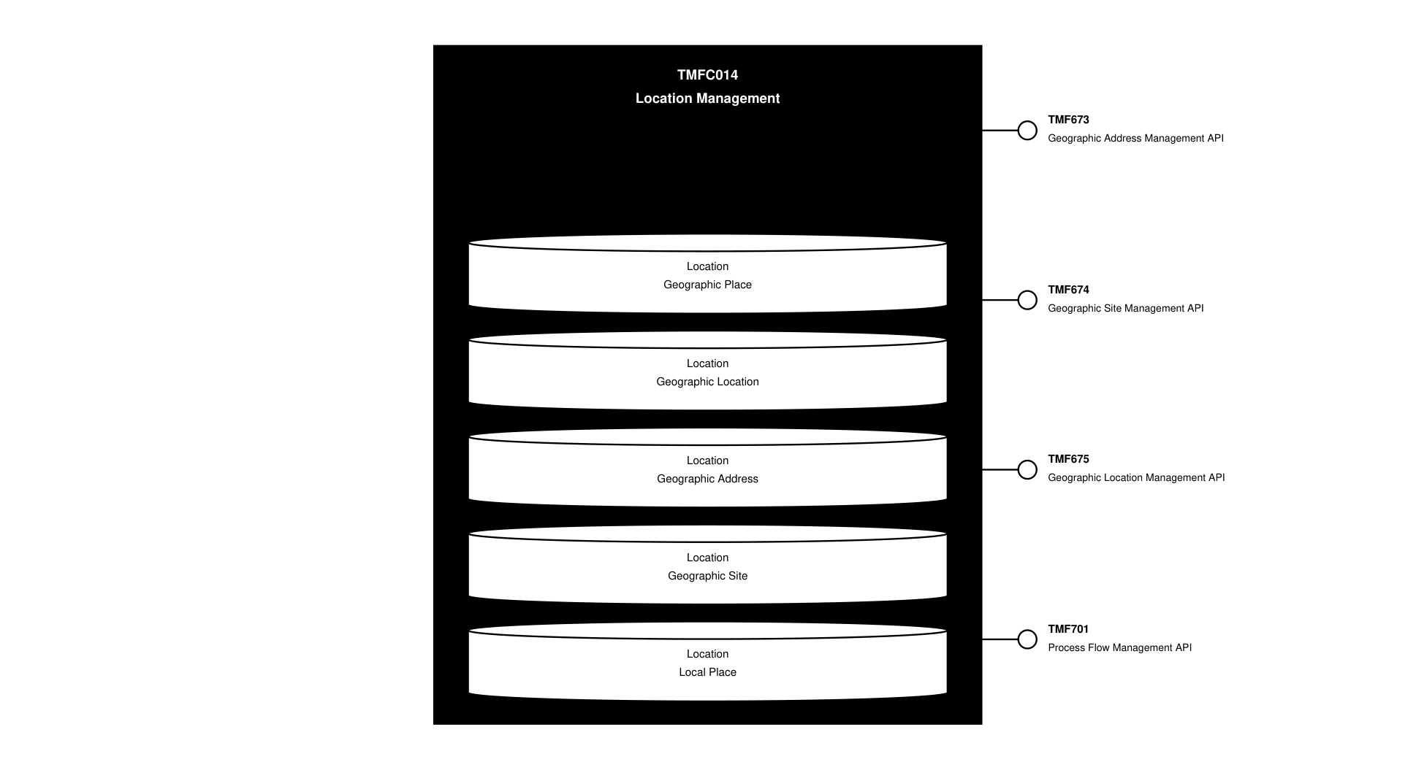
API Context diagram

Exposed APIs
API ID | API Name | Mandatory / Optional | API Version | Resource | Operations
TMF673 | Geographic Address Management API | Mandatory | 4 | geographicAddressValidation  geographicAddress  geographicSubAddress | GET  GET /id  POST  PATCH
TMF674 | Geographic Site Management API | Mandatory | 4 | geographicSite | GET  GET /id  POST  PATCH  DELETE
TMF675 | Geographic Location Management API | Mandatory | 4 | geographicLocation | GET  GET /id  POST  PATCH  DELETE
TMF701 | Process Flow Management API | Optional | 4 | processFlow  taskFlow | POST  GET  GET /id  DELETE  PATCH

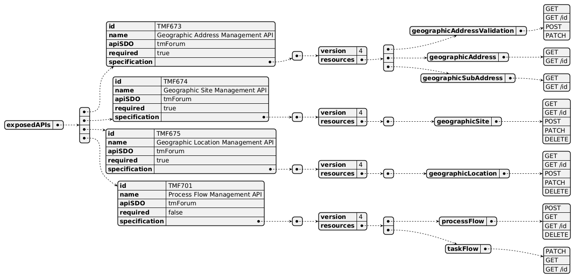
Exposed API diagram

Dependent APIs
API ID | API Name | API Version | Mandatory / Optional | Resource | Operations

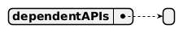
Dependent API diagram

Events
The diagram illustrates the Events which the component may publish and the Events that the component may subscribe to and then may receive. Both lists are derived from the APIs listed in the preceding sections.

Published Events
API ID | API Name | Event Resources
TMF673 | Geographic Address Management API | geographicAddressValidationStateChangeEvent
TMF674 | Geographic Site Management API | geographicSiteAttributeValueChangeEvent  geographicSiteCreateEvent  geographicSiteDeleteEvent  geographicSiteStatusChangeEvent
TMF675 | Geographic Location Management API | geographicLocationAttributeValueChangeEvent  geographicLocationCreateEvent  geographicLocationDeleteEvent

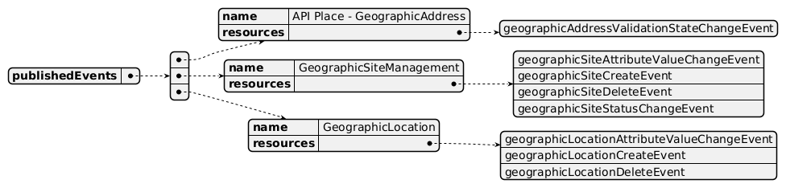
Published Events diagram

Subscribed Events
none listed in the component YAML

Subscribed Events diagram

Machine Readable Component Specification
Refer to the ODA Component Directory on the TM Forum website for the machine-readable component specification files for this component.

References

TMF Standards related versions
Standard | Version(s)
eTOM | *(none)*
SID | v23.5
Functional Framework | v23.0

Jira References
eTOM

ISA-559 Enrich eTOM with business activities necessary to manage any type of Location

Further resources
n/a

Administrative Appendix

Document History

Version History
Version Number | Date | Modified by | Description of changes
0.1.0 | 28-Jun-2022 | Gaetano Biancardi, Sylvie Demarest | Final edits prior to publication
0.2.0 | 19-Aug-2022 | Anastasios Sarantis | Changes asked from the community. Component description changed according to feedback + Functional Framework updates
1.0.0 | 07-Dec-2022 | Goutham Babu | Initial release of document
1.0.1 | 25-Jul-2023 | Ian Turkington | No content changed, simply a layout change to match template 3. Separated the YAML files to a managed repository.
1.0.1 | 15-Aug-2023 | Amaia White | Final edits prior to publication
1.1.0 | 13-May-2024 | Hugo Vaughan, Gaetano Biancardi | Aligned to Frameworks 23.5; aligned to latest template; removed TMF688 from exposed and dependent API
1.1.0 | 12-Jul-2024 | Amaia White | Final edits prior to publication
1.2.0 | 24-Oct-2024 | Gaetano Biancardi | Exposed API: fixed duplication of TMF674
1.2.0 | 14-Mar-2025 | Rosie Wilson | Updated Maturity Level to Beta as confirmed by Gaetano Biancardi, as v4 of TMF675 is still in preview and API confirmed as Mandatory for this component by Anastasios Sarantis; final administrative updates

Release History
Release Status | Date Modified | Modified by | Description of changes
Pre-production | 07-Dec-2023 | Goutham Babu | Initial release of document
Pre-production | 23-Jan-2023 | Adrienne Walcott | Updated to member evaluation status
Pre-production | 15-Aug-2023 | Amaia White | New release 1.0.1
Production | 06-Oct-2023 | Adrienne Walcott | Updated to reflect TM Forum Approved status
Pre-production | 12-Jul-2024 | Amaia White | New release 1.1.0
Production | 30-Aug-2024 | Adrienne Walcott | Updated to reflect TM Forum Approved status
Pre-production | 14-Mar-2025 | Rosie Wilson | New release 1.2.0
Production | 09-May-2025 | Adrienne Walcott | Updated to reflect TM Forum Approved status

Acknowledgements
Team Member | Company | Role
Anastasios Sarantis | Vodafone | Editor
Sylvie Demarest | Orange | Reviewer
Ian Turkington | TM Forum | Additional Input
Hugo Vaughan (TM Forum) | TM Forum | Additional Input

