TMFC020 Digital Identity Management v1.2.0
Components and Canvas
In this deliverable:

Overview
Component Name | ID | Description | ODA Function Block
Digital Identity Management | TMFC020 | The Digital Identity Management component is responsible for authentication of parties (customers, employees, partners), and resources authentication. | Party Management

eTOM Processes, SID Data Entities and Functional Framework Functions

eTOM business activities
eTOM business activities this ODA Component is responsible for:
none listed in the component YAML

SID ABEs
SID ABEs this ODA Component is responsible for:
SID ABE Level 1 | SID ABE Level 2 (or set of BEs) | SID ABE L1 Definition | SID ABE L2 Definition
Digital Identity |  | The Digital Identity ABE contains all Business Entities used for enabling identification / authentication of Party or Resource in order to allow Party or Resource to use their permission carried by their roles. | *(no description available)*

eTOM L2 - SID ABEs links
no eTOM business activities are listed for this component in the YAML — see 2.1

Functional Framework Functions
Function ID | Function Name | Function Description | Aggregate Function Level 1 | Aggregate Function Level 2
1025 | Application Access | Application Access provide access interfaces with authentication and authorization control for the requests and responses related to the application’s functionality, including event logging and usage statistics. | Identification and Permission Management | Identification and Authentication
906 | PKI and Digital Certificates Systems Integration | PKI and Digital Certificates Systems Integration provides integration to Public Key Infrastructure Systems that provides digital certificates, and the support to use public keys and digital certificates. | Identification and Permission Management | Identification and Authentication
899 | Single Sign-On Access Control | Single Sign-On Access Control grant access in cooperation with central Authentication and Authorization functions to secure the most updated security. | Identification and Permission Management | Identification and Authentication
1240 | Identity Verification | Identity Verification (aka authentication) establishes that an actor (i.e. a person or a resource) is who they purport to be using one or several credentials. / According to the reliability of the credentials used the authentication has a level of authentication such as a biometric credential (i.e. facial recognition or finger print) or multi-factor credential with a high level of authentication or a network credential with a low level of authentication. / Note: each permission specifies the minimum level of authentication required. | Identification and Permission Management | Identification and Authentication
1247 | Credentials Establishment | Credentials Establishment creates and/or modifies credentials and associates them with the Digital Identity that will be using them. Credentials can include username/passcode combinations, biometrics, and physical and/or logical passkeys. / Note: A Digital Identity aims to enable identifying Party, Party Roles or Resource Roles. | Identification and Permission Management | Digital Identity Management
1248 | Credentials Query | Credentials Query provides the ability to retrieve non-protected information about the Digital Identity of credentials or about the credentials themselves (e.g.name, photo, badge number, token ID, credentials valid dates, etc.). | Identification and Permission Management | Digital Identity Management

TM Forum Open APIs & Events
The following part covers the APIs and Events; this part is split in 3:

List of Exposed APIs - This is the list of APIs available from this component.

List of Dependent APIs - In order to satisfy the provided API, the component could require the usage of this set of required APIs.

List of Events (generated & consumed) - The events which the component may generate are listed in this section along with a list of the events which it may consume. Since there is a possibility of multiple sources and receivers for each defined event.

API Context Diagram
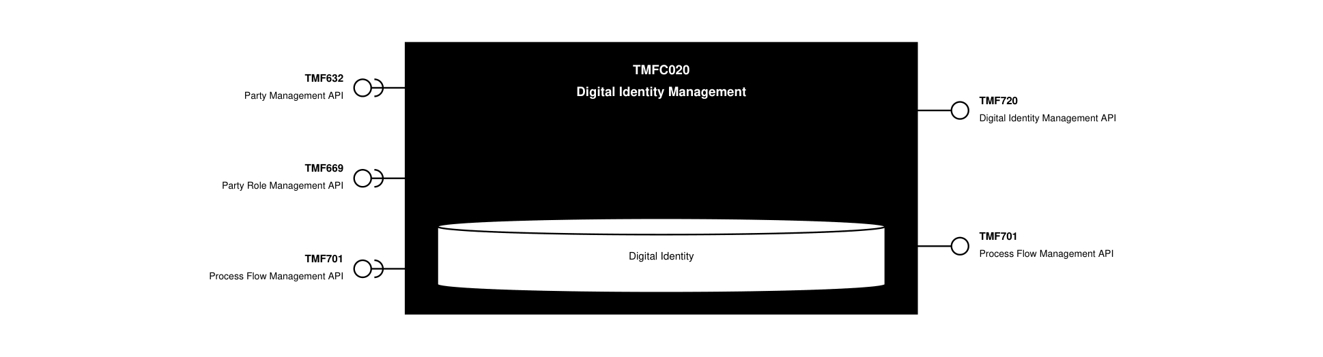
API Context diagram

Exposed APIs
API ID | API Name | Mandatory / Optional | API Version | Resource | Operations
TMF720 | Digital Identity Management API | Mandatory | 4 | digitalIdentity  roles | GET  GET /id  POST  PATCH /id  DELETE /id
TMF701 | Process Flow Management API | Optional | 4 | processFlow  taskFlow | GET  GET /id  POST  DELETE /id  PATCH /id

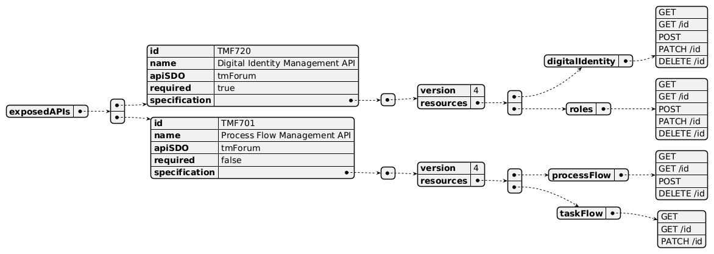
Exposed API diagram

Dependent APIs
API ID | API Name | API Version | Mandatory / Optional | Resource | Operations
TMF632 | Party Management API | 5 | Mandatory | individual  organization | GET  GET /id
TMF632 | Party Management API | 4 | Mandatory | individual  organization | GET  GET /id
TMF669 | Party Role Management API | 5 | Mandatory | partyRole | POST
TMF669 | Party Role Management API | 4 | Mandatory | partyRole | POST
TMF701 | Process Flow Management API | 4 | Optional | processFlow  taskFlow | POST  GET  GET /id  DELETE  PATCH

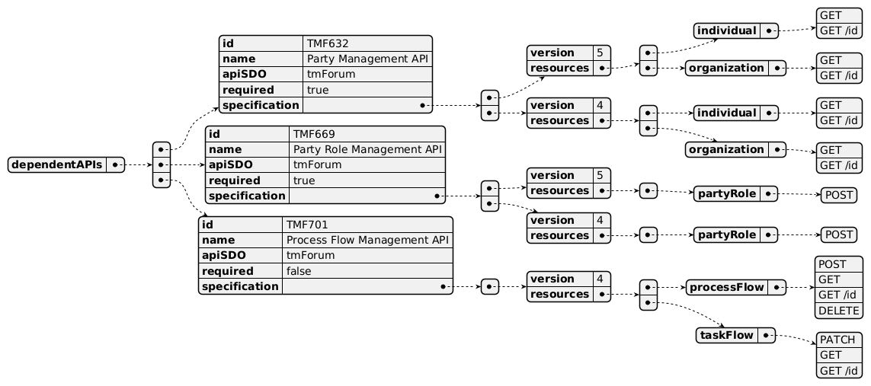
Dependent API diagram

Events
The diagram illustrates the Events which the component may publish and the Events that the component may subscribe to and then may receive. Both lists are derived from the APIs listed in the preceding sections.

Published Events
API ID | API Name | Event Resources
TMF720 | Digital Identity Management API | DigitalIdentityCreateEvent  DigitalIdentityStateChangeEvent  DigitalIdentityDeleteEvent  DigitalIdentityAttributeValueChangeEvent

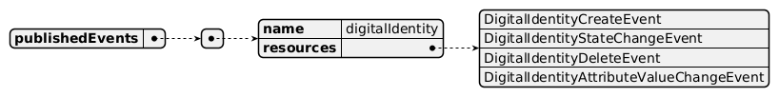
Published Events diagram

Subscribed Events
API ID | API Name | Event Resources
TMF669 | Party Role Management API | partyRoleCreateEvent  partyRoleAttributeValueChangeEvent

Subscribed Events diagram

Machine Readable Component Specification
Refer to the ODA Component Directory on the TM Forum website for the machine-readable component specification files for this component.

References

TMF Standards related versions
Standard | Version(s)
eTOM | *(none)*
SID | v25.0
Functional Framework | v23.5

Jira References
No open Jira issues currently listed for this component.

Further resources
1. IG1228: please refer to IG1228 for defined use cases with ODA components interactions.

Administrative Appendix

Document History

Version History
Version Number | Date | Modified by | Description of changes
1.0.0 | 28-Jun-2022 | Gaetano Biancardi, Sylvie Demarest | Final edits prior to publication
1.1.0 |  | Amaia White | Final edits prior to publication
1.0.1 | 25-Jul-2023 | Ian Turkington | No content changed, simply a layout change to match template 3. Separated the YAML files to a managed repository.
1.0.1 | 14-Aug-2023 | Amaia White | Final edits prior to publication
1.1.0 | 13-May-2024 | Gaetano Biancardi | Component Template Update; component refreshed to ODF 23.5 (updates required only for Functional Framework functions); removed TMF688 from exposed and dependent API
1.1.1 | 15-Sep-2025 | Rosie Wilson | Updates to description per agreed YAML updated on 03-Jun-2025; final administrative updates prior to publication
1.2.0 | 25-Jun-2026 | Sannah Sibaya | Final edits prior to publication

Release History
Release Status | Date Modified | Modified by | Description of changes
Pre-production | 05-Aug-2022 | Goutham Babu | Initial release of document
Pre-production | 05-Sep-2022 | Adrienne Walcott | Updated to reflect TM Forum Member Evaluated status
Pre-production | 14-Aug-2023 | Amaia White | New release of document 1.0.1
Production | 06-Oct-2023 | Adrienne Walcott | Updated to reflect TM Forum Approved status
Pre-production | 12-Jul-2024 | Amaia White | New release of document 1.1.0
Production | 30-Aug-2024 | Adrienne Walcott | Updated to reflect TM Forum Approved status
Pre-production | 15-Sep-2025 | Rosie Wilson | New release of document 1.1.1
Pre-production | 25-Jun-2026 | Sannah Sibaya | New release of document 1.2.0

Acknowledgements
This document was prepared by the members of the TM Forum Component and Canvas project team.
Team Member | Company | Role
Gaetano Biancardi | Accenture | Editor
Sylvie Demarest | Orange | Reviewer
Hugo Vaughan (TM Forum) | TM Forum | Additional Input
Ian Turkington | TM Forum | Additional Input
Anastasios Sarantis | Vodafone | Reviewer
Abinash Vishwakarma | Netcracker | Reviewer
Elisabeth Andersson | MATRIXX | Reviewer
Kamal Maghsoudlou | Ericsson | Reviewer
Jose Macaluso | Xacria | Reviewer
Milind Bhagwat | BT | Reviewer
Ritu Arora | BT | Reviewer
Rosie Wilson | TM Forum | Additional Input

