TMFC022 Party Privacy Management v1.2.0
Components and Canvas
In this deliverable:

Overview
Component Name | ID | Description | ODA Function Block
Party Privacy Management | TMFC022 | The Party Privacy Management component defines the privacy policy rules established by the CSP (according to applicable regulations such as GDPR in Europe); applies these rules to each Party interacting with the CSP and to all of their personal information and personally identifiable information; and registers explicit opt-in and opt-out given by Parties regarding the use of their personal information for dedicated purposes, such as marketing. | Party Management

eTOM Processes, SID Data Entities and Functional Framework Functions

eTOM business activities
eTOM business activities this ODA Component is responsible for:
Identifier | Level | Business Activity Name | Description
1.3.21.2 | L3 | Manage Customer Privacy Profile | Customer Privacy Profile Management process is used to administer the Privacy Profile for each Customer Privacy Profile Type, including the enforcement of the Customer Privacy Profile; Processes to display, and modify the Privacy Profile, and the import/export of the Privacy Profile Rules.

SID ABEs
SID ABEs this ODA Component is responsible for:
SID ABE Level 1 | SID ABE Level 2 (or set of BEs) | SID ABE L1 Definition | SID ABE L2 Definition
Party Privacy | Party Privacy Profile | The Party Privacy Profile ABE contains all entities used by the Party Privacy Management process for specifying / • the information concerned by Privacy rules, / • the Privacy rules themselves, / • and the choices made by Parties for their own Privacy. | The Party Privacy Profile ABE contains all entities used by the Party Privacy Management process for specifying the choices made by Parties for their own Privacy.

eTOM L2 - SID ABEs links
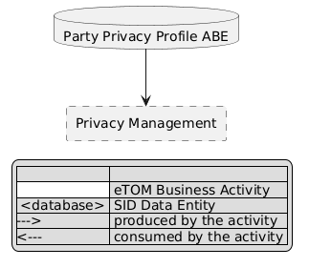
eTOM L2 - SID ABEs links diagram

Functional Framework Functions
Function ID | Function Name | Function Description | Aggregate Function Level 1 | Aggregate Function Level 2
664 | Privacy Profile Type Creation | Privacy Profile Type Creation provides a privacy dashboard function to define and create the privacy profile types by categorizing the Data Subject Parties and defining the elements and of the Privacy for the Privacy Profile Type, both initial and additional for future evolution. / Note: Profiles Type are defined according to the Country Privacy Authority such as National Protective Security Authority (NPSA) for UK. | Privacy Development | Privacy Definition Management
665 | Privacy Profile Rules Configuration | Privacy Profile Rules Configuration provides a Privacy Dashboard function to define default and updated values for the Privacy Profile including the values for the Privacy Rules, and the default Privacy Profile for each Privacy Profile Type. / Note: Profiles Type are defined according to the Country Privacy Authority such as National Protective Security Authority (NPSA) for UK. | Privacy Development | Privacy Definition Management
666 | Privacy Data Browsing Access | Privacy Data Browsing Access provides a Privacy Dashboard access to Privacy Data Browsing used to provide the "Data Subject Party" the ability to view the current privacy profile attributes, of the Privacy Profile, both associated default values of rules defined, and the current values of rules. | Privacy Management | Privacy Repository Management
667 | Privacy Data Updating Access | Privacy Data Updating Access provides a Privacy Dashboard function that provides an access possibility for the Party to alter the Privacy Profile, with authorized values. | Privacy Management | Privacy Repository Management
668 | Privacy Consent Agreement Obtaining | Privacy Consent Agreement Obtaining function is used to obtain consent from the "Data Subject Party" at the time of a change to the Privacy Profile. This can be initiated by the "Data Subject Party" at creation of new usage, or by the Service when delivering a new scenario. | Privacy Management | Privacy Repository Management
945 | Record Retention Management | Record Retention Management of data and information monitor and assures compliance with the retention aspects of federal and state laws, legal requirements and expectations as well as the enterprise policies and procedures. | Privacy Management | Privacy Control

TM Forum Open APIs & Events
The following part covers the APIs and Events; this part is split in 3:

List of Exposed APIs - This is the list of APIs available from this component.

List of Dependent APIs - In order to satisfy the provided API, the component could require the usage of this set of required APIs.

List of Events (generated & consumed) - The events which the component may generate are listed in this section along with a list of the events which it may consume. Since there is a possibility of multiple sources and receivers for each defined event.

API Context Diagram
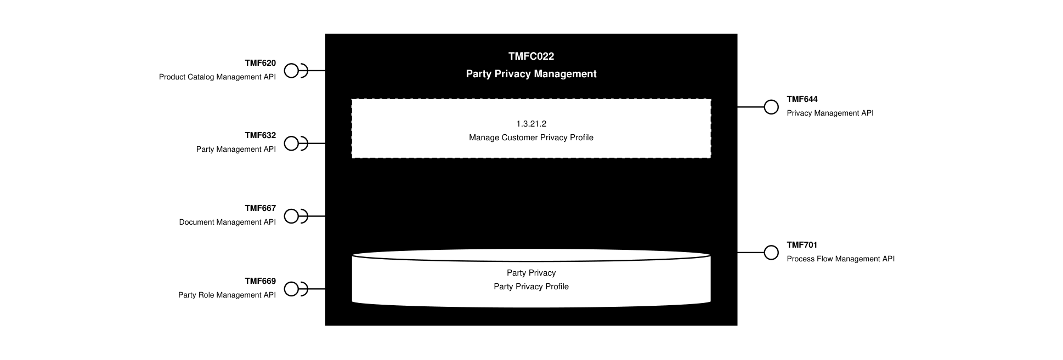
API Context diagram

Exposed APIs
API ID | API Name | Mandatory / Optional | API Version | Resource | Operations
TMF644 | Privacy Management API | Mandatory | 5 | partyPrivacyAgreement  partyPrivacyProfile  partyPrivacyProfileSpecification | GET  GET /id  POST  Patch /id  DELETE
TMF644 | Privacy Management API | Mandatory | 4 | partyPrivacyProfileSpecification  partyPrivacyProfile  partyPrivacyAgreement | GET  GET /id  POST  PATCH /id  DELETE
TMF701 | Process Flow Management API | Optional | 4 | processFlow  taskFlow | GET  GET /id  POST  DELETE /id  PATCH /id

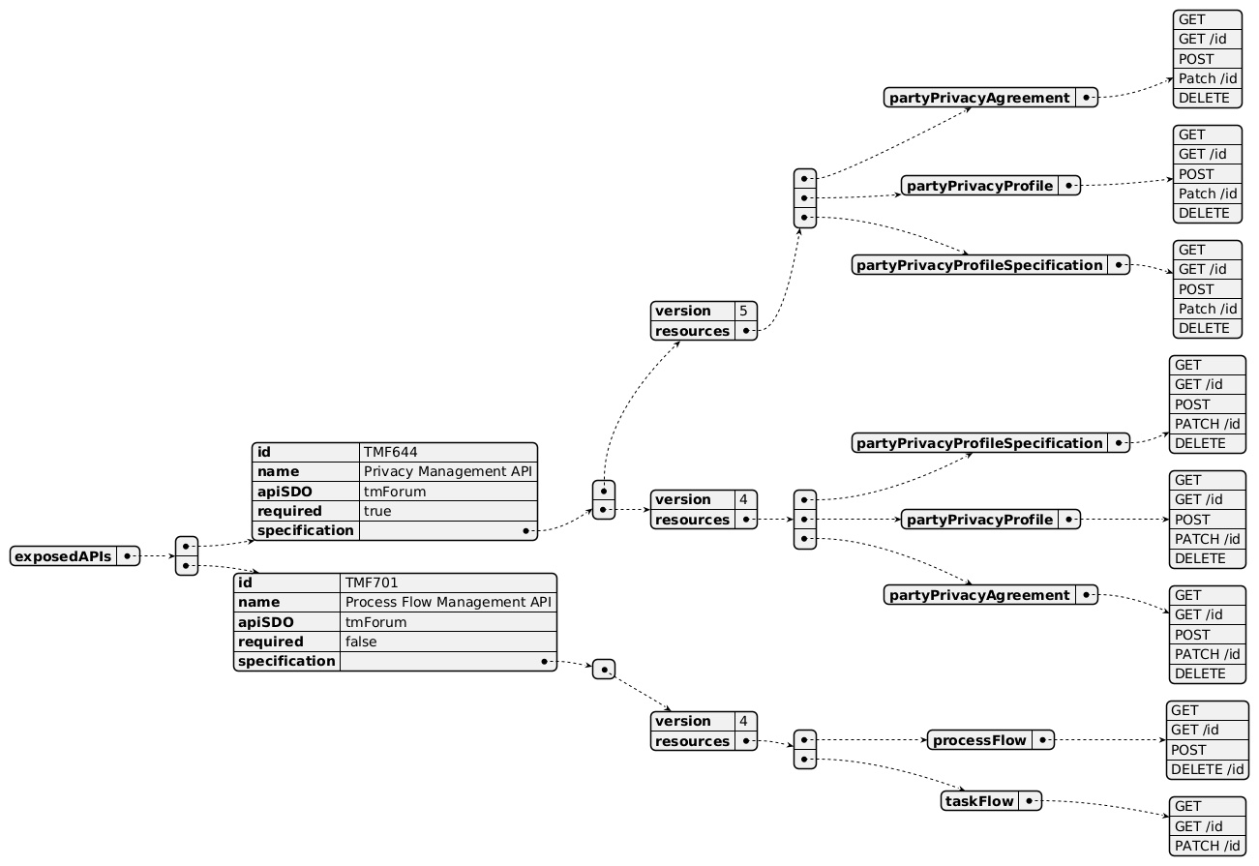
Exposed API diagram

Dependent APIs
API ID | API Name | API Version | Mandatory / Optional | Resource | Operations
TMF620 | Product Catalog Management API | 5 | Optional | productOffering | GET  GET /id
TMF620 | Product Catalog Management API | 4 | Optional | productOffering | GET  GET /id
TMF632 | Party Management API | 5 | Mandatory | individual  organization | GET  GET /id
TMF632 | Party Management API | 4 | Mandatory | individual  organization | GET  GET /id
TMF667 | Document Management API | 4 | Optional | document | GET  GET /id  POST
TMF669 | Party Role Management API | 5 | Mandatory | partyRole | GET  GET /id
TMF669 | Party Role Management API | 4 | Mandatory | partyRole | GET  GET /id

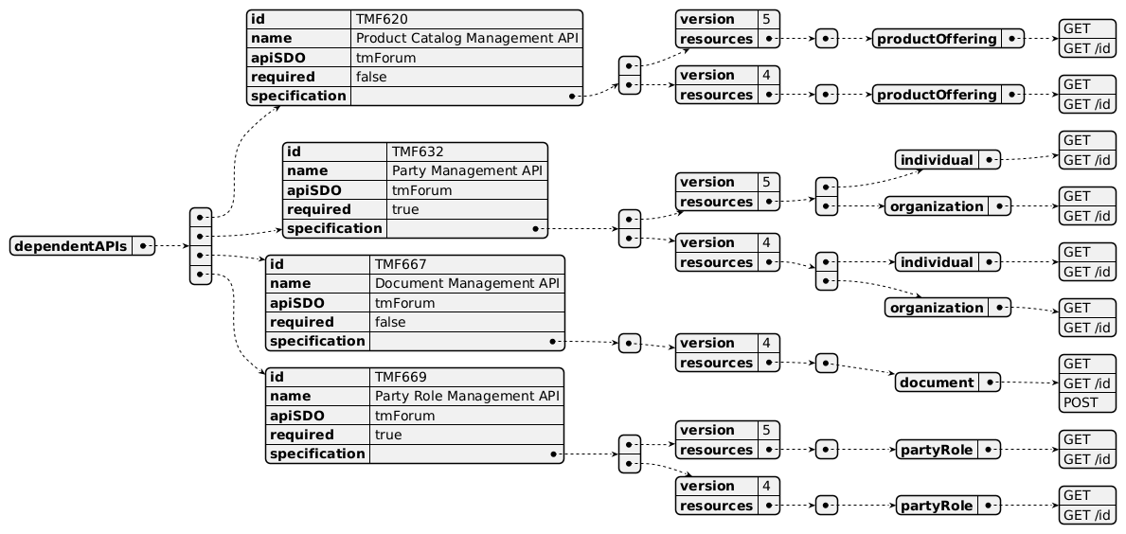
Dependent API diagram

Events
The diagram illustrates the Events which the component may publish and the Events that the component may subscribe to and then may receive. Both lists are derived from the APIs listed in the preceding sections.

Published Events
none listed in the component YAML

Published Events diagram

Subscribed Events
none listed in the component YAML

Subscribed Events diagram

Machine Readable Component Specification
Refer to the ODA Component Directory on the TM Forum website for the machine-readable component specification files for this component.

References

TMF Standards related versions
Standard | Version(s)
eTOM | v25.0
SID | v25.0
Functional Framework | v24.0

Jira References
SID

[ISA-897] Party Privacy ABE - Simplify PartyPrivacyAgreement
API

Treat impact of SID update to TMF644 Privacy Management

Further resources
This component is involved in use cases described in IG1228 How to use ODA - Using Open APIs to realize Use Cases.

Administrative Appendix

Document History

Version History
Version Number | Date | Modified by | Description of changes
1.0.0 | 24-Nov-2023 | Sylvie Demarest | First version of document
1.0.0 | 19-Dec-2023 | Amaia White | Final administrative edits
1.1.0 | 06-Aug-2024 | Sylvie Demarest | Updated Component Template; aligned to Frameworks 23.5
1.1.0 | 06-Sep-2024 | Amaia White | Final administrative edits
1.1.1 | 18-Nov-2024 | Gaetano Biancardi | API version, only major version to be specified
1.1.1 | 24-Dec-2024 | Rosie Wilson | Final administrative edits
1.1.2 | 15-Sep-2025 | Rosie Wilson | Updates to description per agreed YAML updated on 03-Jun-2025; final administrative updates prior to publication
1.2.0 | 25-May-2026 | Hugo Vaughan | Gen 5 API updates
1.2.0 | 26-Jun-2026 | Sannah Sibaya | Final edits prior to publication

Release History
Release Status | Date Modified | Modified by | Description of changes
Pre-production | 19-Dec-2023 | Amaia White | Initial release
Pre-production | 22-Jan-2024 | Adrienne Walcott | Updated to Member Evaluated status
Pre-production | 06-Sep-2024 | Amaia White | Updated to release v1.1.0
Production | 01-Nov-2024 | Adrienne Walcott | Updated to reflect TM Forum Approved status
Pre-production | 24-Dec-2024 | Rosie Wilson | Updated to release v1.1.1
Production | 07-Mar-2025 | Adrienne Walcott | Updated to reflect TM Forum Approved status
Pre-production | 15-Sep-2025 | Rosie Wilson | Updated to release v1.1.2
Production | 14-Nov-2026 | Adrienne Walcott | Updated to reflect TM Forum Approved status
Pre-production | 26-Jun-2026 | Sannah Sibaya | Updated to release v1.2.0

Acknowledgements
This document was prepared by the members of the TM Forum ODA Components & Canvas team.
Team Member | Company | Role
Gaetano Biancardi | Accenture | Reviewer
Anastasios Sarantis | Vodafone | Reviewer
Sylvie Demarest | Orange | Editor
Elisabeth Andersson | MATRIXX | Reviewer
Abinash Vishwakarma | Netcracker | Reviewer
Kamal Maghsoudlou | Ericsson | Reviewer
Jose Macaluso | Xacria | Reviewer
Milind Bhagwat | BT | Reviewer
Ritu Arora | BT | Reviewer

