TMFC023 Party Interaction Management v1.2.2
Components and Canvas
In this deliverable:

Overview
Component Name | ID | Description | ODA Function Block
Party Interaction Management | TMFC023 | Party Interaction deals with the initial greeting and welcoming of a new contact. This will typically be the first component in a customer experience journey, shared by unassisted (self-service, retail kiosk) or assisted (call center, retail store) channels. It will identify known Parties or new Parties and react appropriately to propose available actions. It records all the interactions for the Parties from all channels. | Party Management

eTOM Processes, SID Data Entities and Functional Framework Functions

eTOM business activities
eTOM business activities this ODA Component is responsible for:
Identifier | Level | Business Activity Name | Description
1.3.5 | L2 | Customer Interaction Management | Manage interactions between the customer and the enterprise. Interactions can be triggered by the customer or by the enterprise.
1.3.5.1 | L3 | Create Customer Interaction | Create a record that logs the customer interaction.
1.3.5.2 | L3 | Update Customer Interaction | Update the customer interaction.
1.3.5.3 | L3 | Close Customer Interaction | Close the customer interaction.
1.3.5.4 | L3 | Log Customer Interaction | Record and maintain all information about the customer interaction.
1.3.5.6 | L3 | Track and Manage Customer Interaction | Ensure that Customer Interactions are managed and tracked efficiently.
1.3.5.7 | L3 | Report Customer interaction | Monitor the status of a customer interaction.
1.6.9 | L2 | Business Partner Interaction Management | Manage interactions between parties and the enterprise. Interactions can be triggered by the enterprise (as a result of a query or complaint) or by a Business Partner (for example sending bills or other notifications.)
1.6.9.1 | L3 | Log Business Partner Interaction | Record and maintain all information about the Business Partner interaction.
1.6.9.3 | L3 | Track and Manage Business Partner Interaction | Ensure that Business Partner Interactions are managed and tracked efficiently to meet the Business Partner interaction policies and SLA requirements.
1.6.9.5 | L3 | Analyze & Report Business Partner Interactions | Perform all required analysis on closed requests and on Business Partner contacts and generate related reports.

SID ABEs
SID ABEs this ODA Component is responsible for:
SID ABE Level 1 | SID ABE Level 2 (or set of BEs) | SID ABE L1 Definition | SID ABE L2 Definition
Communication Interaction |  | The Communication Interaction ABE contains all entities needed for specifying a CommunicationInteraction describing an exchange of information during a communication between two or more human(s) and/or machine(s) during a period of time. CommunicationInteraction might concern Parties playing a role of Customer, Supplier… or even Resource, therefore the ABE « Communication Interaction ABE » is located in « Shared Domain ». | *(no description available)*

eTOM L2 - SID ABEs links
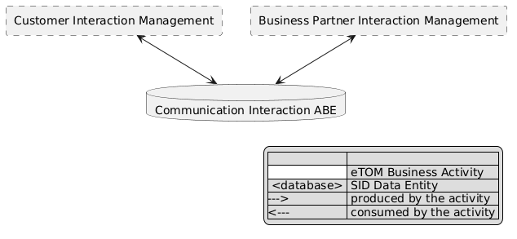
eTOM L2 - SID ABEs links diagram

Functional Framework Functions
Function ID | Function Name | Function Description | Aggregate Function Level 1 | Aggregate Function Level 2
93 | Customer Behavior Tracking | Customer Behavior Tracking function monitor the customer behavior through the customer interaction, public communication and use of products. / It includes mapping the customer relation/context to systems such as call center or self-service touch. | Welcome and Interaction | Customer Interaction Management
163 | Contact Queuing | Contact Queuing; Contact Queuing provides the means to queue the contact until such time that a suitable agent comes available to work the contact. | Welcome and Interaction | Queue Management
165 | Customer Support Collaboration Access | Customer Support Collaboration Access provides the means for customer to agent or agent to support online chatting. | Welcome and Interaction | Customer Interaction Management
168 | Voice Channel Contact Routing | Voice Channel Contact Routing function provides the means for a customer to speak to a service representative, including the mechanism to query the customer (e.g. – IVR) on the nature of their request, and routing of the contact to the best available agent with the skills required for the contact and presents to the agent selected call information. | Welcome and Interaction | Customer Interaction Management
189 | Customer Interaction Information Capturing | Customer Interaction Information Capturing captures customer interaction event data from all channels (agent interaction/notes, web/device click analytics, retail transactions, etc.), including receiving information from Customer Interaction Collection & Storage. | Welcome and Interaction | Customer Interaction Management
191 | Customer Relationship/Context Event Data Accumulation | Customer Relationship/Context Event Data Accumulation provides an ability to accumulate and map customer interaction event data from all channels (agent interaction/notes, web/device click analytics, retail transactions, etc.), including received information from Customer Interaction Collection & Storage. | Welcome and Interaction | Customer Interaction Management
196 | Customer Interaction Logging | Customer Interaction Logging provides collection and storage of all contact events with the customer via all channels whether unassisted (self service, retail kiosk) or assisted (call center, retail store). All types of interactions, including interaction history, order history, trouble ticket history, billing collection history, case management, etc... / The Store of any communications in any current or future form including Fax, IVR, email, Page, text, online chat, social media and postal mail. / The storage of all inbound and outbound interactions with the customer. | Welcome and Interaction | Customer Interaction Management
239 | Recommendation to Customer Notification | Recommendation to Customer Notification provides necessary hooks to reach out to the customer via preferred channels such as SMS, email or Social media. For Inbound, Self-Service or Call Center touch points can get recommendations and a guided action flow to complete the suitable customer treatment (ex. Credit Adjustment handled by agent, or bill dispute initiation via self-service). | Welcome and Interaction | Customer Context Management
1041 | Partner Interaction Journalizing | Partner Interaction Journalizing provides collection & storage of all contact events with the partner via all channels whether unassisted (self service, retail kiosk) or assisted (call center, retail store). | Business Partner Welcome and Interaction | Business Partner Interaction Management

TM Forum Open APIs & Events
The following part covers the APIs and Events; this part is split in 3:

List of Exposed APIs - This is the list of APIs available from this component.

List of Dependent APIs - In order to satisfy the provided API, the component could require the usage of this set of required APIs.

List of Events (generated & consumed) - The events which the component may generate are listed in this section along with a list of the events which it may consume. Since there is a possibility of multiple sources and receivers for each defined event.

API Context Diagram
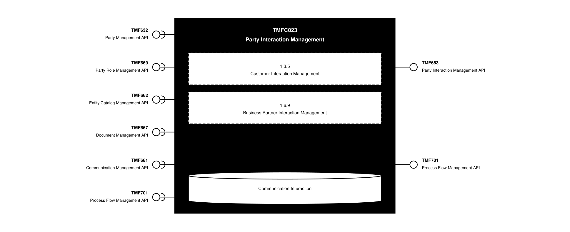
API Context diagram

Exposed APIs
API ID | API Name | Mandatory / Optional | API Version | Resource | Operations
TMF683 | Party Interaction Management API | Mandatory | 5 | partyInteraction | GET  GET /id  POST  PATCH  DELETE
TMF683 | Party Interaction Management API | Mandatory | 4 | partyInteraction | GET  GET /id  POST  PATCH  DELETE
TMF701 | Process Flow Management API | Optional | 4 | processFlow  taskFlow | POST  GET  GET /id  DELETE  PATCH

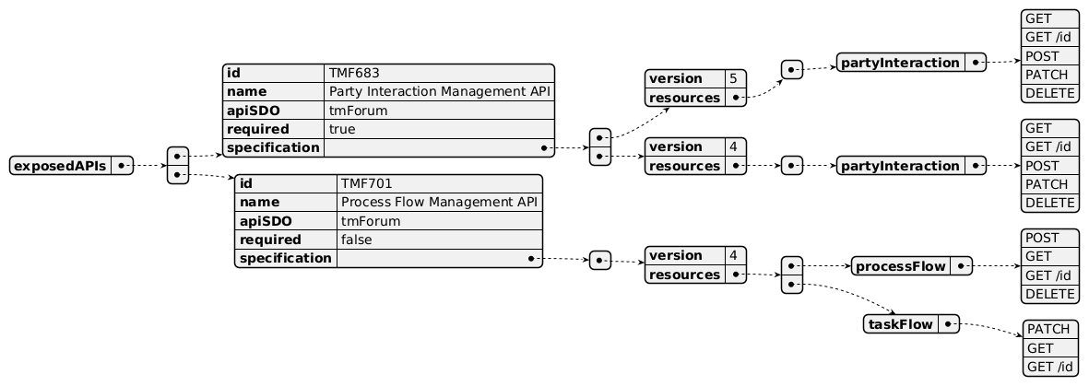
Exposed API diagram

Dependent APIs
API ID | API Name | API Version | Mandatory / Optional | Resource | Operations
TMF632 | Party Management API | 5 | Optional | individual  organization | GET  GET /id
TMF632 | Party Management API | 4 | Optional | individual  organization | GET  GET /id
TMF669 | Party Role Management API | 5 | Optional | partyRole | GET  GET /id
TMF669 | Party Role Management API | 4 | Optional | partyRole | GET  GET /id
TMF662 | Entity Catalog Management API | 4 | Optional | entitySpecification  entityCategory  entityCatalog  entityCatalogItem | GET  GET /id
TMF667 | Document Management API | 4 | Optional | document | GET  GET /id
TMF681 | Communication Management API | 4 | Optional | communicationMessage | GET  GET /id
TMF701 | Process Flow Management API | 4 | Optional | processFlow | POST  GET  GET /id  PATCH

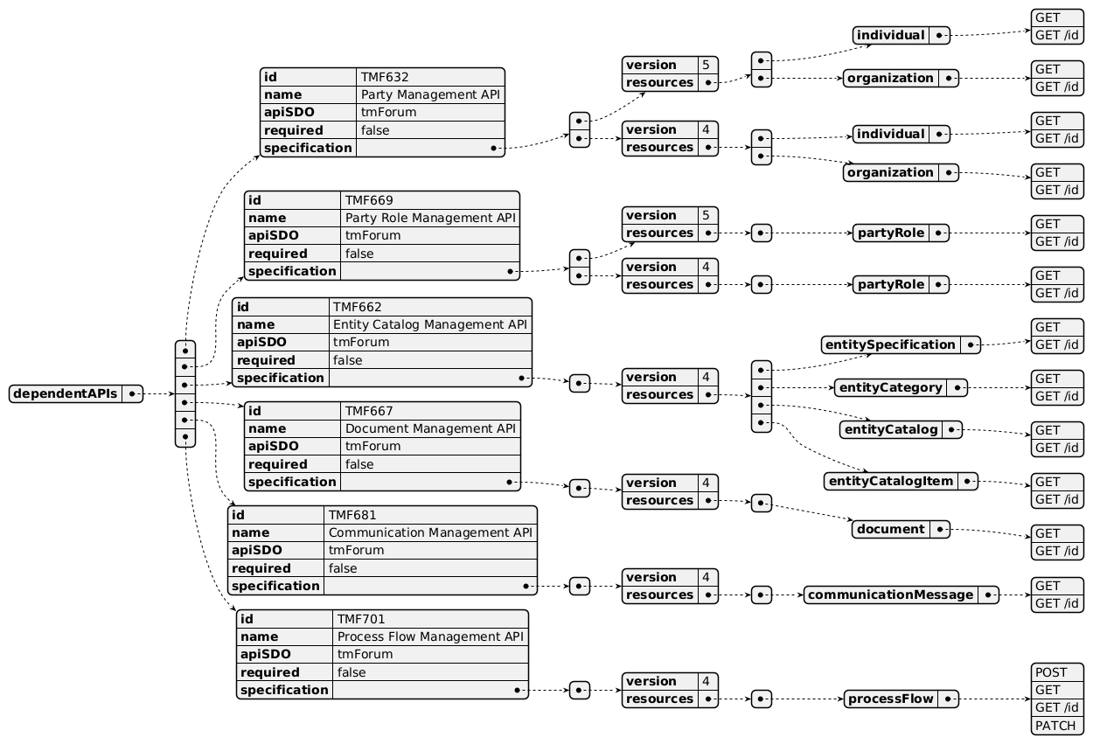
Dependent API diagram

Events
The diagram illustrates the Events which the component may publish and the Events that the component may subscribe to and then may receive. Both lists are derived from the APIs listed in the preceding sections.

Published Events
API ID | API Name | Event Resources
TMF683 | Party Interaction Management API | partyInteractionCreateEvent  partyInteractionAttributeValueChangeEvent  partyInteractionDeleteEvent  partyInteractionStatusChangeEvent
TMF701 | Process Flow Management API | processFlowCreateEvent  processFlowStateChangeEvent  processFlowStateDeleteEvent  processFlowStateAttributeValueChangeEvent  taskFlowCreateEvent  taskFlowStateChangeEvent  taskFlowDeleteEvent  taskFlowAttributeValueChangeEvent  taskFlowInformationRequiredEvent

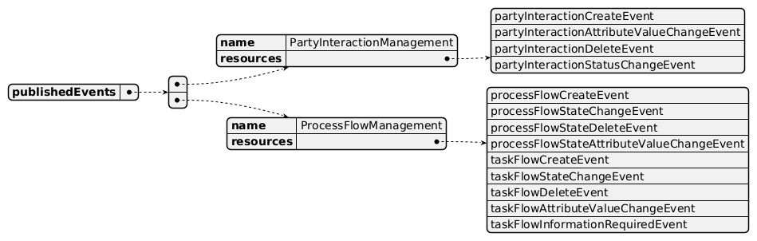
Published Events diagram

Subscribed Events
API ID | API Name | Event Resources
TMF632 | Party Management API | individualCreateEvent  individualAttributeValueChangeEvent  individualStateChangeEvent  individualDeleteEvent  organizationCreateEvent  organizationAttributeValueChangeEvent  organizationStateChangeEvent  organizationDeleteEvent
TMF669 | Party Role Management API | partyRoleCreateEvent
TMF667 | Document Management API | documentChangeEvent  documentSpecificationAttributeValueChangeEvent
TMF701 | Process Flow Management API | processFlowCreateEvent  processFlowStateChangeEvent  taskFlowCreateEvent  taskFlowStateChangeEvent

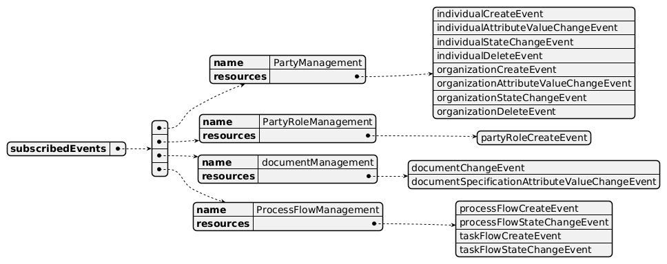
Subscribed Events diagram

Machine Readable Component Specification
Refer to the ODA Component Directory on the TM Forum website for the machine-readable component specification files for this component.

References

TMF Standards related versions
Standard | Version(s)
eTOM | v24.0
SID | v25.0
Functional Framework | v24.0

Jira References
N/A

Further resources
1. IG1228: please refer to IG1228 for defined use cases with ODA components interactions.

Administrative Appendix

Document History

Version History
Version Number | Date | Modified by | Description of changes
1.0.0 | 07-Dec-2022 | Goutham Babu | Final edits prior to publication
1.0.1 | 25-Jul-2023 | Ian Turkington | No content changed, simply a layout change to match template 3. Separated the YAML files to a managed repository.
1.0.1 | 15-Aug-2023 | Amaia White | Final edits prior to publication
1.1.0 | 16-Apr-2024 | Gaetano Biancardi | Component Template updated; Functional Framework: following functions reclassified for Level 2: 164, 168, 239
1.1.0 | 30-Apr-2024 | Amaia White | Final edits prior to publication
1.1.1 | 09-Jul-2025 | Rosie Wilson | Updates to description per agreed YAML updated on 03-Jun-2025
1.1.1 | 15-Jul-2025 | Rosie Wilson | Final edits prior to publication
1.1.2 | 21-Oct-2025 | Gaetano Biancardi | Updated to eTOM/SID/FF to 24.0; TMF688 removed from the specification (Core Functions - exposed and dependent), ODA canvas Operators offer its functions; TMF672 removed from the specification (Core Functions - dependent), ODA canvas Operators offer its functions
1.1.2 | 19-Nov-2025 | Rosie Wilson | Final edits prior to publication
1.2.0 | 05-Jun-2026 | Hugo Vaughan | Gen 5 API updates
1.2.0 | 24-Jun-2026 | Sannah Sibaya | Final edits prior to publication

Release History
Release Status | Date Modified | Modified by | Description of changes
Pre-production | 15-Aug-2023 | Amaia White | New version 1.0.1
Production | 06-Oct-2023 | Adrienne Walcott | Updated to reflect TM Forum Approved status
Pre-production | 30-Apr-2024 | Amaia White | New version 1.1.0
Production | 28-Jun-2024 | Adrienne Walcott | Updated to reflect TM Forum Approved status
Pre-production | 15-Jul-2025 | Rosie Wilson | New version 1.1.1
Production | 05-Sep-2025 | Adrienne Walcott | Updated to reflect TM Forum Approved status
Pre-production | 15-Jul-2025 | Rosie Wilson | New version 1.1.2
Production | 16-Jan-2026 | Adrienne Walcott | Updated to reflect TM Forum Approved status
Pre-production | 24-Jun-2026 | Sannah Sibaya | New version 1.2.0

Acknowledgements
This document was prepared by the members of the TM Forum ODA Components & Canvas team.
Team Member | Company | Role
Gaetano Biancardi | Accenture | Editor
Sylvie Demarest | Orange | Reviewer
Elisabeth Andersson | MATRIXX | Reviewer
Ian Turkington | TM Forum | Additional Input
Hugo Vaughan (TM Forum) | TM Forum | Additional Input
Abinash Vishwakarma | Netcracker | Reviewer
Jose Macaluso | Xacria | Reviewer
Kamal Maghsoudlou | Ericsson | Reviewer
Milind Bhagwat | BT | Reviewer
Ritu Arora | BT | Reviewer
Matteo Destino | Accenture | Reviewer
Julien Rouland | Orange | Reviewer

