TMFC024 Billing Account Management v2.2.1
Components and Canvas
In this deliverable:

Overview
Component Name | ID | Description | ODA Function Block
Billing Account Management | TMFC024 | The billing account management component aims to provide all the needed functionalities to create, configure and modify billing accounts. BAM component has the goal to support and handle the following capabilities/ functionalities. Set-up/ creation of Billing account. Associate payment plan(s), Associate payment method(s) - optional, Account taxes/ fees exception management, Define account associations, Provide account balance details, Set-up Billing contacts, Set-up Billing preferences (e.g., bill cycle frequency, invoice media type, invoice template option, etc.) | Party Management

eTOM Processes, SID Data Entities and Functional Framework Functions

eTOM business activities
eTOM business activities this ODA Component is responsible for:
Identifier | Level | Business Activity Name | Description
1.3.10 | L2 | Customer Bill Payments & Receivables Management | Ensure that enterprise revenue is collected through pre-established collection channels and put in place procedures to recover past due payments.
1.3.10.1 | L3 | Manage Customer Billing Account | Ensure effective management of the customer’s billing account as it relates to the products purchased and consumed throughout the appropriate billing cycle.

SID ABEs
SID ABEs this ODA Component is responsible for:
SID ABE Level 1 | SID ABE Level 2 (or set of BEs) | SID ABE L1 Definition | SID ABE L2 Definition
Customer Billing Account |  | The Customer Billing Account ABE groups the classes concerned with the CustomerBillingAccount, i.e. the billing structure, billing cycles. The Customer Billing Account receives all charges (recurring, one time charge and usage) of the ProductOfferingInstances and Products assigned to it. It is used to manage account and its balance information. Balance represents an amount, with some monetary value, usually an aggregation, that indicates an aspect of financial liability between the service provider and the customer. | *(no description available)*

eTOM L2 - SID ABEs links
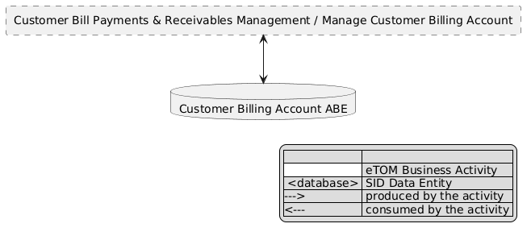
eTOM L2 - SID ABEs links diagram

Functional Framework Functions
Function ID | Function Name | Function Description | Aggregate Function Level 1 | Aggregate Function Level 2
77 | Billing Account Information Configuration | Billing Account Information Configuration updates specific billing account information such as customer bill periods, bill media options, etc. | Invoice Management | Billing Account Administration
73 | Billing Account Reporting | Billing Account Reporting; Grouping charges/statement/accounts for the purpose of creating a report | Invoice Management | Billing Account Administration
76 | Billing Account Structure Configuration | Billing Account Structure Configuration modifies billing accounts based on various account constructs. | Invoice Management | Billing Account Administration
75 | Billing Accounts Creation | Billing Accounts Creation provides the ability to create billing accounts based on various account constructs. Account creation can also be automated with orders received | Invoice Management | Billing Account Administration
248 | Customer Billing Hierarchies Management | Customer Billing Hierarchies Management provide an internet technology driven interface to undertake billing functions directly for management of hierarchies driven billing operations for e.g. corporate customers | Invoice Management | Billing Account Administration

TM Forum Open APIs & Events
The following part covers the APIs and Events; this part is split in 3:

List of Exposed APIs - This is the list of APIs available from this component.

List of Dependent APIs - In order to satisfy the provided API, the component could require the usage of this set of required APIs.

List of Events (generated & consumed) - The events which the component may generate are listed in this section along with a list of the events which it may consume. Since there is a possibility of multiple sources and receivers for each defined event.

API Context Diagram
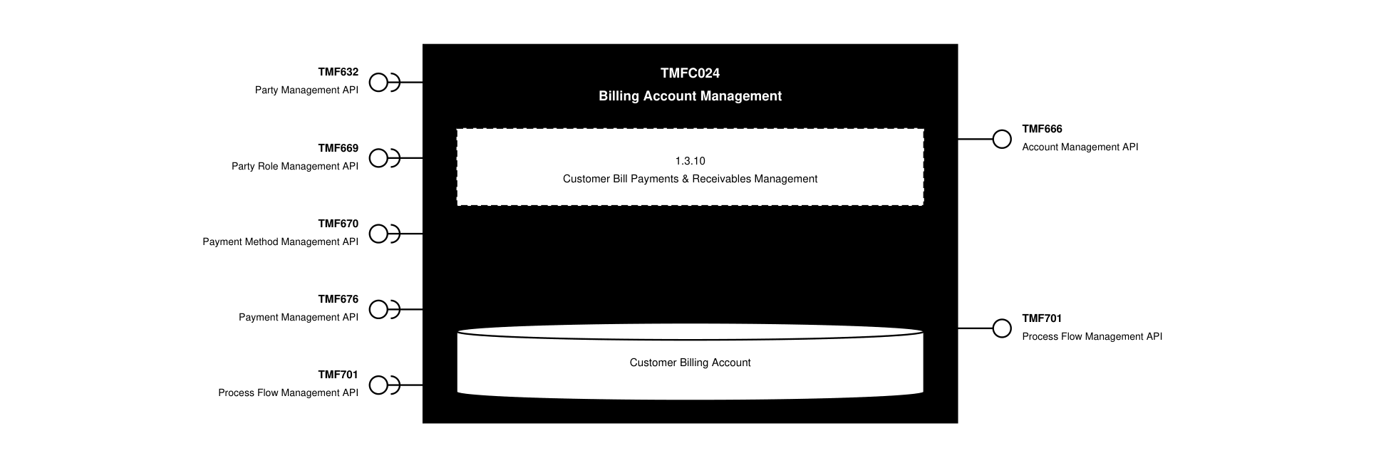
API Context diagram

Exposed APIs
API ID | API Name | Mandatory / Optional | API Version | Resource | Operations
TMF666 | Account Management API | Mandatory | 5 | billFormat  billPresentationMedia  billingAccount  billingCycleSpecification | GET  GET /id  POST  PATCH /id  DELETE /id
TMF666 | Account Management API | Mandatory | 4 | billingAccount  billingCycleSpecification  billFormat  billPresentationMedia | GET  GET /id  POST  PATCH /id  DELETE /id
TMF701 | Process Flow Management API | Optional | 4 | processFlow  taskFlow | GET  GET /id  POST  DELETE /id  PATCH /id

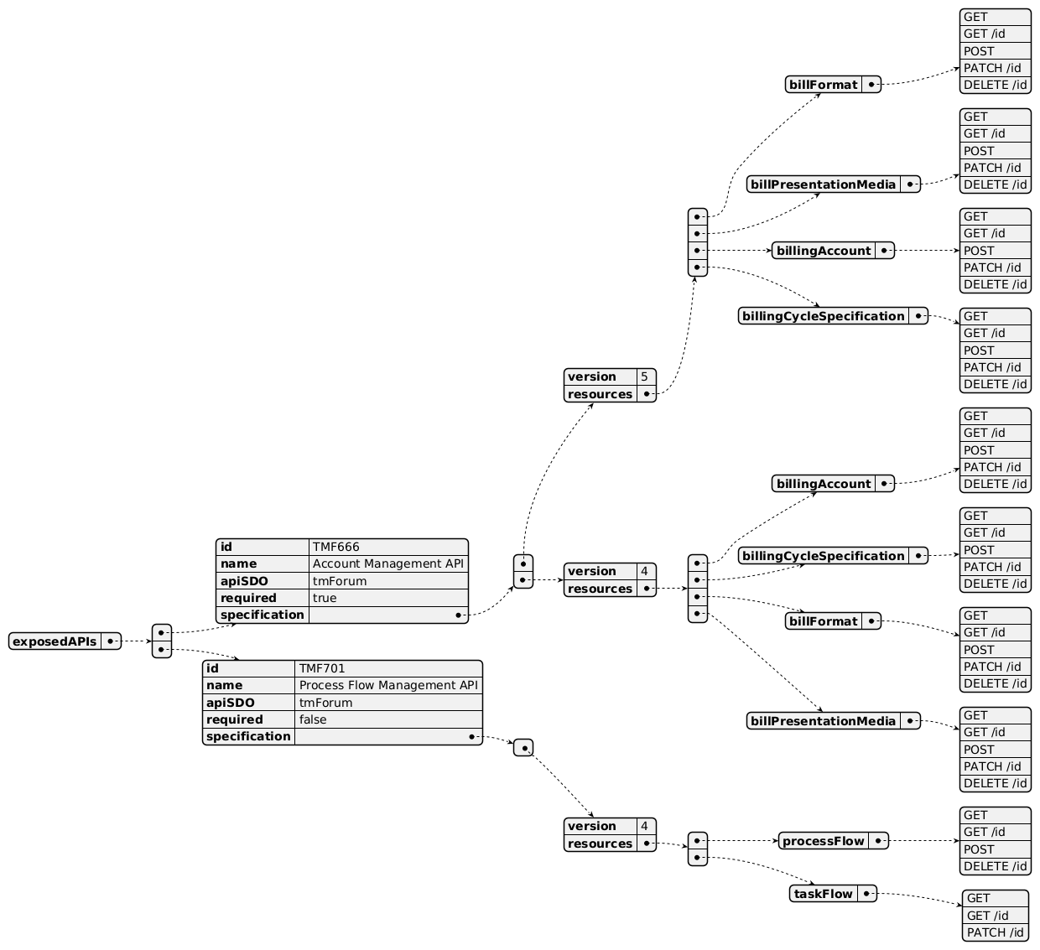
Exposed API diagram

Dependent APIs
API ID | API Name | API Version | Mandatory / Optional | Resource | Operations
TMF632 | Party Management API | 5 | Mandatory | individual  organization | GET  GET /id
TMF632 | Party Management API | 4 | Mandatory | individual  organization | GET  GET /id
TMF669 | Party Role Management API | 5 | Mandatory | partyRole | GET  GET /id
TMF669 | Party Role Management API | 4 | Mandatory | PartyRole | GET  GET /id
TMF670 | Payment Method Management API | 4 | Optional | paymentMethod | GET  GET /id
TMF676 | Payment Management API | 4 | Optional | payment | GET  GET /id
TMF701 | Process Flow Management API | 4 | Optional | processFlow | POST  GET  GET /id  PATCH

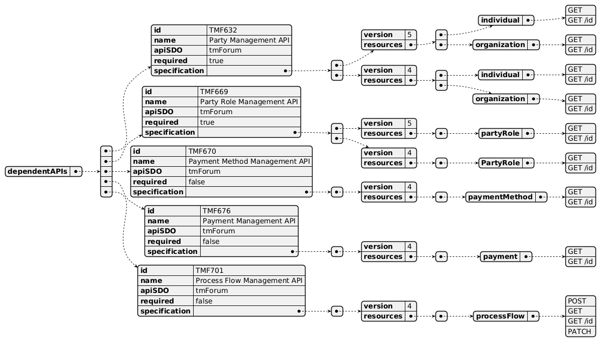
Dependent API diagram

Events
The diagram illustrates the Events which the component may publish and the Events that the component may subscribe to and then may receive. Both lists are derived from the APIs listed in the preceding sections.

Published Events
API ID | API Name | Event Resources
TMF666 | Account Management API | billingAccountAttributeValueChangeEvent  billingAccountStateChangeEvent

Published Events diagram

Subscribed Events
API ID | API Name | Event Resources
TMF669 | Party Role Management API | partyRoleCreateEvent  partyRoleAttributeValueChangeEvent  partyRoleStateChangeEvent  partyRoleDeleteEvent

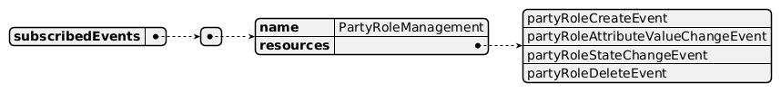
Subscribed Events diagram

Machine Readable Component Specification
Refer to the ODA Component Directory on the TM Forum website for the machine-readable component specification files for this component.

References

TMF Standards related versions
Standard | Version(s)
eTOM | v23.0
SID | v25.0
Functional Framework | v23.0

Jira References
N/A

Further resources
1. IG1228: please refer to IG1228 for defined use cases with ODA components interactions.

TAC-123 - TMFC024 Billing Account Management v1.0.0 (Done, resolved 09-Dec-2022, reporter Gaetano Biancardi, assignee Matteo Destino)

Administrative Appendix

Document History

Version History
Version Number | Date | Modified by | Description of changes
1.0.0 | 07-Dec-2022 | Matteo Destino | Final edits prior to publication
1.1.0 | 28-Mar-2023 | Gaetano Biancardi, Sylvie Demarest | Alignment to ODF 22.5; minor changes on dependent APIs and events
1.1.1 | 25-Jul-2023 | Ian Turkington | No content changed, simply a layout change to match template 3. Separated the YAML files to a managed repository.
1.1.1 | 15-Aug-2023 | Amaia White | Final edits prior to publication
2.0.0 | 16-Apr-2024 | Gaetano Biancardi | eTOM: "Customer Bill Payments & Receivables Management" business activity L2 renamed into "Customer Receivables Management"; machine readable specification corrected to set dependent API TMF670 and TMF676 as optional
2.0.0 | 30-Apr-2024 | Amaia White | Final edits prior to publication
2.1.0 | 18-Nov-2024 | Gaetano Biancardi | TMF688 removed from the core specification, moved to supporting functions; TMF672 removed from the core specification, moved to supporting functions; API version, only major version to be specified
2.1.0 | 24-Dec-2024 | Rosie Wilson | Final edits prior to publication
2.1.1 | 19-Nov-2025 | Rosie Wilson | Description updated; final edits prior to publication
2.2.1 | 26-Jun-2026 | Sannah Sibaya | Final edits prior to publication

Release History
Release Status | Date Modified | Modified by | Description of changes
Pre-production | 07-Dec-2022 | Matteo Destino | Initial release of document
Pre-production | 13-Apr-2023 | Amaia White | Final edits prior to publication
Pre-production | 15-May-2023 | Adrienne Walcott | Updated to Member Evaluated status
Pre-production | 15-Aug-2023 | Amaia White | Final edits prior to publication
Pre-production | 30-Apr-2024 | Amaia White | Final edits prior to publication
Production | 28-Jun-2024 | Adrienne Walcott | Updated to reflect TM Forum Approved status
Pre-production | 24-Dec-2024 | Rosie Wilson | Final edits prior to publication of 2.1.0
Production | 07-Mar-2025 | Adrienne Walcott | Updated to reflect TM Forum Approved status
Pre-production | 19-Nov-2025 | Rosie Wilson | Final edits prior to publication of 2.1.1
Pre-production | 26-Jun-2026 | Sannah Sibaya | Final edits prior to publication

Acknowledgements
This document was prepared by the members of the TM Forum ODA Components & Canvas team.
Team Member | Company | Role
Matteo Destino | Accenture | Editor
Gaetano Biancardi | Accenture | Reviewer
Sylvie Demarest | Orange | Reviewer
Ian Turkington | TM Forum | Additional Input
Hugo Vaughan (TM Forum) | TM Forum | Additional Input
Rosie Wilson | TM Forum | Additional Input
Julien Rouland | Orange | Reviewer
Elisabeth Andersson | MATRIXX | Reviewer

