TMFC027 Product Configurator v2.2.1
Components and Canvas
In this deliverable:

Overview
Component Name | ID | Description | ODA Function Block
Product Configurator | TMFC027 | The Product Configurator component empowers sales by offering the right product combinations, controlling discounting, and automating approvals through support of configuration, pricing and quote generation activities. | Core Commerce

eTOM Processes, SID Data Entities and Functional Framework Functions

eTOM business activities
eTOM business activities this ODA Component is responsible for:
Identifier | Level | Business Activity Name | Description
1.2.5 | L2 | Product Configuration Management | Configuration Management configures or creates a new version of a configuration for an entity, such as a product, as defined by a configuration specification. This process also modifies a configuration and values for configuration parameters, and removes a configuration.
1.2.5.2 | L3 | Manage Product Configuration | Manage Product Configuration business activity is in charge of creating, maintaining, controlling, changing and reporting Product Configuration according to Product Configuration Plans. / Manage Product Configuration will establish and maintaining consistency of a product's performance, functional, and physical attributes within the limits defined by product requirements, product design, and operational information throughout the Products Lifecycle.

SID ABEs
SID ABEs this ODA Component is responsible for:
SID ABE Level 1 | SID ABE Level 2 (or set of BEs) | SID ABE L1 Definition | SID ABE L2 Definition
Product Configuration | ProductConfiguration | A Product Configuration (also referred to as a Product Profile) defines how a Product operates or functions. / A Product Configuration may contain one or more parts, and each part may contain zero or more fields. Each field may have attributes that are statically or dynamically defined. Some of these fields have fixed values, while others provide values from which a choice or choices can be made (e.g. using the EntitySpec/Entity and/or CharacteristicSpec/CharacteristicValue patterns) 1 | A representation of how a Product operates or functions in terms of characteristics and related Resource(s), Product(s), Service(s).

eTOM L2 - SID ABEs links
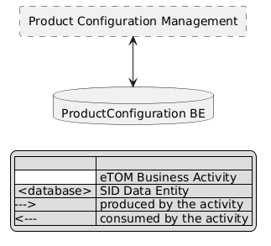
eTOM L2 - SID ABEs links diagram

Functional Framework Functions
Function ID | Function Name | Function Description | Aggregate Function Level 1 | Aggregate Function Level 2
55 | Price & Discount Calculation | Price and Discount Calculation applies pricing and discounting rules and algorithms in the context of the assembled information concerning Products (i.e. instances of Product). | Rating and Follow up | Tariff Calculation and Rating
182 | Inter Product Dependency Identification | Inter-Product Dependency Identification identifies product dependencies, binds new order to purchased product or point to the dependent product required | Product Configuration & Activation | Offer and Product Configuration
205 | Customer Order Eligibility Validation | Customer Order Eligibility Validation function validates that the Offer & products specified on the Customer Order, are eligible from a commercial and functional point of view. / It includes: / • Commercial Eligibility with commercial compatibility with the already customer installed Offers / • Functional Eligibility with the customer's already installed Products (corresponding to ProductSpecification). | Customer Order Management | Customer Order Eligibility Validation
207 | Offer and Product Configuration | The Offer and Product Configuration function enables the configuration of the commercial offer chosen by the customer. / The configuration recovers the choice of an option, the choice of the characteristics values for the Product Specification including installation preferences... / It can be based on product configurator using a rule engine. / It can be used at the same time by Selling, Order Establishment or Develop Sales Proposal Business activities. | Product Configuration & Activation | Offer and Product Configuration
262 | Product Availability Checking 1 | Product Availability Checking function provide an internet technology driven interface for the customer to undertake a product availability check. / E.g., that the product offering is active for sales, the equipment(s) specified in the customer order are on stock. | Customer Order Management | Customer Order Eligibility Validation
274 | Quote Price Support Access | Quote Price Support Access provides self empowered fulfillment function to provide an internet technology driven interface for the customer to get a Quotation price. | Fulfillment Integration Management | Customer Fulfillment Access Management
278 | Customer SLA Preferences Capturing | Customer SLA Preferences Capturing captures the customer's SLA preferences e.g., as part of the fulfillment. | Product Configuration & Activation | Offer and Product Configuration
300 | Discount Calculation | Discounts Calculation determines charge discounts based on pricing plan; including discounts on recurring, one time, and usage charges. / Discounts may be applied at different levels such as cross product, cross location, or cross customer (all customers that are part of a given group plan – some affiliation). The discounts can be apportioned across multiple events. | Rating and Follow up | Tariff Calculation and Rating
320 | Customer Product Proposal Creation | Customer Product Proposal Creation proposes according to what the customer presently has as part of what can be further provided to the customer including bundling, product proposals, etc. | Product Configuration & Activation | Offer and Product Configuration
379 | Product Customization Offering Management | Product Customization Offering Management provides the necessary functionality to manage the customer personalized proposals, taking into account the customer location, needs, current products, as well as the service provider's products, sales emphasis and targets, etc. | Sales Management | Opportunity Management
727 | Product Offer to Customer Verification 2 | Product Offer to Customer Verification enables and verifies the configuration of the commercial offer chosen by the customer. / The configuration consist of technical, functional, and commercial prerequisites and preferences. | Customer Order Management | Customer Order Eligibility Validation
928 | Solution Design Creation | Solution Design Creation function combine/configure the emerged solution based on the existing solution, planned changes and newly designed features (e.g., for site connectivity services) / Selecting relevant Products and Services from Catalog – Browse and select entries from a catalog that might be relevant to the set of captured requirements into the design. | Sales Management | Opportunity Management
930 | Automatic Solution Validation | Obtains configuration constraints from the catalog and validates the correctness of the design against them. | Sales Management | Opportunity Management
931 | Solution Pricing | The Solution Pricing function is concerned with assuring that the designs are priced consistent with pricing used for billing. The common product catalog provides an initial price base for the components that are in the solution vs. the existing configuration at the customer location. | Sales Management | Opportunity Management
932 | Calculation Rules Retrieval | Calculation Rules Retrieval function gives support for tariffication rules including discounting rules. / It supports that discounting rules and guidelines are provided as to standard levels of discounts/promotions that can be provided to the customer. Special discount arrangements can be obtained by following an escalation process. There is workflow functionality to help manage discount escalation. | Sales Management | Opportunity Management
933 | Price/Cost Optimization | Price Optimization enables sales to effectively evaluate the customer, generate recommendations for price decreases and increases, and set negotiation guidelines based on our cost. This includes the application of non-standard pricing. | Sales Management | Opportunity Management

TM Forum Open APIs & Events
The following part covers the APIs and Events; this part is split in 3:

List of Exposed APIs - This is the list of APIs available from this component.

List of Dependent APIs - In order to satisfy the provided API, the component could require the usage of this set of required APIs.

List of Events (generated & consumed) - The events which the component may generate are listed in this section along with a list of the events which it may consume. Since there is a possibility of multiple sources and receivers for each defined event.

API Context Diagram
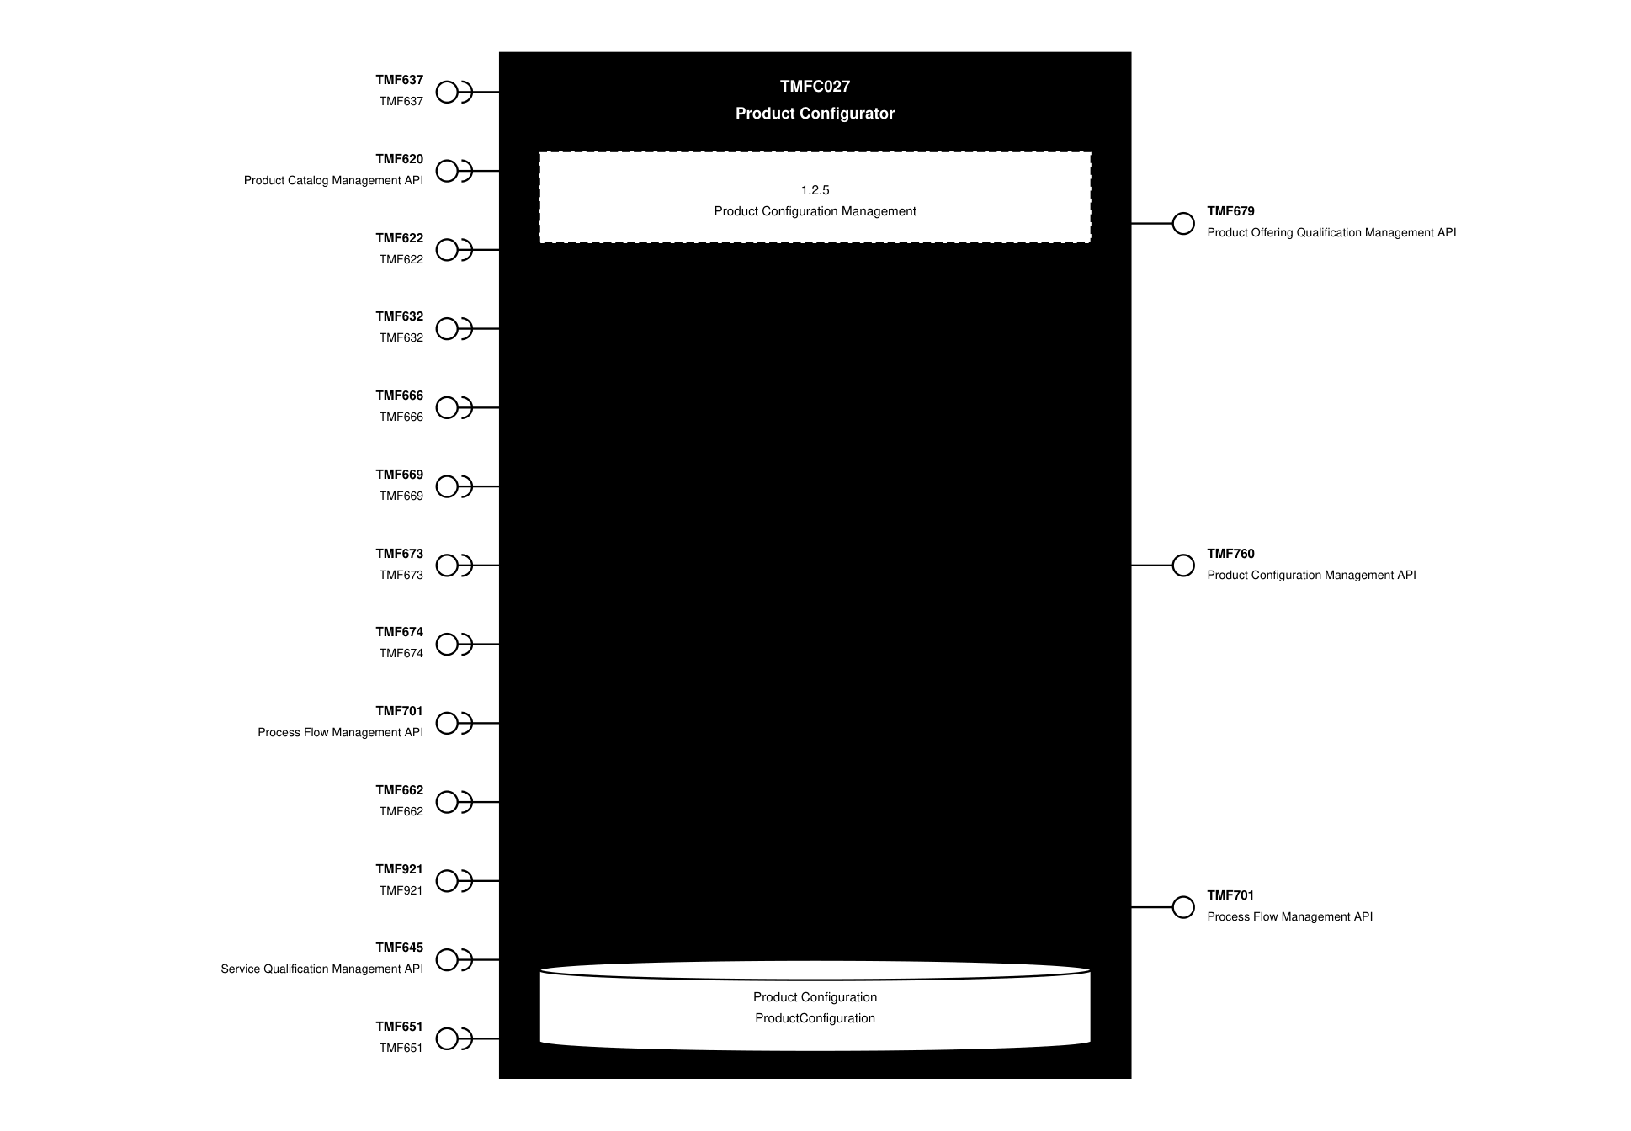
API Context diagram

Exposed APIs
API ID | API Name | Mandatory / Optional | API Version | Resource | Operations
TMF679 | Product Offering Qualification Management API | Mandatory | 4 | productOfferingQualification | GET  GET /id  POST  PATCH /id  DELETE
TMF760 | Product Configuration Management API | Mandatory | 5 | checkProductConfiguration  queryProductConfiguration | GET  POST
TMF701 | Process Flow Management API | Optional | 4 | processFlow  taskFlow | POST  GET  GET /id  DELETE  get /id  PATCH

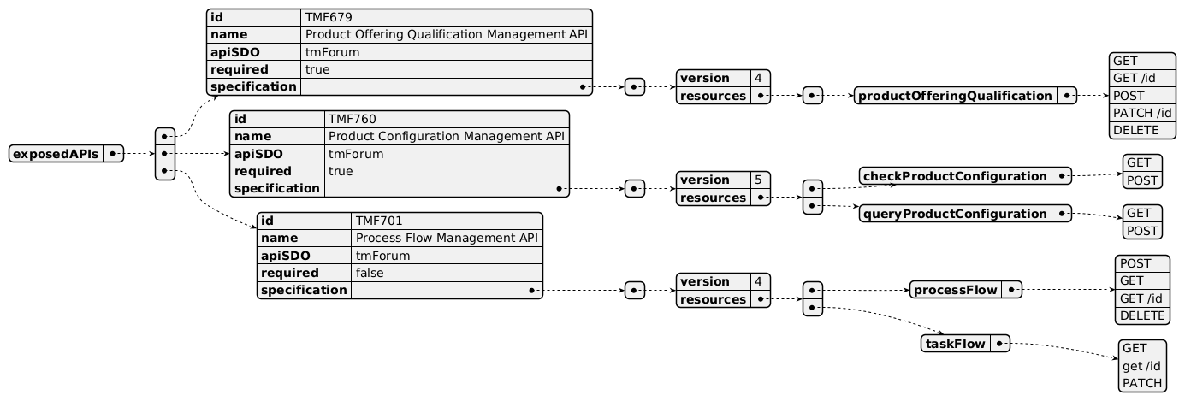
Exposed API diagram

Dependent APIs
API ID | API Name | API Version | Mandatory / Optional | Resource | Operations
TMF637 | TMF637 | 5 | Mandatory | product | GET  GET /id
TMF637 | TMF637 | 4 | Mandatory | product | GET  GET /id
TMF620 | Product Catalog Management API | 5 | Mandatory | productCatalog  category  productOffering  productOfferingPrice  productSpecification | GET  GET /id
TMF620 | Product Catalog Management API | 4 | Mandatory | catalog  category  productOffering  productOfferingPrice  productSpecification | GET  GET /id
TMF622 | TMF622 | 5 | Mandatory | productOrder | GET  GET /id
TMF622 | TMF622 | 4 | Mandatory | productOrder | GET  GET /id
TMF632 | TMF632 | 5 | Optional | individual  organization | GET  GET /id
TMF632 | TMF632 | 4 | Optional | individual  organization | GET  GET /id
TMF666 | TMF666 | 5 | Optional | billingAccount | GET  GET /id
TMF666 | TMF666 | 4 | Optional | billingAccount | GET  GET /id
TMF669 | TMF669 | 5 | Optional | partyRole | GET  GET /id
TMF669 | TMF669 | 4 | Optional | partyRole | GET  GET /id
TMF673 | TMF673 | 4 | Optional | geographicAddress  geographicSubAddress | GET  GET /id
TMF674 | TMF674 | 4 | Optional | geographicSite | GET  GET /id
TMF701 | Process Flow Management API | 4 | Optional | processFlow  taskFlow | POST  GET  GET /id  DELETE  PATCH
TMF662 | TMF662 | 4 | Optional | entityCatalog | GET  GET /id
TMF921 | TMF921 | 5 | Optional | intent | GET  GET /id
TMF921 | TMF921 | 4 | Optional | intent | GET  GET /id
TMF645 | Service Qualification Management API | 5 | Optional | checkServiceQualification  queryServiceQualification | GET  GET /id  POST  PATCH
TMF645 | Service Qualification Management API | 4 | Optional | checkServiceQualification  queryServiceQualification | GET  GET /id  POST  PATCH
TMF651 | TMF651 | 4 | Optional | agreement | GET  GET /id

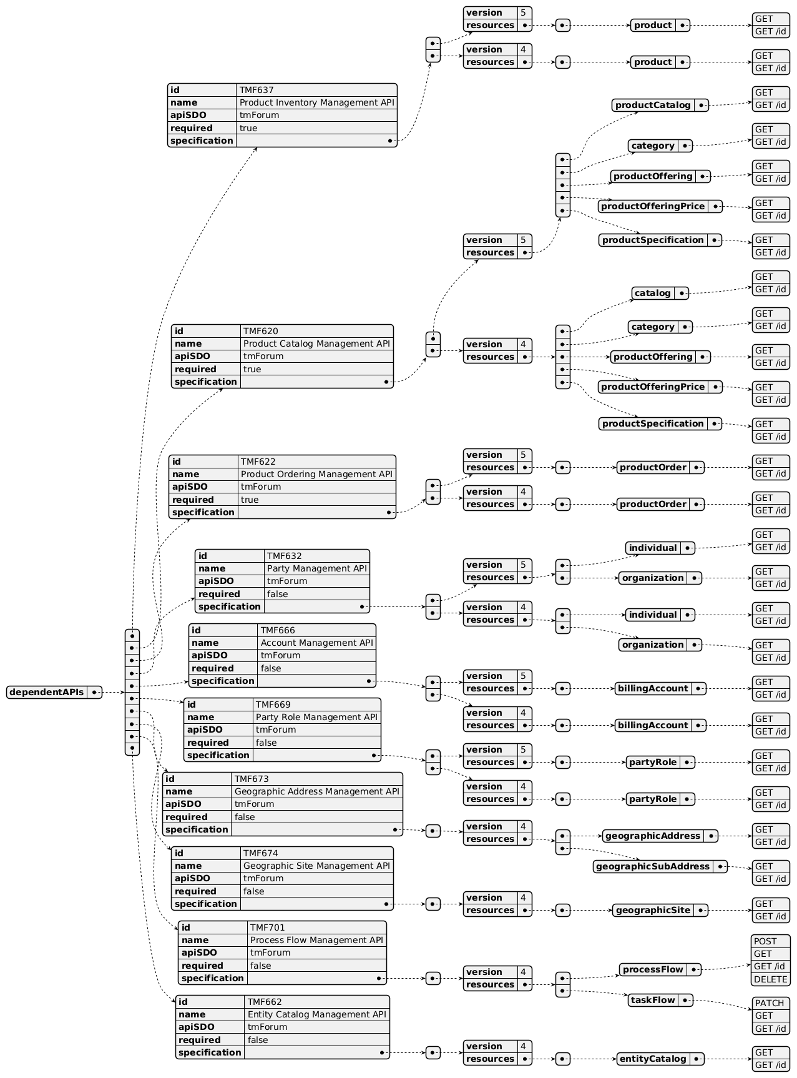
Dependent API diagram (1 of 2)
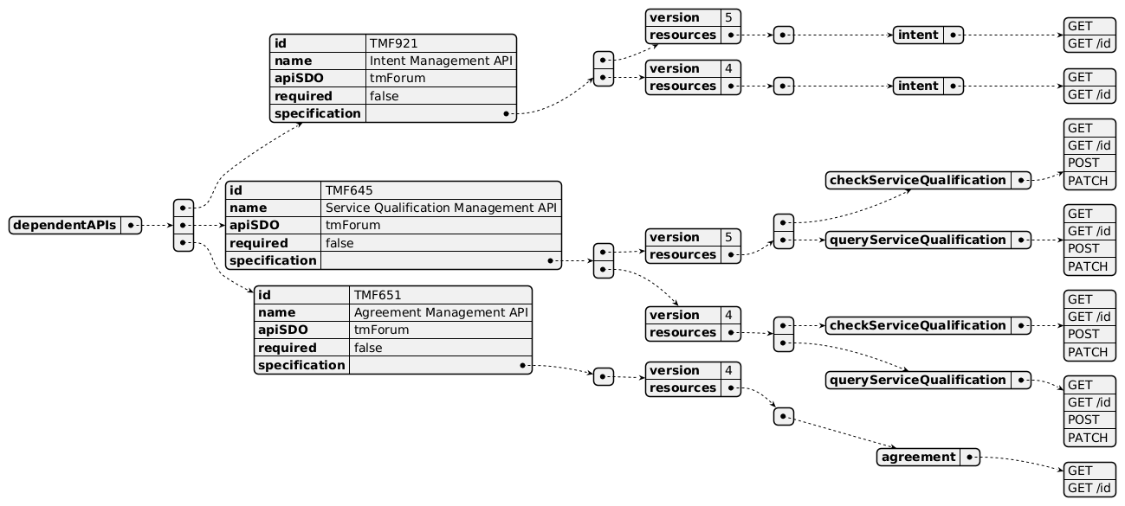
Dependent API diagram (2 of 2)

Events
The diagram illustrates the Events which the component may publish and the Events that the component may subscribe to and then may receive. Both lists are derived from the APIs listed in the preceding sections.

Published Events
API ID | API Name | Event Resources
TMF760 | Product Configuration Management API | checkProductConfigurationAttributeValueChangeEvent  checkProductConfigurationCreateEvent  checkProductConfigurationDeleteEvent  checkProductConfigurationStateChangeEvent  queryProductConfigurationAttributeValueChangeEvent  queryProductConfigurationCreateEvent  queryProductConfigurationDeleteEvent  queryProductConfigurationStateChangeEvent
TMF679 | Product Offering Qualification Management API | ProductOfferingQualificationCreateEvent  ProductOfferingQualificationAttributeValueChangeEvent  ProductOfferingQualificationStateChangeEvent  ProductOfferingQualificationDeleteEvent  ProductOfferingQualificationInformationRequiredEvent

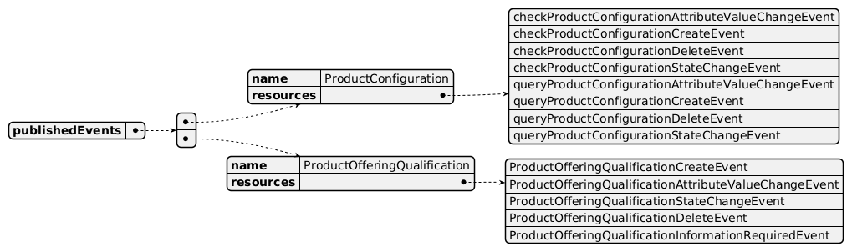
Published Events diagram

Subscribed Events
API ID | API Name | Event Resources
TMF620 | Product Catalog Management API | CatalogCreateEvent  CatalogAttributeValueChangeEvent  CatalogStateChangeEvent  ProductOfferingCreateEvent  ProductOfferingAttributeValueChangeEvent  ProductOfferingStateChangeEvent  ProductOfferingDeleteEvent  ProductOfferingPriceCreateEvent  ProductOfferingPriceAttributeValueChangeEvent  ProductOfferingPriceStateChangeEvent  ProductOfferingPriceDeleteEvent  ProductSpecificationCreateEvent  ProductSpecificationAttributeValueChangeEvent  ProductSpecificationStateChangeEvent  ProductSpecificationDeleteEvent
TMF645 | Service Qualification Management API | checkServiceQualificationStateChangeEvent  queryServiceQualificationStateChangeEvent

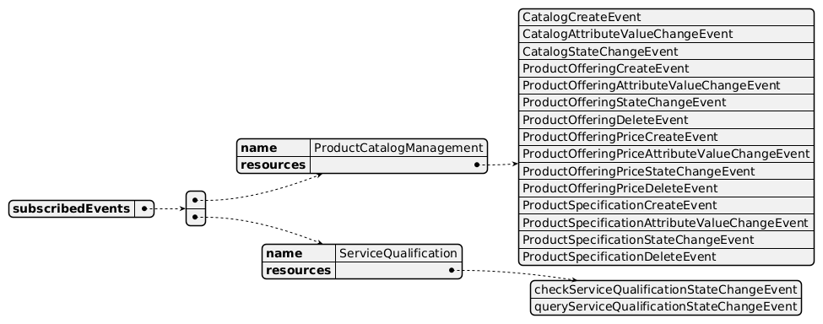
Subscribed Events diagram

Machine Readable Component Specification
Refer to the ODA Component Directory on the TM Forum website for the machine-readable component specification files for this component.

References

TMF Standards related versions
Standard | Version(s)
eTOM | v25.0
SID | v25.0
Functional Framework | v25.0

Jira References
No open Jira issues currently listed for this component.

Further resources
1. IG1228: please refer to IG1228 for defined use cases with ODA components interactions. 2. TAC-246 - Some Missing Dependent APIs (BACKLOG)

Administrative Appendix

Document History

Version History
Version Number | Date | Modified by | Description of changes
1.0.0 | 29-Mar-2022 | Gaetano Biancardi, Anastasios Sarantis, Sylvie Demarest | Final edits prior to publication
1.0.1 | 27-Jul-2023 | Ian Turkington | No content changed, simply a layout change to match template 3. Separated the YAML files to a managed repository.
1.0.1 | 15-Aug-2023 | Amaia White | Final edits prior to publication
2.0.0 | 10-Nov-2023 | Sylvie Demarest | Added TMF760 Product Configuration as exposed API; checked dependent APIs; improved the component description; updated the mapping to Frameworks 23.0
2.1.0 | 24-Jun-2024 | Gaetano Biancardi | Updated to latest component template; exposed API removed: TMF688 Event Mgmt, TMF672 User Roles and Permissions; dependent API removed: TMF688 Event Mgmt
2.1.1 | 18-Nov-2024 | Gaetano Biancardi | API version, only major version to be specified
2.1.1 | 27-Dec-2024 | Rosie Wilson | Final edits prior to publication
2.1.2 | 15-Sep-2025 | Rosie Wilson | Updates to description per agreed YAML updated on 03-Jun-2025; final administrative updates prior to publication
2.2.0 | 10-Mar-2026 | Gaetano Biancardi | Updated dependent APIs, added: TMF651 Agreement Mgmt, TMF645 Service Qualification Mgmt
2.2.0 | 24-Mar-2026 | Elisabeth Andersson | Updated description to clarify that the component is not responsible for quote generation itself but provides input; removed annotation #2 under Functional Framework as this component now takes responsibility for technical qualification checks
2.2.0 | 28-Mar-2026 | Amaia White | Final edits before publication
2.2.1 | 05-Jun-2026 | Hugo Vaughan (TM Forum) | Gen 5 APIs added
2.2.1 | 26-Jun-2026 | Sannah Sibaya | Final edits prior to publication

Release History
Release Status | Date Modified | Modified by | Description of changes
Pre-production | 29-Mar-2022 | Goutham Babu | Initial release
Pre-production | 15-Aug-2023 | Amaia White | New release 1.0.1
Production | 06-Oct-2023 | Adrienne Walcott | Updated to reflect TM Forum Approved status
Pre-production | 20-Dec-2023 | Amaia White | New release 2.0.0
Production | 09-Feb-2024 | Adrienne Walcott | Updated to reflect TM Forum Approved status
Pre-production | 12-Jul-2024 | Amaia White | New release 2.1.0
Production | 30-Aug-2024 | Adrienne Walcott | Updated to reflect TM Forum Approved status
Pre-production | 27-Dec-2024 | Rosie Wilson | New release 2.1.1
Production | 07-Mar-2025 | Adrienne Walcott | Updated to reflect TM Forum Approved status
Pre-production | 15-Sep-2025 | Rosie Wilson | New release 2.1.2
Production | 14-Nov-2025 | Adrienne Walcott | Updated to reflect TM Forum Approved status
Pre-production | 28-Mar-2026 | Amaia White | New release 2.2.0
Pre-production | 26-Jun-2026 | Sannah Sibaya | Final edits prior to publishing

Acknowledgements
This document was prepared by the members of the TM Forum Component and Canvas project team.
Team Member | Company | Role
Gaetano Biancardi | Accenture | Editor
Anastasios Sarantis | Vodafone | Reviewer
Matteo Destino | Accenture | Reviewer
Emmanuel A. Otchere | Huawei | Reviewer
Ian Turkington | TM Forum | Additional Input
Hugo Vaughan (TM Forum) | TM Forum | Additional Input
Abinash Vishwakarma | Netcracker | Reviewer
Elisabeth Andersson | MATRIXX | Reviewer
Kamal Maghsoudlou | Ericsson | Reviewer
Jose Macaluso | Xacria | Reviewer
Milind Bhagwat | BT | Reviewer
Ritu Arora | BT | Reviewer

