TMFC028 Party Management v2.2.0
Components and Canvas
In this deliverable:

Overview
Component Name | ID | Description | ODA Function Block
Party Management | TMFC028 | The Party Management component is responsible for the capture, validation and management of Parties. A Party may be an individual or organization that has a relationship with an enterprise. In this context it is responsible for the end-to-end lifecycle of: Individual, Organization and its related sub-entities, Contact Medium, Currency and tax exemption certificates, Identification, and Community. | Party Management

eTOM Processes, SID Data Entities and Functional Framework Functions

eTOM business activities
eTOM business activities this ODA Component is responsible for:
Identifier | Level | Business Activity Name | Description
1.3.16 | L2 | Customer Inventory Management | Establish, manage, and administer the enterprise's customer inventory, as embodied in the Customer Inventory Database, and monitor and report on the usage and access to the customer inventory, and the quality of the data maintained in it. / Note: validate if the "Customer Inventory Shortcomings" (L3) should be into the scope of this component.
1.3.6 | L2 | Customer Information Management | Manage customer information after customer contracts or associated service orders have been finalized and during the order completion phase. Ensure that any customer information required by other CRM processes is updated as part of the customer order completion. / Note: validate with eTOM team why CIM is an L2 and not an L3 of Customer Inventory Mgmt.
1.3.4 | L2 | Customer Relationship Management | Manage the relationship of the Customer and the enterprise.
1.3.4.2 | L3 | Establish Customer Relationship | Verify the customer identity and manage the customer identity across the Enterprise.
1.3.4.3 | L3 | Re-establish Customer Relationship | Re-establish customer relationship.
1.3.4.4 | L3 | Terminate Customer Relationship | Manage termination as appropriate
1.6.3 | L2 | Party Relationship Development & Retirement | Manage the lifecycles of parties with whom the enterprise has a relationship. Relationship with new parties may be required to broaden the services an enterprise offers, to improve performance, for outsourcing and out-tasking requirements, and so forth.
1.6.3.1 | L3 | Party Relationship Management | Support the lifecycles (development and retirement) of an enterprise's relationships with parties.
1.6.3.1.5 | L4 | Collect Party data | Collect data about a Party and/or a Party playing a role. Data includes basic Party data, identification data, contact data, and additional attributes.
1.6.21 | L2 | Party Inventory Management | Manage the administration of the enterprise's Party inventory.
1.7.7 | L2 | Human Resources Management | The Human Resources Management process grouping provides the human resources infrastructure for the people resources that the enterprise uses to fulfil its objectives.
1.7.7.2 | L3 | Develop the Workforce | Support the definition of the organization of the enterprise and coordinate its reorganizations.

SID ABEs
SID ABEs this ODA Component is responsible for:
SID ABE Level 1 | SID ABE Level 2 (or set of BEs) | SID ABE L1 Definition | SID ABE L2 Definition
Party | Party | The Party ABE enables defining an individual, an organization, or an organization unit that is of interest, involved or that provides value directly or indirectly from an enterprise perspective (Enterprise is to be understood here as provider, service provider or operator). Hence the Party plays one or more roles with the enterprise or with another Party playing a role with the enterprise (indirectly). This is introduced to specify that the only party an enterprise would be interested in and will consider in its systems is a party playing a role (directly or indirectly). Roles would be represented by the PartyRole concept. Additional roles will be defined to cover the needs of the new digital ecosystem." Examples of roles played by Parties include those: Of interest, such as competitors, sales prospects Involved, such as customers, users, employees That provides value directly or indirectly, such as service providers, operators, cloud brokers, infrastructure providers, application developers. This Party ABE defines information about companies and people. Implementations of this model are responsible for ensuring that the relevant privacy legislation standards are adhered to in the countries that will use the implementation. | Represents an individual, organization or organization unit.Party is an abstract concept that should be used in places where the business says something can be an organization , organization unit or an individual
Party | Contact Medium | The Party ABE enables defining an individual, an organization, or an organization unit that is of interest, involved or that provides value directly or indirectly from an enterprise perspective (Enterprise is to be understood here as provider, service provider or operator). Hence the Party plays one or more roles with the enterprise or with another Party playing a role with the enterprise (indirectly). This is introduced to specify that the only party an enterprise would be interested in and will consider in its systems is a party playing a role (directly or indirectly). Roles would be represented by the PartyRole concept. Additional roles will be defined to cover the needs of the new digital ecosystem." Examples of roles played by Parties include those: Of interest, such as competitors, sales prospects Involved, such as customers, users, employees That provides value directly or indirectly, such as service providers, operators, cloud brokers, infrastructure providers, application developers. This Party ABE defines information about companies and people. Implementations of this model are responsible for ensuring that the relevant privacy legislation standards are adhered to in the countries that will use the implementation. | The Contact Medium ABE describes various means by which a PartyRole or PartyAccount/BillingAccountContact can be reached, such as by telephone, fax, email.
Party | TaxExemptionCertificate | The Party ABE enables defining an individual, an organization, or an organization unit that is of interest, involved or that provides value directly or indirectly from an enterprise perspective (Enterprise is to be understood here as provider, service provider or operator). Hence the Party plays one or more roles with the enterprise or with another Party playing a role with the enterprise (indirectly). This is introduced to specify that the only party an enterprise would be interested in and will consider in its systems is a party playing a role (directly or indirectly). Roles would be represented by the PartyRole concept. Additional roles will be defined to cover the needs of the new digital ecosystem." Examples of roles played by Parties include those: Of interest, such as competitors, sales prospects Involved, such as customers, users, employees That provides value directly or indirectly, such as service providers, operators, cloud brokers, infrastructure providers, application developers. This Party ABE defines information about companies and people. Implementations of this model are responsible for ensuring that the relevant privacy legislation standards are adhered to in the countries that will use the implementation. | The certificate describing an exemption from tax (partial or complete) granted for a party and/or a place. Examples include: - Party-based - Individual might be exempt due to health or other personal situation - Organization might be exempt due to its business (e.g. a charity, or government) - Location-based - A City might have a global exemption from purchase tax
Party | Party Identification | The Party ABE enables defining an individual, an organization, or an organization unit that is of interest, involved or that provides value directly or indirectly from an enterprise perspective (Enterprise is to be understood here as provider, service provider or operator). Hence the Party plays one or more roles with the enterprise or with another Party playing a role with the enterprise (indirectly). This is introduced to specify that the only party an enterprise would be interested in and will consider in its systems is a party playing a role (directly or indirectly). Roles would be represented by the PartyRole concept. Additional roles will be defined to cover the needs of the new digital ecosystem." Examples of roles played by Parties include those: Of interest, such as competitors, sales prospects Involved, such as customers, users, employees That provides value directly or indirectly, such as service providers, operators, cloud brokers, infrastructure providers, application developers. This Party ABE defines information about companies and people. Implementations of this model are responsible for ensuring that the relevant privacy legislation standards are adhered to in the countries that will use the implementation. | The Party Identification ABE describes various forms of identification used by individuals and organizations, collectively called parties.
Party | Party Community | The Party ABE enables defining an individual, an organization, or an organization unit that is of interest, involved or that provides value directly or indirectly from an enterprise perspective (Enterprise is to be understood here as provider, service provider or operator). Hence the Party plays one or more roles with the enterprise or with another Party playing a role with the enterprise (indirectly). This is introduced to specify that the only party an enterprise would be interested in and will consider in its systems is a party playing a role (directly or indirectly). Roles would be represented by the PartyRole concept. Additional roles will be defined to cover the needs of the new digital ecosystem." Examples of roles played by Parties include those: Of interest, such as competitors, sales prospects Involved, such as customers, users, employees That provides value directly or indirectly, such as service providers, operators, cloud brokers, infrastructure providers, application developers. This Party ABE defines information about companies and people. Implementations of this model are responsible for ensuring that the relevant privacy legislation standards are adhered to in the countries that will use the implementation. | The Party Community ABE is composed of a Community, which is a PartyRole played by an Organization, CommunityMembers who can commit to a Community, make Contributions to the Community and consume Assets from a Community.

eTOM L2 - SID ABEs links
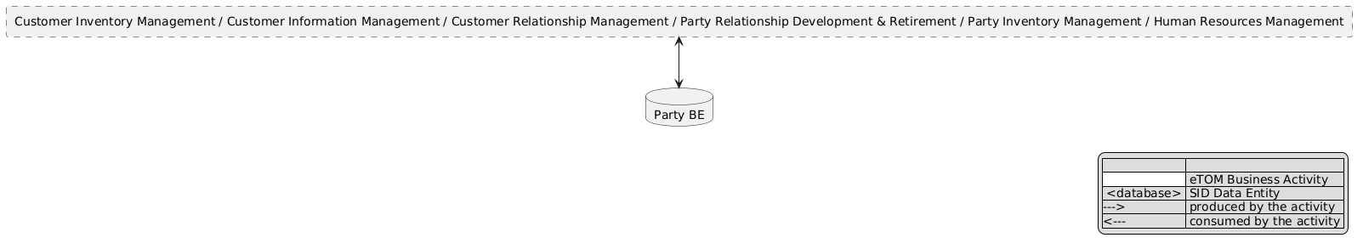
eTOM L2 - SID ABEs links diagram

Functional Framework Functions
Function ID | Function Name | Function Description | Aggregate Function Level 1 | Aggregate Function Level 2
92 | Customer Relation Map Exposure | Customer Relation Map Exposure maps the customer relation/context to systems such as call center or self-service touch. | Customer Information Support | Personalize Customer Profile
369 | Customer Data Fencing | Customer Data Fencing provides a security function that will allow e.g., VNO agents or Dealers to view only their own customers. In some cases, the network provider will use the same BSS environment to serve several VNOs (multi tenancy). | Customer Information Support | Customer Information Management
225 | Customer Details Management | Customer Details Management; Managing customer details - E.g., name, contact persons for this customer, account managers for this customer, addresses (residence, billing, service address, etc.), contact phone numbers (landline, mobile, fax, etc.). | Customer Information Support | Customer Information Management
400 | Customer Information Management | Customer Information Management is a generic function for customer information that also includes functionality for data fencing if accessed by Partner's online access function to make them self-sufficient and avoid the need for them to call the call center for Customer creation and management. | Customer Information Support | Customer Information Management
282 | Customer Information Presentation | Customer Information Presentation displays relevant customer information, such as name, account and lifetime value on a persistent customer dashboard. | Customer Information Support | Customer Information Management
226 | Customer Preferences Administration | Customer Preferences Administration administrates customer proprietary information preferences (CPNI), email versus US Mail, how to be contacted (based on type of communication), web look and feel, do not solicit me. Personalization allows delivery of services that more closely match the customer's need. | Customer Information Support | Customer Information Management
364 | Customer/Prospect Data Acquisition | Customer/Prospect Data Acquisition obtains all necessary information to make a sale. The prospect could be a new or current customer. Customer/Prospect Data Acquisition includes information about the service location, billing address, demographic information about the customer, any existing products and services the customer currently has, as well as the customer's needs (requirements). | Customer Information Support | Customer Information Management
233 | Customer Actions Profile Updating | Customer Actions Profile Updating updates customer profiling based on implicit and explicit actions, transactions (ex., deriving actual channel preference from a customer whose implicit preference is SMS, not email). | Customer Information Support | Collect & Qualify Customer Information
195 | Customers Hierarchy and Group Management | Customer Hierarchy and Group Management function stores the customer hierarchy and/or groups such as company, relationships and household structures. / Manages complex customer relationships such as an individual who performs multiple roles, or hierarchies such as complex corporate structures. This function should be able to deal with several levels of complexity from single service accounts to multinational corporations. Hierarchies are defined by an account type and its relationships with parent and child accounts. | Customer Information Support | Collect & Qualify Customer Information
122 | Customer Information Searching | Customer Information Searching search the existing customer base using various criteria (name, address, subscriber number, equipment id, billing account number, etc.) and find the customer record to add the order (using Customer Information Management). | Customer Information Support | Collect & Qualify Customer Information
91 | Customer Profile Updating | Customer Profile Updating function concerns the management of our knowledge of the individual customer to keep or produce an up-to-date, accurate and legally compliant Customer information. / It will incorporate into the customer profile, all relevant information gathered through all contacts with the customer. | Customer Information Support | Collect & Qualify Customer Information
121 | Registration | Customer Registration registers a new customer if this is a new customer (using Customer Information Management). | Customer Information Support | Collect & Qualify Customer Information
124 | Guided Customer Information Capturing | Guided Customer Information Capturing provides a step-by-step guide at the channel to capture the specific information items to be collected (e.g. customer identification, required product / order and the pertinent data for the order). Including Validation guidance – for each information element, may provide set of valid input. | Customer Information Support | Collect & Qualify Customer Information
1032 | Partner Group and Hierarchy Definition | Partner Group and Hierarchy Assigning assigns partners to relevant groups and hierarchies and make the grouping available to the concerned organizations within the enterprise. | Business Partner Welcome and interaction | Business Partner Relationship Management
1033 | Partner Group and Hierarchy Assigning | Partner Group and Hierarchy Definition defines and creates partner group types and hierarchy criteria in line with the partner strategy to support partner collaboration with the different organizations of the enterprise. | Business Partner Welcome and interaction | Business Partner Relationship Management
1035 | Partner Preferences Management | Partner Preferences Management function provide the necessary functionalities to manage partner preferences and partner information details in collaboration with the partner. This includes management of the stored profile information including creation, updating and deletion as well as lifecycle management by supervision of validity and recency. | Business Partner Welcome and interaction | Business Partner Relationship Management
1034 | Partner Profile Management | Partner Profile Management function provide the necessary functionalities to manage partner information details for internal usages. This includes management of the stored profile information including creation, updating and deletion as well as lifecycle management by supervision to keep information valid and up to date. | Business Partner Management | Business Partner Relationship Management
1036 | Partner Profile Enquiry and Filtering | Partner Profile Enquiry and Filtering function provide the necessary functionalities to inquire stored profiles including filtering to both ensure access based on authority levels and for the convenience for the reader. | Business Partner Management | Business Partner Role Repository Management
1037 | Partner Profile Storage | Partner Profile Storage function secure data availability and integrity for the partner profile management. | Business Partner Management | Business Partner Role Repository Management
746 | Partner Workflow Management | Partner Workflow Management function provide workflow and orchestration for supplier/partner management activities. | Business Partner Management | Business Partner Role Repository Management

TM Forum Open APIs & Events
The following part covers the APIs and Events; this part is split in 3:

List of Exposed APIs - This is the list of APIs available from this component.

List of Dependent APIs - In order to satisfy the provided API, the component could require the usage of this set of required APIs.

List of Events (generated & consumed) - The events which the component may generate are listed in this section along with a list of the events which it may consume. Since there is a possibility of multiple sources and receivers for each defined event.

API Context Diagram
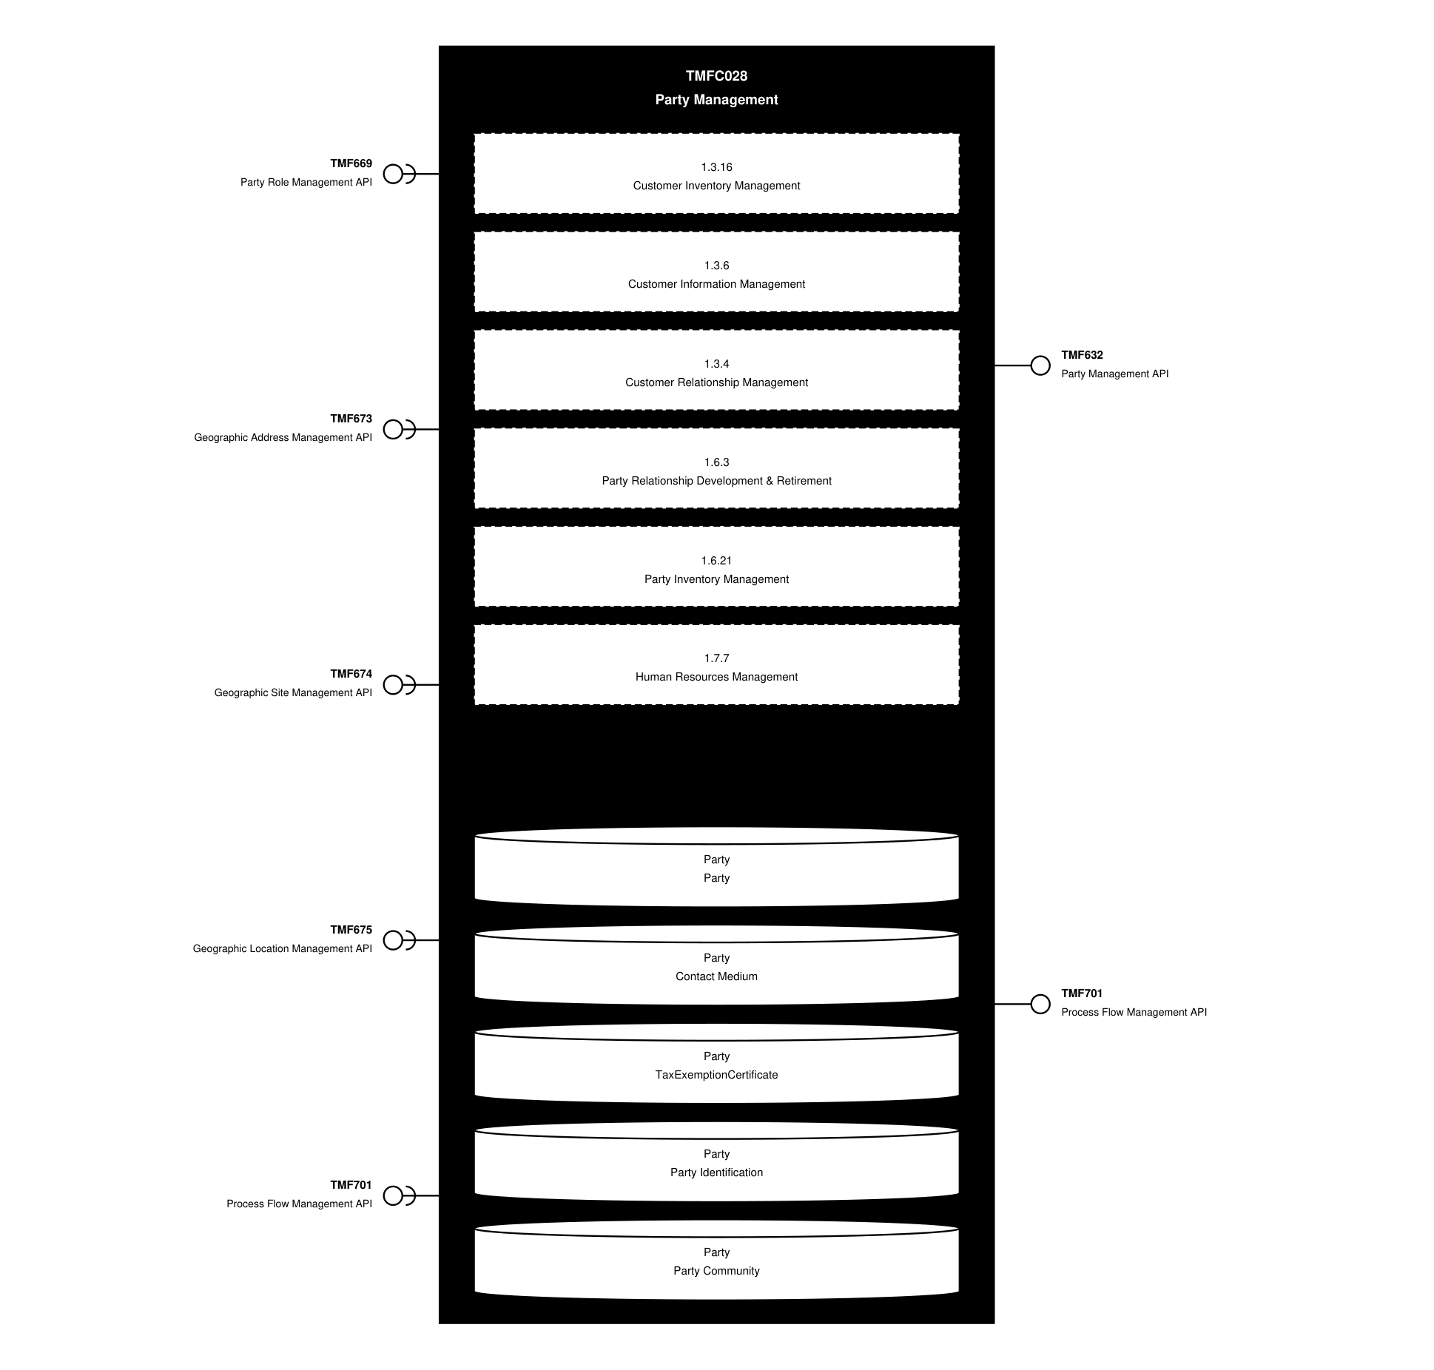
API Context diagram

Exposed APIs
API ID | API Name | Mandatory / Optional | API Version | Resource | Operations
TMF632 | Party Management API | Mandatory | 5 | individual  organization | GET  GET /id  POST  PATCH /id  DELETE /id  Delete /id
TMF632 | Party Management API | Mandatory | 4 | individual  organization | GET  GET /id  POST  PATCH /id  DELETE /id
TMF701 | Process Flow Management API | Optional | 4 | processFlow  taskFlow | GET  GET /id  POST  DELETE /id  PATCH /id

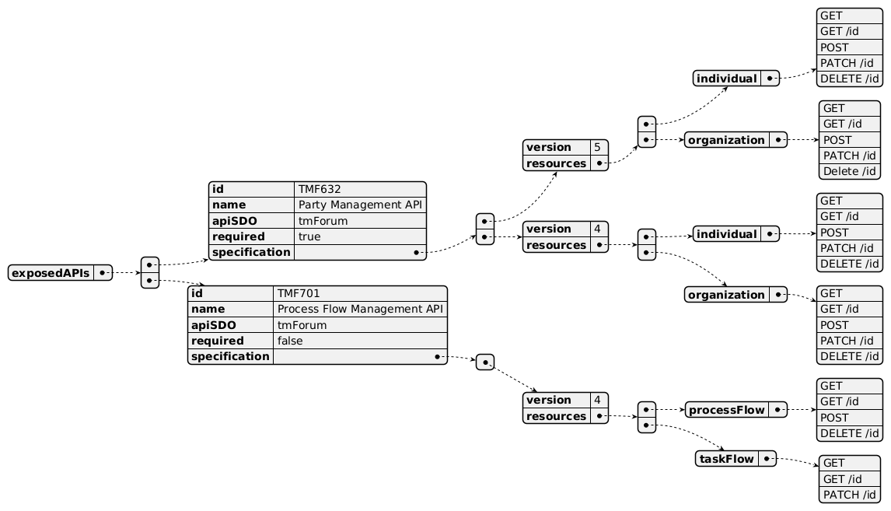
Exposed API diagram

Dependent APIs
API ID | API Name | API Version | Mandatory / Optional | Resource | Operations
TMF669 | Party Role Management API | 5 | Mandatory | partyRole | GET  GET /id
TMF669 | Party Role Management API | 4 | Mandatory | partyRole | GET  GET /id
TMF673 | Geographic Address Management API | 4 | Optional | geographicAddress | GET  GET /id
TMF674 | Geographic Site Management API | 4 | Optional | geographicSite | GET  GET /id
TMF675 | Geographic Location Management API | 4 | Optional | geographicLocation | GET  GET /id
TMF701 | Process Flow Management API | 4 | Optional | processFlow  taskFlow | POST  GET  GET /id  DELETE  PATCH

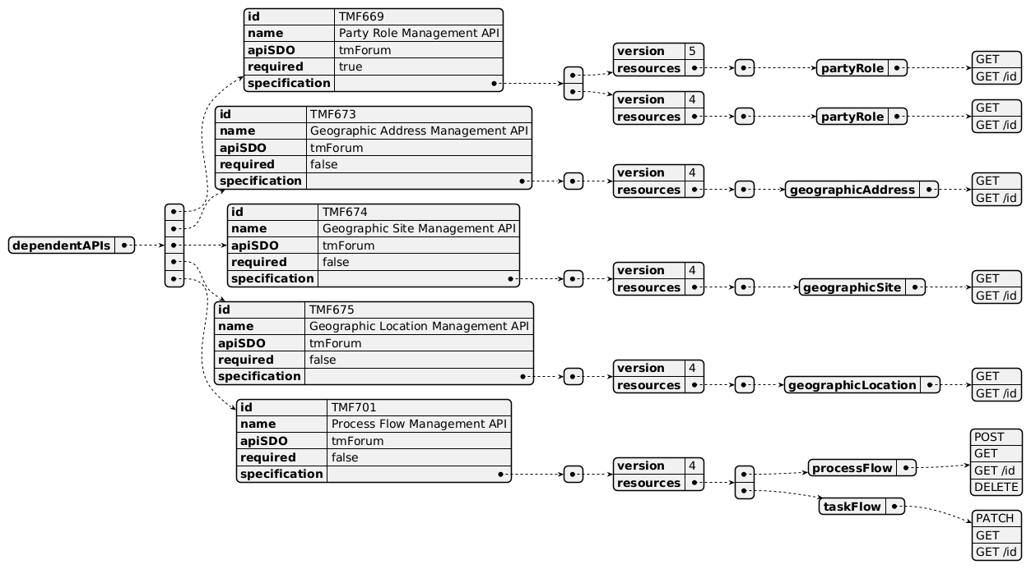
Dependent API diagram

Events
The diagram illustrates the Events which the component may publish and the Events that the component may subscribe to and then may receive. Both lists are derived from the APIs listed in the preceding sections.

Published Events
API ID | API Name | Event Resources
TMF632 | Party Management API | IndividualCreateEvent  IndividualAttributeValueChangeEvent  IndividualStateChangeEvent  IndividualDeleteEvent  OrganizationCreateEvent  OrganizationAttributeValueChangeEvent  OrganizationStateChangeEvent  OrganizationDeleteEvent

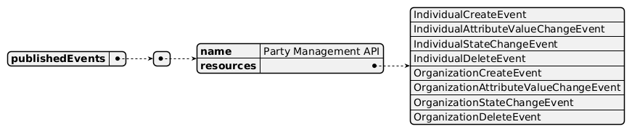
Published Events diagram

Subscribed Events
none listed in the component YAML

Subscribed Events diagram

Machine Readable Component Specification
Refer to the ODA Component Directory on the TM Forum website for the machine-readable component specification files for this component.

References

TMF Standards related versions
Standard | Version(s)
eTOM | v23.0, v26.0
SID | v25.0
Functional Framework | v23.0

Jira References
No open Jira issues currently listed for this component.

Further resources
none currently listed

Administrative Appendix

Document History

Version History
Version Number | Date | Modified by | Description of changes
1.0.0 | 05-Aug-2022 | Gaetano Biancardi, Sylvie Demarest | Final edits prior to publication
1.1.0 | 07-Oct-2022 | Gaetano Biancardi, Sylvie Demarest | Final edits prior to publication
1.2.0 | 13-Jun-2023 | Amaia White | Final edits prior to publication
1.2.1 | 25-Jul-2023 | Ian Turkington | No content changed, simply a layout change to match template 3. Separated the YAML files to a managed repository.
1.2.1 | 14-Aug-2023 | Amaia White | Final edits prior to publication
2.0.0 | 27-Sep-2023 | Gaetano Biancardi | Removed the following exposed API to address an issue identified by the TMF community around TMF629/TMF668 not handling party role for customer and partners: TMF668 Partner Mgmt, TMF629 Customer Mgmt
2.1.0 | 14-Oct-2024 | Gaetano Biancardi | New template applied; exposed API: TMF672 User Roles And Permissions removed (moved to canvas services), TMF688 Event removed (moved to canvas services); dependent API: TMF688 Event removed (moved to canvas services); eTOM removed (per eTOM v23.5): 1.6.3.1 (Party Relationship Management), 1.6.3.1.5 (Collect Party data), 1.6.3 (Party Relationship Development & Retirement); Functional Framework reclassified (per FF v23.5): 1036, 1037, 746, 1032, 1033, 1035, 1034
2.1.0 | 30-Oct-2024 | Amaia White | New version to 2.1.0
2.1.1 | 09-Jul-2025 | Rosie Wilson | Updates to description per agreed YAML updated on 03-Jun-2025
2.1.1 | 15-Jul-2025 | Rosie Wilson | Final administrative updates
2.2.0 | 24-Jun-2026 | Sannah Sibaya | Final edits prior to publishing

Release History
Release Status | Date Modified | Modified by | Description of changes
Pre-production | 05-Aug-2022 | Goutham Babu | Initial release of document
Pre-production | 07-Oct-2022 | Alan Pope | Updated to version 1.1.0
Pre-production | 07-Nov-2022 | Adrienne Walcott | Updated to reflect Member Evaluated status
Pre-production | 13-Jun-2023 | Amaia White | Updated to version 1.2.0
Pre-production | 17-Jul-2022 | Adrienne Walcott | Updated to reflect Member Evaluated status
Pre-production | 14-Aug-2023 | Amaia White | Updated to version 1.2.1
Production | 06-Oct-2023 | Adrienne Walcott | Updated to reflect TM Forum Approved status
Pre-production | 16-Oct-2023 | Amaia White | Updated to version 2.0.0
Production | 08-Dec-2023 | Adrienne Walcott | Updated to reflect TM Forum Approved status
Pre-production | 30-Oct-2024 | Amaia White | Updated to version 2.1.0
Production | 27-Dec-2024 | Adrienne Walcott | Updated to reflect TM Forum Approved status
Pre-production | 15-Jul-2025 | Rosie Wilson | Updated to version 2.1.1
Pre-production | 24-Jun-2026 | Sannah Sibaya | Updated to version 2.2.0

Acknowledgements
This document was prepared by the members of the TM Forum ODA Components & Canvas team.
Team Member | Company | Role
Matteo Destino | Accenture | Editor
Gaetano Biancardi | Accenture | Editor
Sylvie Demarest | Orange | Reviewer
Ian Turkington | TM Forum | Additional Input
Hugo Vaughan (TM Forum) | TM Forum | Additional Input
Elisabeth Andersson | MATRIXX | Reviewer
Abinash Vishwakarma | Netcracker | Reviewer
Jose Macaluso | Xacria | Reviewer
Kamal Maghsoudlou | Ericsson | Reviewer
Milind Bhagwat | BT | Reviewer
Ritu Arora | BT | Reviewer

