TMFC029 Payment Management v1.3.2
Components and Canvas
In this deliverable:

Overview
Component Name | ID | Description | ODA Function Block
Payment Management | TMFC029 | Payment Management component manages methods used by parties to make payments. It also administers payment plans, handles payments, assigns payments against bills, settlements, and other objects requiring payments. | Party Management

eTOM Processes, SID Data Entities and Functional Framework Functions

eTOM business activities
eTOM business activities this ODA Component is responsible for:
Identifier | Level | Business Activity Name | Description
1.3.10 | L2 | Customer Bill Payments & Receivables Management | Ensure that enterprise revenue is collected through pre-established collection channels and put in place procedures to recover past due payments.
1.3.10.2 | L3 | Manage Customer Payments | The purpose of the Manage Customer Payments process is to collect payments made by the customer and reconcile the payments to the invoices. This process is meant to match these payments with the services/invoices delivered to this customer. These processes can include credit/debit/EFT payments using various channels, either directly or through third parties, and cash or check payments, either directly or through third parties. / In all the above cases these processes are responsible for the processes interacting with the customers and/or the third parties. The processes are also responsible for establishing managing back-end bank accounts for receipt of the customer payments and for the transfer of funds collected by third parties. These processes are responsible for reconciling the money received into the bank accounts against the payments expected in the invoices. Additionally, these processes inform the Financial Management on all those payments for updating the ledger.
1.6.16 | L2 | Business Partner Payments & Receivables Management | Party Bill Payments & Receivables Management is responsible for management of methods used by parties to make payments, administers payment plans, handles payments, and collects debt.
1.6.16.1 | L3 | Business Partner Payment Management | Manage methods used by parties to make payments, administer payment plans, handle payments, and collect debt.
1.6.16.1.1 | L4 | Business Partner Payment Handling | Receive payments from parties, remit payments to parties, and apply payments to any form of request for payment, such as bills, settlements or other forms of revenue sharing, purchases, charges, or payment plans as needed.
1.6.16.1.2 | L4 | Business Partner Payment Method Management | Define and manage the various types of payment methods and the methods by which an individual Business Partner may make an inbound and/or outbound payment. Define and manage the various types of payment methods and the methods by which an individual Business Partner may make an inbound and/or outbound payment.
1.6.16.1.3 | L4 | Business Partner Payment Plan Administration | Develop and manage payment plans that specify how a Business Partner will pay over a specified period of time for a product that has been acquired. This process may also develop and manage template Business Partner payment plans that define typical payment plans that are used.

SID ABEs
SID ABEs this ODA Component is responsible for:
SID ABE Level 1 | SID ABE Level 2 (or set of BEs) | SID ABE L1 Definition | SID ABE L2 Definition
Party Payment |  | The Party Payment ABE contains all Entities required to describe a payment such as PaymentMethod and BankAccount. | *(no description available)*

eTOM L2 - SID ABEs links
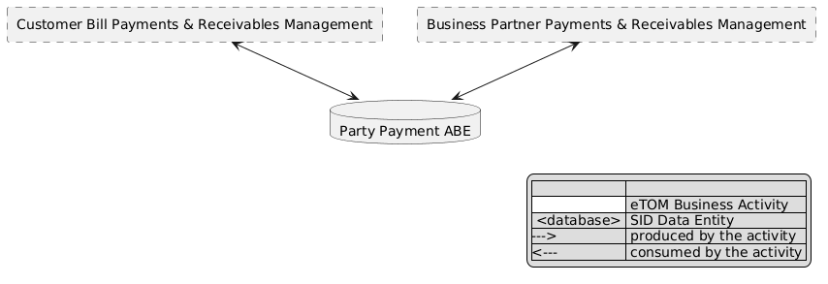
eTOM L2 - SID ABEs links diagram

Functional Framework Functions
Function ID | Function Name | Function Description | Aggregate Function Level 1 | Aggregate Function Level 2
30 | Advance Payment Acceptance | Advance Payment Acceptance; Advance Payments are accepted before initiation of service - usually at time of ordering. Interest is not accrued on advance payments. | Customer Financial Management | Payment Management
33 | Deposit Management | Deposit Management manages amounts held as a guarantee of payment. Interest may be accumulated on this deposit amount. If payment is not made in a timely manner, a portion of this deposit may be applied to the outstanding balance. Based on business policy, deposits may be refunded with applicable interest after some period of time. Deposit Management maintains and executes on these policies. | Customer Financial Management | Payment Management
153 | Collection Payment Agreement Monitoring | Collection Payment Agreement Monitoring monitors the inclusion of a payment schedule or a promise of payment, negotiated with the customer during the dunning process. | Customer Financial Management | Payment Management
156 | Collection Payment Planning | Collection Payment Planning is creating a payment plan based on system recommendation or CSR decision to build a payment plan. This is a dunning activity. | Customer Financial Management | Payment Management
157 | Collection Payment Plan Monitoring | Collection Payment Plan Monitoring monitors the payment plan execution and trigger events for the collection monitoring process. This is a dunning activity. | Customer Financial Management | Payment Management
171 | Customer Support Payment Management | Customer Support Payment Management function provides front end functionality for the CSR in their day-to-day payment support related activities. | Customer Financial Management | Payment Management
251 | Customer Bill Payment | Customer Bill Payment provide an internet technology driven interface to the customer to undertake direct payments | Customer Financial Management | Payment Management
321 | Bank Interface Direct Debit Payment Receiving | Bank Interface Direct Debit Payment Receiving supports receiving of direct debit payments from the nominated (specified) bank accounts. | Customer Financial Management | Payment Management
322 | Payment Transaction Refunding | Payment Transaction Refunding supports refund transactions based on the saved payment transaction details. | Customer Financial Management | Payment Management
323 | Payment Interface Management | Payment Interface Management manages interfaces between the service provider and payment channel organizations | Customer Financial Management | Payment Management
324 | Financial Transaction Settlement | Financial Transaction Settlement submits authorized transactions to the financial institutions for settlement. | Customer Financial Management | Payment Management
325 | Financial Institution Reconciliation | Financial Institution Reconciliation supports the reconciliation process with financial institutions | Customer Financial Management | Payment Management
326 | Financial Institution Payment Authorization Linking | Financial Institution Payment Authorization Linking liaises with financial institutions for payment authorization | Customer Financial Management | Payment Management
327 | Remittance Details Access | Remittance Details Access; Provides remittance details to the bill accounts receivable management application within the service provider billing system. | Customer Financial Management | Payment Management
328 | Financial Institution Security Verification | Financial Institution Security Verification supports financial institutions’ security standards (e.g., “Verified by Visa” and “MasterCard SecureCode”). | Customer Financial Management | Payment Management
658 | Partner Payments Management | Partner Payments Management handles payments in the area of Supplier/Partner billing and settlement. Logging and tracking of full or partial payments. | Business Partner Financial Management | Business Partner Payment Management
936 | Customer Support Invoice Payment | Customer Support Invoice Payment function is to accept customer payment via the customer service representative (CSR) for immediate Payment of Invoices using existing or new pay means. | Customer Financial Management | Payment Management
937 | Customer Support Prepaid Recharge Payment | Customer Support Prepaid Recharge Payment function is to accept customer payment via the customer service representative (CSR) for Prepaid recharge using vouchers or other pay means | Customer Financial Management | Payment Management
1065 | Procurement Order Payment | Procurement Order Payment provides payment of supplier order. | Business Partner Financial Management | Business Partner Payment Management

TM Forum Open APIs & Events
The following part covers the APIs and Events; this part is split in 3:

List of Exposed APIs - This is the list of APIs available from this component.

List of Dependent APIs - In order to satisfy the provided API, the component could require the usage of this set of required APIs.

List of Events (generated & consumed) - The events which the component may generate are listed in this section along with a list of the events which it may consume. Since there is a possibility of multiple sources and receivers for each defined event.

API Context Diagram
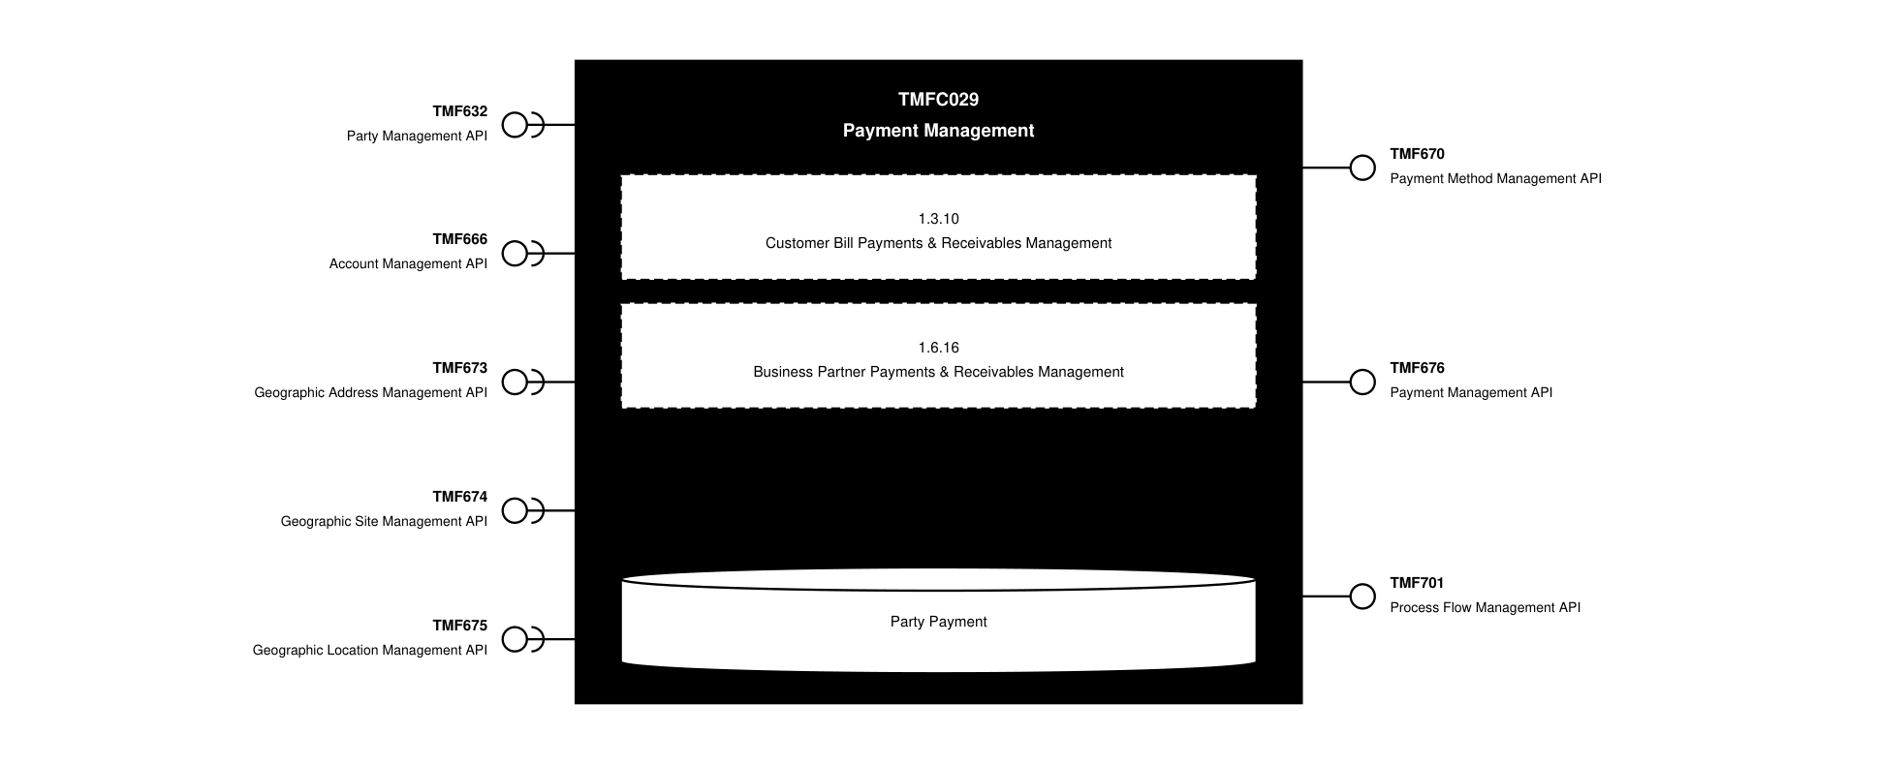
API Context diagram

Exposed APIs
API ID | API Name | Mandatory / Optional | API Version | Resource | Operations
TMF670 | Payment Method Management API | Mandatory | 4 | paymentMethod | GET  GET /id  POST  PATCH  DELETE
TMF676 | Payment Management API | Mandatory | 4 | payment  refund | GET  GET /id  POST
TMF701 | Process Flow Management API | Optional | 4 | processFlow  taskFlow | POST  GET  GET /id  DELETE  PATCH

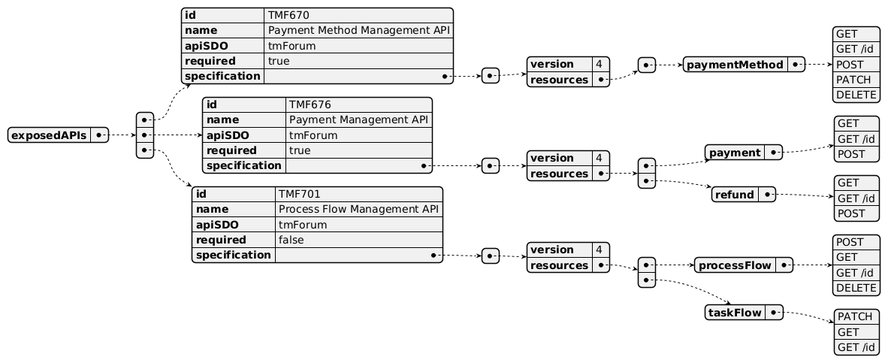
Exposed API diagram

Dependent APIs
API ID | API Name | API Version | Mandatory / Optional | Resource | Operations
TMF632 | Party Management API | 5 | Optional | individual  organization | GET  GET /id
TMF632 | Party Management API | 4 | Optional | individual  organization | GET  GET /id
TMF666 | Account Management API | 5 | Optional | billFormat  billPresentationMedia  billingAccount  billingCycleSpecification  financialAccount  partyAccount  settlementAccount | GET  GET /id
TMF666 | Account Management API | 4 | Optional | partyAccount  billingAccount  settlementAccount  financialAccount  billingCycleSpecification  billFormat  billPresentationMedia | GET  GET /id
TMF673 | Geographic Address Management API | 4 | Optional | geographicAddressValidation  geographicAddress  geographicSubAddress | GET  GET /id
TMF674 | Geographic Site Management API | 4 | Optional | geographicSite | GET  GET /id
TMF675 | Geographic Location Management API | 4 | Optional | geographicLocation | GET  GET /id

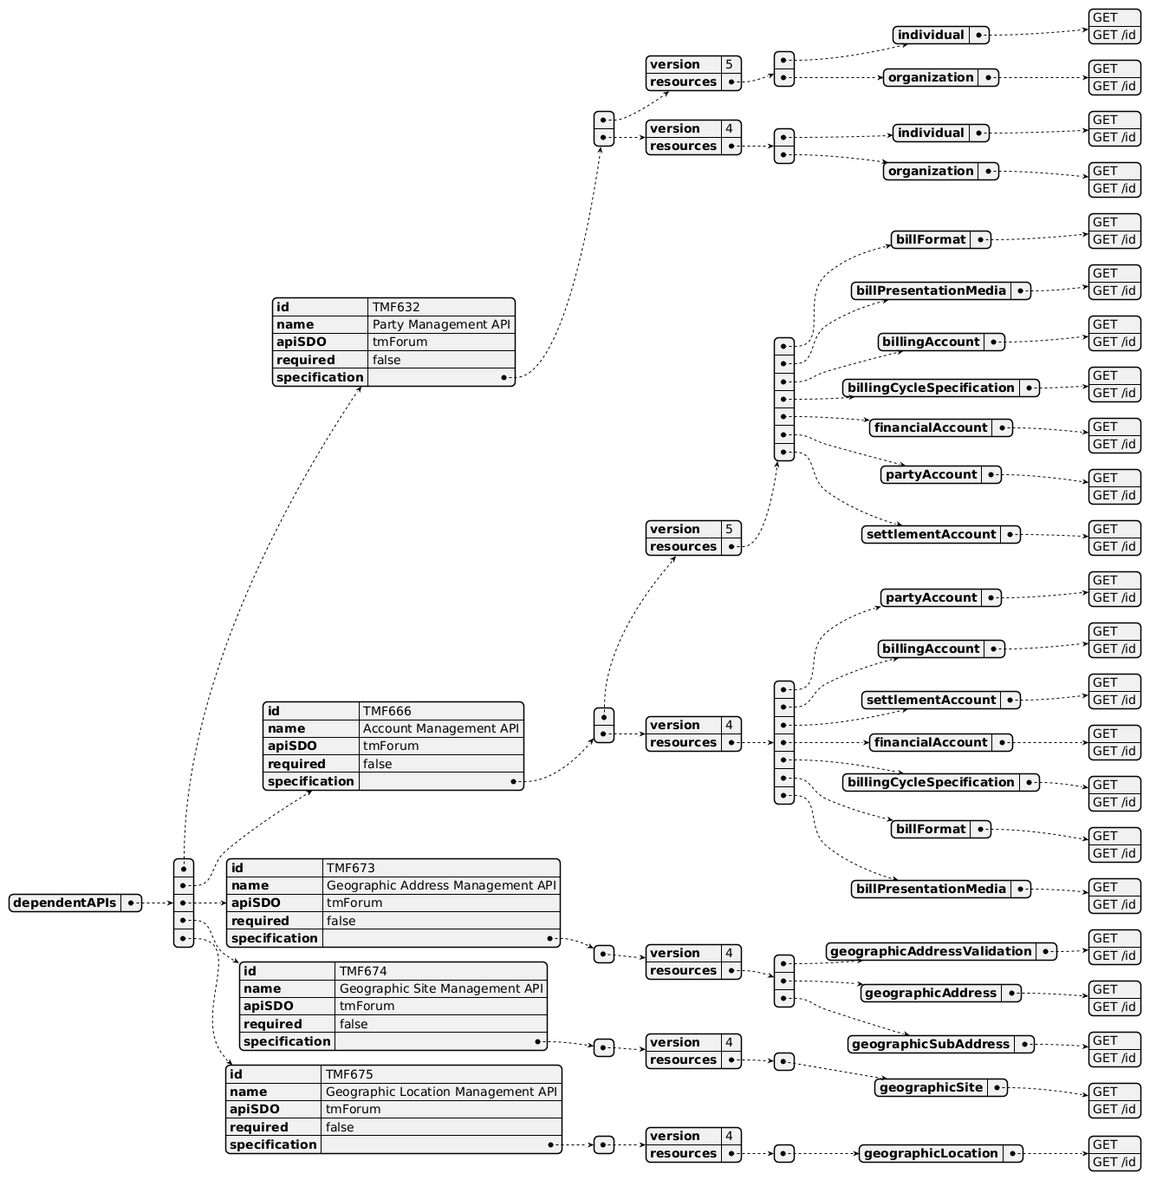
Dependent API diagram

Events
The diagram illustrates the Events which the component may publish and the Events that the component may subscribe to and then may receive. Both lists are derived from the APIs listed in the preceding sections.

Published Events
API ID | API Name | Event Resources
TMF676 | Payment Management API | PaymentAttributeValueChangeEvent  PaymentCreateEvent  PaymentDeleteEvent  PaymentStatusChangeEvent  RefundAttributeValueChangeEvent  RefundCreateEvent  RefundStatusChangeEvent
TMF670 | Payment Method Management API | PaymentMethodAttributeValueChangeEvent  PaymentMethodCreateEvent  PaymentMethodDeleteEvent  PaymentMethodStatusChangeEvent
TMF701 | Process Flow Management API | ProcessFlowCreateEvent  ProcessFlowStateChangeEvent  ProcessFlowStateDeleteEvent  ProcessFlowStateAttributeValueChangeEvent  TaskFlowCreateEvent  TaskFlowStateChangeEvent  TaskFlowDeleteEvent  TaskFlowAttributeValueChangeEvent  TaskFlowInformationRequiredEvent

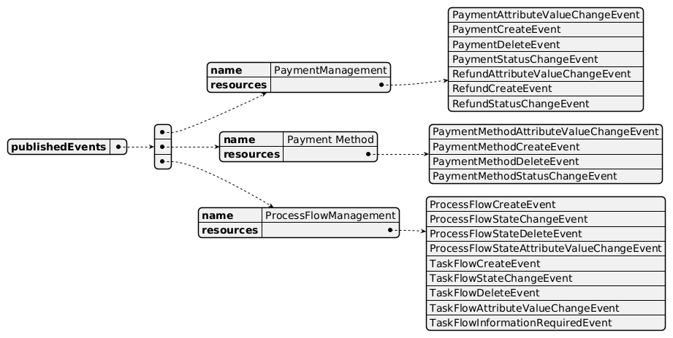
Published Events diagram

Subscribed Events
none listed in the component YAML

Subscribed Events diagram

Machine Readable Component Specification
Refer to the ODA Component Directory on the TM Forum website for the machine-readable component specification files for this component.

References

TMF Standards related versions
Standard | Version(s)
eTOM | v23.0
SID | v25.0
Functional Framework | v24.0

Jira References

ISA-642 - Review Function 327 - Remittance Details Access (SME REVIEW): review Function 327 - Remittance Details Access name and definition

ISA-643 - Review Functions 156 - Collection Payment Planning and Function 157 - Collection Payment Plan Monitoring definitions (SME REVIEW): review Functions 156 & 157 definition (delete link to dunning)

ISA-644 - Review Function 200 - Customer Loyalty Prize selection classification (BACKLOG): review Function 200 - Customer Loyalty Prize Selection classification (not in Payment Mgt)

Further resources
1. IG1228: please refer to IG1228 for defined use cases with ODA components interactions.

Administrative Appendix

Document History

Version History
Version Number | Date | Modified by | Description of changes
1.0.0 | 07-Dec-2023 | Goutham Babu | Final edits prior to publication
1.0.1 | 25-Jul-2023 | Ian Turkington | No content changed, simply a layout change to match template 3. Separated the YAML files to a managed repository.
1.0.1 | 15-Aug-2023 | Amaia White | Final edits prior to publication
1.1.0 | 16-Apr-2024 | Gaetano Biancardi | Component template updated; eTOM process renamed from "Customer Bill Payments & Receivables Management" to "Customer Receivable Management"
1.1.0 | 02-May-2024 | Amaia White | Final edits prior to publication
1.2.0 | 18-Nov-2024 | Gaetano Biancardi | TMF688 removed from the core specification, moved to supporting functions; TMF672 removed from the core specification, moved to supporting functions; API version, only major version to be specified
1.2.0 | 27-Dec-2024 | Rosie Wilson | Final edits prior to publication
1.2.1 | 09-Jul-2025 | Rosie Wilson | Updates to description per agreed YAML updated on 03-Jun-2025
1.2.1 | 15-Jul-2025 | Rosie Wilson | Final edits prior to publication

Release History
Release Status | Date Modified | Modified by | Description of changes
Pre-production | 07-Dec-2023 | Goutham Babu | Initial release
Pre-production | 23-Jan-2023 | Adrienne Walcott | Updated to Member Evaluated status
Pre-production | 15-Aug-2023 | Amaia White | New release 1.0.1
Production | 06-Oct-2023 | Adrienne Walcott | Updated to reflect TM Forum Approved status
Pre-production | 02-May-2024 | Amaia White | New release 1.1.0
Production | 28-Jun-2024 | Adrienne Walcott | Updated to reflect TM Forum Approved status
Pre-production | 27-Dec-2024 | Rosie Wilson | New release 1.2.0
Production | 07-Mar-2025 | Adrienne Walcott | Updated to reflect TM Forum Approved status
Pre-production | 15-Jul-2025 | Rosie Wilson | New release 1.2.1

Acknowledgements
Team Member | Company | Role
Anastasios Sarantis | Vodafone | Editor
Ian Turkington | TM Forum | Additional Input
Hugo Vaughan (TM Forum) | TM Forum | Additional Input
Gaetano Biancardi | Accenture | Additional Input
Elisabeth Andersson | MATRIXX | Reviewer
Abinash Vishwakarma | Netcracker | Reviewer
Jose Macaluso | Xacria | Reviewer
Kamal Maghsoudlou | Ericsson | Reviewer
Milind Bhagwat | BT | Reviewer
Ritu Arora | BT | Reviewer
Matteo Destino | Accenture | Reviewer

