TMFC030 Bill Generation Management v2.1.0
Components and Canvas
In this deliverable:

Overview
Component Name | ID | Description | ODA Function Block
Bill Generation Management | TMFC030 | The Bill Generation component is responsible for Party invoice management. It addresses the invoice formatting, presentation and dispatching via the appropriate means of communication. | Party Management

eTOM Processes, SID Data Entities and Functional Framework Functions

eTOM business activities
eTOM business activities this ODA Component is responsible for:
Identifier | Level | Business Activity Name | Description
1.3.9 | L2 | Customer Bill Invoice Management | Ensure the bill invoice is created, physically and/or electronically produced and distributed to customers, and that the appropriate taxes, discounts, adjustments, rebates and credits for the products and services delivered to customers have been applied.
1.3.9.2 | L3 | Create Customer Bill Invoice | Production of a timely and accurate invoice in accordance with the specific billing cycles and reflective of the final charges for services, together with any adjustments, delivered to the customer by the Service Provider and respective other parties.
1.3.9.2.1 | L4 | Render & Format Customer Invoice | Render and format the customer bill invoice.
1.3.9.2.2 | L4 | Deliver Electronic Invoice | Deliver the electronic copy of an invoice to customers.
1.3.9.2.3 | L4 | Verify Customer Invoice Quality | Verify Customer invoice quality before distribution to the customer in electronic form and the process responsible for physical invoice production and distribution.
1.3.9.2.4 | L4 | Manage Customer Invoice Quality | Store the customer invoice for a period of time is to address regulation and/or internal requirements, during which they can be accessed to support any customer or regulator agency inquiries on bill invoices.
1.3.9.3 | L3 | Produce & Distribute Customer Bill | Physical production and distribution of bills to customers in accordance with the specified billing cycle.
1.3.9.3.1 | L4 | Co-ordinate Billing Insertion | Co-ordinate with promotional processes for any billing insertions to be included with the bill.
1.3.9.3.2 | L4 | Establish & Manage Bill Production Cycle | Establish and manage the physical bill production cycle.
1.3.9.3.3 | L4 | Deliver Invoice Information | Deliver the invoice information to the physical production processes.
1.3.9.4 | L3 | Pricing, Discounting, Adjustments & Rebates Application | Ensure that the bill invoice is reflective of all the commercially agreed billable events and any bill invoice adjustments agreed between a Service Provider and the customer.
1.3.9.4.2 | L4 | Apply Pricing, Discounting, Adjustments & Rebates to Customer Account | Determine the customer account or customer specific pricing, charges, discounts, and taxation that should be delivered to the invoice(s) for the customer.
1.6.15 | L2 | BP Bill/Invoice Management | Business Partner Bill/Invoice Management manages the Business Partner bill/invoice process, controls bills/invoices, manages the lifecycle of bills/invoices. A bill is a notice for payment which is supposed to be preceded by an invoice in most cases.
1.6.15.2 | L3 | BP Bill/Invoice Control | Establish and maintain Business Partner bill invoice formats, maintain lists of parties who are eligible for receiving bills/invoices, and define the billing cycles.
1.6.15.2.1 | L4 | Establish & Maintain BP Bill Invoice Format | Establish and maintain BP bill invoice formats, and any interaction with specific parties to modify the format.
1.6.15.2.2 | L4 | Maintain Bill Invoice BP List | Maintain lists of parties who are eligible for receiving bills/invoices.
1.6.15.2.3 | L4 | Define BP Billing Cycle | Define the billing cycles and their dates according to cash flow needs as established by financial management processes.
1.6.15.3.2 | L4 | Create BP Bill/Invoice | Produce a timely and accurate bill/invoice in accordance with a specific billing cycle, on demand after the purchase of an offering, on request by a BP, and so forth. Ensure that a bill/invoice is reflective of the final charges for products, together wit ( this looks same as above and incomplete)
1.6.15.3.3 | L4 | Distribute BP Bill/Invoice | Provide bills/invoices to one or more parties and ensure the delivery of bills/invoices to one or more parties.
1.6.15.3.4 | L4 | Manage BP Bill/Invoice Archive | Store a BP bill/invoice for a period of time to address regulation and/or internal requirements, during which it can be accessed to support any BP, such as a government/regulator agency or internal BP, inquiries about a bill/invoice.
1.6.15.3.5 | L4 | Receive BP Bill/Invoice | Receive and record the bill/invoice from a BP . Compare a BP bill/invoice against all transactions with the BP that would result in a bill/invoice being sent to the enterprise. Manage the interactions between a BP and an enterprise. Approve a BP bill/invo
1.6.15.3.6 | L4 | Administer Commercial Arrangement for BP Bill/Invoice Creation Capability | Establish the requirements for, and manage the agreed commercial arrangements with, appropriate outsourced parties of the creation capabilities.

SID ABEs
SID ABEs this ODA Component is responsible for:
SID ABE Level 1 | SID ABE Level 2 (or set of BEs) | SID ABE L1 Definition | SID ABE L2 Definition
Customer Bill |  | The Customer Bill ABE represents the specification of different formats of CustomerBill, the schedule of the production of bills and the Customer Bills themselves. | *(no description available)*

eTOM L2 - SID ABEs links
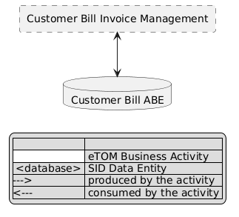
eTOM L2 - SID ABEs links diagram

Functional Framework Functions
Function ID | Function Name | Function Description | Aggregate Function Level 1 | Aggregate Function Level 2
65 | Bill Image Presentation | Bill Image Presentation provides presentation of an exact bill image or after invoking a transactional document generation function. | Invoice Management | Invoicing
62 | Invoice Items Listing | Invoice Items Listing lists all invoice items for a specific invoice. | Invoice Management | Invoicing
63 | Invoice Listing | Invoice Listing function will list all invoices for a customer both over time and for customers with multiple invoices. | Invoice Management | Invoicing
329 | Invoice Tax Calculation | "Invoice Tax Calculation provides the necessary functionality to calculate taxes, including surcharges and fees, where applicable. / This function can occur within the Invoicing application or through the use of an external Tax module." | Invoice Management | Invoicing
309 | Invoice Balance Calculation | Provides the means to calculate the balance due for an invoice/bill. | Invoice Management | Invoicing
310 | Invoice Charges Compilation | Invoice Charges Compilation assembles charges (including charge distribution- charges incurred by other customers), credits, taxes, fees and adjustments that affect the balance due. | Invoice Management | Invoicing
312 | Invoice Detail Collection | Provides appropriate levels of detail regarding items on the invoice. This detail is provided to revenue reporting and/or Bill Format &; Render. | Invoice Management | Invoicing
311 | Invoice Totals Calculation | Provides subtotals and totals at various levels. | Invoice Management | Invoicing

TM Forum Open APIs & Events
The following part covers the APIs and Events; this part is split in 3:

List of Exposed APIs - This is the list of APIs available from this component.

List of Dependent APIs - In order to satisfy the provided API, the component could require the usage of this set of required APIs.

List of Events (generated & consumed) - The events which the component may generate are listed in this section along with a list of the events which it may consume. Since there is a possibility of multiple sources and receivers for each defined event.

API Context Diagram
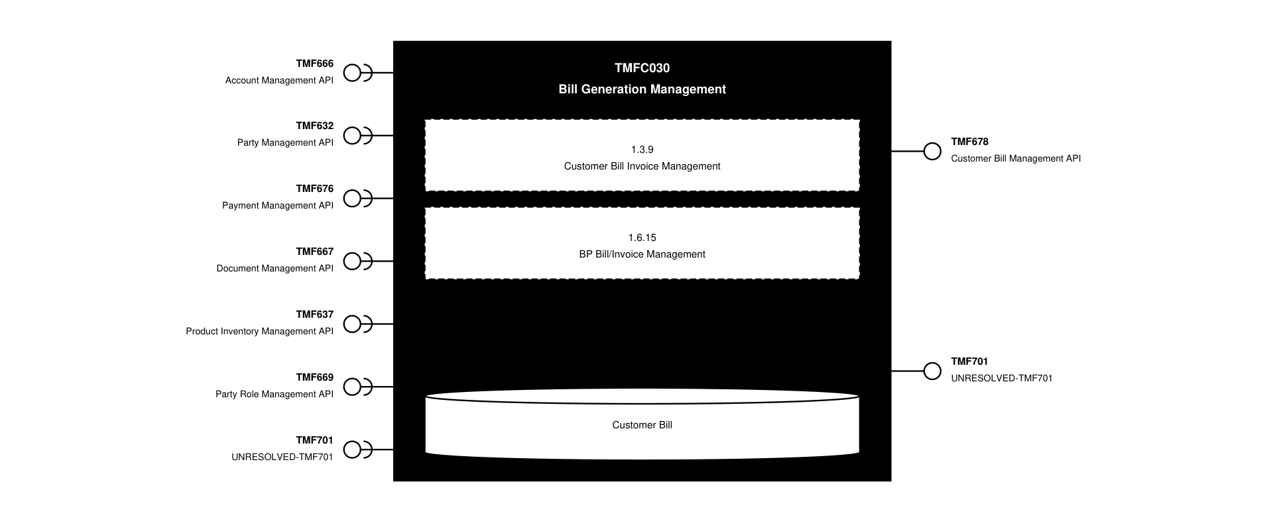
API Context diagram

Exposed APIs
API ID | API Name | Mandatory / Optional | API Version | Resource | Operations
TMF678 | Customer Bill Management API | Mandatory | 5 | billCycle  customerBill  customerBillOnDemand | GET  GET /id  POST  PATCH /id
TMF678 | Customer Bill Management API | Mandatory | 4 | customerBillOnDemand  customerBill  billCycle | GET  POST  GET /id  PATCH /id
TMF701 | UNRESOLVED-TMF701 | Optional | 4 | processFlow  taskFlow | GET  GET /id  POST  DELETE /id  PATCH /id

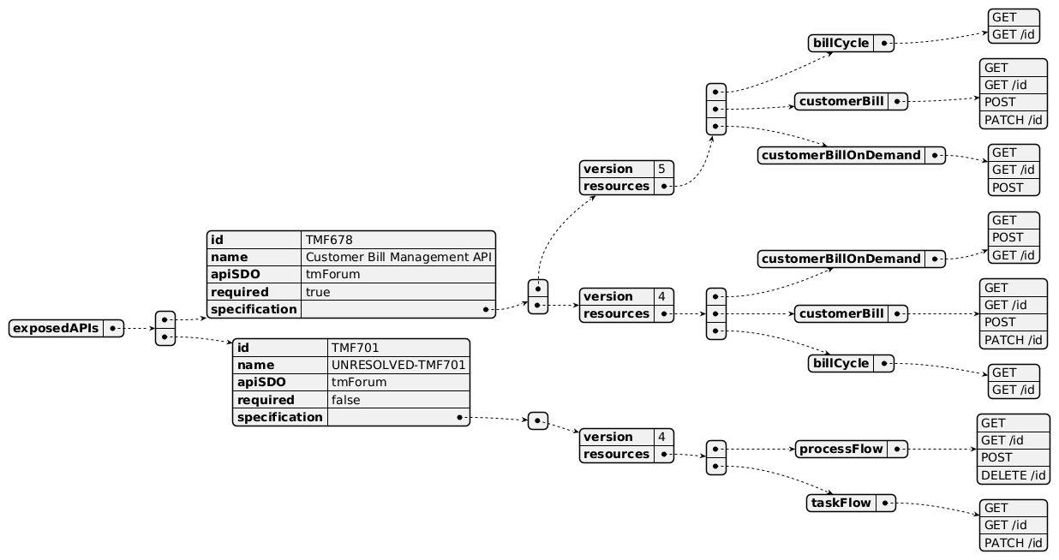
Exposed API diagram

Dependent APIs
API ID | API Name | API Version | Mandatory / Optional | Resource | Operations
TMF666 | Account Management API | 5 | Mandatory | billFormat  billPresentationMedia  billingAccount  billingCycleSpecification | GET  GET /id
TMF666 | Account Management API | 4 | Mandatory | billingAccount  billingCycleSpecification  billFormat  billPresentationMedia | GET  GET /id
TMF632 | Party Management API | 5 | Mandatory | individual  organization | GET  GET /id
TMF632 | Party Management API | 4 | Mandatory | individual  organization | GET  GET /id
TMF676 | Payment Management API | 4 | Optional | payment  refund | GET  GET /id  POST
TMF667 | Document Management API | 4 | Optional | document | GET  GET /id  POST
TMF637 | Product Inventory Management API | 5 | Optional | product | GET  GET /id
TMF637 | Product Inventory Management API | 4 | Optional | product | GET  GET /id
TMF669 | Party Role Management API | 5 | Mandatory | partyRole | GET  GET /id
TMF669 | Party Role Management API | 4 | Mandatory | PartyRole | GET  GET /id
TMF701 | UNRESOLVED-TMF701 | 4 | Optional | processFlow  taskFlow | POST  GET  GET /id  PATCH

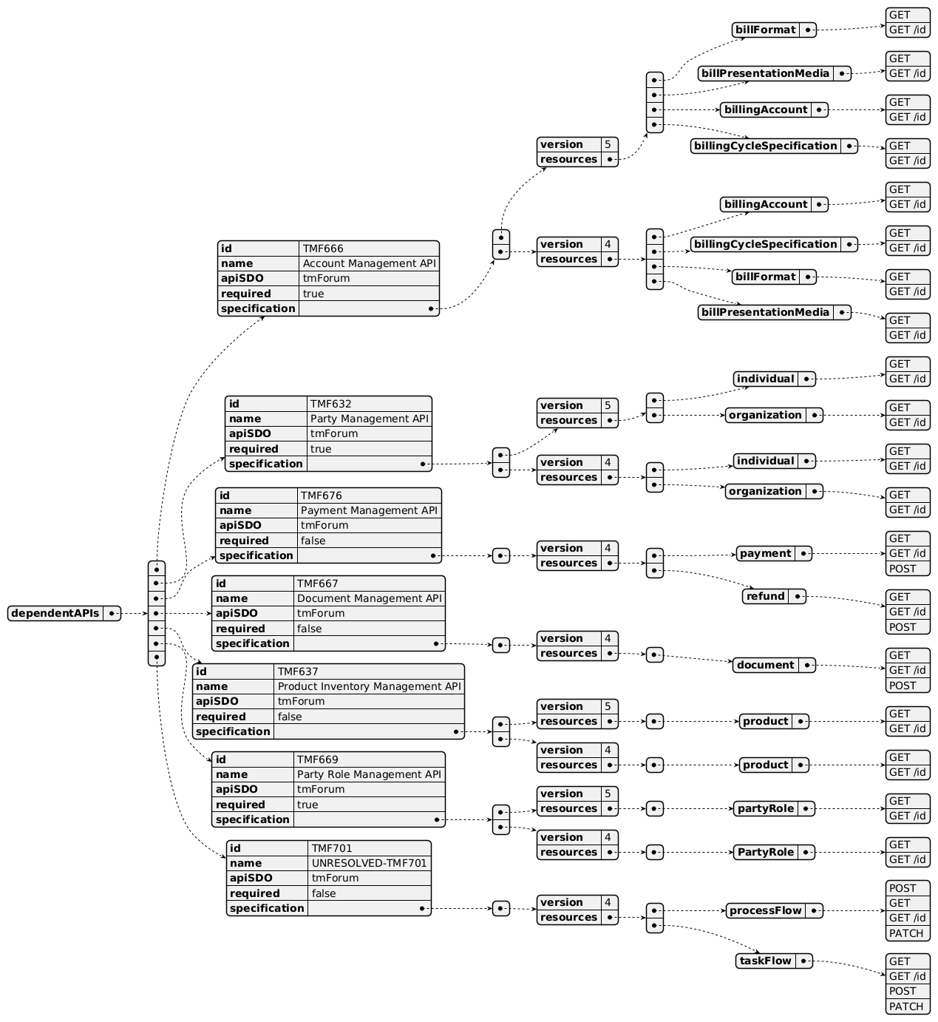
Dependent API diagram

Events
The diagram illustrates the Events which the component may publish and the Events that the component may subscribe to and then may receive. Both lists are derived from the APIs listed in the preceding sections.

Published Events
none listed in the component YAML
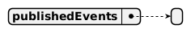
Published Events diagram

Subscribed Events
API ID | API Name | Event Resources
TMF669 | Party Role Management API | partyRoleAttributeValueChangeEvent  partyRoleStateChangeEvent  partyRoleDeleteEvent

Subscribed Events diagram

Machine Readable Component Specification
Refer to the ODA Component Directory on the TM Forum website for the machine-readable component specification files for this component.

References

TMF Standards related versions
Standard | Version(s)
eTOM | v23.0
SID | v25.0
Functional Framework | v23.0

Jira References

SID: to be updated to separate Customer Bill ABE from Party Bill ABE - ISA-847 - TMFC030: Bill Generation Management - SID update request (BACKLOG)

eTOM: to review L3/L4 mapping for (FX-1225): Produce & Distribute Customer Bill; Pricing, Discounting, Adjustments & Rebates Application; BP Bill/Invoice Management

OpenAPI: TMF678_Customer_Bill_Management remove following resources - AP-4648 - TMFC030: Bill Generation Management (DONE): Bill Cycle, Bill Cycle Specification

ODA Component: add new component for Party Communication Mgmt

Further resources
1. IG1228: please refer to IG1228 for defined use cases with ODA components interactions.

Administrative Appendix

Document History

Version History
Version Number | Date | Modified by | Description of changes
1.0.0 | 27-Sep-2023 | Gaetano Biancardi | Final edits prior to publication
2.0.0 | 21-Nov-2023 | Gaetano Biancardi | Functional Framework added: 309 Invoice Balance Calculation, 310 Invoice Charges Compilation, 312 Invoice Detail Collection, 311 Invoice Totals Calculation; Open API: TMF666 removed "appliedCustomerBillingRate" resource and related API methods
2.1.0 | 19-May-2024 | Gaetano Biancardi | Updated to new component template; updated to ODF v23.5; removed TMF672 as mandatory dependent API; exposed API removed: TMF688 Event Mgmt, TMF672 User Roles and Permissions; dependent API removed: TMF688 Event Mgmt
2.1.0 | 12-Jul-2024 | Amaia White | Final edits prior to publication
2.2.0 | 21-Oct-2024 | Gaetano Biancardi | Dependent API: added TMF678 Customer Bill Mgmt to retrieve appliedCustomerBillingRate; exposed API: added POST to TMF678 Customer Bill resource
2.2.0 | 03-Dec-2024 | Elisabeth Andersson | Updated YAML file to remove TMF688 and TMF672 from the core specification, as the two APIs are moved to supporting functions
2.2.0 | 27-Dec-2024 | Rosie Wilson | Final edits prior to publication
3.0.0 | 28-Oct-2025 | Julien Rouland | Updated the SID part to include party bill cycle, and updated the exposed API resources associated (TMF678); removed following functions in overlap with bill calc: 1.3.9.4 Pricing, Discounting, Adjustments & Rebates Application, 1.3.9.4.2 Apply Pricing, Discounting, Adjustments & Rebates to Customer Account
3.0.0 | 19-Nov-2025 | Rosie Wilson | Updated description; final edits prior to publication
3.1.0 | 25-Jun-2026 | Sannah Sibaya | Final edits prior to publication

Release History
Release Status | Date Modified | Modified by | Description of changes
Pre-production | 20-Oct-2023 | Amaia White | Initial release of document
Pre-production | 20-Nov-2023 | Adrienne Walcott | Updated to Member Evaluated status
Pre-production | 20-Dec-2023 | Amaia White | New version release 2.0
Production | 09-Feb-2024 | Adrienne Walcott | Updated to reflect TM Forum Approved status
Pre-production | 12-Jul-2024 | Amaia White | New version release 2.1.0
Production | 30-Aug-2024 | Adrienne Walcott | Updated to reflect TM Forum Approved status
Pre-production | 27-Dec-2024 | Rosie Wilson | Updated to version 2.2.0
Production | 07-Mar-2025 | Adrienne Walcott | Updated to reflect TM Forum Approved status
Pre-production | 19-Nov-2025 | Rosie Wilson | Updated to version 3.0.0
Pre-production | 25-Jun-2026 | Sannah Sibaya | Updated to version 3.1.0

Acknowledgements
This document was prepared by the members of the TM Forum ODA Components & Canvas team.
Team Member | Company | Role
Gaetano Biancardi | Accenture | Editor
Sylvie Demarest | Orange | Reviewer
Elisabeth Andersson | MATRIXX | Additional Input
Julien Rouland | Orange | Editor
Rosie Wilson | TM Forum | Editor
Muhammad Salman Sami | Whalecloud | Reviewer
Milind Bhagwat | BT | Reviewer
Abinash Vishwakarma | Netcracker | Reviewer
Luca Icardi | Accenture | Reviewer
Kamal Maghsoudlou | Ericsson | Reviewer

