TMFC031 Bill Calculation v3.1.0
Components and Canvas
In this deliverable:

Overview
Component Name | ID | Description | ODA Function Block
Bill Calculation | TMFC031 | The Bill Calculation component processes all charges against billing accounts during bill cycles. Bill Calculation can be executed both on a cyclic basis and on demand. It performs calculations with bill compilation of charges, credits, fees & taxes, including pro rata, at various levels, such as product and/or account level that have been generated since the last run for that account, applying promotions and discounts. | Core Commerce

eTOM Processes, SID Data Entities and Functional Framework Functions

eTOM business activities
eTOM business activities this ODA Component is responsible for:
Identifier | Level | Business Activity Name | Description
1.3.9 | L2 | Customer Bill Invoice Management | Ensure the bill invoice is created, physically and/or electronically produced and distributed to customers, and that the appropriate taxes, discounts, adjustments, rebates and credits for the products and services delivered to customers have been applied.
1.3.9.4 | L3 | Pricing, Discounting, Adjustments & Rebates Application | Ensure that the bill invoice is reflective of all the commercially agreed billable events and any bill invoice adjustments agreed between a Service Provider and the customer.
1.3.9.4.1 | L4 | Obtain Billing Events | Accept billing events that have been collected, translated, correlated, assembled, guided and service rated before determining the information would be applied to the customer’s bill invoice(s).
1.3.9.4.2 | L4 | Apply Pricing, Discounting, Adjustments & Rebates to Customer Account | Determine the customer account or customer specific pricing, charges, discounts, and taxation that should be delivered to the invoice(s) for the customer.
1.3.9.4.3 | L4 | Apply Agreed Customer Bill Adjustment | Apply and review any adjustment agreed in the previous billing period and make these included to the invoice.
1.6.15 | L2 | BP Bill/Invoice Management | Business Partner Bill/Invoice Management manages the Business Partner bill/invoice process, controls bills/invoices, manages the lifecycle of bills/invoices. A bill is a notice for payment which is supposed to be preceded by an invoice in most cases.
1.6.15.1 | L3 | BP Bill/Invoice Process Management | Make certain that there is capability so that the Bill Invoice Management processes can operate effectively and design and develop an enterprise's invoicing process.
1.6.15.3 | L3 | BP Bill/Invoice Lifecycle Management | Ensure bills/invoices are created, physically and/or electronically produced and distributed to parties, and that the appropriate taxes, discounts, adjustments, rebates and credits for the products delivered to parties have been applied.
1.6.15.3.1 | L4 | Apply BP Pricing, Discounting, Adjustments & Rebates | Ensure that a bill/invoice is reflective of all the commercially agreed billable events and any bill/invoice adjustments agreed between an enterprise and a BP.
1.6.15.3.5 | L4 | Receive BP Bill/Invoice | Receive and record the bill/invoice from a BP. Compare a BP bill/invoice against all transactions with the BP that would result in a bill/invoice being sent to the enterprise. Manage the interactions between a BP and an enterprise. Approve a BP bill/invoice.

SID ABEs
SID ABEs this ODA Component is responsible for:
SID ABE Level 1 | SID ABE Level 2 (or set of BEs) | SID ABE L1 Definition | SID ABE L2 Definition
Applied Customer Billing Rate |  | The Applied Customer Billing Rate ABE deals with the correlation of related usage for subsequent rating, rates applied to the usage (both regulated and non-regulated), discounts to usage, and any taxes due on the rated usage. | *(no description available)*
Applied Party Billing Rate |  | This ABE is still preliminary | *(no description available)*

eTOM L2 - SID ABEs links
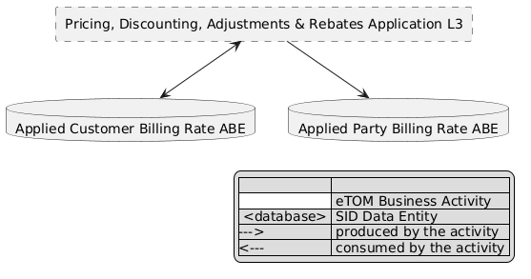
eTOM L2 - SID ABEs links diagram

Functional Framework Functions
Function ID | Function Name | Function Description | Aggregate Function Level 1 | Aggregate Function Level 2
67 | Usage Summary and Details Presentation | Usage Summary and Details Presentation present usage summary and details (billed and non-billed) for a specific time period. | Invoice Management | Invoicing
87 | Billing Event Processing Guiding | Billing Event Processing Guiding support for a consistent processing. | Invoice Management | Invoicing
316 | Billing Administration | The Billing Administration function manages the data that are necessary to perform the bill calculation: billing cycle data, management of runs, groups and cycles of invoicing. | Invoice Management | Invoicing
399 | Billing Management Integration | Billing Management Integration provide a Virtual Network Operators online access function to make them self sufficient for Billing management. Including the use of VNO/Dealer data fencing. | Invoice Management | Invoicing
32 | Billing Initialization | Billing Initialization initializes the bill and sends to the Bill Calculation application the required information for accounts that are going to be processed. | Invoice Management | Invoicing
72 | Billing Account Price Plan Determining | Billing Account Price Plan Determining associates a charge record with the appropriate price plan. | Invoice Management | Billing Account Administration
70 | Charge To Billing Account Distribution | Charge To Billing Account Distribution identifies the related prepaid or postpaid billing account for a given charge (recurring, one time, usage). | Invoice Management | Billing Account Administration
68 | Charges to Billing Statement Identification | Charges to Billing Statement Identification identifies what charges are to be included in the statement. | Invoice Management | Billing Account Administration
158 | Commitment Tracking Result Determining | Commitment Tracking Result Determining determines the outcome of the evaluation (financial benefits or penalties) in the context of the gathered data for commitment tracking. | Rating and Follow up | Bill Calculation
159 | Commitment Tracking Terms & Conditions Evaluation | Commitment Tracking Terms & Conditions Evaluation evaluates the terms and conditions in the context of the gathered data for commitment tracking. | Rating and Follow up | Bill Calculation
160 | Commitment Tracking Data Collection | Commitment Tracking Data Collection collects data to be used in the evaluation of the terms and conditions to monitor financial commitments between the customer and the provider. | Rating and Follow up | Bill Calculation
256 | Customer Bill Usage and Charges Viewing | Customer Bill Usage and Charges Viewing provides an internet technology driven interface to the customer to undertake Usage and charges comparison and unbilled charges view directly for themselves. | Rating and Follow up | Bill Calculation
89 | Billing Event Aggregation | Billing Event Aggregation is part of the Billing Event Processing to supply aggregated billing events to the Billing System. | Invoice Management | Invoicing
90 | Billing Event Processing Analyzing | Billing Event Processing Analyzing provides billing event analysis and billing event aggregations analysis to control the usage data sent to the Billing System. | Invoice Management | Invoicing
183 | Bill Charges Aggregation | Bill Charges Aggregation function determines charges (including recurring, one time and usage charges) for purchased products and services in a given bill run based on the customer price plan set at time of the customer order/contract negotiation. | Rating and Follow up | Bill Calculation
60 | Split Bill Charge Distribution | Split Bill Charge Distribution provides charge and event distribution to support a split bill. | Rating and Follow up | Tariff Calculation and Rating
184 | Currency Conversion | Currency Conversion identifies the required currency conversion if any needed to appropriately bill the customer. | Rating and Follow up | Bill Calculation
61 | On Demand Bill Calculation | On Demand Bill Calculation function will invoke a bill calculation on demand for e.g. a purchase. | Rating and Follow up | Bill Calculation
300 | Discount Calculation | Discounts Calculation determines charge discounts based on pricing plan; including discounts on recurring, one time, and usage charges. Discounts may be applied at different levels such as cross product, cross location, or cross customer (all customers that are part of a given group plan – some affiliation). The discounts can be apportioned across multiple events. | Rating and Follow up | Tariff Calculation and Rating
55 | Price and Discount Calculation | Price and Discount Calculation applies pricing and discounting rules and algorithms in the context of the assembled information concerning Products (i.e. instances of Product). | Rating and Follow up | Tariff Calculation and Rating
69 | Charge To Billing Account Identification | Charge To Billing Account Identification associates incurred charge to the billing account liable for its payment. | Invoice Management | Billing Account Administration

TM Forum Open APIs & Events
The following part covers the APIs and Events; this part is split in 3:

List of Exposed APIs - This is the list of APIs available from this component.

List of Dependent APIs - In order to satisfy the provided API, the component could require the usage of this set of required APIs.

List of Events (generated & consumed) - The events which the component may generate are listed in this section along with a list of the events which it may consume. Since there is a possibility of multiple sources and receivers for each defined event.

API Context Diagram
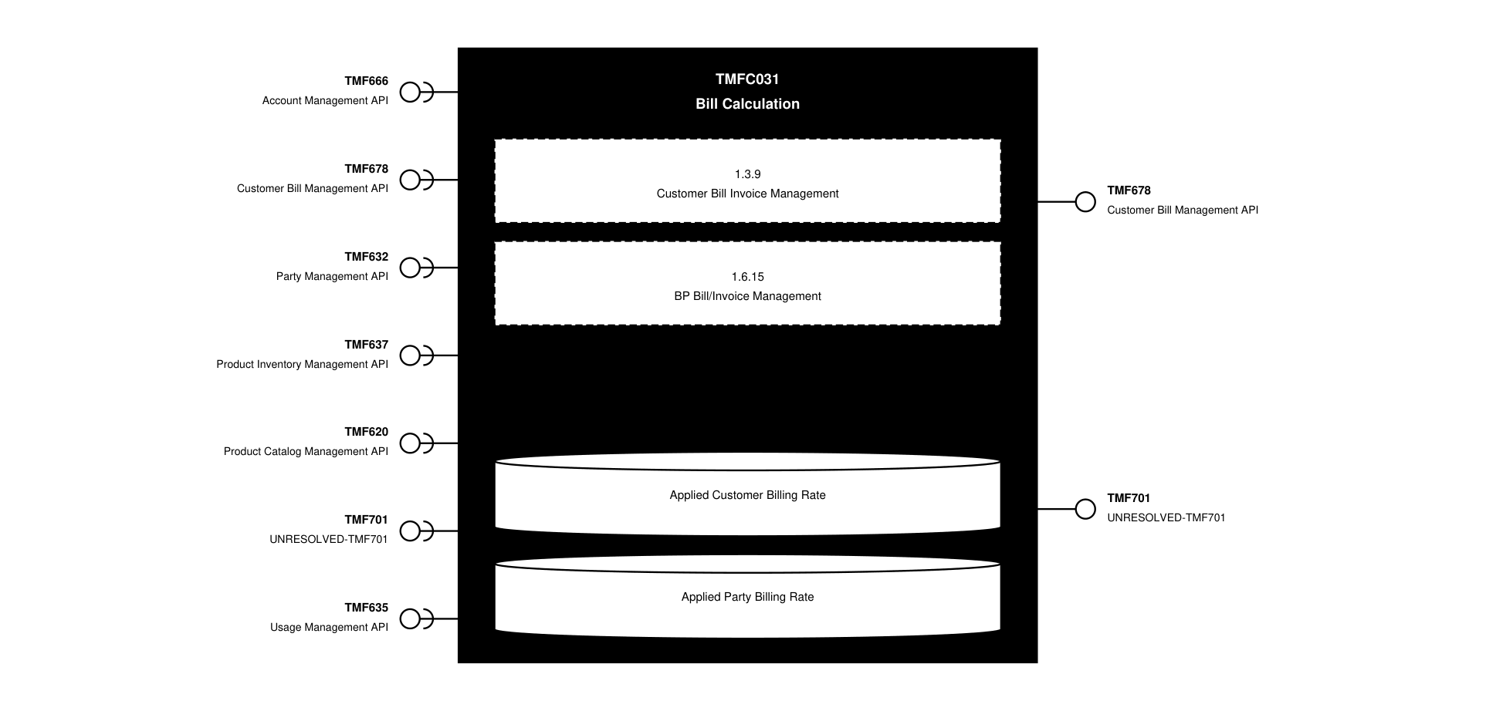
API Context diagram

Exposed APIs
API ID | API Name | Mandatory / Optional | API Version | Resource | Operations
TMF678 | Customer Bill Management API | Mandatory | 5 | appliedCustomerBillingRate | GET  GET /id
TMF678 | Customer Bill Management API | Mandatory | 4 | appliedCustomerBillingRate | GET  GET /id
TMF701 | UNRESOLVED-TMF701 | Optional | 4 | processFlow  taskFlow | GET  GET /id  POST  DELETE /id  PATCH /id

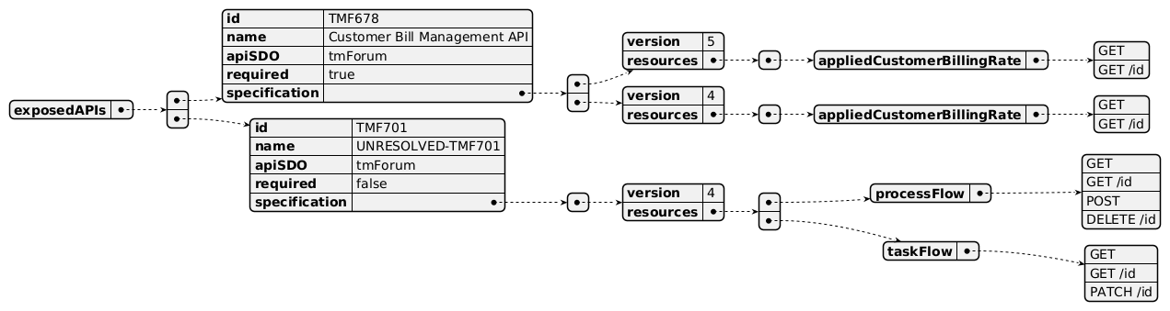
Exposed API diagram

Dependent APIs
API ID | API Name | API Version | Mandatory / Optional | Resource | Operations
TMF666 | Account Management API | 5 | Mandatory | billingAccount | GET  GET /id
TMF666 | Account Management API | 4 | Mandatory | BillingAccount | GET  GET /id
TMF678 | Customer Bill Management API | 5 | Mandatory | billingCycle | GET  GET /id
TMF632 | Party Management API | 5 | Optional | individual  organization | GET  GET /id
TMF632 | Party Management API | 4 | Optional | individual  organization | GET  GET /id
TMF637 | Product Inventory Management API | 5 | Mandatory | product | GET  GET /id
TMF637 | Product Inventory Management API | 4 | Mandatory | product | GET  GET /id
TMF620 | Product Catalog Management API | 5 | Optional | productOffering  productOfferingPrice  productSpecification | GET  GET /id
TMF620 | Product Catalog Management API | 4 | Optional | productOffering  productOfferingPrice  productSpecification | GET  GET /id
TMF701 | UNRESOLVED-TMF701 | 4 | Optional | processFlow | POST  GET  GET /id  PATCH
TMF635 | Usage Management API | 4 | Optional | usage  usageSpecification | GET  GET /id

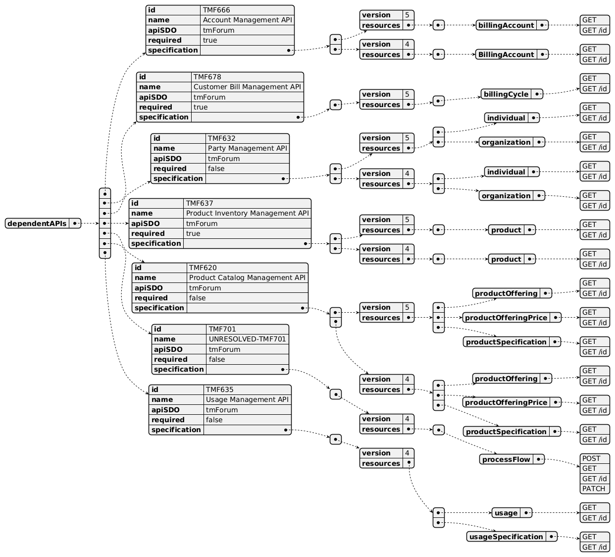
Dependent API diagram

Events
The diagram illustrates the Events which the component may publish and the Events that the component may subscribe to and then may receive. Both lists are derived from the APIs listed in the preceding sections.

Published Events
none listed in the component YAML
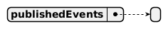
Published Events diagram

Subscribed Events
API ID | API Name | Event Resources
TMF635 | Usage Management API | UsageCreateEvent  UsageAttributeValueChangeEvent  UsageDeleteEvent  UsageStateChangeEvent  UsageSpecificationCreateEvent  UsageSpecificationAttributeValueChangeEvent  UsageSpecificationDeleteEvent

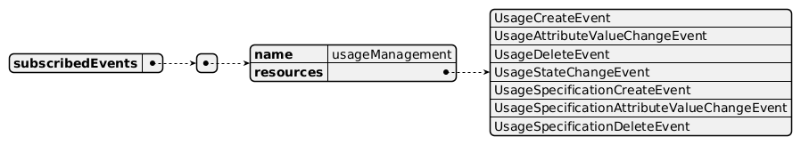
Subscribed Events diagram

Machine Readable Component Specification
Refer to the ODA Component Directory on the TM Forum website for the machine-readable component specification files for this component.

References

TMF Standards related versions
Standard | Version(s)
eTOM | v23.5
SID | v23.5.0
Functional Framework | v23.5.0.1

Jira References
SID

ISA-894 - Formalize association between ProductUsage and AppliedCustomerBillingProductUsageRate (Done): in SID, rated ProductUsage represents AppliedCustomerBillingProductUsageRate. See ticket for more details.
eTOM n/a
Functional Framework

ISA-1032 - Clarification of Bill-time fee and what types it refers to in function 58 (BACKLOG): clarification of Function 58 to understand the types of fees that are underpinned by this function - bill-time fee.

ISA-1033 - FF 73 - what type of reporting does this function cover? (BACKLOG): clarification of Function 73 to understand what type of reporting is meant by the function to determine the component to map to.

ISA-996 - Master Data Management has repurposed catalog related functions (BACKLOG): Function 6 re-purposed by Data Repository Management.
OpenAPI

AP-4740 - Formalize association between ProductUsage and AppliedCustomerBillingProductUsageRate (OPEN)

AP-5471 - TMF767 - updates for consistency with other 2 Usage APIs: 767 Product Usage (DONE): the future of Usage Management APIs moving to Product, Service & Resource from version 5.

AP-6883 - TMF678 - add POST, PATCH, DELETE operations on appliedCustomerBillingRate (BACKLOG): currently only GET operations are available for Applied Customer Billing Rate; this is a request to add POST and PATCH.
ODA Component n/a

Further resources
1. IG1228: please refer to IG1228 for defined use cases with ODA components interactions.

Administrative Appendix

Document History

Version History
Version Number | Date | Modified by | Description of changes
1.0.0 | 27-Sep-2023 | Gaetano Biancardi | First version of document
1.0.0 | 19-Dec-2023 | Amaia White | Final administrative edits
1.1.0 | 29-Jan-2024 | Elisabeth Andersson | Functional Framework added: 6 Unbilled Invoice Items Listing, 68 Charges to Billing Statement Identification, 69 Charge To Billing Account Identification, 70 Charge To Billing Account Distribution, 158 Commitment Tracking Result Determining, 159 Commitment Tracking Terms & Conditions Evaluation, 160 Commitment Tracking Data Collection, 256 Customer Bill Usage and Charges Viewing
1.1.0 | 01-Mar-2024 | Amaia White | Final administrative edits prior to release
2.0.0 | 29-May-2024 | Elisabeth Andersson, Gaetano Biancardi | Updated to the latest template; added TMF620 Product Catalog as dependent API; modified API optionality (Optional to Mandatory: TMF637, TMF669, 635; removed TMF672 and TMF688 as they will be part of Canvas Services; removed TMF669; removed the need to access billingFormat and billingPresentationMedia from TMF666; updated TMF666 billingAccount and billingCycleSpecification to only have GET and GET/id); updated to 23.5 version of frameworks; eTOM updates: removed 1.3.9.3, added 1.6.15.3.1, added higher-level descriptions for already-included lower levels for 1.6.15; FF updates: changed aggregate action levels for 158, 159, 160, 258, added 60, 61, 89, 90, 183, 184
2.0.0 | 06-Sep-2024 | Amaia White | Final administrative edits prior to publication
3.0.0 | 27-Oct-2025 | Elisabeth Andersson | Removed dependency on TMF666 for the Bill Cycle Specification and instead added TMF678 Bill Cycle operations, providing the instantiated Bill Cycle for a given period required by Bill Calculation; updated ISA-894 as resolved (in SID, rated ProductUsage represents AppliedCustomerBillingProductUsageRate); added Jira ticket dependency to TMF678 - add POST, PATCH, DELETE operations on appliedCustomerBillingRate (BACKLOG)
3.0.0 | 19-Nov-2025 | Rosie Wilson | Updated description; final administrative edits prior to publication
3.1.0 | 25-May-2026 | Hugo Vaughan | Gen 5 API updates
3.1.0 | 25-Jun-2026 | Sannah Sibaya | Final edits prior to publication

Release History
Release Status | Date Modified | Modified by | Description of changes
Pre-production | 19-Dec-2023 | Amaia White | Initial release
Pre-production | 22-Jan-2024 | Adrienne Walcott | Updated to Member Evaluated status
Pre-production | 01-Mar-2024 | Amaia White | Release of v1.1.0
Production | 26-Apr-2024 | Adrienne Walcott | Updated to reflect TM Forum Approved status
Pre-production | 06-Sep-2024 | Amaia White | Release of v2.0.0
Pre-production | 19-Nov-2025 | Rosie Wilson | Release of v3.0.0
Production | 16-Jan-2026 | Adrienne Walcott | Updated to reflect TM Forum Approved status
Pre-production | 25-Jun-2026 | Sannah Sibaya | Release of v3.1.0

Acknowledgements
This document was prepared by the members of the TM Forum ODA Components & Canvas team.
Team Member | Company | Role
Gaetano Biancardi | Accenture | Author
Sylvie Demarest | Orange | Reviewer
Elisabeth Andersson | MATRIXX | Key Contributor
Rosie Wilson | TM Forum | Editor
Julien Rouland | Orange | Key Contributor / Reviewer
Muhammad Salman Sami | Whalecloud | Reviewer
Milind Bhagwat | BT | Reviewer
Abinash Vishwakarma | Netcracker | Reviewer
Luca Icardi | Accenture | Reviewer
Kamal Maghsoudlou | Ericsson | Reviewer

