TMFC035 Permissions Management v1.2.1
Components and Canvas
In this deliverable:

Overview
Component Name | ID | Description | ODA Function Block
Permissions Management | TMFC035 | The Permissions Management component manages and exposes roles and related permissions. This component enables creation, modification and deletion of permissions and delegate permissions. When a specific role is assigned, a set of permissions is inherited. | Party Management

eTOM Processes, SID Data Entities and Functional Framework Functions

eTOM business activities
eTOM business activities this ODA Component is responsible for:
none listed in the component YAML

SID ABEs
SID ABEs this ODA Component is responsible for:
SID ABE Level 1 | SID ABE Level 2 (or set of BEs) | SID ABE L1 Definition | SID ABE L2 Definition
Permission | PermissionSpecSet | Permission ABE contains all Business Entities for describing Permission Specifications, effective Permissions granted including the scope of permissions. | PermissionSpecSet specifies a set of permissions that might concern one or many PartyRoleSpecifications. A PermissionSpecSet contains one or many ImplicitPermissionSpec.
Permission | PermissionSet | Permission ABE contains all Business Entities for describing Permission Specifications, effective Permissions granted including the scope of permissions. | Each PermissionSet may refer to a PermissionSpecSet if it corresponds to applying permissions specified for a PartyRoleSpecification. If PermissionSet corresponds to permissions granted by another PartyRole it has no relationship with a PermissionSpecSet.
Permission | Permission | Permission ABE contains all Business Entities for describing Permission Specifications, effective Permissions granted including the scope of permissions. | Permission represents permissions granted to a PartyRole that might be either implicit (ImplicitPermission) or explicit through delegation (ExplicitPermission).
Party | PartyRole | The Party ABE enables defining an individual, an organization, or an organization unit that is of interest, involved or that provides value directly or indirectly from an enterprise perspective (Enterprise is to be understood here as provider, service provider or operator). Hence the Party plays one or more roles with the enterprise or with another Party playing a role with the enterprise (indirectly). This is introduced to specify that the only party an enterprise would be interested in and will consider in its systems is a party playing a role (directly or indirectly). Roles would be represented by the PartyRole concept. Additional roles will be defined to cover the needs of the new digital ecosystem." Examples of roles played by Parties include those: Of interest, such as competitors, sales prospects Involved, such as customers, users, employees That provides value directly or indirectly, such as service providers, operators, cloud brokers, infrastructure providers, application developers. This Party ABE defines information about companies and people. Implementations of this model are responsible for ensuring that the relevant privacy legislation standards are adhered to in the countries that will use the implementation. | The part played by a party in a given con text with any characteristics, such as expected pattern of behavior, attributes, and/or associations that it entails. PartyRole should be used in places where the business refers to a Party playing a Role.
Party | PartyRoleSpecification | The Party ABE enables defining an individual, an organization, or an organization unit that is of interest, involved or that provides value directly or indirectly from an enterprise perspective (Enterprise is to be understood here as provider, service provider or operator). Hence the Party plays one or more roles with the enterprise or with another Party playing a role with the enterprise (indirectly). This is introduced to specify that the only party an enterprise would be interested in and will consider in its systems is a party playing a role (directly or indirectly). Roles would be represented by the PartyRole concept. Additional roles will be defined to cover the needs of the new digital ecosystem." Examples of roles played by Parties include those: Of interest, such as competitors, sales prospects Involved, such as customers, users, employees That provides value directly or indirectly, such as service providers, operators, cloud brokers, infrastructure providers, application developers. This Party ABE defines information about companies and people. Implementations of this model are responsible for ensuring that the relevant privacy legislation standards are adhered to in the countries that will use the implementation. | The definition of a role a party may play. this is entityone Task
Party | Party Organization | The Party ABE enables defining an individual, an organization, or an organization unit that is of interest, involved or that provides value directly or indirectly from an enterprise perspective (Enterprise is to be understood here as provider, service provider or operator). Hence the Party plays one or more roles with the enterprise or with another Party playing a role with the enterprise (indirectly). This is introduced to specify that the only party an enterprise would be interested in and will consider in its systems is a party playing a role (directly or indirectly). Roles would be represented by the PartyRole concept. Additional roles will be defined to cover the needs of the new digital ecosystem." Examples of roles played by Parties include those: Of interest, such as competitors, sales prospects Involved, such as customers, users, employees That provides value directly or indirectly, such as service providers, operators, cloud brokers, infrastructure providers, application developers. This Party ABE defines information about companies and people. Implementations of this model are responsible for ensuring that the relevant privacy legislation standards are adhered to in the countries that will use the implementation. | The Party Organization ABE is used to model Party Organization.
Market Sales Party Roles |  | Market Sales Party Roles ABE contains all PartyRoles related to the Market Sales Domain such as MarketingManager, SalesAgent... | *(no description available)*
Service Party Roles |  | The Service Party Roles ABE contains all PartyRoles related to the Service Domain such as ServiceManager. | *(no description available)*
Resource Party Roles |  | Resource Party Roles ABE contains all PartyRoles related to the Resource Domain such as Technician and ResourceManager. | *(no description available)*

eTOM L2 - SID ABEs links
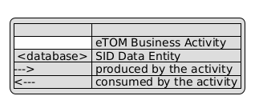
eTOM L2 - SID ABEs links diagram

Functional Framework Functions
Function ID | Function Name | Function Description | Aggregate Function Level 1 | Aggregate Function Level 2
899 | Single Sign-On Access Control | Single Sign-On Access Control grant access in cooperation with central Authentication and Authorization functions to secure the most updated security. | Identification and Permission Management | Identification and Authentication
906 | PKI and Digital Certificates Systems Integration | PKI and Digital Certificates Systems Integration provides integration to Public Key Infrastructure Systems that provides digital certificates, and the support to use public keys and digital certificates. | Identification and Permission Management | Identification and Authentication
1025 | Application Access | Application Access provides access interfaces with authentication and authorization control for the requests and responses related to the application’s functionality, including event logging and usage statistics. | Identification and Permission Management | Identification and Authentication
897 | Building Access Control | Building Access Control checks, stops or allows physical access to facilities according to access roles and rules. | Identification and Permission Management | Permission Control
900 | Authorization Control | Authorization Control Management sets and administrates the Role and Rule based access to functions. | Identification and Permission Management | Permission Control
898 | Application Security Management | Application Security Management administrates the roles and rules that applies to getting the right to use an application. | Identification and Permission Management | Permission Definition
260 | Anonymous User Account Creation | Anonymous User Account Creation provides account creation for anonymous user account, either through external customer self empowered fulfillment function or internal customer support access. | Identification and Permission Management | Digital Identity Management
1181 | Party Role Assignment | Party Role Assignment Function consists in assigning a party role to a person according to a type of role such as Customer or Payer. Sometimes a party role might be not played by a Party when unknown. For example, we might not know the Party that uses a mail box. | Identification and Permission Management | Role and Permission Assignment / Configuration
1182 | Permission Perimeter Configuration | Permission Perimeter Configuration Function consists in specifying on which perimeter the permission carried by the Party Role applies on. A perimeter defines: - either an object or a set of objects such as a Product, a Billing Account, etc. - or using selection criteria to identify objects on which permission applies such as geographical area where the Distributor has right to sell. | Identification and Permission Management | Role and Permission Assignment / Configuration

TM Forum Open APIs & Events
The following part covers the APIs and Events; this part is split in 3:

List of Exposed APIs - This is the list of APIs available from this component.

List of Dependent APIs - In order to satisfy the provided API, the component could require the usage of this set of required APIs.

List of Events (generated & consumed) - The events which the component may generate are listed in this section along with a list of the events which it may consume. Since there is a possibility of multiple sources and receivers for each defined event.

API Context Diagram
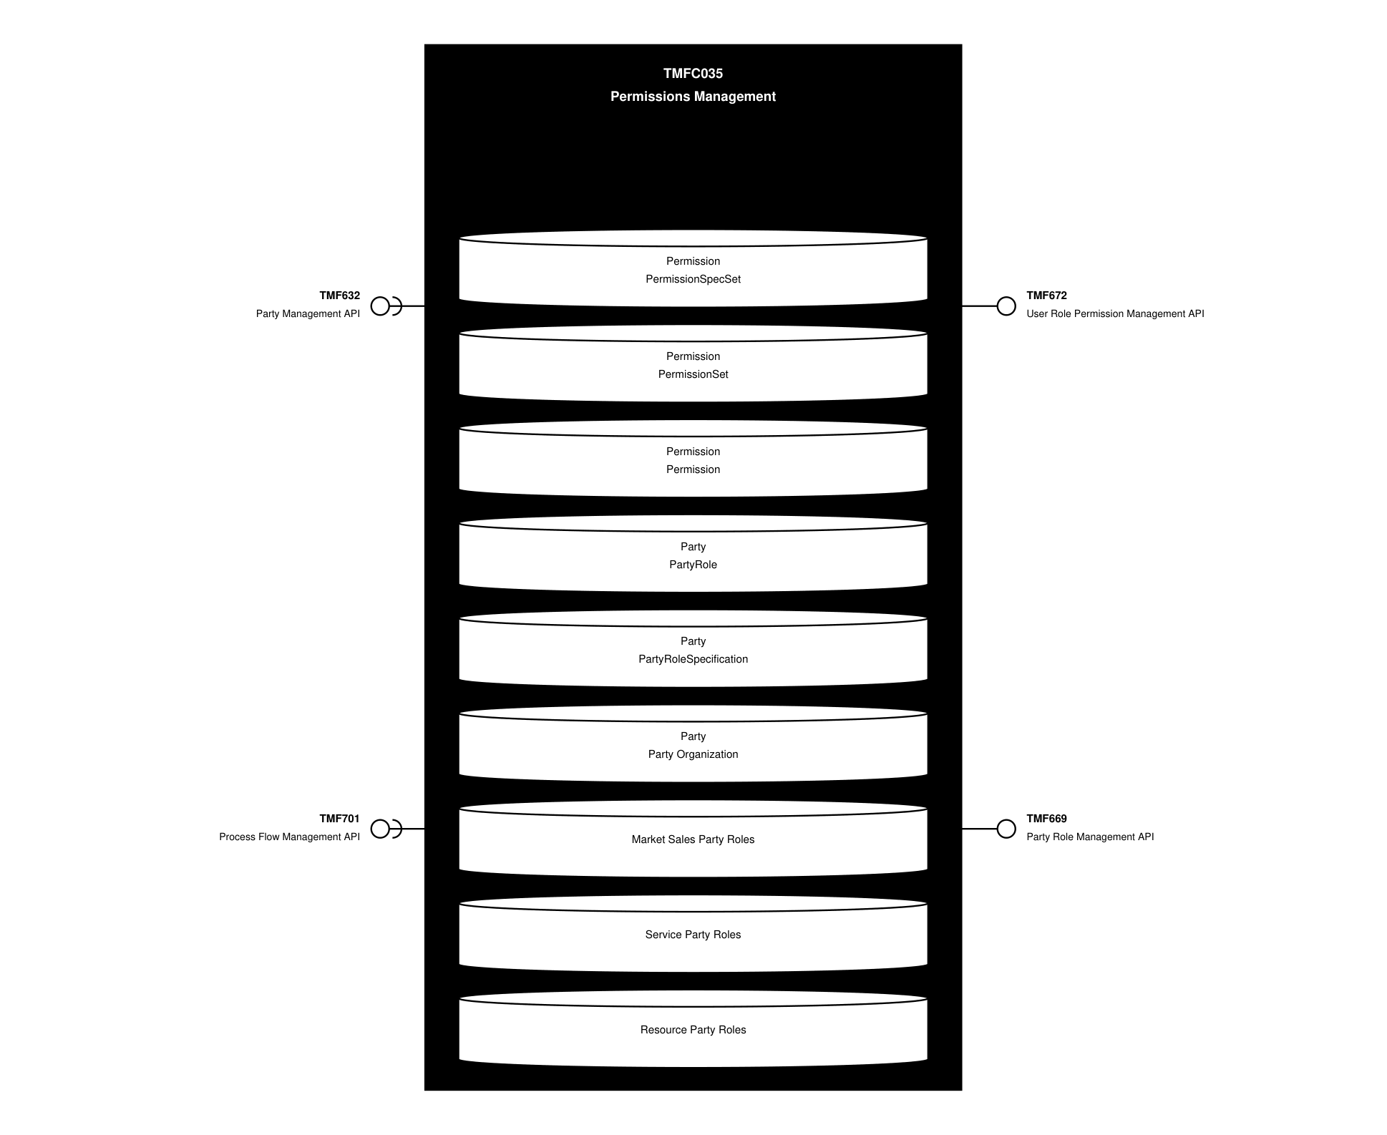
API Context diagram

Exposed APIs
API ID | API Name | Mandatory / Optional | API Version | Resource | Operations
TMF672 | User Role Permission Management API | Mandatory | 4 | permission  userRole | GET  GET /id  POST  PATCH /id  DELETE /id
TMF669 | Party Role Management API | Mandatory | 5 | partyRole | GET  GET /id  POST  PATCH /id  DELETE /id
TMF669 | Party Role Management API | Mandatory | 4 | partyRole | GET  GET /id  POST  PATCH /id  DELETE /id

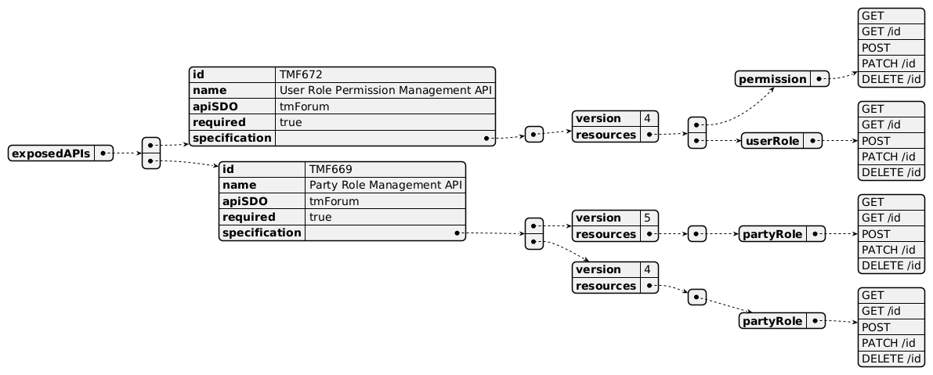
Exposed API diagram

Dependent APIs
API ID | API Name | API Version | Mandatory / Optional | Resource | Operations
TMF632 | Party Management API | 5 | Mandatory | individual  organization | GET  GET /id
TMF632 | Party Management API | 4 | Mandatory | individual  organization | GET  GET /id
TMF701 | Process Flow Management API | 4 | Optional | processFlow  taskFlow | POST  GET  GET /id  DELETE  PATCH

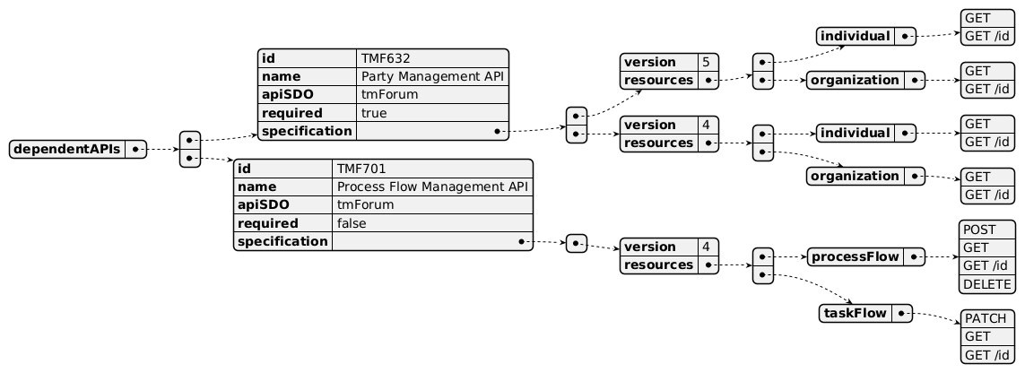
Dependent API diagram

Events
The diagram illustrates the Events which the component may publish and the Events that the component may subscribe to and then may receive. Both lists are derived from the APIs listed in the preceding sections.

Published Events
API ID | API Name | Event Resources
TMF672 | User Role Permission Management API | permissionCreateEvent  permissionAttributeValueChangeEvent  permissionStateChangeEvent  permissionDeleteEvent  userRoleCreateEvent  userRoleAttributeValueChangeEvent  userRoleStateChangeEvent  userRoleDeleteEvent
TMF669 | Party Role Management API | PartyRoleCreateEvent  PartyRoleAttributeValueChangeEvent  PartyRoleStateChangeEvent  PartyRoleDeleteEvent

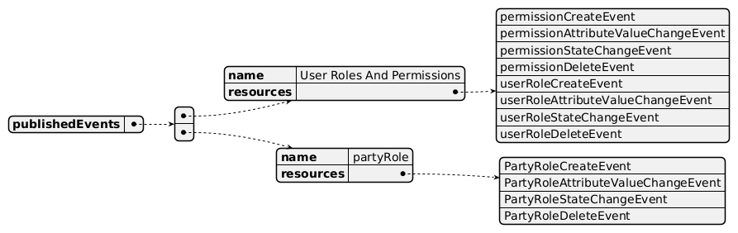
Published Events diagram

Subscribed Events
API ID | API Name | Event Resources
TMF632 | Party Management API | individualCreateEvent  individualAttributeValueChangeEvent  individualStateChangeEvent  organizationCreateEvenet  organizationAttributeValueChangeEvent  organizationStateChangeEvent
TMF701 | Process Flow Management API | processFlowCreateEvent  processFlowStateChangeEvent  taskFlowCreateEvent  taskFlowStateChangeEvent

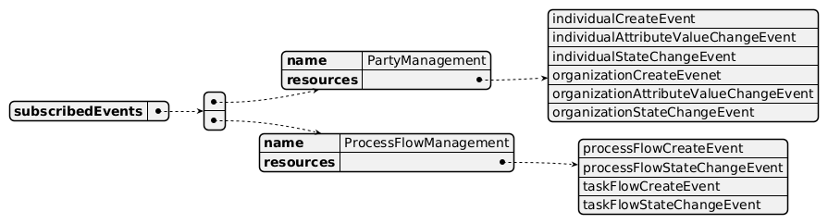
Subscribed Events diagram

Machine Readable Component Specification
Refer to the ODA Component Directory on the TM Forum website for the machine-readable component specification files for this component.

References

TMF Standards related versions
Standard | Version(s)
eTOM | *(none)*
SID | v25.0
Functional Framework | v26.0

Jira References
[ISA-758] Manage Party Roles and Permissions: enrich eTOM with business activities managing party roles specifications and permissions/permissions specifications.

Further resources
1. IG1228: please refer to IG1228 for defined use cases with ODA components interactions.

Administrative Appendix

Document History

Version History
Version Number | Date | Modified by | Description of changes
1.0.0 | 11-Jan-2023 | Matteo Destino | Initial draft for Party Role and Permissions Management Component
1.0.0 |  | Amaia White | Final edits prior to publication
1.0.1 | 25-Jul-2023 | Ian Turkington | No content changed, simply a layout change to match template 3.
1.1.0 | 27-Aug-2024 | Hugo Vaughan | Links to Frameworks confirmed for 23.5; TMF688 removed from core specification
1.1.0 | 06-Sep-2024 | Amaia White | Final edits prior to publication of v1.1.0
1.1.1 | 20-Jan-2026 | Rosie Wilson | Updates to description per agreed YAML updated on 03-Jun-2025
1.2.0 | 05-Jun-2026 | Hugo Vaughan | Gen 5 API updates
1.2.1 | 25-Jun-2026 | Sannah Sibaya | Final edits prior to publication

Release History
Release Status | Date Modified | Modified by | Description of changes
Pre-production | 14-Jun-2023 | Amaia White | Initial release of document
Pre-production | 17-Jul-2023 | Adrienne Walcott | Updated to Member Evaluated status
Pre-production | 14-Aug-2023 | Amaia White | New release v1.0.1
Production | 06-Oct-2023 | Adrienne Walcott | Updated to reflect TM Forum Approved status
Pre-production | 06-Sep-2024 | Amaia White | New release 1.1.0
Pre-production | 20-Jan-2026 | Rosie Wilson | New release 1.1.1
Pre-production | 25-Jun-2026 | Sannah Sibaya | New release 1.2.1

Acknowledgements
This document was prepared by the members of the TM Forum Component and Canvas project team.
Team Member | Company | Role
Matteo Destino | Accenture | Editor
Gaetano Biancardi | Accenture | Reviewer
Emmanuel A. Otchere | Huawei | Additional Input
David Milham | TM Forum | Additional Input
Hugo Vaughan (TM Forum) | TM Forum | Additional Input
Ian Turkington | TM Forum | Additional Input
Elisabeth Andersson | MATRIXX | Reviewer
Abinash Vishwakarma | Netcracker | Reviewer
Jose Macaluso | Xacria | Reviewer
Milind Bhagwat | BT | Reviewer
Ritu Arora | BT | Reviewer
Rosie Wilson | TM Forum | Additional Input

