TMFC036 Lead and Opportunity Management v1.3.0
Components and Canvas
In this deliverable:

Overview
Component Name | ID | Description | ODA Function Block
Lead and Opportunity Management | TMFC036 | Lead and Opportunity Management component provides the functionality for lead and opportunity capture, qualification, reporting, and support during the pre-sales stage. | Party Management

eTOM Processes, SID Data Entities and Functional Framework Functions

eTOM business activities
eTOM business activities this ODA Component is responsible for:
Identifier | Level | Business Activity Name | Description
1.1.11 | L2 | Contact/Lead/Prospect Management | Develop the appropriate relationships with contacts, leads, and prospects with the intent to convert them to consumers, such as customers, or providers, such as partners, of an enterprise's offerings.
1.1.11.1 | L3 | Manage Sales Contact | Manage all sales contacts between potential or existing parties and the enterprise.
1.1.11.2 | L3 | Manage Sales Lead | Collect and administer a sales lead and the associated probabilities of the lead becoming a prospect.
1.1.11.3 | L3 | Manage Sales Prospect | Match a sales prospect with the most appropriate products and ensure that a prospect is handled appropriately.
1.1.9 | L2 | Selling | Responsible for managing prospective customers, for qualifying and educating customers, and matching customer expectations / Managing prospective parties with whom an enterprise may do business, such as potential existing or new customers and partners, for qualifying and educating them, and ensuring their expectations are met.
1.1.9.1 | L3 | Qualify Selling Opportunity | Ensure that a sales prospect is qualified in terms of any associated risk and the amount of effort required to achieve a sale.
1.1.9.3 | L3 | Acquire Sales Prospect Data | Capture and record all pertinent sales prospect data required for qualifying an opportunity and for the initiation, realization and deployment of the agreed sales proposal.
1.1.7 | L2 | Market Sales Support & Readiness | Market Sales Support & Readiness processes ensure the support capability is in place to allow the CRM Fulfillment, Assurance and Billing processes to operate effectively.
1.1.7.2 | L3 | Support Selling | Administer and manage the operation of the various sales channels and to ensure that there is capability (for example, information, materials, systems and resources) to support the Selling processes.
1.1.7.5 | L3 | Manage Sales Accounts | Manage the sales accounts assigned to the sales channel on a day-day basis.

SID ABEs
SID ABEs this ODA Component is responsible for:
SID ABE Level 1 | SID ABE Level 2 (or set of BEs) | SID ABE L1 Definition | SID ABE L2 Definition
Sales Lead and Opportunity | Sales Lead | Sales Lead and Opportunity ABE provides the ability to track sales leads through their life cycle up until the time the prospect become customers, including proposals made to potential customers, and the amount of potential revenue the leads represent in the form of a sales pipeline. | Sales Lead ABE provides the ability to track sales leads through their lifecycle up until the time the prospect becomes a customer.
Sales Lead and Opportunity | Sales Opportunity | Sales Lead and Opportunity ABE provides the ability to track sales leads through their life cycle up until the time the prospect become customers, including proposals made to potential customers, and the amount of potential revenue the leads represent in the form of a sales pipeline. | Sales Opportunity ABE provides the ability to track pending deals and the amount of potential revenue the leads represent in the form of a sales pipeline including proposals made to potential customers.

eTOM L2 - SID ABEs links
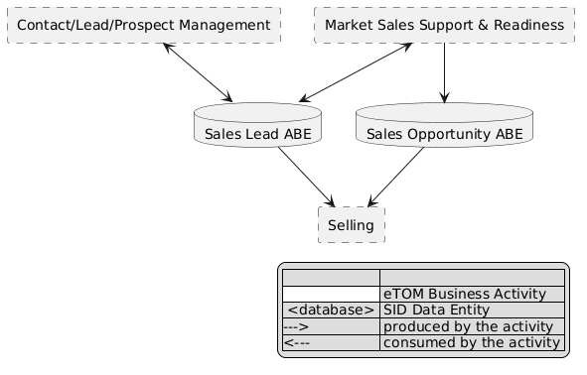
eTOM L2 - SID ABEs links diagram

Functional Framework Functions
Function ID | Function Name | Function Description | Aggregate Function Level 1 | Aggregate Function Level 2
394 | Sales Aids Support | Sales Aids Support provides job aids functions to access active aids like template or wizard types of context-aware scripting to e.g. aid lead qualification as an example. | Sales Management | Opportunity Management
372 | Sales Opportunity Management | Sales Opportunity Management creates, manages and develop sales opportunities for customers. | Sales Management | Opportunity Management
375 | Funnel Assigning | Funnel Assigning provides the necessary functionality to assign sales personnel to leads within a given funnel/pipeline. | Presales Management | Sales Lead Management
374 | Funnel Creation | Funnel Creation provides the necessary functionality to create a new sales funnel or pipeline | Presales Management | Sales Lead Management
376 | Funnel Leads Tracking | Funnel Leads Tracking provides the necessary functionality to track and manage the funnel process of the various leads and opportunities. | Presales Management | Sales Lead Management
726 | Sales Lead Capturing | Sales Lead Capturing handles the generation of leads. A lead can be generated from many sources and customer interactions including the result of a targeted marketing campaign. Potential customer information is obtained from external sources or from internally generated data. | Presales Management | Sales Lead Management

TM Forum Open APIs & Events
The following part covers the APIs and Events; this part is split in 3:

List of Exposed APIs - This is the list of APIs available from this component.

List of Dependent APIs - In order to satisfy the provided API, the component could require the usage of this set of required APIs.

List of Events (generated & consumed) - The events which the component may generate are listed in this section along with a list of the events which it may consume. Since there is a possibility of multiple sources and receivers for each defined event.

API Context Diagram
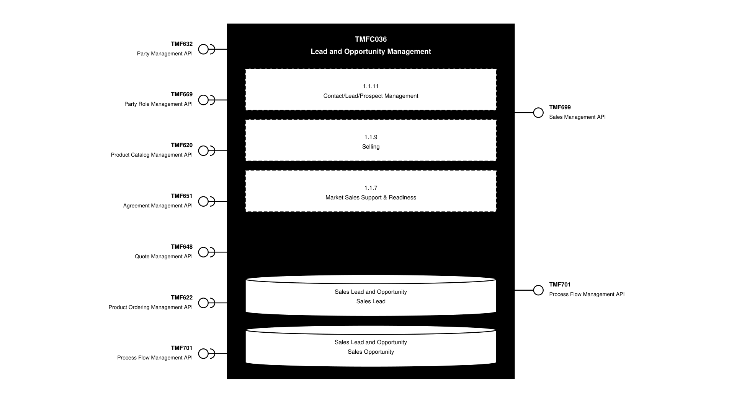
API Context diagram

Exposed APIs
API ID | API Name | Mandatory / Optional | API Version | Resource | Operations
TMF699 | Sales Management API | Mandatory | 4 | salesLead  salesOpportunity | GET  GET /id  POST  PATCH  DELETE
TMF701 | Process Flow Management API | Optional | 4 | processFlow  taskFlow | POST  GET  GET /id  DELETE  PATCH

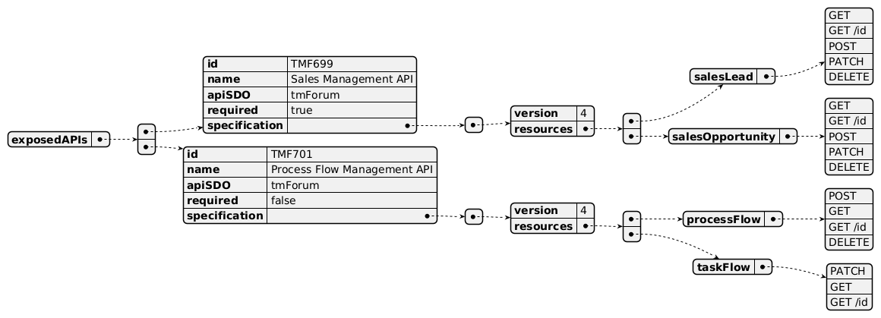
Exposed API diagram

Dependent APIs
API ID | API Name | API Version | Mandatory / Optional | Resource | Operations
TMF632 | Party Management API | 5 | Optional | individual  organization | GET  GET /id
TMF632 | Party Management API | 4 | Optional | individual  organization | GET  GET /id
TMF669 | Party Role Management API | 5 | Optional | partyRole | GET  GET /id
TMF669 | Party Role Management API | 4 | Optional | partyRole | GET  GET /id
TMF620 | Product Catalog Management API | 5 | Optional | productOffering  productOfferingPrice | GET  GET /id
TMF620 | Product Catalog Management API | 4 | Optional | productOffering  productOfferingPrice | GET  GET /id
TMF651 | Agreement Management API | 4 | Optional | agreement  agreementSpecification | GET  GET /id
TMF648 | Quote Management API | 4 | Optional | quote | GET  GET /id
TMF622 | Product Ordering Management API | 5 | Optional | productOrder | GET  GET /id
TMF622 | Product Ordering Management API | 4 | Optional | productOrder | GET  GET /id
TMF701 | Process Flow Management API | 4 | Optional | processFlow  taskFlow | POST  GET  GET /id  DELETE  PATCH

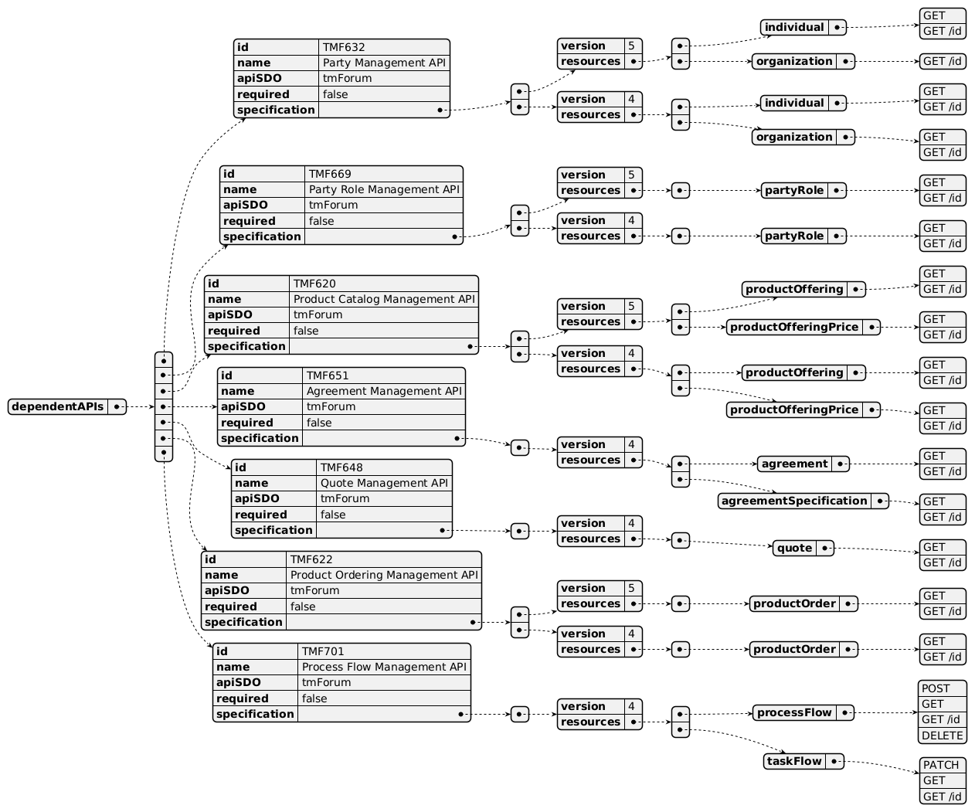
Dependent API diagram

Events
The diagram illustrates the Events which the component may publish and the Events that the component may subscribe to and then may receive. Both lists are derived from the APIs listed in the preceding sections.

Published Events
API ID | API Name | Event Resources
TMF699 | Sales Management API | SalesLeadCreateEvent  SalesLeadAttributeValueChangeEvent  SalesLeadStateChangeEvent  SalesLeadDeleteEvent  SalesOpportunityCreateEvent  SalesOpportunityAttributeValueChangeEvent  SalesOpportunityStateChangeEvent  SalesOpportunityDeleteEvent
TMF701 | Process Flow Management API | processFlowCreateEvent  processFlowStateChangeEvent  processFlowStateDeleteEvent  processFlowStateAttributeValueChangeEvent  processFlowSpecificationAttributeValueChangeEvent  processFlowSpecificationCreateEvent  processFlowSpecificationDeleteEvent  processFlowSpecificationStateChangeEvent  taskFlowCreateEvent  taskFlowStateChangeEvent  taskFlowDeleteEvent  taskFlowAttributeValueChangeEvent  taskFlowInformationRequiredEvent  taskFlowSpecificationAttributeValueChangeEvent  taskFlowSpecificationCreateEvent  taskFlowSpecificationDeleteEvent  taskFlowSpecificationStateChangeEvent

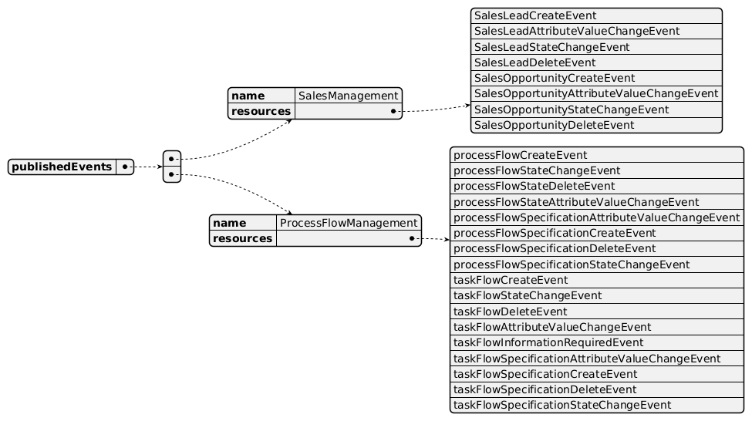
Published Events diagram

Subscribed Events
API ID | API Name | Event Resources
TMF632 | Party Management API | IndividualCreateEvent  IndividualAttributeValueChangeEvent  IndividualStateChangeEvent  IndividualDeleteEvent  OrganizationCreateEvent  OrganizationAttributeValueChangeEvent  OrganizationStateChangeEvent  OrganizationDeleteEvent
TMF620 | Product Catalog Management API | ProductOfferingCreateEvent  ProductOfferingAttributeValueChangeEvent  ProductOfferingStateChangeEvent  ProductOfferingDeleteEvent  ProductSpecificationCreateEvent  ProductSpecificationAttributeValueChangeEvent  ProductSpecificationStateChangeEvent  ProductSpecificationDeleteEvent  ProductOfferingPriceCreateEvent  ProductOfferingPriceAttributeValueChangeEvent  ProductOfferingPriceStateChangeEvent  ProductOfferingPriceDeleteEvent
TMF622 | Product Ordering Management API | ProductOrderCreateEvent  ProductOrderAttributeValueChangeEvent  ProductOrderDeleteEvent  ProductOrderStateChangeEvent  ProductOrderInformationRequiredEvent
TMF651 | Agreement Management API | AgreementCreateEvent  AgreementAttributeValueChangeEvent  AgreementStateChangeEvent  AgreementDeleteEvent  AgreementSpecificationCreateEvent  AgreementSpecificationAttributeValueChangeEvent  AgreementSpecificationStateChangeEvent  AgreementSpecificationDeleteEvent
TMF648 | Quote Management API | QuoteCreateEvent  QuoteStateChangeEvent  QuoteDeleteEvent  QuoteInformationRequiredEvent  QuoteAttributeValueChangeEvent
TMF669 | Party Role Management API | PartyRoleCreateEvent  PartyRoleAttributeValueChangeEvent  PartyRoleStateChangeEvent  PartyRoleDeleteEvent

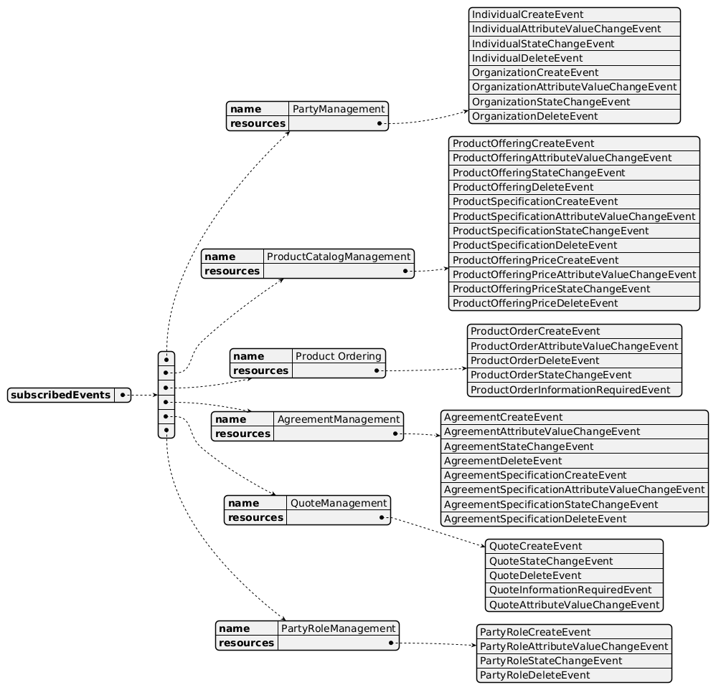
Subscribed Events diagram

Machine Readable Component Specification
Refer to the ODA Component Directory on the TM Forum website for the machine-readable component specification files for this component.

References

TMF Standards related versions
Standard | Version(s)
eTOM | v23.0
SID | v25.0
Functional Framework | v23.0

Jira References
eTOM

[ISA-710] 1.1.7.4 - Manage Sales Inventory to be reviewed: as currently defined this inventory mixes information related to Lead and Opportunities Management (sales prospects) and information related to customer orders (actual sales, sales commissions). Do we really need eTOM activities for inventories management? And if yes the scope here corresponds to historic CRM solutions we need to split in smaller pieces. This L3 needs to be reviewed and at least duplicate entries need to be deleted, and granularity of information managed needs to be improved.

[ISA-711] eTOM 1.1.9 - Selling to be reviewed: this L2 mixes activities related to Opportunity and Sales Prospects, but also others related to quotation (sales proposal) or product order initialization (cross/up-sell, negotiate sales/contract). A clearer separation is needed.
SID

[ISA-712] Sales Lead & Opportunity ABE improvements:

2 level 2 ABEs could be created for Sales Lead and for Sales Opportunity

A relationship between Sales Lead (resp. Sales Opportunity) and Customer Product Order could be added

A relationship between Sales Opportunity and Agreement could also be added
Functional Framework

[ISA-713] Functional FK - review Sales Opportunity Aggregate Function content: most of the functions classified in this Aggregate Function are not related to Sales Opportunity but to quotation or customer product order, so they need to be moved - or deleted if duplicates.
Open APIs TMF699 Sales Management API:

This API covers Sales Lead and Sales Opportunity management. Sales quotation, as announced in the introduction as covered later, is in fact already covered (or should be) by TMF648 Quote Management.

In the resource model of this API the link between Sales Opportunity and Sales Quote BEs is missing.

This API appears in the Early Adoption page only: it needs to be released soon.

Further resources
1. IG1228: please refer to IG1228 for defined use cases with ODA components interactions.

Administrative Appendix

Document History

Version History
Version Number | Date | Modified by | Description of changes
1.0.0 | 13-Apr-2023 | Amaia White | Final edits prior to publication
1.0.1 | 25-Jul-2023 | Ian Turkington | No content changed, simply a layout change to match template 3.
1.0.1 | 15-Aug-2023 | Amaia White | Final edits prior to publication
1.1.0 | 05-Aug-2024 | Gaetano Biancardi | Applied new Component Template; dependent API removed: TMF688 Event Management; exposed API removed: TMF688 Event Management
1.1.0 | 06-Sep-2024 | Amaia White | Final edits prior to publication
1.2.0 | 18-Nov-2024 | Gaetano Biancardi | API version, only major version to be specified
1.2.0 | 27-Dec-2024 | Rosie Wilson | Final edits prior to publication
1.2.1 | 09-Jul-2025 | Rosie Wilson | Updates to description per agreed YAML updated on 03-Jun-2025; final edits prior to publication

Release History
Release Status | Date Modified | Modified by | Description of changes
Pre-production | 13-Apr-2023 | Amaia White | Initial release
Pre-production | 15-May-2023 | Adrienne Walcott | Updated to Member Evaluated status
Pre-production | 15-Aug-2023 | Amaia White | New release v1.0.1
Production | 06-Oct-2023 | Adrienne Walcott | Updated to reflect TM Forum Approved status
Pre-production | 06-Sep-2024 | Amaia White | New release v1.1.0
Production | 01-Nov-2024 | Adrienne Walcott | Updated to reflect TM Forum Approved status
Pre-production | 27-Dec-2024 | Rosie Wilson | New release v1.2.0
Production | 07-Mar-2025 | Adrienne Walcott | Updated to reflect TM Forum Approved status
Pre-production | 09-Jul-2025 | Rosie Wilson | New release v1.2.1

Acknowledgements
This document was prepared by the members of the TM Forum Component and Canvas project team.
Team Member | Company | Role
Gaetano Biancardi | Accenture | Editor
Hugo Vaughan (TM Forum) | TM Forum | Additional Input
Ian Turkington | TM Forum | Additional Input
Abinash Vishwakarma | Netcracker | Reviewer
Jose Macaluso | Xacria | Reviewer
Kamal Maghsoudlou | Ericsson | Reviewer
Milind Bhagwat | BT | Reviewer
Ritu Arora | BT | Reviewer
Matteo Destino | Accenture | Reviewer
Elisabeth Andersson | MATRIXX | Reviewer

