TMFC037 Service Performance Management v1.3.0
Components and Canvas
In this deliverable:

Overview
Component Name | ID | Description | ODA Function Block
Service Performance Management | TMFC037 | Service Performance Management component monitors, analyzes, and reports on end-to-end service performance. This can include a real-time, end-to-end view to ensure that each service is functioning correctly as well as a historical view. These functions build on the Resource Performance data and active end-to-end service performance test data to provide a view of a service. The component provides a key input to determine Quality of Service. | Production

eTOM Processes, SID Data Entities and Functional Framework Functions

eTOM business activities
eTOM business activities this ODA Component is responsible for:
Identifier | Level | Business Activity Name | Description
1.4.7 | L2 | Service Performance Management | Service Performance Management business process directs and controls activities that define Service Performance Objectives (e.g. Service Availability, Service Quality, Process efficiency, Service Reliability, etc.), sets performance goals & targets, track performance trends, monitor performance, analyze performance, control performance (optimize, troubleshoot), report or communicate performance, and manage consequences of service performance. Service Performance Management business process supports the Enterprise Performance Management goals. These goals include quality, efficiency, reliability, availability, monetary (cost, profitability, etc.) mandates along with any productivity requirement of service delivery and service engagement by the organization. It includes identifying, establishing the applying the methodologies that define and manage service performance criteria to meet business objectives. / This process was renamed in 23.5 it was named Service Quality Management.
1.4.7.6 | L3 | Manage Service Performance Requirement | Manage Service Performance Requirement business activity controls activities and underlying tasks that define the performance requirements for a service. It sets the standards and expectations for service performance. / Manage Service Performance Requirement's goal is to ensure that the service meets or exceeds predefined performance standards. It involves setting service performance goals and making changes to these goals as necessary. It also includes defining the information required to measure service performance.
1.4.7.7 | L3 | Manage Service Performance Plan | Manage Service Performance Plan business activity controls the creating, implementing, improving, and terminating of plan(s) for service performance. / Manage Service Performance Plan's goal is to ensure that there is a clear and effective plan in place for managing service performance. This includes defining the plan, implementing it, making improvements to the plan over time, and terminating the plan when it is no longer needed.
1.4.7.8 | L3 | Manage Service Performance Measure | Manage Service Performance Measure business activity controls the definition, change, and removal of measures for service performance.
1.4.7.9 | L3 | Manage Service Performance Analysis | Manage Service Performance Analysis business activity controls activities and tasks supporting assessment, investigating, auditing, and reporting on service performance.
1.4.7.10 | L3 | Manage Service Performance Control | Manage Service Performance Control business activity is responsible for monitoring, evaluating, and improving service performance. / Manage Service Performance Control's goal is to maintain control over service performance. This includes monitoring performance on an ongoing basis, evaluating whether performance goals are being met, and providing support for making improvements as necessary.
1.4.7.11 | L3 | Manage Service Performance Reporting | Manage Service Performance Reporting business activity is responsible for creating, changing, and publishing reports on service performance. / Manage Service Performance Reporting's goal is to communicate information about service performance to relevant stakeholders. This includes creating reports that accurately reflect current performance levels, making changes to these reports as necessary, and publishing these reports in a timely manner.

SID ABEs
SID ABEs this ODA Component is responsible for:
SID ABE Level 1 | SID ABE Level 2 (or set of BEs) | SID ABE L1 Definition | SID ABE L2 Definition
Service Performance |  | The Service Performance ABE collects information used to correlate, consolidate, and validate various performance statistics and other operational characteristics of Know-Hows (a.k.a. CFS) and Technical Solutions (a.k.a. RFS). It provides a set of entities that enables performance monitoring and reporting. Each of these entities also enables network performance assessment against planned goals, performs various aspects of trend analysis, including error rate and cause analysis and Service degradation. Entities in this ABE also enable the traffic trend analysis. | *(no description available)*
Performance | MeasurementProductionJob | *(no description available)* | *(no description available)*
Performance | AdhocCollection | *(no description available)* | *(no description available)*
Performance | MeasurementCollectionJob | *(no description available)* | *(no description available)*
Performance | Performance Threshold | The Performance ABE is a pattern that represents a measure of the manner in which a Product and/or Service and/or Resource is functioning. | *(no description available)*
Resource Trouble | Alarm | The Resource Trouble ABE collects information about problems found in allocated resource instances, regardless of whether the problem is physical or logical. Entities in this ABE capture detection, root cause, and resoluiton of these problems and maintain a history of the activities involved in diagnosing and solving the problem. This history includes tracking, reporting, assigning people to fix the problem, testing and verification, and overall administration of repair activities. | *(no description available)*

eTOM L2 - SID ABEs links
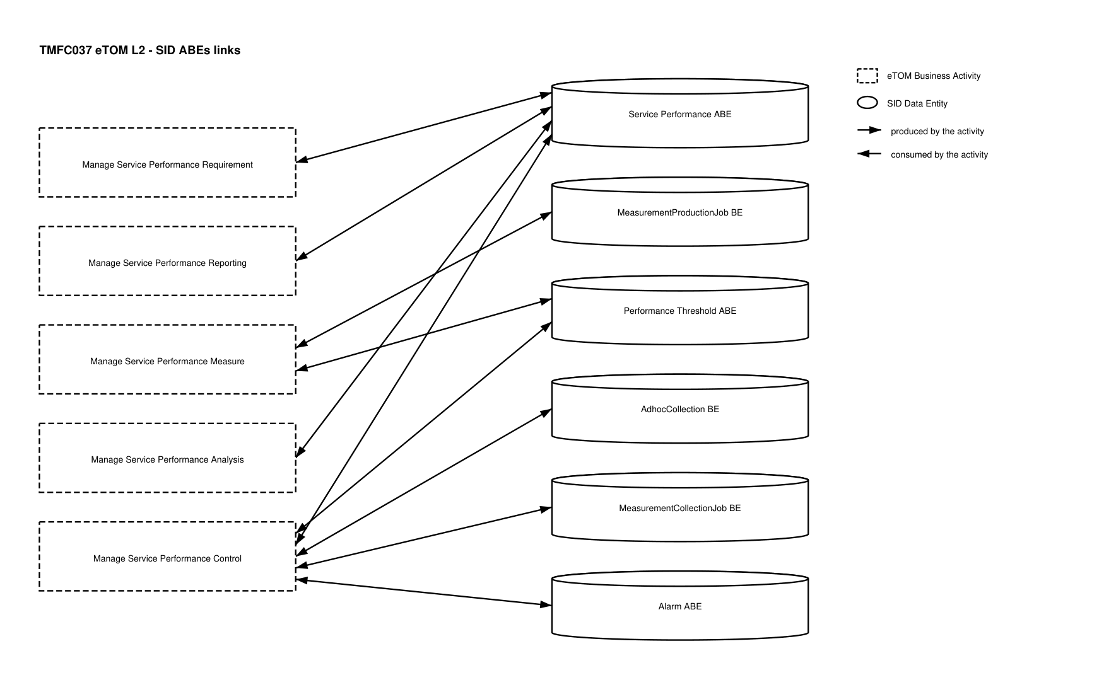
eTOM L2 - SID ABEs links diagram

Functional Framework Functions
Function ID | Function Name | Function Description | Aggregate Function Level 1 | Aggregate Function Level 2
603 | Service Performance Data Collection | Service Performance Data Collection collects Service Performance Data from the Resource Management functions related to a specific Service (or directly in the absence of Resource Performance Management function) and Collection of Service Performance data from the end-to-end tests done by the service test functions internally or from external Service Test applications. Including archiving. | Service Quality and Performance Management | Service Quality and Performance Inventory Management
604 | Service Performance Event Correlation | Service Performance Event Correlation maps the performance data to service topology and identifies service related performance problems, event filtering included. | Service Quality and Performance Management | Service Quality and Performance Analysis
605 | Service Performance Monitoring | Service Performance Monitoring provides monitoring of service performance data including notification and accumulation for e.g. Service Performance Dashboard. | Service Quality and Performance Management | Service Quality and Performance Analysis
606 | Service Performance Reporting | Service Performance Reporting provides the necessary functionality required to generate reports about the performance of the service provider's services. These reports may be generated as part of the normal periodic operations ("scheduled") or may be as a result of a specific analysis request ("in-demand"). Report types include near real time, historical view, and trend analysis. Relevant performance reports are also provided to service/network planning to perform network updates. | *(no description available)* | Service Quality and Performance Inventory Management

TM Forum Open APIs & Events
The following part covers the APIs and Events; this part is split in 3:

List of Exposed APIs - This is the list of APIs available from this component.

List of Dependent APIs - In order to satisfy the provided API, the component could require the usage of this set of required APIs.

List of Events (generated & consumed) - The events which the component may generate are listed in this section along with a list of the events which it may consume. Since there is a possibility of multiple sources and receivers for each defined event.

API Context Diagram
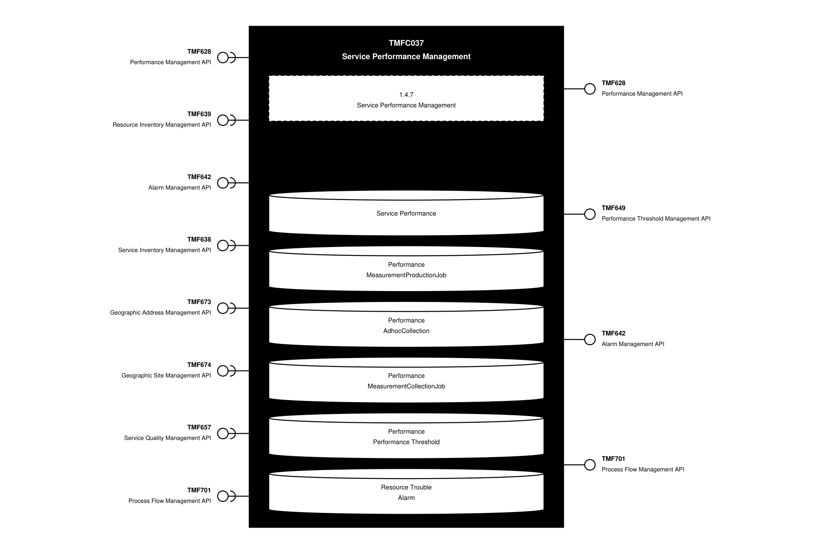
API Context diagram

Exposed APIs
API ID | API Name | Mandatory / Optional | API Version | Resource | Operations
TMF628 | Performance Management API | Mandatory | 5 | measurementCollectionJob  onDemandCollection  performanceIndicatorGroupSpecification  performanceIndicatorSpecification  trackingRecord | POST  GET  GET /id  PATCH /id  DELETE /id
TMF649 | Performance Threshold Management API | Mandatory | 4 | threshold  thresholdJob | POST  GET  GET /id  PATCH /id  DELETE /id
TMF642 | Alarm Management API | Optional | 5 | alarm | GET  GET /id  POST
TMF642 | Alarm Management API | Optional | 4 | alarm | POST  GET  GET /id  PATCH /id  DELETE /id
TMF701 | Process Flow Management API | Optional | 4 | processFlow  taskFlow | POST  GET  GET /id  DELETE  PATCH

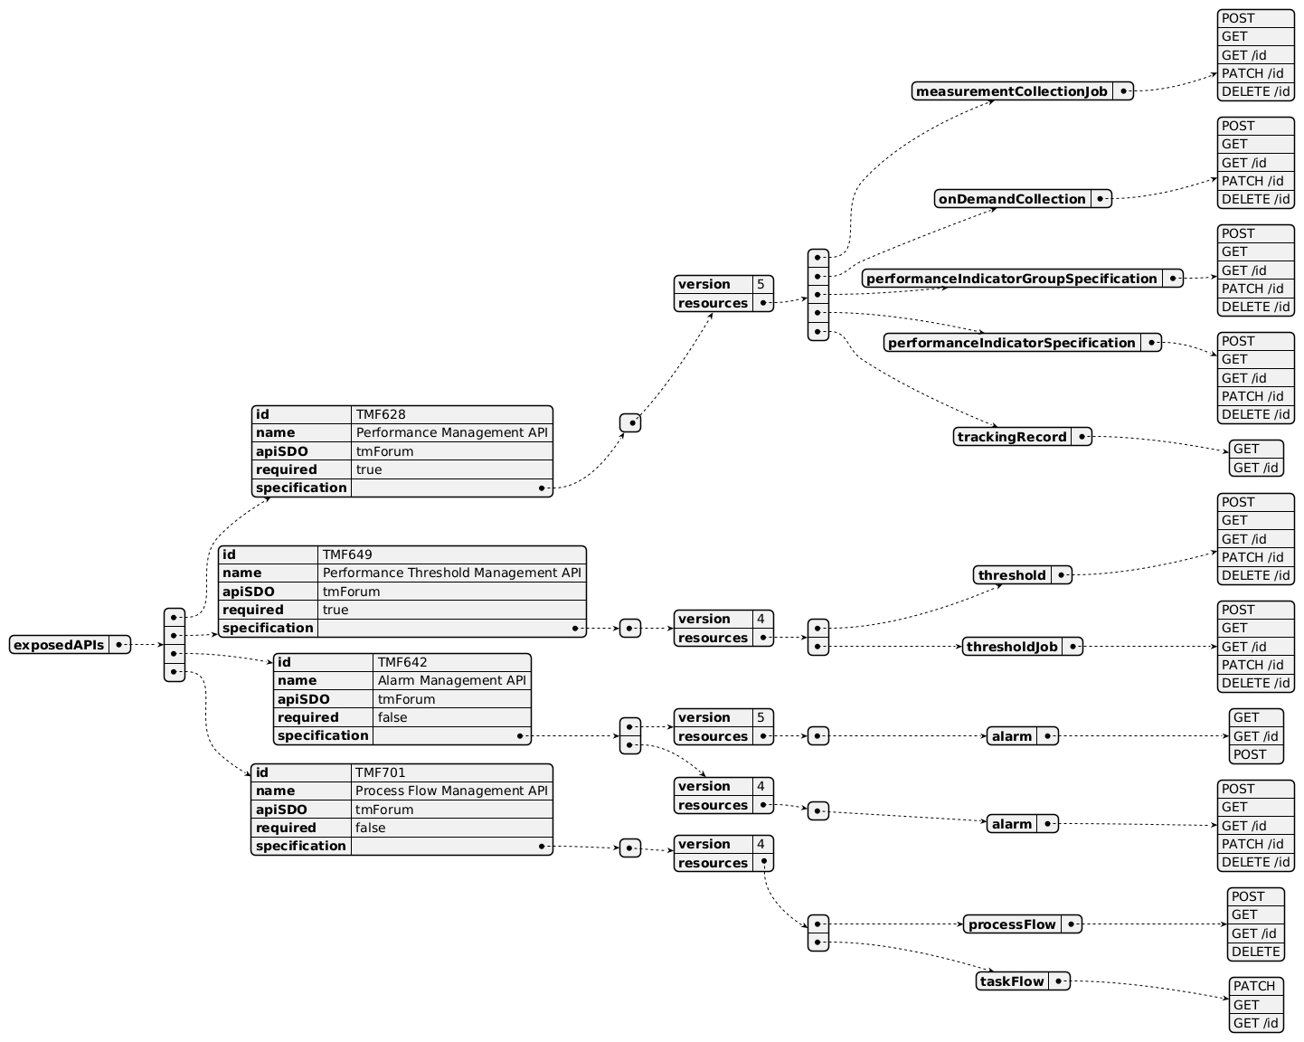
Exposed API diagram

Dependent APIs
API ID | API Name | API Version | Mandatory / Optional | Resource | Operations
TMF628 | Performance Management API | 5 | Optional | measurementCollectionJob  onDemandCollection  performanceIndicatorGroupSpecification  performanceIndicatorSpecification  trackingRecord | POST  GET  GET /id  PATCH /id  DELETE /id
TMF639 | Resource Inventory Management API | 4 | Optional | resource | GET  GET /id
TMF642 | Alarm Management API | 4 | Optional | alarm | GET  GET /id
TMF638 | Service Inventory Management API | 5 | Mandatory | service | GET  GET /id
TMF638 | Service Inventory Management API | 4 | Mandatory | service | GET  GET /id
TMF673 | Geographic Address Management API | 4 | Optional | geographicAddress  geographicSubAddress | GET  GET /id
TMF674 | Geographic Site Management API | 4 | Optional | geographicSite | GET  GET /id
TMF657 | Service Quality Management API | 4 | Optional | serviceLevelObjective  serviceLevelSpecification | GET  GET /id
TMF701 | Process Flow Management API | 4 | Optional | processFlow  taskFlow | POST  GET  GET /id  DELETE  PATCH

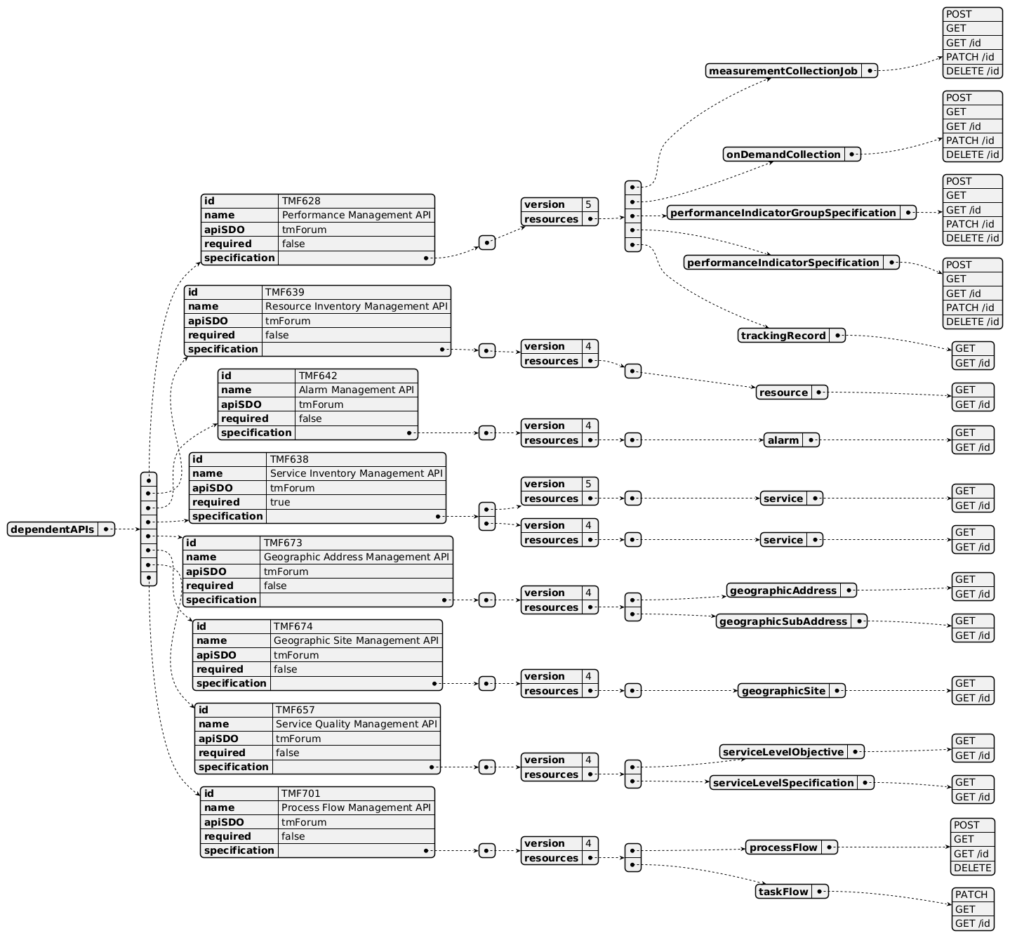
Dependent API diagram

Events
The diagram illustrates the Events which the component may publish and the Events that the component may subscribe to and then may receive. Both lists are derived from the APIs listed in the preceding sections.

Published Events
API ID | API Name | Event Resources
TMF701 | Process Flow Management API | processFlowCreateEvent  processFlowStateChangeEvent  processFlowStateDeleteEvent  processFlowStateAttributeValueChangeEvent  taskFlowCreateEvent  taskFlowStateChangeEvent  taskFlowDeleteEvent  taskFlowAttributeValueChangeEvent  taskFlowInformationRequiredEvent
TMF642 | Alarm Management API | alarmStateChange<br>alarmCreateEvent  alarmClearEvent<br>alarmAckEvent
TMF628 | Performance Management API | measurementCollectionJobCreateEvent  measurementCollectionJobExecutionStateChangeEvent  measurementCollectionJobDeleteEvent  measurementCollectionJobAttributeValueChangeEvent  measurementCollectionJobFilesReadyEvent  measurementCollectionJobFilesPreparationErrorEvent  onDemandCollectionCreateEvent  onDemandCollectionExecutionStateChangeEvent  onDemandCollectionDeleteEvent  onDemandCollectionAttributeValueChangeEvent  onDemandCollectionFilesReadyEvent  onDemandCollectionFilesPreparationErrorEvent
TMF649 | Performance Threshold Management API | thresholdCreateNotification  thresholdChangeNotification  thresholdRuleCreateNotification  thresholdRuleChangedNotification  thresholdJobCreateNotification  thresholdJobChangedNotification  thresholdJobSuspendNotification  thresholdJobResumeNotification

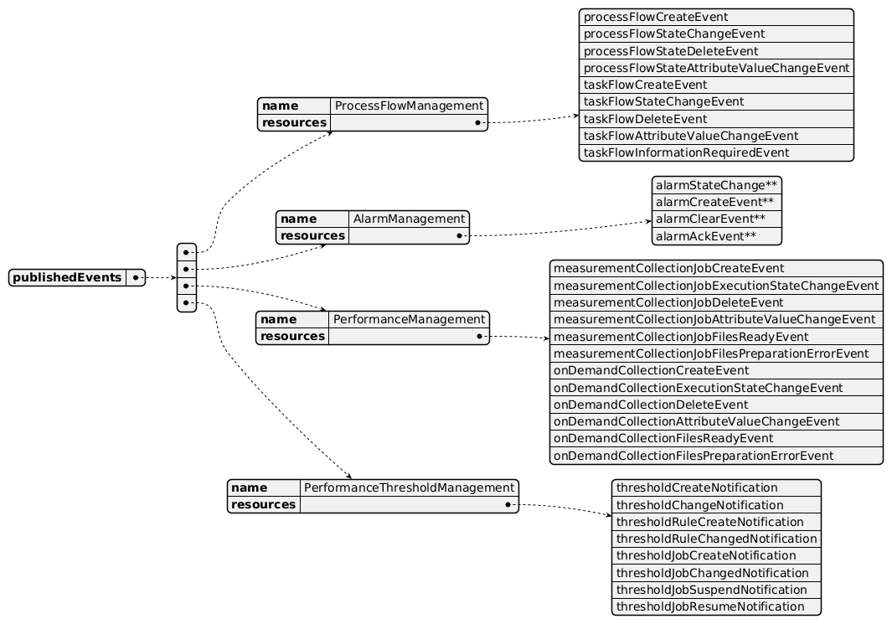
Published Events diagram

Subscribed Events
API ID | API Name | Event Resources
TMF633 | Service Catalog Management API | serviceSpecificationChangeEvent
TMF638 | Service Inventory Management API | serviceCreateEvent  serviceAttributeValueChangeEvent  serviceStateChangeEvent  serviceDeleteEvent
TMF639 | Resource Inventory Management API | resourceCreateEvent  resourceAttributeValueChangeEvent  resourceStateChangeEvent  resourceDeleteEvent
TMF701 | Process Flow Management API | processFlowCreateEvent  processFlowStateChangeEvent  taskFlowCreateEvent  taskFlowStateChangeEvent

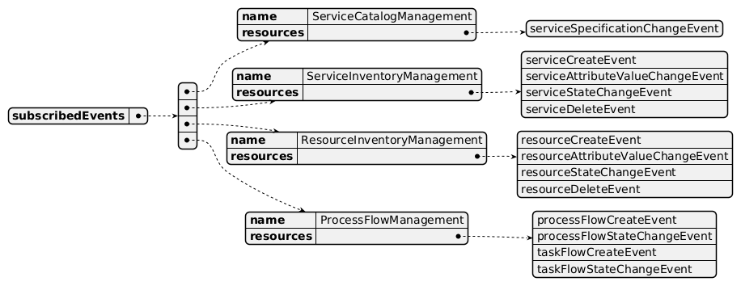
Subscribed Events diagram

Machine Readable Component Specification
Refer to the ODA Component Directory on the TM Forum website for the machine-readable component specification files for this component.

References

TMF Standards related versions
Standard | Version(s)
eTOM | v25.0
SID | v25.0
Functional Framework | v25.0

Jira References
eTOM *(none currently listed)*
SID

ISA-693 Alarm ABE is currently at Resource level. We also need Alarm at Service Level.

ISA-1319 Performance ABE is a pattern, and we need performance at Resource and Service Level.
Open API

AP-4257 TMF649 is in preview state. We need to publish an API to set Thresholds for Performance Management.

TMFC037 and TMFC038 currently expose the same API - TMF628 Performance Management API - which violates the ODA component principle stating that a single Open API specification must be exposed by only one ODA component. This issue needs to be addressed.

Further resources

IG1228: please refer to IG1228 for defined use cases with ODA components interactions.

Administrative Appendix

Document History

Version History
Version Number | Date | Modified by | Description of changes
1.0.0 | 13-Apr-2023 | Amaia White | Final edits prior to publication
1.0.1 | 25-Jul-2023 | Ian Turkington | No content changed, simply a layout change to match template 3. Separated the YAML files to a managed repository.
1.0.1 | 14-Aug-2023 | Amaia White | Final edits prior to publication
1.1.0 | 13-Aug-2024 | Milind Bhagwat | Moved to new template
1.1.0 | 06-Sep-2024 | Amaia White | Final edits prior to publication
1.2.0 | 17-Dec-2024 | Milind Bhagwat | Update to remove event API
1.2.0 | 27-Dec-2024 | Rosie Wilson | Final edits prior to publication
1.2.1 | 03-Jun-2025 | Gaetano Biancardi | TMF638 Service Inventory Management API: diagram correction to mark it as mandatory (was already mandatory in the table)
1.2.1 | 15-Jul-2025 | Milind Bhagwat | Added new eTOM business activities; updated table and diagrams for API versions; responded to some comments
1.2.1 | 15-Sep-2025 | Rosie Wilson | Updated Maturity Level to Beta as asset contains Preview APIs; final edits prior to publication
1.3.0 | 05-Jun-2026 | Hugo Vaughan | Gen 5 API updates
1.3.0 | 25-Jun-2026 | Sannah Sibaya | Final edits prior to publication

Release History
Release Status | Date Modified | Modified by | Description of changes
Pre-production | 13-Apr-2023 | Amaia White | First release
Pre-production | 15-May-2023 | Adrienne Walcott | Updated to Member Evaluated status
Pre-production | 14-Aug-2023 | Amaia White | New release 1.0.1
Production | 06-Oct-2023 | Adrienne Walcott | Updated to reflect TM Forum Approved status
Pre-production | 06-Sep-2024 | Amaia White | New release 1.1.0
Production | 01-Nov-2024 | Adrienne Walcott | Updated to reflect TM Forum Approved status
Pre-production | 18-Dec-2024 | Rosie Wilson | New release 1.2.0
Production | 07-Mar-2025 | Adrienne Walcott | Updated to reflect TM Forum Approved status
Pre-production | 15-Sep-2025 | Rosie Wilson | New release 1.2.1
Pre-production | 25-Jun-2026 | Sannah Sibaya | New release 1.3.0

Acknowledgements
This document was prepared by the members of the TM Forum Component and Canvas project team.
Team Member | Company | Role
Milind Bhagwat | BT | Editor
Matteo Destino | Accenture | Reviewer
Gaetano Biancardi | Accenture | Reviewer
Hugo Vaughan (TM Forum) | TM Forum | Additional Input
Ian Turkington | TM Forum | Additional Input
Julien Rouland | Orange | Reviewer
Elisabeth Andersson | MATRIXX | Reviewer
Andres Zoque | Netcracker | Reviewer
Kamal Maghsoudlou | Ericsson | Reviewer
Johan Snyman | CSGI | Reviewer
Rosie Wilson | TM Forum | Additional Input

