TMFC038 Resource Performance Management v1.3.0
Components and Canvas
In this deliverable:

Overview
Component Name | ID | Description | ODA Function Block
Resource Performance Management | TMFC038 | Resource Performance Management component monitors, analyzes, and reports on the performance of the service provider's resources. | Production

eTOM Processes, SID Data Entities and Functional Framework Functions

eTOM business activities
eTOM business activities this ODA Component is responsible for:
Identifier | Level | Business Activity Name | Description
1.5.4 | L2 | Resource Readiness and Support | Resource Readiness & Support processes are responsible for managing resource infrastructure to ensure that appropriate application, computing and network resources are available and ready to support the Fulfillment, Assurance and Billing processes in instantiating and managing resource instances, and for monitoring and reporting on the capabilities and costs of the individual FAB processes. / Responsibilities of these processes include but are not limited to: / • Supporting the operational introduction of new and/or modified resource infrastructure and conducting operations readiness testing and acceptance; / • Managing planned outages; / • Managing and ensuring the ongoing quality of the Resource Inventory; / • Analyzing availability and performance over time on resources or groups of resources, including trend analysis and forecasting; / • Demand balancing in order to maintain resource capacity and performance / • Performing proactive maintenance and repair activities; / • Establishing and managing the workforce to support the eTOM processes / • Managing spares, repairs, warehousing, transport and distribution of resources and consumable goods. / • Conducting Vulnerability Management; / • Conducting Threat Assessments; / • Conducting Risk Assessments; / • Conducting Risk Mitigation; / • Conducting Secure Configuration Activities
1.5.4.2 | L3 | Enable Resource Performance Management | The responsibilities of the Enable Resource Performance Management processes are twofold - support Resource Performance Management processes by proactively monitoring and assessing resource infrastructure performance, and monitoring, managing and reporting on the capability of the Resource Performance Management processes. / / Proactive management is undertaken using a range of performance parameters, whether technical, time, economic or process related. / / The responsibilities of the processes include, but are not limited to: / / • Undertaking proactive monitoring regimes of resource infrastructure as required to ensure ongoing performance within agreed parameters over time; / • Developing and maintaining a repository of acceptable performance threshold standards for resource instances to support the Resource Performance Management processes; / • Undertaking trend analysis, and producing reports, of the performance of resource infrastructure to identify any longer term deterioration; / • Monitoring and analyzing the resource instance analyzes produced by the Resource Performance Management processes to identify problems that may be applicable to the resource infrastructure as a whole; / • Sourcing details relating to resource instance performance and analysis from the resource inventory to assist in the development of trend analyzes; / • Logging the results of the analysis into the resource inventory repository; / • Establishing and managing resource performance data collection schedules, including managing the collection of the necessary information from the Resource Data Collection & Distribution processes, to support proactive monitoring and analysis activity, and requests from Resource Performance / / Management processes for additional data to support resource instance performance analysis; / • Establishing and managing facilities to support management of planned resource infrastructure and resource instance outages; / • Establishing, maintaining and managing the testing of resource performance control plans to cater for anticipated resource performance disruptions; / • Proactively triggering the instantiation of control plans to manage performance through programmed and/or foreseen potentially disruptive events, i.e. anticipated traffic loads on Xmas day, planned outages, etc.; / • Tracking and monitoring of the Resource Performance Management processes and associated costs (including where resource infrastructure is deployed and managed by third parties), and reporting on the capability of the Resource Performance Management processes; / • Establishing and managing resource performance notification facilities and lists to support the Resource Performance Management notification and reporting processes / • Supporting the Support Service Quality Management process.
1.5.9 | L2 | Resource Performance Management | Resource Performance Management processes encompass managing, tracking, monitoring, analyzing, controlling and reporting on the performance of specific resources. They work with basic information received from the Resource Data Collection & Distribution processes. / / If the analysis identifies a resource performance violation or a potential service performance violation, information will be passed to Resource Trouble Management and/or Service Quality Management as appropriate. The latter processes are responsible for deciding on and carrying out the appropriate action/response. This may include requests to the Resource Performance Management processes to install controls to optimize the specific resource performance. / The Resource Performance Management processes will continue to track the resource performance problem, ensuring that resource performance is restored to a level required to support services.
1.5.9.1 | L3 | Monitor Resource Performance | The objective of the Monitor Resource Performance processes is to monitor received resource performance information and undertake first-in detection. / The responsibilities of the processes include, but are not limited to: / •Undertaking the role of first in detection by monitoring the received specific resource performance data; / •Comparing the received specific resource performance data to performance standards set for each specific resource (available from the Resource Inventory); / •Assessing and recording received specific resource performance data which is within tolerance limits for performance standards, and for which continuous monitoring and measuring of specific resource performance is required; / •Recording the results of the continuous monitoring for reporting through the Report Resource Performance processes; / •Detecting performance threshold violations which represent specific resource failures due to abnormal performance; / •Passing information about resource failures due to performance threshold violations to Resource Trouble Management to manage any necessary restoration activity as determined by that process; / •Passing information about potential specific service performance degradations arising from specific resource degradations to Service Quality Management to manage any necessary restoration activity as determined by that process; / •Detecting performance degradation for specific resources which provide early warning of potential issues; / •Forwarding resource performance degradation notifications to other Resource Performance Management processes, which manage activities to restore normal specific resource performance / •Logging specific resource performance degradation and violation details within the repository in the Manage Resource Inventory processes to ensure historical records are available to support the needs of other processes.
1.5.9.2 | L3 | Analyze Resource Performance | The objective of the Analyze Resource Performance processes is to analyze the information received from the Monitor Resource Performance process to evaluate the performance of a specific resource. / / The responsibilities of the processes include, but are not limited to: / •Undertaking analysis as required on specific resource performance information received from the Monitor Resource Performance processes; / •Initiating, modifying and cancelling continuous performance data collection schedules for specific resources required to analyze specific resource performance. These schedules are established through requests sent to the Enable Resource Data Collection & Distribution processes; / •Determining the root causes of specific resource performance degradations and violations; / •Recording the results of the analysis and intermediate updates in the Resource Inventory for historical analysis and for use as required by other processes / •Undertaking specific detailed analysis (if the original requested came from Service Quality Management processes) to discover the root cause of service performance degradations that may be arising due to interactions between resource instances, without any specific resource instance having an unacceptable performance in its own right.
1.5.9.4 | L3 | Report Resource Performance | The objective of the Report Resource Performance processes is to monitor the status of resource performance degradation reports, provide notifications of any changes and provide management reports. / These processes are responsible for continuously monitoring the status of resource performance degradation reports and managing notifications to other processes in the Resource-Ops and other layers, and to other parties registered to receive notifications of any status changes. Notification lists are managed and maintained by the Enable Resource Performance Management processes. / These processes record, analyze and assess the resource performance degradation report status changes to provide management reports and any specialized summaries of the efficiency and effectiveness of the overall Resource Performance Management process. These specialized summaries could be specific reports required by specific audiences.
1.5.9.5 | L3 | Create Resource Performance Degradation Report | The objective of the Create Resource Performance Degradation Report process is to create a new resource performance degradation report, modify existing resource performance degradation reports, and request cancellation of existing resource performance degradation reports. / A new resource performance degradation report may be created as a result of specific resource performance notifications undertaken by the Monitor Resource Performance processes, or at the request of analysis undertaken by other Service-Ops or Resource-Ops or party management processes which detect that some form of deterioration or failure has occurred requires an assessment of the specific resource performance. / If the resource performance degradation report is created as a result of a notification or request from processes other than Monitor Resource Performance processes, the Create Resource Performance Degradation Report processes are responsible for converting the received information into a form suitable for the Resource Performance Management processes, and for requesting additional information if required.
1.5.9.7 | L3 | Close Resource Performance Degradation Report | Close a resource performance degradation report when the resource performance has been resolved

SID ABEs
SID ABEs this ODA Component is responsible for:
SID ABE Level 1 | SID ABE Level 2 (or set of BEs) | SID ABE L1 Definition | SID ABE L2 Definition
Resource Performance |  | The Resource Performance ABE collects information used to correlate, consolidate, and validate various performance statistics and other operational characteristics of Resources. Each of these entities also enables network performance assessment against planned goals, performs various aspects of trend analysis, including error rate and cause analysis and Resource degradation. Entities in this ABE also includes statistics defining Resource loading, and traffic trend analysis. | *(no description available)*
Performance | MeasurementProductionJob | *(no description available)* | *(no description available)*
Performance | AdhocCollection | *(no description available)* | *(no description available)*
Performance | MeasurementCollectionJob | *(no description available)* | *(no description available)*
Performance | Performance Threshold | The Performance ABE is a pattern that represents a measure of the manner in which a Product and/or Service and/or Resource is functioning. | *(no description available)*
Resource Trouble | Alarm | The Resource Trouble ABE collects information about problems found in allocated resource instances, regardless of whether the problem is physical or logical. Entities in this ABE capture detection, root cause, and resoluiton of these problems and maintain a history of the activities involved in diagnosing and solving the problem. This history includes tracking, reporting, assigning people to fix the problem, testing and verification, and overall administration of repair activities. | *(no description available)*

eTOM L2 - SID ABEs links
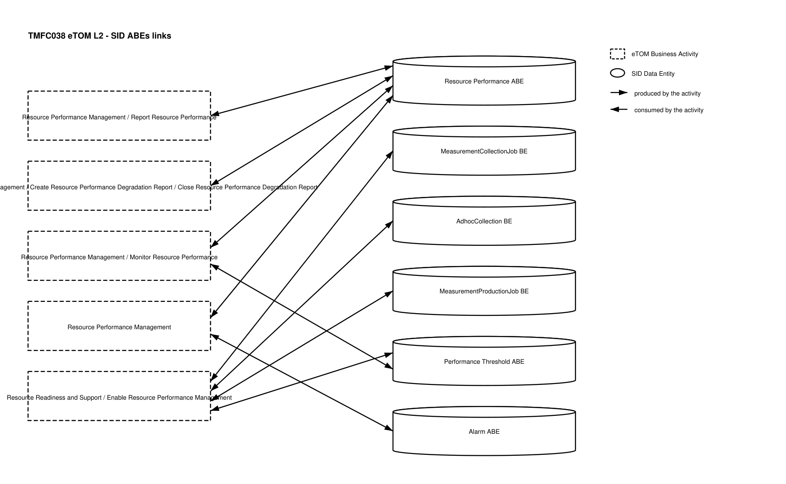
eTOM L2 - SID ABEs links diagram

Functional Framework Functions
Function ID | Function Name | Function Description | Aggregate Function Level 1 | Aggregate Function Level 2
498 | Resource Performance Data Analyzing | Resource Performance Data Analyzing functions provide the necessary functionality to analyze the performance of the various service provider's resources. This includes: Analyzing performance data received from Resource Performance Monitoring and historic performance data or system environment data / • Notify operations applications for automatic or manual action in case of alarming analysis results. / • Determining the root causes of resource performance degradations | Resource Performance Management | Resource Performance Supervision
499 | Resource Performance Data Aggregation and Trend Analyzing | Resource Performance Data Aggregation and Trend Analyzing provides data aggregation and trend analysis in resource performance monitoring | Resource Performance Management | Resource Performance Supervision
501 | Resource Performance Event Correlation | Resource Performance Event Correlation provides performance event correlation in resource performance monitoring. | Resource Performance Management | Resource Performance Supervision
502 | Resource Performance Data Accumulation | Resource Performance Data Accumulation provides performance data accumulation for resource performance monitoring, including real time monitoring data | Resource Performance Management | Resource Performance Supervision
903 | Anomaly Monitoring | Anomaly Monitoring; System and network monitoring activity, determining whether it is normal or anomalous, based on rules, signatures or heuristics. | Resource Performance Management | Resource Performance Supervision
1066 | Resource Performance Event Filtering | [Data-quality issue: this row's Description in the source document is a verbatim copy of function 502's description, not a description of "Resource Performance Event Filtering."] Resource Performance Data Accumulation provides performance data accumulation for resource performance monitoring, including real time monitoring data | Resource Performance Management | Resource Performance Supervision

TM Forum Open APIs & Events
The following part covers the APIs and Events; this part is split in 3:

List of Exposed APIs - This is the list of APIs available from this component.

List of Dependent APIs - In order to satisfy the provided API, the component could require the usage of this set of required APIs.

List of Events (generated & consumed) - The events which the component may generate are listed in this section along with a list of the events which it may consume. Since there is a possibility of multiple sources and receivers for each defined event.

API Context Diagram
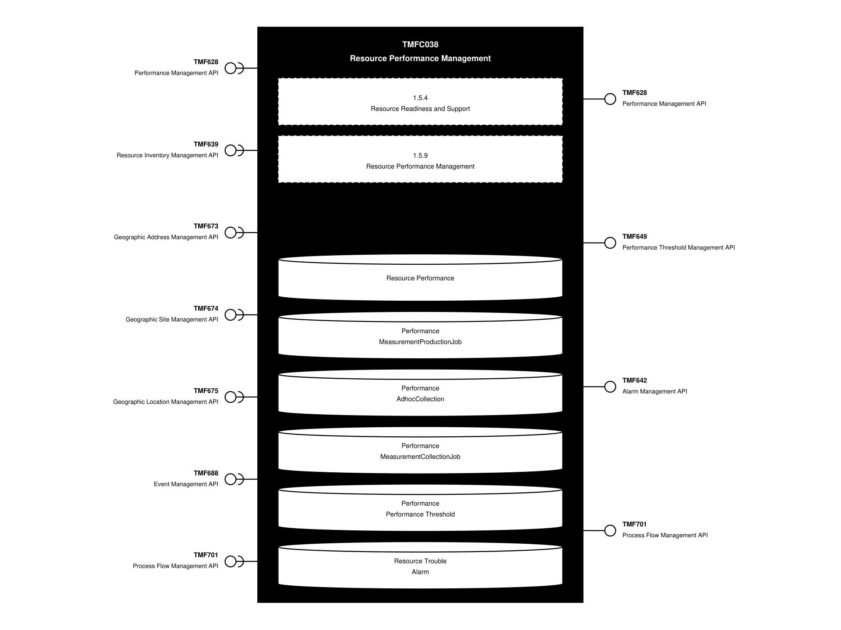
API Context diagram

Exposed APIs
API ID | API Name | Mandatory / Optional | API Version | Resource | Operations
TMF628 | Performance Management API | Mandatory | 4 | measurementCollectionJob*  onDemandCollection*  performanceIndicatorGroupSpecification*  performanceIndicatorSpecification*  trackingRecord* | POST  GET  GET /id  PATCH /id  DELETE /id
TMF649 | Performance Threshold Management API | Mandatory | 4 | threshold  thresholdJob | POST  GET  GET /id  PATCH /id  DELETE /id
TMF642 | Alarm Management API | Optional | 5 | alarm | GET  GET /id  POST
TMF642 | Alarm Management API | Optional | 4 | alarm | POST  GET  GET /id  PATCH /id  DELETE /id
TMF701 | Process Flow Management API | Optional | 4 | processFlow  taskFlow | POST  GET  GET /id  DELETE  PATCH

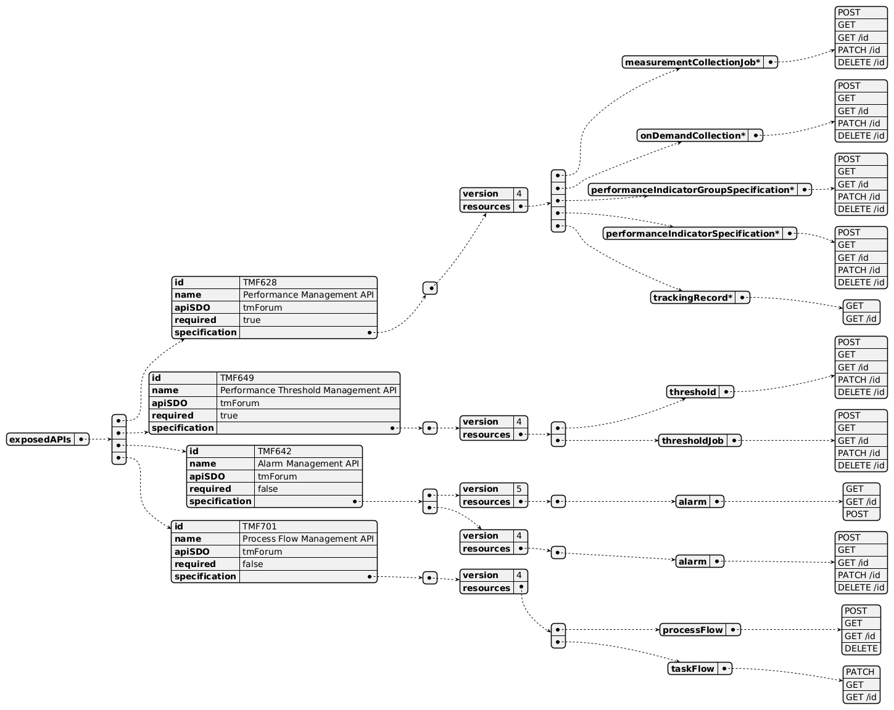
Exposed API diagram

Dependent APIs
API ID | API Name | API Version | Mandatory / Optional | Resource | Operations
TMF628 | Performance Management API | 4 | Optional | measurementCollectionJob*  onDemandCollection*  performanceIndicatorGroupSpecification*  performanceIndicatorSpecification*  trackingRecord* | POST  GET  GET /id  PATCH /id  DELETE /id
TMF639 | Resource Inventory Management API | 4 | Mandatory | resource | GET  GET /id
TMF673 | Geographic Address Management API | 4 | Optional | geographicAddress  geographicSubAddress | GET  GET /id
TMF674 | Geographic Site Management API | 4 | Optional | geographicSite | GET  GET /id
TMF675 | Geographic Location Management API | 4 | Optional | geographicLocation | GET  GET /id
TMF688 | Event Management API | 4 | Optional | event | GET  GET /id
TMF701 | Process Flow Management API | 4 | Optional | processFlow  taskFlow | POST  GET  GET /id  DELETE  PATCH

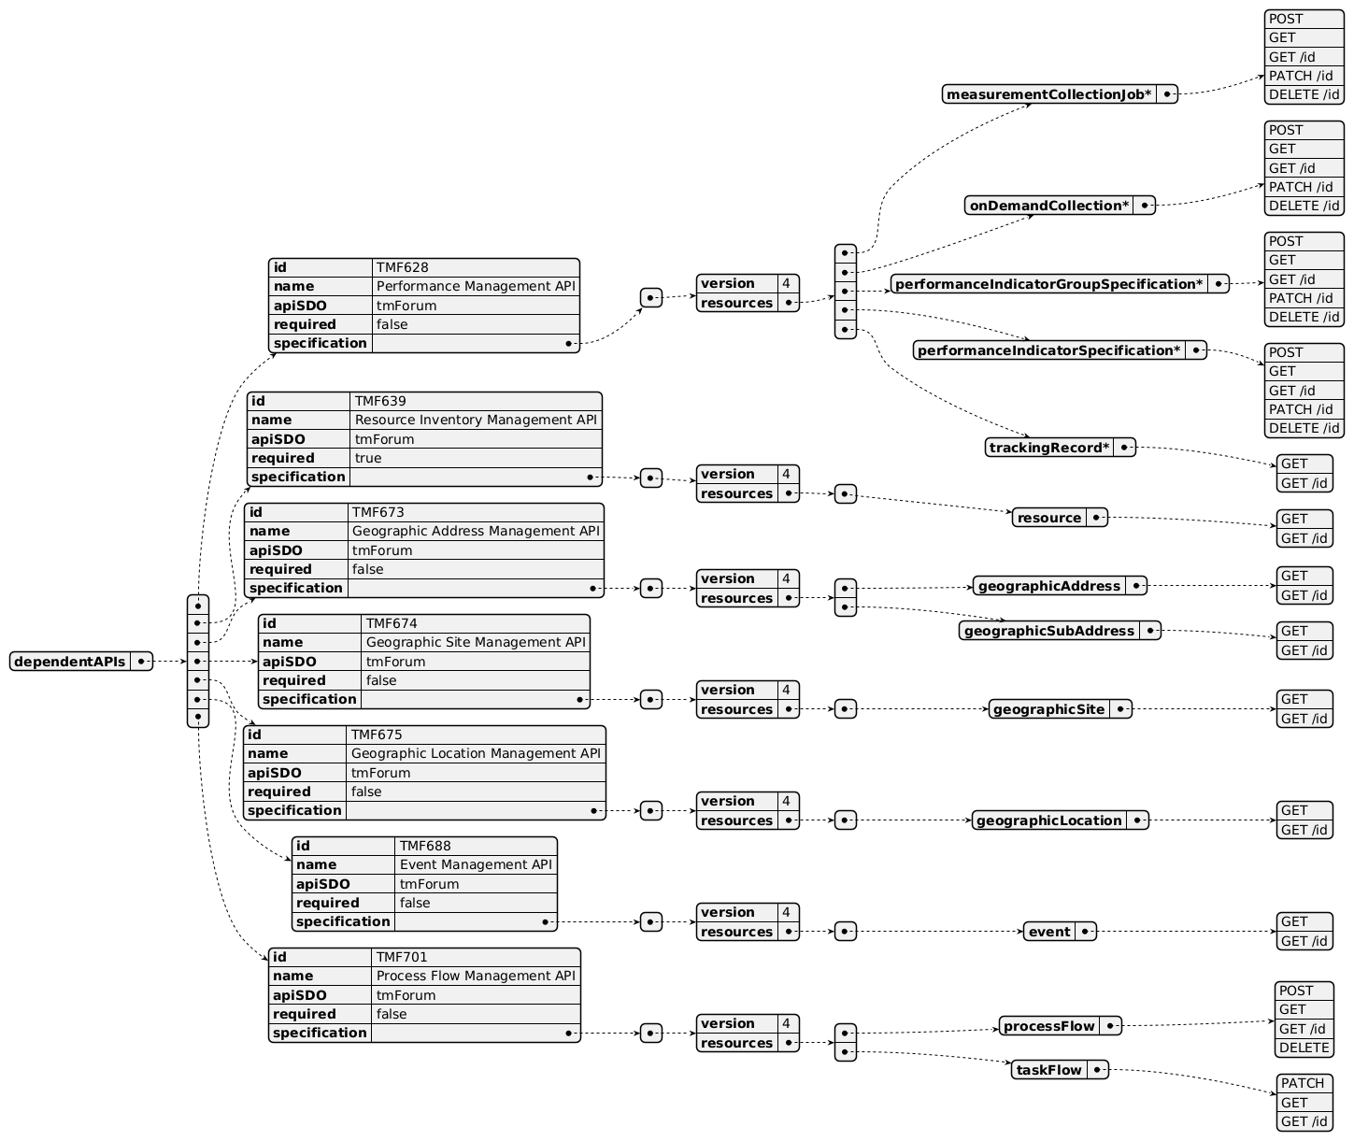
Dependent API diagram

Events
The diagram illustrates the Events which the component may publish and the Events that the component may subscribe to and then may receive. Both lists are derived from the APIs listed in the preceding sections.

Published Events
API ID | API Name | Event Resources
TMF701 | Process Flow Management API | processFlowCreateEvent  processFlowStateChangeEvent  processFlowStateDeleteEvent  processFlowStateAttributeValueChangeEvent  taskFlowCreateEvent  taskFlowStateChangeEvent  taskFlowDeleteEvent  taskFlowAttributeValueChangeEvent  taskFlowInformationRequiredEvent
TMF642 | Alarm Management API | alarmStateChange<br>alarmCreateEvent  alarmClearEvent<br>alarmAckEvent
TMF628 | Performance Management API | measurementCollectionJobCreateEvent  measurementCollectionJobExecutionStateChangeEvent  measurementCollectionJobDeleteEvent  measurementCollectionJobAttributeValueChangeEvent  measurementCollectionJobFilesReadyEvent  measurementCollectionJobFilesPreparationErrorEvent  onDemandCollectionCreateEvent  onDemandCollectionExecutionStateChangeEvent  onDemandCollectionDeleteEvent  onDemandCollectionAttributeValueChangeEvent  onDemandCollectionFilesReadyEvent  onDemandCollectionFilesPreparationErrorEvent
TMF649 | Performance Threshold Management API | thresholdCreateNotification  thresholdChangeNotification  thresholdRuleCreateNotification  thresholdRuleChangeNotification  thresholdJobCreateNotification  thresholdJobChangedNotification  thresholdJobSuspendedNotification  thresholdJobResumedNotification

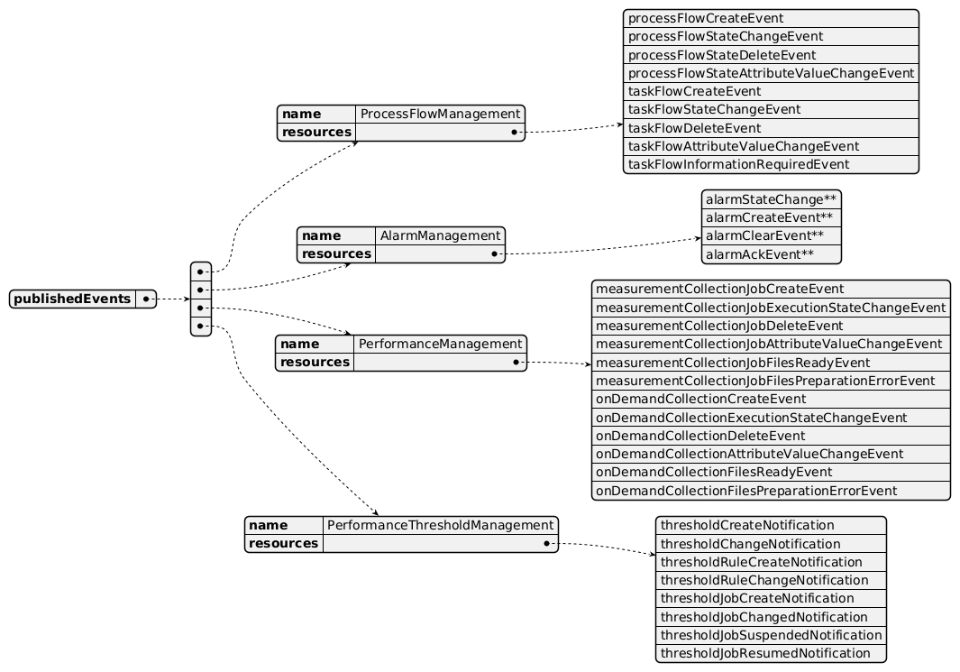
Published Events diagram

Subscribed Events
API ID | API Name | Event Resources
TMF634 | Resource Catalog Management API | ResourceSpecificationChangeEvent
TMF639 | Resource Inventory Management API | ResourceCreateEvent  ResourceAttributeValueChangeEvent  ResourceStateChangeEvent  ResourceDeleteEvent
TMF673 | Geographic Address Management API | geographicAddressValidationStateChange
TMF701 | Process Flow Management API | processFlowCreateEvent  processFlowStateChangeEvent  processFlowStateDeleteEvent  processFlowStateAttributeValueChangeEvent  taskFlowCreateEvent  taskFlowStateChangeEvent  taskFlowDeleteEvent  taskFlowAttributeValueChangeEvent

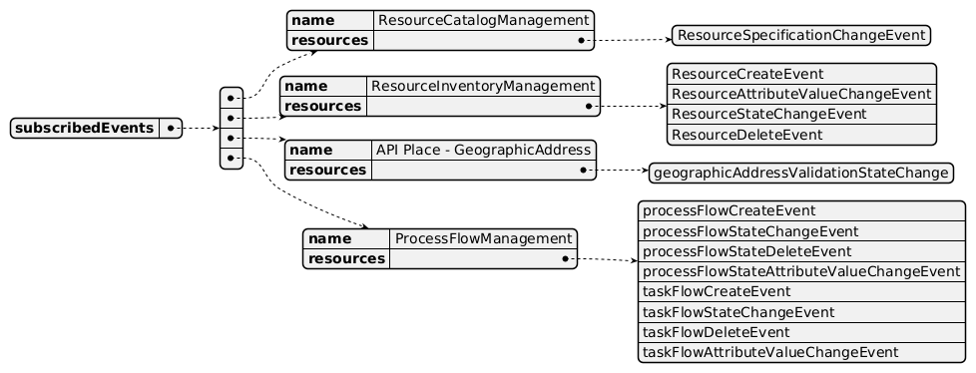
Subscribed Events diagram

Machine Readable Component Specification
Refer to the ODA Component Directory on the TM Forum website for the machine-readable component specification files for this component.

References

TMF Standards related versions
Standard | Version(s)
eTOM | v24.5
SID | v25.0
Functional Framework | v24.5

Jira References
No open Jira issues currently listed for this component.

Further resources
IG1228: please refer to IG1228 for defined use cases with ODA components interactions.

Administrative Appendix

Document History

Version History
Version Number | Date | Modified by | Description of changes
0.0.1 | 18-May-2023 | Milind Bhagwat | First draft
1.0.0 | 13-Jun-2023 | Amaia White | Final edits prior to publication
1.0.1 | 25-Jul-2023 | Ian Turkington | No content changed, simply a layout change to match template 3. Separated the YAML files to a managed repository.
1.0.1 | 14-Aug-2023 | Amaia White | Final edits prior to publication
1.1.0 | 13-Aug-2024 | Milind Bhagwat | Further edits
1.1.0 | 06-Sep-2024 | Amaia White | Final edits prior to publication
1.2.0 | 17-Dec-2024 | Milind Bhagwat | Removed Event API from exposed and dependent API list
1.2.0 | 27-Dec-2024 | Rosie Wilson | Final edits prior to publication

Release History
Release Status | Date Modified | Modified by | Description of changes
Pre-production | 13-Jun-2023 | Amaia White | Initial release
Pre-production | 14-Aug-2023 | Amaia White | New release v1.0.1
Production | 06-Oct-2023 | Adrienne Walcott | Updated to reflect TM Forum Approved status
Pre-production | 06-Sep-2024 | Amaia White | New release 1.1.0
Production | 01-Nov-2024 | Adrienne Walcott | Updated to reflect TM Forum Approved status
Pre-production | 18-Dec-2024 | Rosie Wilson | New release 1.2.0
Production | 07-Mar-2025 | Adrienne Walcott | Updated to reflect TM Forum Approved status

Acknowledgements
This document was prepared by the members of the TM Forum Component and Canvas project team.
Team Member | Company | Role
Milind Bhagwat | BT | Author
Gaetano Biancardi | Accenture | Reviewer
Sylvie Demarest | Orange | Reviewer
Hugo Vaughan (TM Forum) | TM Forum | Additional Input
Ian Turkington | TM Forum | Additional Input

