TMFC039 Agreement Management v1.2.0
Components and Canvas
In this deliverable:

Overview
Component Name | ID | Description | ODA Function Block
Agreement Management | TMFC039 | The Agreement Management component is responsible for creating, storing, editing, and tracking agreed arrangements with related terms and conditions over a lifecycle. The component manages offers, records acceptance, and associated considerations and intentions to establish agreements as legally binding. This component also provides workflows and templates that facilitate collaboration, communication and negotiation of agreements between parties, and administers the translation of agreements into contracts, when required. It provides secure storage, version control, compliance management, and renewal notifications for agreements. | Party Management

eTOM Processes, SID Data Entities and Functional Framework Functions

eTOM business activities
eTOM business activities this ODA Component is responsible for:
Identifier | Level | Business Activity Name | Description
1.6.5 | L2 | Party Agreement Management | Party Agreement Management manages all aspects of agreements with parties, including customers. Agreements include: / Purchasing agreements for products, services, and resources that meet the enterprise’s needs / On-boarding agreements for a Party's offerings / Service Level Agreements with one or more other parties / Agreements to use a Party as a sales channel / Reusable template agreements that can be used to create any of the above.
1.7.14 | L2 | Enterprise Governance | Enterprise Governance business process manages activities that ensure accountability and control of the strategic direction of the organization.
1.7.14.5 | L3 | Manage Contract | Manage Contract business activity is in charge of managing agreements, from their creation through to their execution by chosen party, as well as the termination of contracts. / / Manage Contract business activity cover tasks that include managing contract creation, execution of contracts, analysis of contracts to maximize operational and financial performance and reducing financial risk.

SID ABEs
SID ABEs this ODA Component is responsible for:
SID ABE Level 1 | SID ABE Level 2 (or set of BEs) | SID ABE L1 Definition | SID ABE L2 Definition
Agreement | Agreement | One form of business interaction in which Parties (for example, Service Providers or Customers) engage is an agreement. An agreement is a contract or arrangement, either written or verbal and sometimes enforceable by law, such as a service level agreement or a customer price agreement. An agreement involves a number of other business entities, such as Products, Services, and/or Resources. | A type of BusinessInteraction that Represents a contract or arrangement, either written or verbal and sometimes enforceable by law.
Agreement | AgreementItem | One form of business interaction in which Parties (for example, Service Providers or Customers) engage is an agreement. An agreement is a contract or arrangement, either written or verbal and sometimes enforceable by law, such as a service level agreement or a customer price agreement. An agreement involves a number of other business entities, such as Products, Services, and/or Resources. | The purpose for an Agreement expressed in terms of a Product, Service, Resource, and/or their respective specifications, inherited from BusinessInteractionItem.
Agreement | AgreementTermOrCondition | One form of business interaction in which Parties (for example, Service Providers or Customers) engage is an agreement. An agreement is a contract or arrangement, either written or verbal and sometimes enforceable by law, such as a service level agreement or a customer price agreement. An agreement involves a number of other business entities, such as Products, Services, and/or Resources. | Aspects of the LegalyBindingAgreement not formally specified elsewhere in the LegalyBindingAgreement and that cannot be captured elsewhere in a formal notation, or automatically monitored and require a more human level of management.
Agreement | AgreementAuthorization | One form of business interaction in which Parties (for example, Service Providers or Customers) engage is an agreement. An agreement is a contract or arrangement, either written or verbal and sometimes enforceable by law, such as a service level agreement or a customer price agreement. An agreement involves a number of other business entities, such as Products, Services, and/or Resources. | Represents the authorization of an Agreement through its signature. BusinessParticpant responsible for approving an Agreement.
Agreement | AgreementApproval | One form of business interaction in which Parties (for example, Service Providers or Customers) engage is an agreement. An agreement is a contract or arrangement, either written or verbal and sometimes enforceable by law, such as a service level agreement or a customer price agreement. An agreement involves a number of other business entities, such as Products, Services, and/or Resources. | A group of AgreementAuthorizations that materializes the fact that an Agreement has been approved by the participants involved in an Agreement. required from the Business Participants involved in the Agreement.

eTOM L2 - SID ABEs links
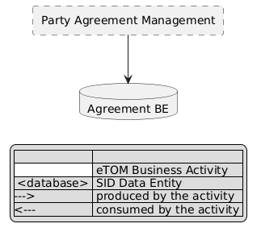
eTOM L2 - SID ABEs links diagram

Functional Framework Functions
Function ID | Function Name | Function Description | Aggregate Function Level 1 | Aggregate Function Level 2
1026 | Partner Collaboration Constraints Collection | Partner Collaboration Constraints Collection function collect external and internal constraints that can impact a partner collaboration. The partner strategy definition is impacted by various factors, like partner’s geographical location, governmental regulatory, product and services offered etc. The function also provides capability to consider security and financial risks, environmental and legal issues and existing agreements etc. | Purchasing Strategy Management | Purchasing Strategy Definition
1045 | Partner Agreement Tracking | Partner Agreement Tracking function keeps the association of the partner product offerings with the agreements and tracks anomalies for single products or group of products of the partner. | Business Partner Management | Business Partner Agreement Management
1043 | Partner Agreement Storage and Searching | Partner Agreement Storage and Searching function provides the ability to view Partner's existing agreements, search for partner agreements based on meta-data and to search text strings within agreements. The data can also be mined for partner strategy, negotiation, workflow and interaction purposes. | Business Partner Management | Business Partner Agreement Management
1044 | Partner Agreement Implementation | Agreement Implementation function provides support for the implementation of the agreement’s terms and conditions to be used by related organizations during operations. | Business Partner Management | Business Partner Agreement Management
1042 | Partner Agreement Creation | Partner Agreement Creation function provides the functionality to automate the creation of an agreement based on templates or from scratch. The function allows to create and maintain predefined agreement options and templates with terms and conditions (e.g. pricing information, payment clauses, legal texts, etc.) for different purposes and services. | Business Partner Management | Business Partner Agreement Management
1180 | Customer Framework Agreement Approval | Customer Framework Agreement Approval Function manages all approval of Party Roles involved in the Framework Agreement (Customer Roles as well as CSP roles). | Sales Management | Framework Agreement Management
1179 | Customer Framework Agreement Definition | The Customer Framework Agreement Definition Function consists in defining the agreement that describes the commitments and company features valid for associated customer orders. / It defines a subset of catalog offers and products which will be marketed to a customer with particular conditions (configurations of product, rates, discounts, SLA such as availability rate, restoration time guaranties, and associated penalties for the CSP). | Sales Management | Framework Agreement Management
363 | Product Agreement Storage | Product Agreement Storage provides functionality necessary to store and make available the Product Agreements. / This function allows: / • to instantiate or update Product Agreement approved by the customer with their party involved, their configuration, their approvals and their status, / • to update Product Agreements status, / • to search and read Product Agreements. | Product Agreement Management | Product Agreement Storage
361 | Product Agreement Implementation | Product Agreement Implementation function provides functionality pertaining to the implementation of the Product Agreement (a.k.a. contract) across fulfillment, assurance, and billing according to Product Agreement Specification. / A Product Agreement represents the approval by the Customer and the Vendor of all term or conditions of a ProductOffering. | Product Management | Product Agreement Implementation
653 | Contract Management | Contract Management, including establishment, modification, and termination. | Business Partner Management | Business Partner Agreement Management

TM Forum Open APIs & Events
The following part covers the APIs and Events; this part is split in 3:

List of Exposed APIs - This is the list of APIs available from this component.

List of Dependent APIs - In order to satisfy the provided API, the component could require the usage of this set of required APIs.

List of Events (generated & consumed) - The events which the component may generate are listed in this section along with a list of the events which it may consume. Since there is a possibility of multiple sources and receivers for each defined event.

API Context Diagram
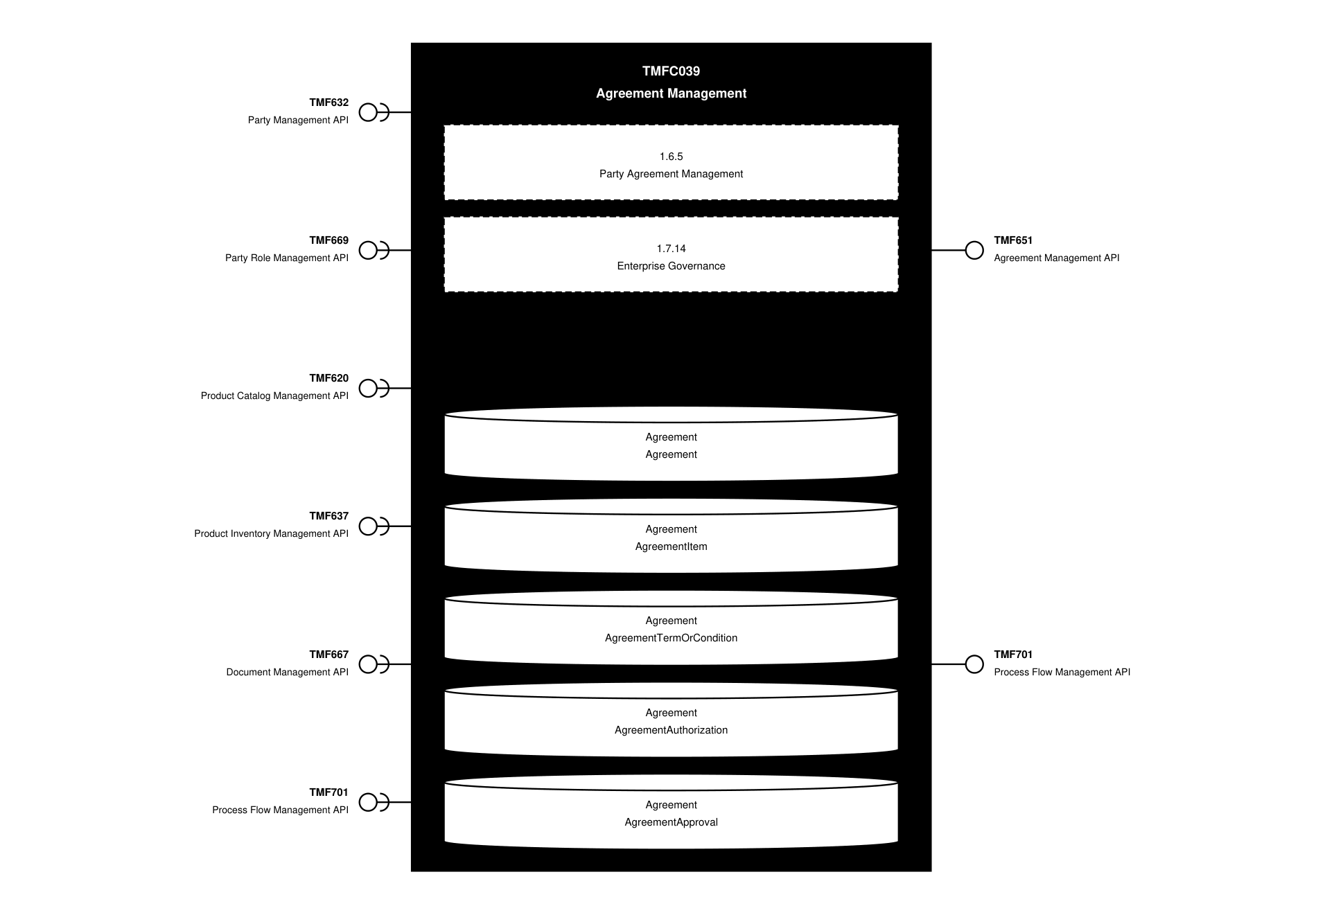
API Context diagram

Exposed APIs
API ID | API Name | Mandatory / Optional | API Version | Resource | Operations
TMF651 | Agreement Management API | Mandatory | 4 | agreement  agreementSpecification | GET  GET /id  POST  PATCH /id  DELETE /id
TMF701 | Process Flow Management API | Optional | 4 | processFlow  taskFlow | POST  GET  GET /id  DELETE  PATCH

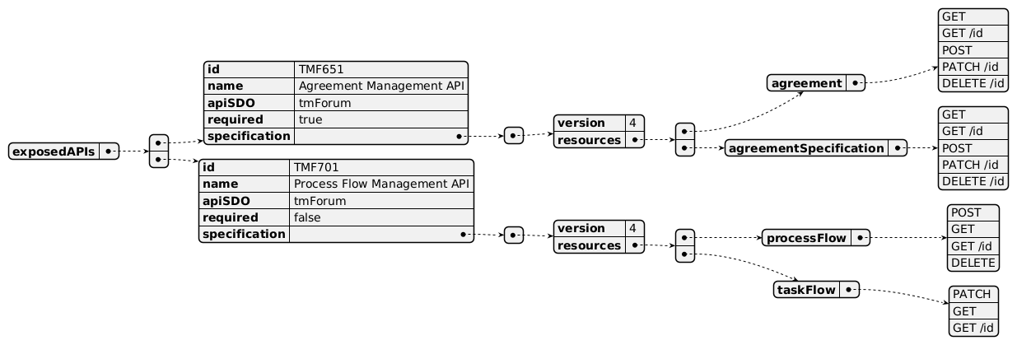
Exposed API diagram

Dependent APIs
API ID | API Name | API Version | Mandatory / Optional | Resource | Operations
TMF632 | Party Management API | 5 | Mandatory | individual  organization | GET  GET /id
TMF632 | Party Management API | 4 | Mandatory | individual  organization | GET  GET /id
TMF669 | Party Role Management API | 5 | Optional | partyRole | GET  GET /id
TMF669 | Party Role Management API | 4 | Optional | partyRole | GET  GET /id
TMF620 | Product Catalog Management API | 5 | Optional | productOffering  productOfferingPrice | GET  GET /id
TMF620 | Product Catalog Management API | 4 | Optional | productOffering  productOfferingPrice | GET  GET /id
TMF637 | Product Inventory Management API | 5 | Optional | product | GET  GET /id
TMF637 | Product Inventory Management API | 4 | Optional | product | GET  GET /id
TMF667 | Document Management API | 4 | Optional | document | GET  GET /id
TMF701 | Process Flow Management API | 4 | Optional | processFlow  taskFlow | POST  GET  GET /id  DELETE  PATCH

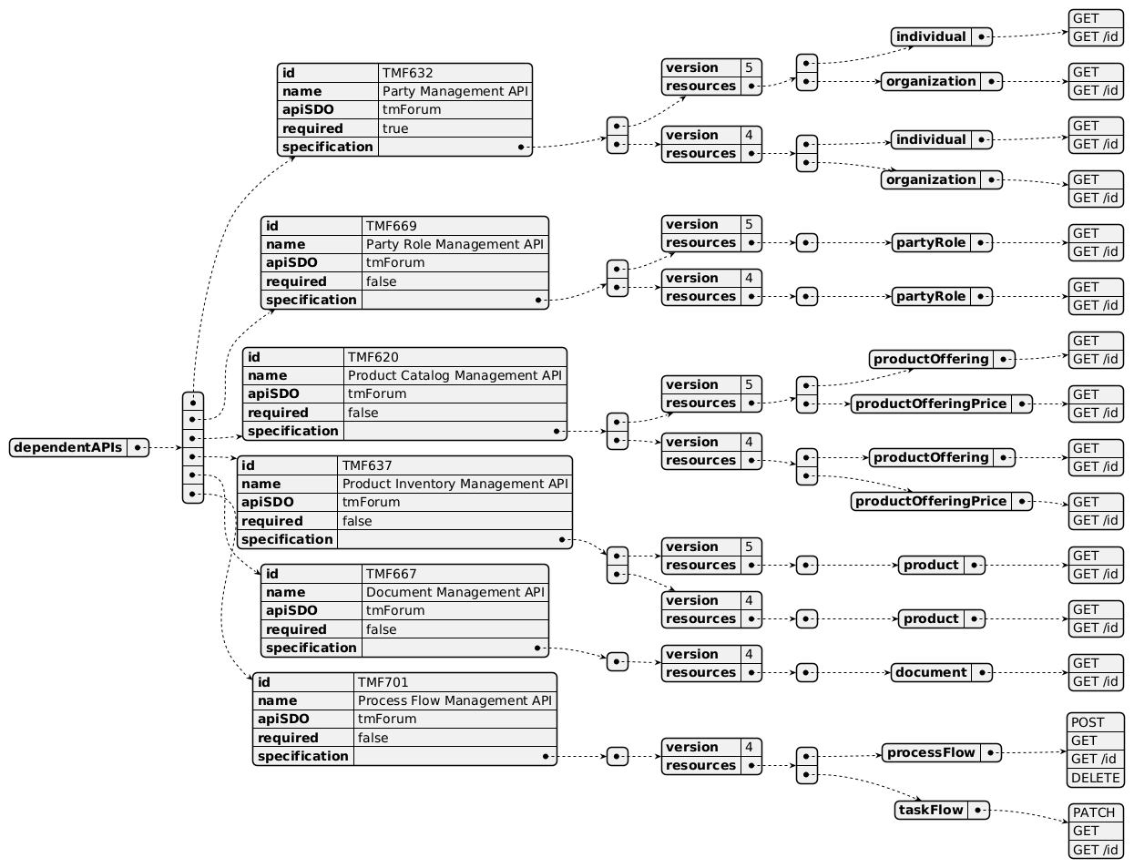
Dependent API diagram

Events
The diagram illustrates the Events which the component may publish and the Events that the component may subscribe to and then may receive. Both lists are derived from the APIs listed in the preceding sections.

Published Events
API ID | API Name | Event Resources
TMF651 | Agreement Management API | agreementCreateEvent  agreementAttributeValueChangeEvent  agreementStateChangeEvent  agreementSpecificationCreateEvent  agreementSpecificationAttributeValueChangeEvent

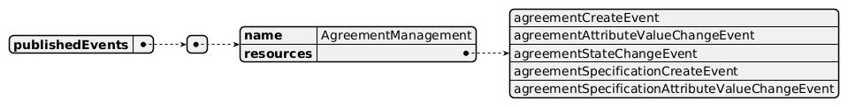
Published Events diagram

Subscribed Events
API ID | API Name | Event Resources
TMF632 | Party Management API | individualDeleteEvent  organizationDeleteEvent

Subscribed Events diagram

Machine Readable Component Specification
Refer to the ODA Component Directory on the TM Forum website for the machine-readable component specification files for this component.

References

TMF Standards related versions
Standard | Version(s)
eTOM | v23.0
SID | v25.0
Functional Framework | v23.0

Jira References
eTOM [ISA-756] Review eTOM business activities related to agreement and or contract management - TM Forum JIRA
In eTOM 22.5 we have:

In Business Partner Domain: L2 – Party Agreement Management (1.6.5).

Its definition includes "all aspects of agreements with parties, including customers" which seems to be an anomaly: we should have distinct business activities related to customer and partners

Its definition also includes "Purchasing agreements for products, services and resources that meet the enterprise's needs": whatever the enterprise will need for its internal activities, it will always order products and product offerings to its suppliers or partners (nether services nor resources).

And "Applicable sub-processes are also used by other processes, such as Product Offering Agreement Management and Party Privacy Agreement Management.": Product Offering Agreement Management

In Customer Domain: nothing related to agreement and/or contract management (except for Privacy)

In Product Domain: L4 – Product Offering Agreement Management (1.2.7.2.4) in L3 – Product Offering Development & Retirement (1.2.7.2) in L2 – Product Specification & Offering Development & Retirement (1.2.7), with the following definition: "Develop a template agreement that defines the terms/conditions associated with a product offering."

In Market Sales Domain: L3 – Negotiate Sales/Contract (1.1.9.5) in L2 - Selling (1.1.9). Refer to ISA-711 ticket already created.

In Enterprise domain: L3 Manage Contract (1.7.14.5) in L2 Enterprise Governance (1.7.14) which definition is very generic: "Manage Contract business activity is in charge of managing agreements, from their creation through to their execution by chosen party, as well as the termination of contracts."
We need to have a clear set of business activities, defined at consistent levels and able to manage the different types of agreement and/or contract specification, and their instantiations in their related business context.
SID [ISA-757] Review SID Agreement ABE - TM Forum JIRA
Describe all the types of agreements and contracts needed by a CSP, such as framework agreements, employees' contracts, suppliers' contracts, customer contracts with their specific links to other BEs such as catalogs. Clarify the difference between agreement and contract terms. Remove the positioning of the Agreement BE as specialization of Business Interaction and replaced it by clear and explicit relationships to Party and Party Roles. Review the Service Level Agreement part of the ABE: SLA and SLA conditions can be better described as product specification and configuration, with their scope of application on other products, and their rating rules through the product offering subscribed. Review the definition of BEs such as AgreementTermOrCondition or AgreementItem (not meaningful to link to Service or Resource levels).

Further resources
none currently listed

Administrative Appendix

Document History

Version History
Version Number | Date | Modified by | Description of changes
1.0.0 | 13-Jun-2023 | Matteo Destino | Initial draft for Rights and Permissions component, with eTOM, SID and Open API mapping
1.0.0 |  | Amaia White | Final edits prior to publication
1.0.1 | 25-Jul-2023 | Ian Turkington | No content changed, simply a layout change to match template 3. Separated the YAML files to a managed repository.
1.0.1 | 14-Aug-2023 | Amaia White | Final edits prior to publication
1.1.0 | 27-Aug-2024 | Gaetano Biancardi | New Component template applied. Exposed API: removed: TMF688 Event Management. Dependant API: removed: TMF688 Event Management. Functional Framework Function, following functions added: Customer Framework Agreement Approval 1180, Customer Framework Agreement Definition 1179, Product Agreement Storage 363, Product Agreement Implementation 361, Contract Management 653, Partner Agreement Creation 1042, Partner Agreement Storage and Searching 1043, Partner Agreement Implementation 1044, Partner Agreement Tracking 1045
1.1.1 | 09-Sep-2025 | Rosie Wilson | Updates to description per agreed YAML updated on 03 Jun 2025. Final administrative updates prior to publication
1.2.0 | 05-Jun-2026 | Hugo Vaughan | Gen 5 API updates
1.2.0 | 25-Jun-2026 | Sannah Sibaya | Final edits prior to publication

Release History
Release Status | Date Modified | Modified by | Description of changes
Pre-production | 13-Jun-2023 | Amaia White | Initial release of document
Pre-production | 17-Jul-2023 | Adrienne Walcott | Updated to Member Evaluated status
Pre-production | 14-Aug-2023 | Amaia White | New release of document
Production | 06-Oct-2023 | Adrienne Walcott | Updated to reflect TM Forum Approved status
Pre-production | 06-Sep-2024 | Amaia White | New release of document
Production
Pre-production | 09-Sep-2025 | Rosie Wilson | v1.1.1
Production | 14-Nov-2025 | Adrienne Walcott | Updated to reflect TM Forum Approved status
Pre-production | 25-Jun-2026 | Sannah Sibaya | v1.2.0

Acknowledgements
This document was prepared by the members of the TM Forum Component and Canvas project team.
Team Member | Company | Role
Matteo Destino | Accenture | Editor
Cecile Ludwichowski | Orange | Additional Input
Emmanuel A. Otchere | Huawei | Additional Input
Gaetano Biancardi | Accenture | Reviewer
Sylvie Demarest | Orange | Reviewer
Anastasios Sarantis | Vodafone | Reviewer
Hugo Vaughan (TM Forum) | TM Forum | Reviewer
Abinash Vishwakarma | Netcracker | Reviewer
Elisabeth Andersson | MATRIXX | Reviewer
Kamal Maghsoudlou | Ericsson | Reviewer
Jose Macaluso | Xacria | Reviewer
Milind Bhagwat | BT | Reviewer
Ritu Arora | BT | Reviewer

