TMFC040 Product Usage Management v1.2.0
Components and Canvas
In this deliverable:

Overview
Component Name | ID | Description | ODA Function Block
Product Usage Management | TMFC040 | Product Usage Management component provides a standardized mechanism for creation, update, retrieval, import and export of a collection of usages. It allows a service provider to retrieve usage generated by a partner service platform in order to rate it, and provides rated usage to a partner for consumption follow-up purposes. | Core Commerce

eTOM Processes, SID Data Entities and Functional Framework Functions

eTOM business activities
eTOM business activities this ODA Component is responsible for:
Identifier | Level | Business Activity Name | Description
1.2.16 | L2 | Product Usage Management | The Product Usage management processes encompass the functions required to guide, distribute, mediate, summarize, accumulate, and analyze Product Usage records. These processes may occur in real-time, near real-time (i.e. just at the end of the usage), or may be executed on a periodic basis. / / Based on Service Usage, this process aims at identifying Product Usage. For example, for a Video on Demand where you can watch a video as many times as you want during 72 hours, several Service Usages might have been tracked (each time the user watches the video) and only one Product Usage will be identified for all Service Usages in the 72 hours after the first watch. / / The guiding processes ensure that the Product Usage records used in the billing processes are appropriately related to the correct customer billing account and products. / / The Product Usage records are edited and if necessary reformatted (mediated) to meet the needs of subsequent processes. The billing event records may also be enriched with additional data during this process.
1.2.16.1 | L3 | Product Usages | The Enrich Product Usages processes will augment the product usage records by adding data to the records from sources such as customer, product, or other reference data.
1.2.16.1.1 | L4 | Add Product Usage Data | Add data to the records from sources such as customer, product, or other reference data to augment the product usage records.
1.2.16.1.2 | L4 | Assign Product Usage Price | Assign a price to product usage without consideration of specific product or customer information. The assigned price may be used to enrich the product usage record.
1.2.16.2 | L3 | Guide and Assign Product Usages | The Guide Product Usages processes ensure that the event records used in the billing process relate to the correct customer billing account and products. A specific product usage record may be related to multiple customer billing accounts and subscribed products. / / Distribution of product usage records to other processes may also occur.
1.2.16.2.1 | L4 | Assign Product Usages | Ensure that the Product Usages used in the billing process relate to the correct Product.
1.2.16.2.2 | L4 | Distribute Product Usage | Distribute billing event records to other processes.
1.2.16.2.3 | L4 | Guide Product Usages | Guide Product Usages process is in charge of identifying Product Usages based on Service Usages. / For example, for a Video on Demand where you can watch a video as many times as you want during 72 hours, several Service Usages might have been tracked (each time the user watches the video) and only one Product Usage will be identified for all Service Usages in the 72 hours after the first watch.
1.2.16.3 | L3 | Mediate Product Usages | The Mediate Product Usages process edits and reformats the data record to meet the needs of a recipient application.
1.2.16.3.1 | L4 | Edit Product Usages | Edit the data record for recipient applications.
1.2.16.3.2 | L4 | Reformat Product Usages | Reformat the data record for recipient applications.
1.2.16.4 | L3 | Report Product Usage Records | The purpose of the Report Product Usage Record processes is to generate reports on Product Usage records based on requests from other processes. / These processes produce reports that may identify abnormalities, which may be caused by fraudulent activity or related to customer complaints. / Investigation of problems related to these product usage records is also part of this process. / / These processes also support other processes such as customer review of product usages (pre-billing and post-billing).
1.2.16.4.1 | L4 | Generate Product Usage Report | Generate reports on product usage records based on requests from other processes.
1.2.16.4.2 | L4 | Investigate Product Usage Related Problem | Investigate problems related to product usage records.
1.2.16.4.3 | L4 | Support Product Usage Related Process | Support other processes such as customer review of product usages (pre-billing and post-billing).
1.2.17 | L2 | Product Rating & Rate Assignment | The purpose of Product Rating & Assignment is to rate a value (monetary or other) to Product Usage or a set of Product Usages and assign the result to a Product and a Billing Account. The charge may be either a credit or a debit and can be handled either online or offline. / / Online charging is performed in real-time, requiring an authorization component which may affect how the service is rendered and enables an operator to provide prepaid services to its customers. Whereas offline charging is performed after the service is rendered and is not required to be done in real-time and generally relates to subscription-based products.
1.2.17.1 | L3 | Perform Rating | Process responsible for calculating the value of a product usage or a set of product usages, before, during or after the rendering of the service, based on parameters of the request (type, quantity, etc.), parameters of the customer/subscriber (tariffs, price plans, accumulated usage, contracts, etc.) and other parameters (time-of-day, taxes, etc.). The same request may be rated differently for different subscribers based on their purchased offers or agreements.
1.2.17.2 | L3 | Aggregate Items For Rate Assignment | This process is responsible for accumulating contributing items, which can be quantities, values (monetary or other) or both. Aggregation can occur over time or can be initiated to gather a “snapshot” of the items at a point in time.
1.2.17.3 | L3 | Manage Customer Assignment Hierarchy | Customer hierarchies are commonly used for corporate customers, family plans or other types of affinity groups. This process manages the assignment relationships among subscribers, e.g. sharing, inheriting or restricting balances, price plans and discounts. Thereby assuring that a charge is added to or subtracted from the correct account balance.
1.2.17.4 | L3 | Provide Advice of Rate | The activity of Provide Advice of Rate (aka Advice of Charge) is responsible for providing advice on rates, in real-time or offline, an estimate or value of the rate for a specific usage request. The advice is usually based upon performing a full rating process for the request.
1.2.17.5 | L3 | Apply Rate Level Discounts | This process applies discounts to product prices at an individual product level. A discount may be expressed as a monetary amount or percentage and modifies a price for a product. When a discount is expressed as a percentage, the discounting process determines the discount calculated in relation to the price for the product. / / The discount may be displayed as a separate entry on the bill or may be combined with the rate for the product to only show as one entry. / / Discounts may be a one-time event or may have some duration (days, months, life of product, etc.). Discounts may apply to a specific customer or be generally available based on selection of products (for example - bundles). Discounting structures may involve tiers, tapers, or thresholds.

SID ABEs
SID ABEs this ODA Component is responsible for:
SID ABE Level 1 | SID ABE Level 2 (or set of BEs) | SID ABE L1 Definition | SID ABE L2 Definition
Product Usage |  | Product Usage ABE represents specification of usages enabled by Products and usages of products tracked. | *(no description available)*
Product Offering Instance | Product Price | A ProductOfferingInstance represents the instantiation of a ProductOfferingSpecification for a specific Customer. It may carry ProductPrice and commitment choice. | The Product Price ABE describes all the prices applied to Products.

eTOM L2 - SID ABEs links
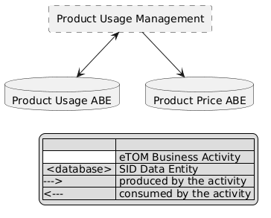
eTOM L2 - SID ABEs links diagram

Functional Framework Functions
Function ID | Function Name | Function Description | Aggregate Function Level 1 | Aggregate Function Level 2
253 | Customer Usage and Charges Report Access | Customer Usage and Charges Report Access provides an internet technology driven interface to the customer to access web-based reports for (historical) usage and charges directly for themselves. | / Rating and Follow-up | / Bill Calculation
55 | Price and Discount Calculation | Price and Discount Calculation applies pricing and discounting rules and algorithms in the context of the assembled information concerning Products (i.e. instances of Product). | / Rating and Follow up | / Tariff Calculation and Rating
125 | Charging Event Accumulation | Charging Event Accumulation function accumulates events that provide measurements that will be used in the charge calculation (e.g. used allowance). | / Rating and Follow up | / Tariff Calculation and Rating
126 | Event Charge/Credit Calculation | Event Charge/Credit Calculation calculates event-level charges/credits (one time, recurring, and usage). | / Rating and Follow up | / Tariff Calculation and Rating
127 | Calculated Charges/Credits Proration | Calculated Charges/Credits Proration provides proration of calculated charges/credits. The function handles partial rating of a period. | / Rating and Follow up | / Tariff Calculation and Rating
128 | Late Arrival Usage Charges/Credits Recalculation | Late Arrival Usage Charges/Credits Recalculation provides recalculation of charges/credits based on information received later (e.g. from the Service Level Agreement function, delayed call detail record file arrival, delayed order arrival). Recalculation may be necessary: pre-billing (prior to Bill Calculation), during the Bill Calculation process, and/or post-billing. | / Rating and Follow up | / Tariff Calculation and Rating
186 | Charging/Rating Recalculation | Charging/Rating Recalculation function recalculates the charges, when appropriate, across product, location, or customer, and considerations based on business rules. | / Rating and Follow up | / Tariff Calculation and Rating
300 | Discounts Calculation | Discounts Calculation determines charge discounts based on pricing plan; including discounts on recurring, one time, and usage charges. Discounts may be applied at different levels such as cross product, cross location, or cross customer (all customers that are part of a given group plan – some affiliation). The discounts can be apportioned across multiple events. | / Rating and Follow up | / Tariff Calculation and Rating
67 | Usage Summary and Details Presentation | Usage Summary and Details Presentation presents usage summary and details (billed and non-billed) for a specific time period. ** | Invoice Management | Invoicing
85 | Billing Event Processing Distribution | Billing Event Processing Distribution function for correlation and distribution of usage data for processing of e.g. bill, customer and product. To supply relevant usage data to the Billing System. | Invoice Management | Invoicing
86 | Billing Event Processing Enrichment | Billing Event Processing Enrichment with complementing data e.g. product or location information to supply relevant information to the Billing System. | Invoice Management | Invoicing

TM Forum Open APIs & Events
The following part covers the APIs and Events; this part is split in 3:

List of Exposed APIs - This is the list of APIs available from this component.

List of Dependent APIs - In order to satisfy the provided API, the component could require the usage of this set of required APIs.

List of Events (generated & consumed) - The events which the component may generate are listed in this section along with a list of the events which it may consume. Since there is a possibility of multiple sources and receivers for each defined event.

API Context Diagram
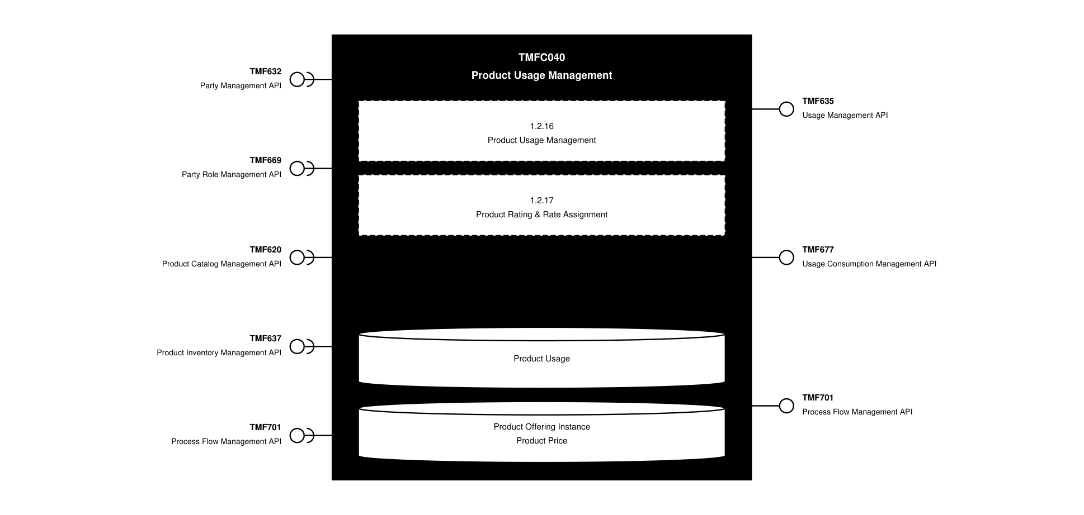
API Context diagram

Exposed APIs
API ID | API Name | Mandatory / Optional | API Version | Resource | Operations
TMF635 | Usage Management API | Mandatory | 4 | usage | GET  GET /id  POST  PATCH /id
TMF677 | Usage Consumption Management API | Mandatory | 5 | queryUsageConsumption | GET  GET /id  POST
TMF677 | Usage Consumption Management API | Mandatory | 4 | queryUsageConsumption | GET  GET /id  POST
TMF701 | Process Flow Management API | Optional | 4 | processFlow  taskFlow | GET  GET /id  POST  DELETE /id  PATCH /id

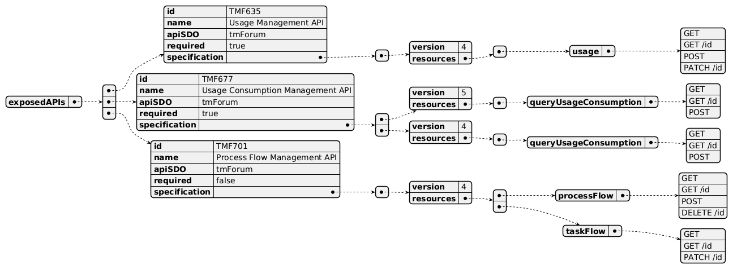
Exposed API diagram

Dependent APIs
API ID | API Name | API Version | Mandatory / Optional | Resource | Operations
TMF632 | Party Management API | 5 | Mandatory | individual  organization | GET  GET /id
TMF632 | Party Management API | 4 | Mandatory | individual  organization | GET  GET /id
TMF669 | Party Role Management API | 5 | Optional | partyRole | GET  GET /id
TMF669 | Party Role Management API | 4 | Optional | partyRole | GET  GET /id
TMF620 | Product Catalog Management API | 5 | Optional | productOffering  productOfferingPrice  productSpecification | GET  GET /id
TMF620 | Product Catalog Management API | 4 | Optional | productOffering  productOfferingPrice  productSpecification | GET  GET /id
TMF637 | Product Inventory Management API | 5 | Optional | product | GET  GET /id
TMF637 | Product Inventory Management API | 4 | Optional | product | GET  GET /id
TMF701 | Process Flow Management API | 4 | Optional | processFlow | POST  GET  GET /id  PATCH

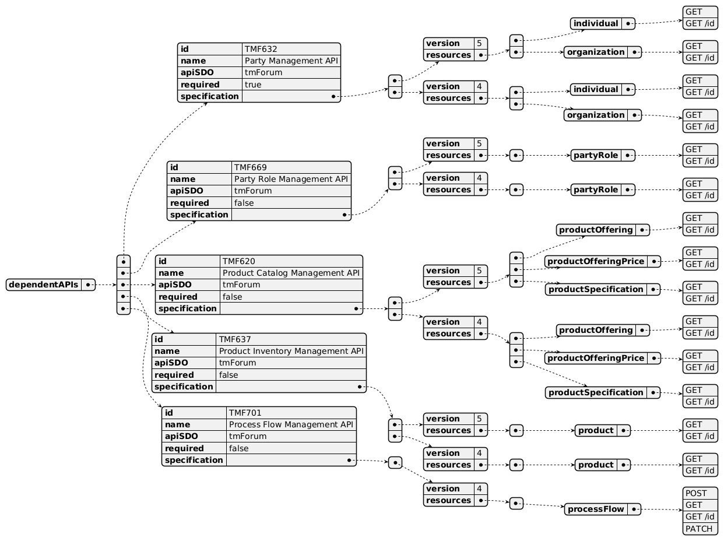
Dependent API diagram

Events
The diagram illustrates the Events which the component may publish and the Events that the component may subscribe to and then may receive. Both lists are derived from the APIs listed in the preceding sections.

Published Events
API ID | API Name | Event Resources
TMF677 | Usage Consumption Management API | queryUsageConsumptionCreateEvent  queryUsageConsumptionDeleteEvent  queryUsageConsumptionStateChangeEvent
TMF635 | Usage Management API | usageCreateEvent  usageAttributeValueChangeEvent  usageDeleteEvent  usageStateChangeEvent

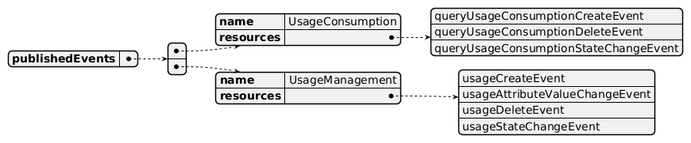
Published Events diagram

Subscribed Events
API ID | API Name | Event Resources
TMF632 | Party Management API | individualDeleteEvent  organizationDeleteEvent
TMF669 | Party Role Management API | partyRoleCreateEvent  partyRoleAttributeValueChangeEvent  partyRoleStateChangeEvent  partyRoleDeleteEvent

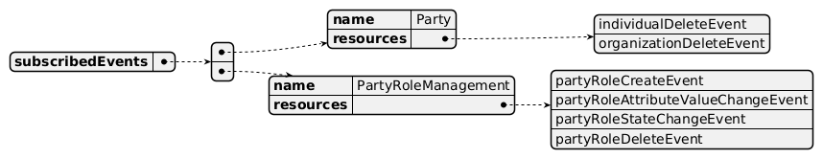
Subscribed Events diagram

Machine Readable Component Specification
Refer to the ODA Component Directory on the TM Forum website for the machine-readable component specification files for this component.

References

TMF Standards related versions
Standard | Version(s)
eTOM | v23.0
SID | v25.0
Functional Framework | v23.0

Jira References
none currently listed

Further resources
1. IG1228: please refer to IG1228 for defined use cases with ODA components interactions.

Administrative Appendix

Document History

Version History
Version Number | Date | Modified by | Description of changes
1.0.0 | 27-Sep-2023 | Gaetano Biancardi | Final edits prior to publication
1.1.0 | 08-Oct-2024 | Elisabeth Andersson | Updated to the latest version of the Component Template. Added comment and Jira tickets related to Usage API evolution of v5. Clarified the scope of SID for this component in relation to ProductUsageSpecification. Changed requirements for TMF620 and TMF672 from Mandatory to Optional. Mapped to the latest Frameworks with the following changes: Functional Framework: name change of Aggregation level 1 and 2 (253, 55, 125, 126, 127, 128, 186, 300); added functions (65, 85, 86). Business Process Framework: Business Process Name change: 1.2.17.3
1.1.0 | 14-Nov-2024 | Amaia White | Final edits prior to publication
1.1.1 | 20-Jan-2026 | Rosie Wilson | Updates to description per agreed YAML updated on 03 Jun 2025. Final administrative updates prior to publication
1.2.0 | 25-May-2026 | Hugo Vaughan | Gen 5 API updates
1.2.0 | 25-Jun-2026 | Sannah Sibaya | Final edits prior to publication

Release History
Release Status | Date Modified | Modified by | Description of changes
Pre-production | 13-Feb-2024 | Gaetano Biancardi | Initial release of document
Production | 26-Apr-2024 | Adrienne Walcott | Updated to reflect TM Forum Approved status
Pre-production | 14-Nov-2024 | Amaia White | Release of version 1.1.0
Production | 27-Dec-2024 | Adrienne Walcott | Updated to reflect TM Forum Approved status
Pre-production | 20-Jan-2026 | Rosie Wilson | Release of version 1.1.1
Production | 20-Mar-2026 | Adrienne Walcott | Updated to reflect TM Forum Approved status
Pre-production | 25-Jun-2026 | Sannah Sibaya | Release of version 1.2.0

Acknowledgements
This document was prepared by the members of the TM Forum ODA Components & Canvas team.
Team Member | Company | Role
Gaetano Biancardi | Accenture | Lead Editor
Sylvie Demarest | Orange | Reviewer
Elisabeth Andersson | MATRIXX | Lead Editor
Rosie Wilson | TM Forum | Additional Input
Hugo Vaughan (TM Forum) | TM Forum | Additional Input
Abinash Vishwakarma | Netcracker | Reviewer
Jose Macaluso | Xacria | Reviewer
Milind Bhagwat | BT | Reviewer
Ritu Arora | BT | Reviewer
Matteo Destino | Accenture | Reviewer

