TMFC041 Anomaly Management v1.3.0
Components and Canvas
In this deliverable:

Overview
Component Name | ID | Description | ODA Function Block
Anomaly Management | TMFC041 | The Anomaly Management component is responsible for predicting, detecting and managing anomalous patterns in the usage and behavior of products, services and resources in order to avoid occurrence of problems. Anomaly Management has functionality for predicting, detecting and flagging unusual patterns or outliers for products, services and resource entities, and initiating mitigatory actions to prevent outlier patterns in usage or behavior becoming problems. In the event of failure to predict or detect an early warning sign of a possible problem occurrence, the component hands off mitigatory actions to the Party Problem Management component. | Intelligence Management

eTOM Processes, SID Data Entities and Functional Framework Functions

eTOM business activities
eTOM business activities this ODA Component is responsible for:
none listed in the component YAML

SID ABEs
SID ABEs this ODA Component is responsible for:
SID ABE Level 1 | SID ABE Level 2 (or set of BEs) | SID ABE L1 Definition | SID ABE L2 Definition
Anomaly | Anomaly Entity | Anomaly ABE represents any unusual or unexpected event, observation, pattern, or item that is significantly different from the norm that an enterprise wishes to detect, analyze, assess and mitigate within an autonomous environment. In order for the autonomous operations environment to behave within the calibrated operational level, anomalies may require administrative and operational guidance. Anomaly ABE entities provide a means of defining boundary conditions and lifecycle behavior for Anomalies, as well as providing control over the end-to-end management process for Anomalies. | The Anomaly Entity ABE contains entities that are used to represent the various aspects of an Anomaly. This includes Product, Service, and Resource Anomalies as well as entities for concepts such as anomaly categorization, grouping, indicators, thresholds, consequences, reporting and notification.
Anomaly | Anomaly Management Plan | Anomaly ABE represents any unusual or unexpected event, observation, pattern, or item that is significantly different from the norm that an enterprise wishes to detect, analyze, assess and mitigate within an autonomous environment. In order for the autonomous operations environment to behave within the calibrated operational level, anomalies may require administrative and operational guidance. Anomaly ABE entities provide a means of defining boundary conditions and lifecycle behavior for Anomalies, as well as providing control over the end-to-end management process for Anomalies. | The Anomaly Management Plan ABE contains a group of entities that define the management plan for an Anomaly. For instance, the Anomaly management process typically involves stages such as Prediction, Detection, Mitigation, etc. Each stage necessitates a tailored strategy, which could include fixed logic for addressing the Anomaly and machine learning modules offering recommendations. The AnomalyManagementPlan ABE comprises the AnomalyManagementPlanSpecification and AnomalyManagementPlan entities. These entities, adhering to the EntitySpecification-Entity pattern, allow Anomaly Management implementers to specify additional attributes essential for articulating the management plan. The AnomalyManagementPlan is commonly utilized by the Closed Loop system, which oversees Anomalies, to configure the functions and workflows responsible for Anomaly Management.
Anomaly | Anomaly Specification | Anomaly ABE represents any unusual or unexpected event, observation, pattern, or item that is significantly different from the norm that an enterprise wishes to detect, analyze, assess and mitigate within an autonomous environment. In order for the autonomous operations environment to behave within the calibrated operational level, anomalies may require administrative and operational guidance. Anomaly ABE entities provide a means of defining boundary conditions and lifecycle behavior for Anomalies, as well as providing control over the end-to-end management process for Anomalies. | The Anomaly Specification ABE contains entities that are used to define the shared characteristics and behavior of Anomaly entities associated with Product, Service and Resource. It also includes related entities that specify the characteristic of grouping, categorization, indicators, and applicability of the Anomaly.

eTOM L2 - SID ABEs links
no eTOM business activities are listed for this component in the YAML — see 2.1

Functional Framework Functions
Function ID | Function Name | Function Description | Aggregate Function Level 1 | Aggregate Function Level 2
1352 | Anomaly Pattern Collection | This function collects and stores "patterns" from various sources for use in anomaly detection. It takes input from a pattern discovery or pattern management source to be used internally for anomaly pattern processing | Anomaly Management | Anomaly Detection
1353 | Anomaly Normal Description Capture | Anomaly Normal-Day Description Capture function is used to capture reference points to be used in the anomaly pattern processing. It takes as inputs of "normal-day" behavior, trend or pattern etc. and outputs a categorization of patterns | Anomaly Management | Anomaly Detection
1354 | Anomaly Pattern Correlation | This function exposes analysis of the correlation between different anomaly patterns and their possible causes and impacts. It takes as input a pattern dataset and outputs the correlations between different anomaly patterns | Anomaly Management | Anomaly Detection
1355 | Anomaly Learning | This function uses training methods to train and update the anomaly detection models based on data patterns and feedback (man/machine). It takes as input a dataset and outputs a model that can identify anomalies | Anomaly Management | Anomaly Detection
1356 | Anomaly Alerting | This function sends alerts out (to users or other components) when an anomaly is detected. It takes as input the data and the model from the Anomaly Learning function, and outputs a signal to alert when the model identifies anomalies | Anomaly Management | Anomaly Detection
1357 | Anomaly Reporting | This function generates and renders reports on the detected anomalies and their details. It takes as input the data and the anomalies identified, and outputs a report detailing these anomalies | Anomaly Management | Anomaly Detection
1358 | Anomaly Pattern Analysis | This function performs statistical and graphical analysis on patterns received and inferred to identify trends and outliers. It takes as input patterns and outputs an analysis of the patterns found to be outliers | Anomaly Management | Anomaly Detection
1359 | Univariate Anomaly Detection | Detects anomalies in one variable, like revenue, cost, etc. The model is selected automatically based on pattern. It takes as input a univariate dataset and outputs the identified anomalies | Anomaly Management | Anomaly Detection
1360 | Multivariate Anomaly Detection | Detects anomalies in multiple variables with correlations, which are usually gathered from products, services or resources (including devices, IoT and equipment etc.) or other complex systems. It takes as input a multivariate dataset and outputs the identified anomalies | Anomaly Management | Anomaly Detection
1361 | Anomaly Model Selection | This function selects the best-fitting anomaly detection model from own or an external model repository for a given data set or scenario. It takes as input a dataset and potential models, and outputs the best model for a given anomaly detection requirement | Anomaly Management | Anomaly Detection
1362 | Real-time Model Inferencing | This function (a.k.a Streaming Detection) performs anomaly detection on real-time data streams using a given or selected model. It takes as input new data and the selected model, and outputs identified anomalies in real-time | Anomaly Management | Anomaly Detection
1363 | Anomaly Batch Inferencing | This function performs anomaly detection on batch data sets using given or selected model. It takes as input a batch of new data and the selected model, and outputs identified anomalies | Anomaly Management | Anomaly Detection
1364 | Anomaly Pattern Matching | This function compares the detected anomalies with known anomaly patterns to find similarities and differences. It will compare observed patterns to known patterns (either anomalous or non-anomalous) to identify matches. It takes input from a dataset and a set of known patterns, and output matches between the observed and known patterns | Anomaly Management | Anomaly Detection

TM Forum Open APIs & Events
The following part covers the APIs and Events; this part is split in 3:

List of Exposed APIs - This is the list of APIs available from this component.

List of Dependent APIs - In order to satisfy the provided API, the component could require the usage of this set of required APIs.

List of Events (generated & consumed) - The events which the component may generate are listed in this section along with a list of the events which it may consume. Since there is a possibility of multiple sources and receivers for each defined event.

API Context Diagram
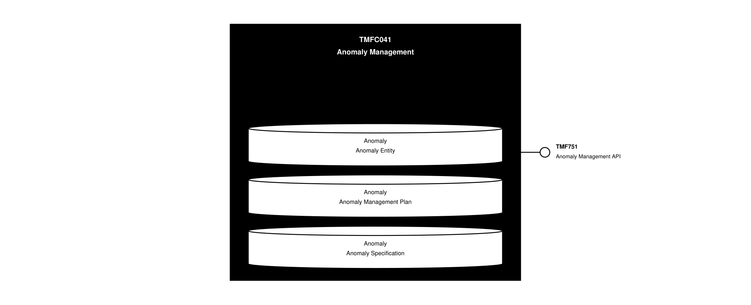
API Context diagram

Exposed APIs
API ID | API Name | Mandatory / Optional | API Version | Resource | Operations
TMF751 | Anomaly Management API | Mandatory | 4 | anomalySpecification  anomaly | GET  GET /id  POST  PATCH /id  DELETE /id

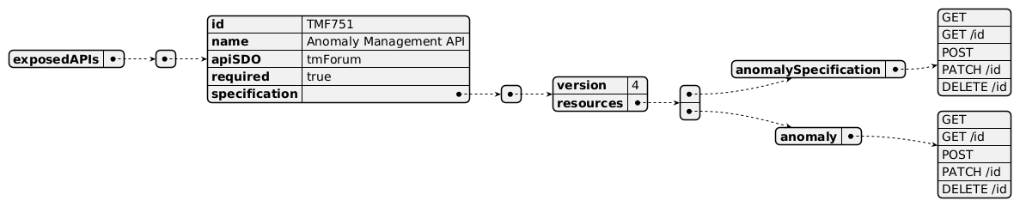
Exposed API diagram

Dependent APIs
API ID | API Name | API Version | Mandatory / Optional | Resource | Operations

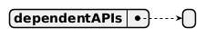
Dependent API diagram

Events
The diagram illustrates the Events which the component may publish and the Events that the component may subscribe to and then may receive. Both lists are derived from the APIs listed in the preceding sections.

Published Events
API ID | API Name | Event Resources
TMF751 | Anomaly Management API | anomalyCreateEvent  anomalyDeleteEvent  anomalyAttributeValueChangeEvent  anomalyStateChangeEvent  anomalySpecificationStatusChangeEvent  anomalySpecificationAttributeValueChangeEvent  anomalySpecificationCreateEvent  anomalySpecificationDeleteEvent

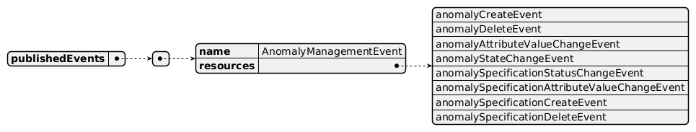
Published Events diagram

Subscribed Events
API ID | API Name | Event Resources
TMF915 | AI Management API | aiContractSpecificationCreateEvent  aiContractSpecificationDeleteEvent  aiContractSpecificationAttributeValueChangeEvent  aiModelSpecificationCreateEvent  aiModelSpecificationDeleteEvent  aiModelSpecificationAttributeValueChangeEvent  aiModelCreateEvent  aiModelStateChangeEvent  aiModelDeleteEvent  aiModelAttributeValueChangeEvent  aiContractCreateEvent  aiContractDeleteEvent  aiContractAttributeValueChangeEvent  aiContractStateChangeEvent
TMF642 | Alarm Management API | alarmCreateEvent  alarmStateChangeEvent  alarmDeleteEvent

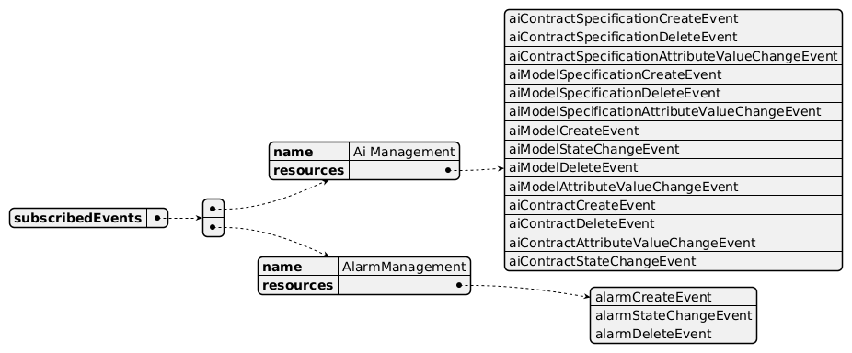
Subscribed Events diagram

Machine Readable Component Specification
Refer to the ODA Component Directory on the TM Forum website for the machine-readable component specification files for this component.

References

TMF Standards related versions
Standard | Version(s)
eTOM | *(none)*
SID | v25.0
Functional Framework | v24.0

Jira References
none currently listed

Further resources
1. IG1219 AI Closed Loop Automation - Anomaly Detection and Resolution 2. TR308 Anomaly Detector ODA Component Requirements v1.0.0 – TM Forum 3. TR309 Anomaly Predictor ODA Component Requirements v1.0.0 (tmforum.org) 4. TR310 Anomaly Mitigator ODA Component Requirements v1.0.0 (tmforum.org) 5. TR308A Anomaly Detector Business Process Scenarios v1.0.0 – TM Forum 6. TR309A Anomaly Predictor Business Process Scenarios v1.0.0 – TM Forum 7. TR310A Anomaly Mitigator Business Process Scenarios v1.0.0 – TM Forum 8. TR308E: Anomaly Detector Use Cases (WIP) 9. TMFSNNN: Anomaly Management - Product Ordering Anomaly Detection Detailed Use Case (WIP) 10. IG1228: please refer to IG1228 for defined use cases with ODA components interactions.

Administrative Appendix

Document History

Version History
Version Number | Date | Modified by | Description of changes
1.0.0 Alpha | 12-Aug-2024 | Emmanuel A. Otchere, Manoj Nair | Initial Release
1.0.0 Alpha | 21-Oct-2024 | Manoj Nair | Removed TMF672 User & Roles Management from the dependent API list as it is expected to be supported by Canvas. Added the relevant resources and operations against each API to align with the component spec template
1.1.0 | 19-Nov-2024 | Gaetano Biancardi | TMF688 removed from the core specification, moved to supporting functions. API version, only major version to be specified
1.1.0 | 26-Nov-2024 | Amaia White | Final edits prior to publication

Release History
Release Status | Date Modified | Modified by | Description of changes
Pre-production | 12-Aug-2024 | Emmanuel A. Otchere, Manoj Nair | Component description, reference ISA objects, associated APIs and events
Pre-production | 14-Oct-2024 | Adrienne Walcott | Updated to Member Evaluated status
Pre-production | 26-Nov-2024 | Amaia White | Updated to version 1.1.0
Pre-production | 17-Feb-2025 | Adrienne Walcott | Updated to Member Evaluated status

Acknowledgements
This document was prepared by the members of the TM Forum Component and Canvas project team.
Team Member | Company | Role
Emmanuel A. Otchere | Huawei | Project Chair (AI-CLA), Author
Manoj Nair | Netcracker | Author
Gaetano Biancardi | Accenture | Additional Input

