TMFC043 Fault Management v1.1.0
Components and Canvas
In this deliverable:

Overview
Component Name | ID | Description | ODA Function Block
Fault Management | TMFC043 | Fault Management component involves identifying, diagnosing, and resolving issues that prevent the communication resources and their overlaying services from functioning correctly. Its scope covers this functionality at the ODA Production layer while business related resolutions are not part of its scope. The Fault Management component manages the currently active alarms or problem candidates, potentially modifying or enhancing their data to make persistent alarms more actionable. It may apply logic to preserve alarms that reflect actual problems, eliminating those that are merely symptoms. Various actions can be taken using the alarm/problem information as part of the resolution process, such as applying automated/automonous corrective actions or opening trouble tickets. | Production

eTOM Processes, SID Data Entities and Functional Framework Functions

eTOM business activities
eTOM business activities this ODA Component is responsible for:
Identifier | Level | Business Activity Name | Description
1.5.8 | L2 | Resource Trouble Management | Resource Trouble Management processes are responsible for the management of troubles, including security events, associated with specific resources. The objectives of these processes are to efficiently and effectively manage reported resource trouble, isolate the root cause and act to resolve the resource trouble.
1.4.6 | L2 | Service Problem Management | Service Problem Management processes are responsible for the management of problems associated with specific services. The objective of these processes is to respond immediately to reported service problems or failures in order to minimize their effects on customers, and to invoke the restoration of the service, or provide an alternate service as soon as possible.

SID ABEs
SID ABEs this ODA Component is responsible for:
SID ABE Level 1 | SID ABE Level 2 (or set of BEs) | SID ABE L1 Definition | SID ABE L2 Definition
Resource Trouble | Resource Alarm | The Resource Trouble ABE collects information about problems found in allocated resource instances, regardless of whether the problem is physical or logical. Entities in this ABE capture detection, root cause, and resoluiton of these problems and maintain a history of the activities involved in diagnosing and solving the problem. This history includes tracking, reporting, assigning people to fix the problem, testing and verification, and overall administration of repair activities. | *(no description available)*
Resource Trouble | AlarmSeverityAssignmentProfile | The Resource Trouble ABE collects information about problems found in allocated resource instances, regardless of whether the problem is physical or logical. Entities in this ABE capture detection, root cause, and resoluiton of these problems and maintain a history of the activities involved in diagnosing and solving the problem. This history includes tracking, reporting, assigning people to fix the problem, testing and verification, and overall administration of repair activities. | This object class models the (flexible) severity assignment to specified probable causes. So the ASAP object includes a table, with each row specifying the probable cause (plus optionally the probableCauseQualifier and / or the nativeProbableCause) and the assigned severity for "service affecting", "non service affecting" and "service independent or unknown" alarms. Probable cause, probableCauseQualifier and nativeProbableCause are the coordinates of the ASAP entries, so there must not be two ASAP entries with the same coordinates. It is the responsibility of the EMS to enforce this. Alarms against entities that are not modeled by the interface are reported using the "AID" objectType. For these "AID" alarms the ASAP mechanism is not applicable. Typically the ASAP function is implemented in the OS or NE where the alarm is originated. I. e. the severity will usually be assigned directly by the NE, so it is up to the EMS to download the defined ASAP to the NE. Other alarms, e.g. on arcs like SNCs, may be generated by the target OS. An alarm becomes reportable by NE/target OS: - when for PTP, CTP, FTP: AlarmReporting changes from "off" to "on" - when for SNC, TopologicalLink, Equipment, EquipmentHolder, GTP: alarmReportingIndicator changes from false to true. Alarms are always reportable for all other objects as they do not have any alarm reporting attribute. When an alarm becomes reportable the ASAPs are applied (accessed via the asapPointer). The severity of the alarm is adopted from the ASAP entry that matches for all of the following: - same probableCause - same probableCauseQualifier (an empty string is a match) - same nativeProbableCause (an empty string is a match). For example, if the reportable alarm has LOS probableCause and an ASAP entry is found with LOS probableCause and both probableCauseQualifier and nativeProbableCause are empty strings, then the search is successful. If there is a matching ASAP, then the severities are adopted on the following basis: - the alarm is service affecting: the severity specified in the serviceAffecting field is assigned - the alarm is service non affecting: the severity specified in the serviceNonAffecting field is assigned - the alarm is service independent or NE/target OS is not equipped to determine if the alarm affects service or not: the severity specified in the serviceIndependentOrUnknown field is assigned. If the assigned severity specified in the ASAP is: - "FREE_CHOICE" then the NE/target OS are free to determine the severity. If there is no local mechanism on the ME/EMS to determine severity then the severity "INDETERMINATE" should be assigned. - "NOTALARMED" then the EMS should not emit an alarm over the EML-NML interface. If there is no ASAP that matches, then the NE/target OS is free to determine the severity. If there is no local mechanism on the NE/target OS to determine severity then the severity "INDETERMINATE" should be assigned. Once a severity has been assigned, the alarm notification is emitted (other than for "NOTALARMED"). Note: Any operation of alarm retrieval will not include "NOTALARMED" alarms.
Service Problem |  | The Service Problem ABE manages faults, alarms, and outages from a Service point-of-view. This is then correlated to trouble tickets, regardless of whether the cause is physical or logical. Other entities in this ABE are used to direct the recovery from each of these types of problems. They provide the ability to associate Resource faults and alarms to degradation and outages of Services that run on those Resources. | *(no description available)*

eTOM L2 - SID ABEs links
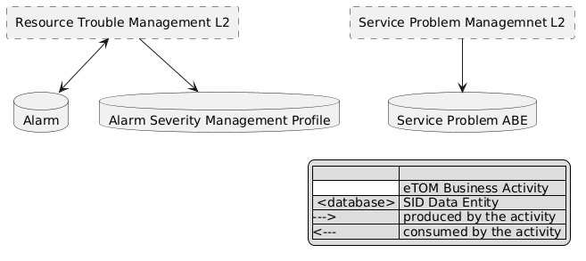
eTOM L2 - SID ABEs links diagram

Functional Framework Functions
Function ID | Function Name | Function Description | Aggregate Function Level 1 | Aggregate Function Level 2
1187 | Resource Trouble Resolution | Resource Trouble Resolution Function identifies the necessary resolution actions to solve the Resource Trouble according to Resource Problem Policy. It is based on diagnostic results. | Resource Trouble Management | Resource Trouble Analysis
615 | Service Problem Tracking & Management | Service Problem Tracking & Management functions provides necessary functionality to assure that service problems are assigned, coordinated, and restored efficiently, escalating as needed. | Service Problem Management | Service Problem Repository Management
1155 | Resource Diagnostic and Test Analysis | Resource Diagnostic and Test Analysis Function includes: - Management of success/failure result feedback of diagnostic and correction provided by technicians or the systems after a correction - Offline analysis of the success/failure data compared to the diagnostic and correction rules to provide modifications to improve them. This analysis is done using statistical diagnostic data and test results to evaluate their relevance and the needed updates. | Resource Strategic Analysis | Resource Diagnostic and Test Quality Loop
1186 | Resource Trouble Cause Identification | Resource Trouble Cause Identification Function supports the trouble causes identification, that is to say the reasons why the installed resource is in trouble and among these reasons the root cause of the resource trouble. It implements Resource Problem Policy composed of diagnostic actions (Test, inventories and historic consultation, workforce intervention, etc.) The identification of the resource trouble cause can be made through: - Analysis of associated Service Trouble Ticket Information (first diagnostic) - Analysis of associated Resource Trouble Ticket Information (first diagnostic) - Analysis of Resource alarm events (fault of performance data) - Issuing resource tests, including one time tests or a series of tests over a period of time - Analysis of previous resource test results, resource usage historic, QoS historic, equipment logs, anomaly historic, etc. | Resource Trouble Management | Resource Trouble Analysis
610 | Service Problem Prioritization | Prioritization of currently open service problems, giving consideration to problem impact, service level agreement, etc. The function will send notifications to operations applications for manual or automatic mitigation or correction. | Service Problem Management | Service Problem Resolution
612 | Service Problem Automatic Correction | Service Problem Automatic Correction functions provide the necessary maintenance functionality to automatically resolve service problems back to a normal operational state or mitigation of the service problems. This involve automated restoration activities. | Service Problem Management | Service Problem Resolution
979 | Service Assurance Control Calculation | Service Assurance Control Calculation calculates corrective actions to prevent or restore performance and quality. The calculations are rule based and takes the service's dynamics into account to perform a closed loop control to hold the performance and quality at a decided level. | Service Problem Management | Service Problem Resolution
980 | Service Assurance Trouble Mitigation | Service Assurance Trouble Mitigation have autonomic rules to minimize the lack of service by doing mitigation action e.g. restart or re-routing etc. to mitigate the negative impact for the customer from a service problem or fall-out. | Service Problem Management | Service Problem Resolution
1067 | Service Problem Manual Correction Support | Service Problem Manual Correction Support functions provide the functionality of dispatching of field technicians for manual restoration activities to resolve the service problem back to a normal operational state as efficiently as possible. This may involve reconfiguration, re-assignments, or temporary work-arounds | Service Problem Management | Service Problem Resolution

TM Forum Open APIs & Events
The following part covers the APIs and Events; this part is split in 3:

List of Exposed APIs - This is the list of APIs available from this component.

List of Dependent APIs - In order to satisfy the provided API, the component could require the usage of this set of required APIs.

List of Events (generated & consumed) - The events which the component may generate are listed in this section along with a list of the events which it may consume. Since there is a possibility of multiple sources and receivers for each defined event.

API Context Diagram
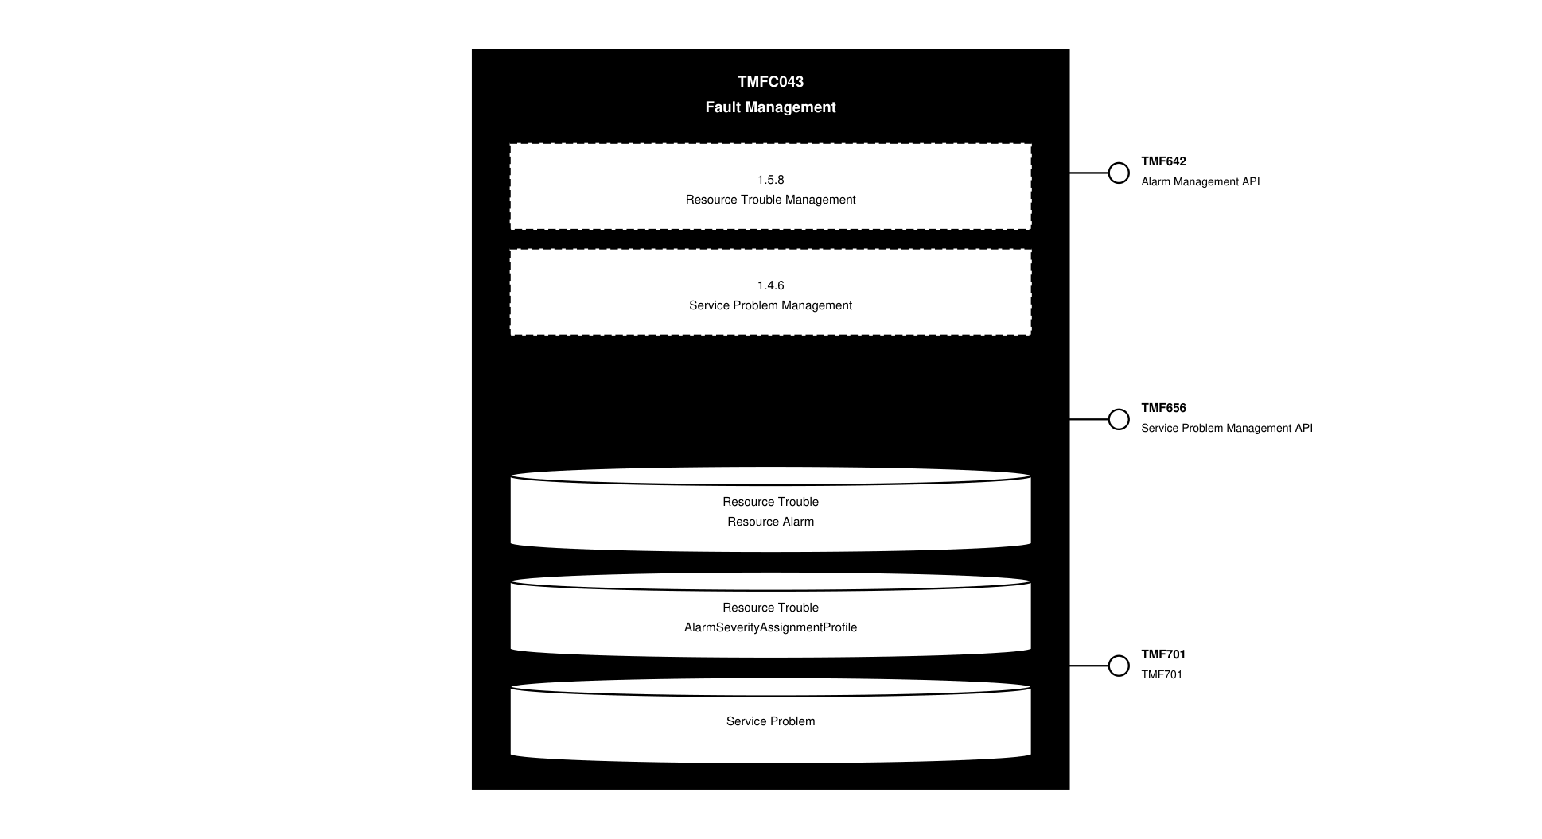
API Context diagram

Exposed APIs
API ID | API Name | Mandatory / Optional | API Version | Resource | Operations
TMF642 | Alarm Management API | Mandatory | 5 | ackAlarm  alarm  clearAlarm  groupAlarm  unAckAlarm  unGroupAlarm  commentAlarm | GET  GET /id  POST  PATCH  DELETE
TMF642 | Alarm Management API | Mandatory | 4 | alarm  ackAlarm  unAckAlarm  clearAlarm  commentAlarmlarm  groupAlarm  unGroupAlarm | GET  GET /id  POST  PATCH  DELETE
TMF656 | Service Problem Management API | Optional | 5 | problemGroup  problemUngroup  serviceProblem | POST  GET  GET /id  DELETE
TMF656 | Service Problem Management API | Optional | 4 | serviceProblem  problemGroup  problemUnGroup | GET  GET /id  POST  DELETE
TMF701 | TMF701 | Optional | 4 | processFlow  taskFlow | POST  GET  GET /id  DELETE  PATCH

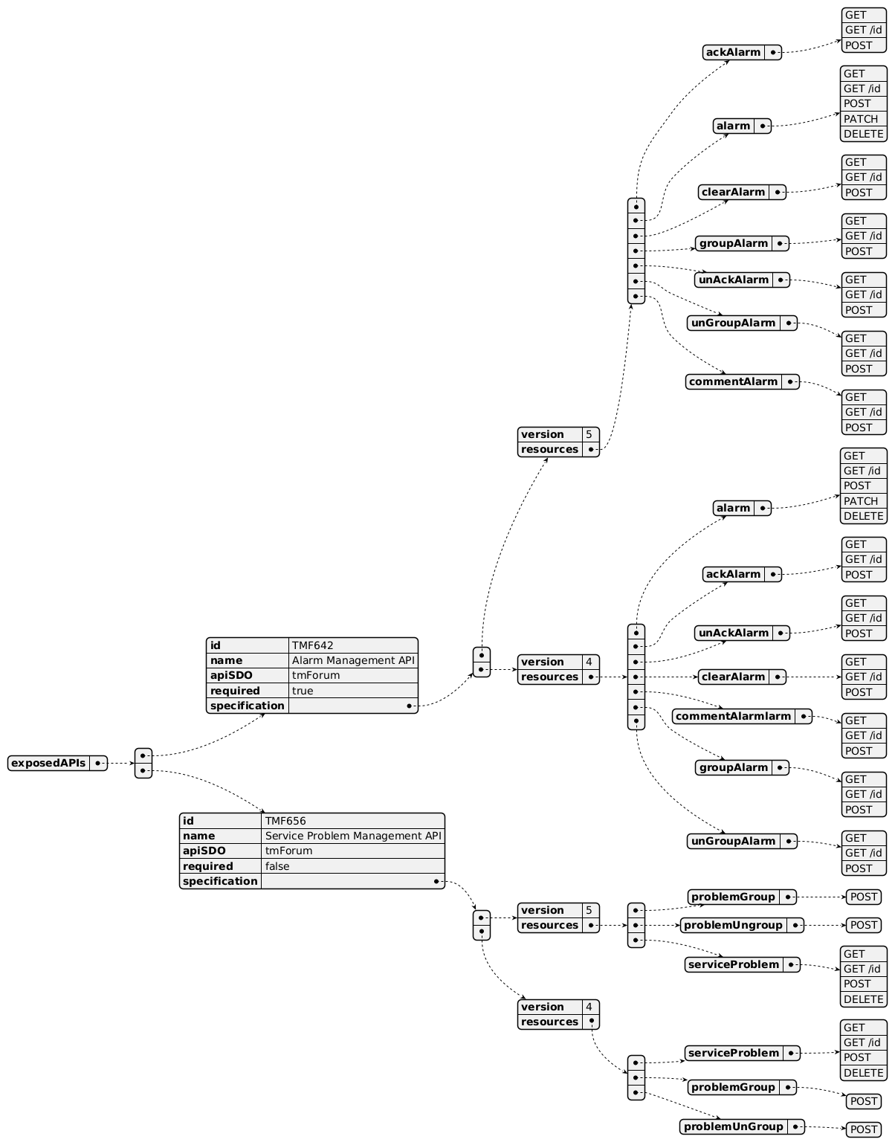
Exposed API diagram (1 of 2)
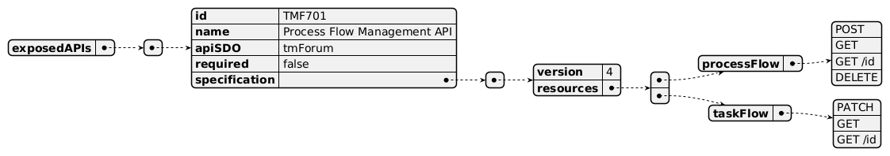
Exposed API diagram (2 of 2)

Dependent APIs
API ID | API Name | API Version | Mandatory / Optional | Resource | Operations

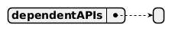
Dependent API diagram

Events
The diagram illustrates the Events which the component may publish and the Events that the component may subscribe to and then may receive. Both lists are derived from the APIs listed in the preceding sections.

Published Events
API ID | API Name | Event Resources
TMF642 | Alarm Management API | alarmCreateEvent  alarmAttributeValueChangeEvent  alarmStateChangeEvent  alarmDeleteEvent  ackAlarmsCreateEvent  ackAlarmsStateChangeEvent  unAckAlarmsCreateEvent  unAckAlarmsStateChangeEvent  clearAlarmsCreateEvent  clearAlarmsStateChangeEvent  commentAlarmsCreateEvent  commentAlarmsStateChangeEvent  groupAlarmsCreateEvent  groupAlarmsStateChangeEvent  unGroupAlarmsCreateEvent  unGroupAlarmsStateChangeEvent
TMF701 | ProcessFlowManagement | processFlowCreateEvent  processFlowStateChangeEvent  processFlowStateDeleteEvent  processFlowStateAttributeValueChangeEvent  taskFlowCreateEvent  taskFlowStateChangeEvent  taskFlowDeleteEvent  taskFlowAttributeValueChangeEvent  taskFlowInformationRequiredEvent
TMF656 | Service Problem Management API | problemAcknowledgementCreateEvent  problemAcknowledgementDeleteEvent  problemAcknowledgementStateChangeEvent  problemGroupCreateEvent  problemGroupDeleteEvent  problemGroupStateChangeEvent  problemUnacknowledgementCreateEvent  problemUnacknowledgementDeleteEvent  problemUnacknowledgementStateChangeEvent  problemUngroupCreateEvent  problemUngroupDeleteEvent  problemUngroupStateChangeEvent  serviceProblemAttributeValueChangeEvent  serviceProblemCreateEvent  serviceProblemDeleteEvent  serviceProblemInformationRequiredEvent  serviceProblemStateChangeEvent

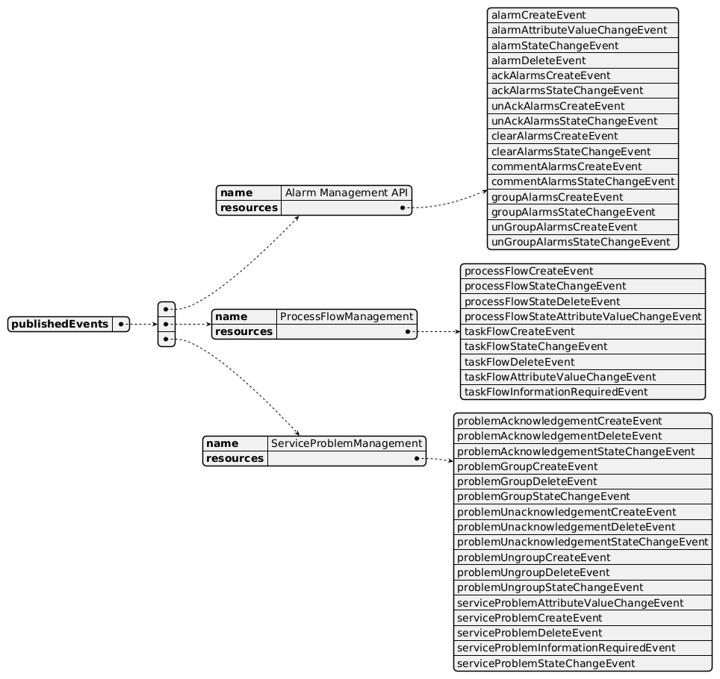
Published Events diagram

Subscribed Events
API ID | API Name | Event Resources
TMF633 | Service Catalog Management API | serviceCatalogCreateEvent  serviceCatalogChangeEvent  serviceCatalogDeleteEvent  serviceCategoryCreateEvent  serviceCategoryChangeEvent  serviceCategoryDeleteEvent  serviceCandidateCreateEvent  serviceCandidateChangeEvent  serviceCandidateDeleteEvent  serviceSpecificationCreateEvent  serviceSpecificationChangeEvent  serviceSpecificationDeleteEvent
TMF638 | Service Inventory Management API | serviceCreateEvent  serviceChangeEvent  serviceDeleteEvent  serviceStateChangeEvent
TMF639 | Resource Inventory Management API | resourceCreateEvent  resourceChangeEvent  resourceDeleteEvent  resourceStateChangeEvent
TMF673 | Geographic Address Management API | geographicAddressValidationStateChangeEvent
TMF674 | Geographic Site Management API | geographicSiteCreateEvent  geographicSiteAttributeValueChangeEvent  geographicSiteStatusChangeEvent  geographicSiteDeleteEvent
TMF675 | GeographicLocationManagement | geographicLocationCreateEvent  geographicLocationAttributeValueChangeEvent  geographicLocationDeleteEvent
TMF642 | Alarm Management API | alarmCreateEvent  alarmAttributeValueChangeEvent  alarmStateChangeEvent  alarmDeleteEvent  ackAlarmsCreateEvent  ackAlarmsStateChangeEvent  unAckAlarmsCreateEvent  unAckAlarmsStateChangeEvent  clearAlarmsCreateEvent  clearAlarmsStateChangeEvent  commentAlarmsCreateEvent  commentAlarmsStateChangeEvent  groupAlarmsCreateEvent  groupAlarmsStateChangeEvent  unGroupAlarmsCreateEvent  unGroupAlarmsStateChangeEvent
TMF656 | Service Problem Management API | problemAcknowledgementCreateEvent  problemAcknowledgementDeleteEvent  problemAcknowledgementStateChangeEvent  problemGroupCreateEvent  problemGroupDeleteEvent  problemGroupStateChangeEvent  problemUnacknowledgementCreateEvent  problemUnacknowledgementDeleteEvent  problemUnacknowledgementStateChangeEvent  problemUngroupCreateEvent  problemUngroupDeleteEvent  problemUngroupStateChangeEvent  serviceProblemAttributeValueChangeEvent  serviceProblemCreateEvent  serviceProblemDeleteEvent  serviceProblemInformationRequiredEvent  serviceProblemStateChangeEvent
TMF621 | Trouble Ticket Management API | troubleTicketCreateEvent  troubleTicketAttributeValueChangeEvent  troubleTicketStatusChangeEvent  troubleTicketDeleteEvent  troubleTicketResolvedEvent  troubleTicketInformationRequiredEvent
TMF632 | Party Management API | individualDeleteEvent  organizationDeleteEvent
TMF669 | Party Role Management API | partyRoleDeleteEvent
TMF662 | Entity Catalog Management API | entityCatalogCreateEvent  entityCatalogDeleteEvent  entityCatalogItemCreateEvent  entityCatalogItemDeleteEvent  entitySpecificationCreateEvent  entitySpecificationDeleteEvent  associationSpecificationCreateEvent  associationSpecificationDeleteEvent  associationCreateEvent  associationDeleteEvent

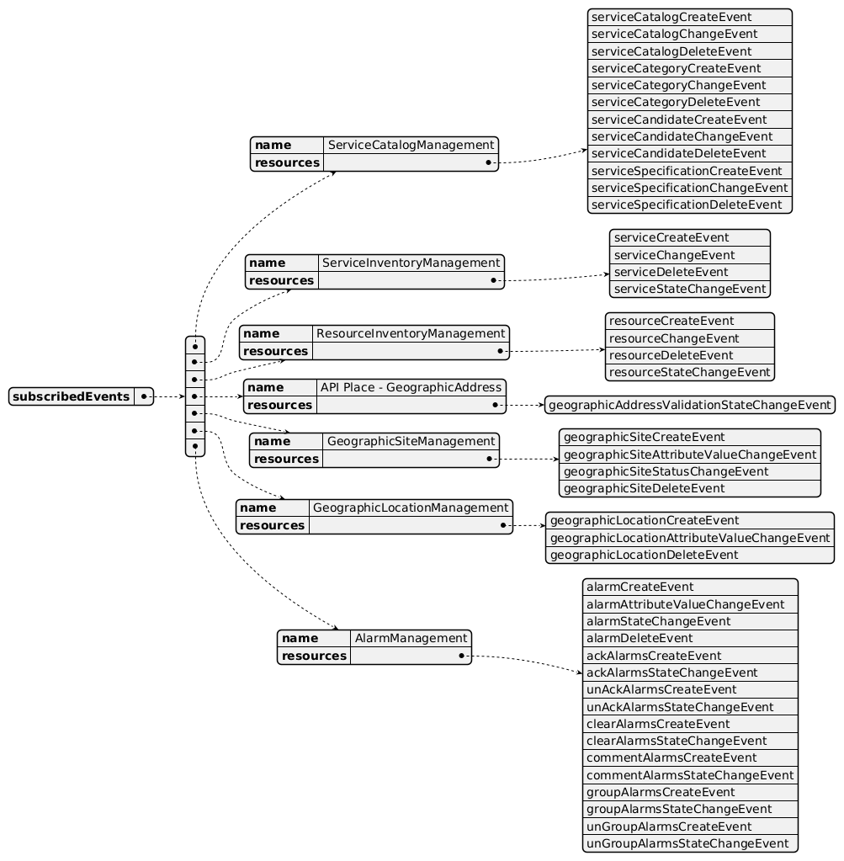
Subscribed Events diagram (1 of 2)
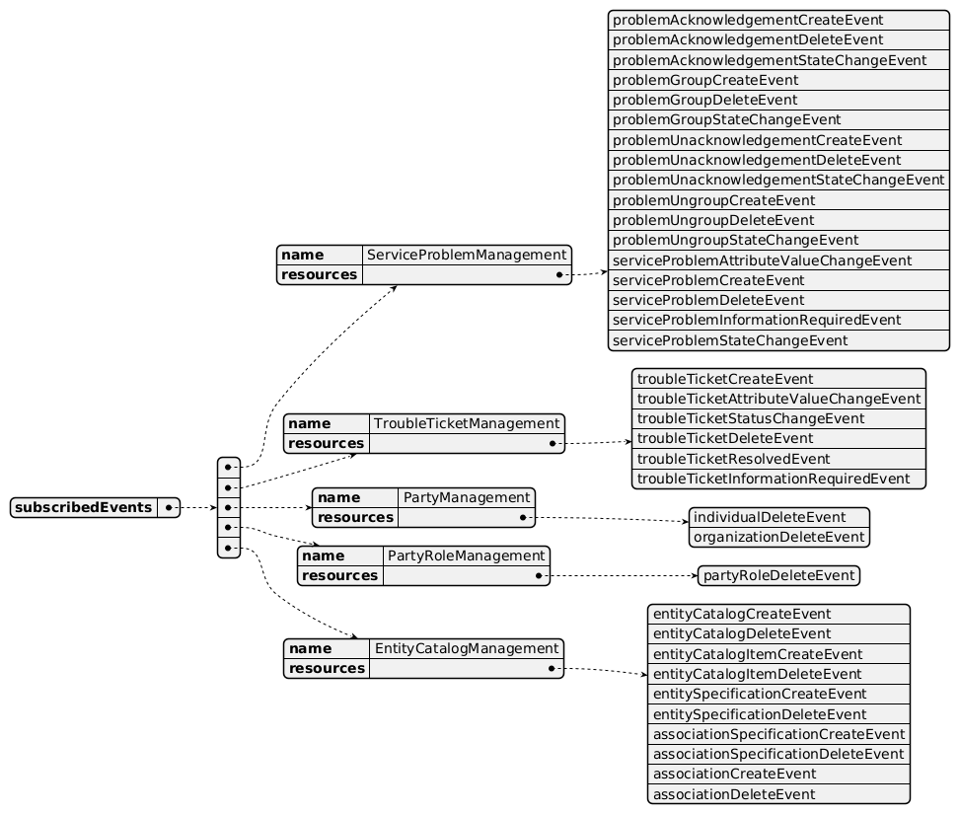
Subscribed Events diagram (2 of 2)

Machine Readable Component Specification
Refer to the ODA Component Directory on the TM Forum website for the machine-readable component specification files for this component.

References

TMF Standards related versions
Standard | Version(s)
eTOM | v25.0
SID | v25.0
Functional Framework | v25.0

Jira References
SID [ISA-1288] Missing Network Trouble Ticket Entity - TM Forum JIRA

Further resources
1. IG1228: please refer to IG1228 for defined use cases with ODA components interactions.

Administrative Appendix

Document History

Version History
Version Number | Date | Modified by | Description of changes
1.0.0 | 11-Feb-2025 | Yuval Stein | First Version
1.0.0 | 19-May-2025 | Rosie Wilson | Final Administrative Updates
1.0.1 | 09-Jul-2025 | Rosie Wilson | Updates to description per agreed YAML updated on 03 Jun 2025. Final Administrative Updates
1.1.0 | 05-Jun-2026 | Hugo Vaughan | Gen 5 API updates
1.1.0 | 25-Jun-2026 | Sannah Sibaya | Final edits prior to publication

Release History
Release Status | Date Modified | Modified by | Description of changes
Pre-production | 19-May-2025 | Rosie Wilson | First Version
Pre-production | 23-Jun-2025 | Adrienne Walcott | Updated to Member Evaluated status
Pre-production | 09-Jul-2025 | Rosie Wilson | New release 1.0.1
Production | 18-Aug-2025 | Adrienne Walcott | Updated to Member Evaluated status
Pre-production | 25-Jun-2026 | Sannah Sibaya | New Release 1.1.0

Acknowledgements
This document was prepared by the members of the TM Forum Component and Canvas project team.
Team Member | Company | Role
Yuval Stein | Amdocs | Author
Vance Shipley | SigScale | Contributor
Milind Bhagwat | BT | Contributor
Gaetano Biancardi | Accenture | Reviewer
Sylvie Demarest | Orange | Reviewer
Emmanuel A. Otchere | Huawei | Reviewer
Anastasios Sarantis | City Fibre | Reviewer
Abinash Vishwakarma | Netcracker | Reviewer
Jose Macaluso | Xacria | Reviewer
Kamal Maghsoudlou | Ericsson | Reviewer
Milind Bhagwat | BT | Reviewer
Ritu Arora | BT | Reviewer
Matteo Destino | Accenture | Reviewer

