TMFC046 Workforce Management v1.2.0
Components and Canvas
In this deliverable:

Overview
Component Name | ID | Description | ODA Function Block
Workforce Management | TMFC046 | Workforce Management component provides capabilities to describe teams, organizations, skills and availability of sales / technical experts. It provides the ability to reserve time slots to carry out assigned tasks (internal or customer facing). It allows the reservation (and updates/rescheduling) of appointments and interventions. | Production

eTOM Processes, SID Data Entities and Functional Framework Functions

eTOM business activities
eTOM business activities this ODA Component is responsible for:
Identifier | Level | Business Activity Name | Description
1.5.4 | L2 | Resource Readiness & Support | Manage resource infrastructure to ensure that appropriate application, computing and network resources are available and ready to support the Fulfillment, Assurance and Billing processes in instantiating and managing resource instances, and for monitoring
1.5.4.8 | L3 | Manage Field Workforce | "Managing the staff performing manual activities along with managing the actual activity being performed. - Note: The current focus of the Manage Field Workforce processes is field Staff and others managed through work orders, etc. There is opportunity fo

SID ABEs
SID ABEs this ODA Component is responsible for:
SID ABE Level 1 | SID ABE Level 2 (or set of BEs) | SID ABE L1 Definition | SID ABE L2 Definition
Workforce |  | The Workforce ABE models the human and other field resources with their roles, skills, calendar, and other characteristics. It also models the work description and reservation and assignment of a technician to a task. It contains Work, Work Specification, WorkforceResource, and WorkforceSchedule. | *(no description available)*

eTOM L2 - SID ABEs links
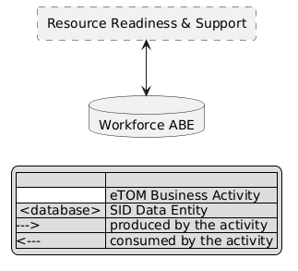
eTOM L2 - SID ABEs links diagram

Functional Framework Functions
Function ID | Function Name | Function Description | Aggregate Function Level 1 | Aggregate Function Level 2
119 | Center Time Management | Center Time Management supports all of the time management of a service provider Agent/CSR/LCM etc. including tracking of hours worked, hours spent in training and other activities. It includes all time attributes used in the scheduling of resources to meet center SLAs. This function would also track time associated with a specific activity whether it be a short (single contact) or long running, multiple contact and team related activity. This aspect of time may span center resources. | Workforce Operational Management | Workforce Activity Tracking
1326 | Work List Management | Work List Management function supports organizing and prioritizing tasks for individuals or groups. It includes: / 1. Task Identification and Prioritization: Worklist managers determine the importance of tasks and prioritize them based on urgency and impact. / 2. Task Assignment: They allocate tasks to the appropriate individuals or teams, ensuring the right people are working on the right tasks. / 3. Workflow Optimization: Worklist management streamlines processes, reducing delays and bottlenecks. / 4. Monitoring Progress: Managers track task completion and ensure adherence to deadlines. / 5. Resource Allocation: They allocate resources like time, manpower, and equipment effectively. / 6. Communication Facilitation: They foster communication among team members and stakeholders. / 7. Risk Mitigation: Managers identify and address potential risks to prevent disruptions in workflow. | Workforce Operational Management | Workforce Activity Tracking
113 | Care-center Compliance Management | Care-center Compliance Management manages compliance with customer service / work-center methods and procedures. | Workforce Operational Management | Workforce Organisation
116 | Center Activity Management | Center Activity Management includes the necessary functionality to track activities performed within a work center. These activities range from orders placed, sales closed, problems resolved, ticket closed, etc. Most work centers incorporate a detailed activity tracking mechanism with associated reporting for individual agent performance and is typically rolled up to support center-level performance as well. | Workforce Operational Management | Workforce Organisation
449 | Resource Change Project Collaboration | Resource Change Project Collaboration provides interfaces to Workforce Management, supports collaborative project management across business boundaries and supports links to vendors ERP - via B2B portals and to internal network engineering duties for in-station and street activities. | Workforce Operational Management | Workforce Organisation
1184 | Workforce Agenda Booking | The Workforce Agenda Booking Function enables to manage Workforce appointment with any Party such as Customer, Business Partner and tracks the appointment in the workforce calendar. | Workforce Operational Management | Workforce Appointment Management
1183 | Workforce Availability Check | The Workforce Availability Check Function enables to check the availability of Workforce. | Workforce Operational Management | Workforce Appointment Management
114 | Care-center Case Queing | Care-center Case Queuing addresses the work queuing and work assignment for cases received from various channels including incoming calls, email, and back-office/front-office work distribution and queuing. Work Queuing can be on-line (active customer contact) or off line (no customer "on the line"). | Workforce Operational Management | Workforce Schedule Management
554 | Workforce Appointment Schedule Configuration | Workforce Appointment Schedule Configuration provides configuration of rules and routines for the workforce appointment schedule. | Workforce Operational Management | Workforce Schedule Management
555 | Workload Forecasting | Workload Forecasting provides forecasting of the workload and respective assignable staffing requirements on a daily, weekly, and longer period basis. | Workforce Operational Management | Workforce Schedule Management
556 | Workforce Availability Management | Workforce Availability Management provides management of staff availability, including vacation time. | Workforce Operational Management | Workforce Schedule Management
558 | Workforce Dispatchability Management | Workforce Dispatchability Management provides management of the dispatchable technicians, including skill sets. | Workforce Operational Management | Workforce Schedule Management
482 | Workforce Management | Workforce Management function coordinate the availability and deployment of workforce resources to their in-service locations for e.g. preventative maintenance and change management. | Workforce Operational Management | Workforce Schedule Management
561 | Workforce Scheduling | Workforce Schedule Management function provide the necessary functionality to manage the work schedule, appointment schedule and resource schedule of the dispatchable workforce. | Workforce Operational Management | Workforce Schedule Management

TM Forum Open APIs & Events
The following part covers the APIs and Events; this part is split in 3:

List of Exposed APIs - This is the list of APIs available from this component.

List of Dependent APIs - In order to satisfy the provided API, the component could require the usage of this set of required APIs.

List of Events (generated & consumed) - The events which the component may generate are listed in this section along with a list of the events which it may consume. Since there is a possibility of multiple sources and receivers for each defined event.

API Context Diagram
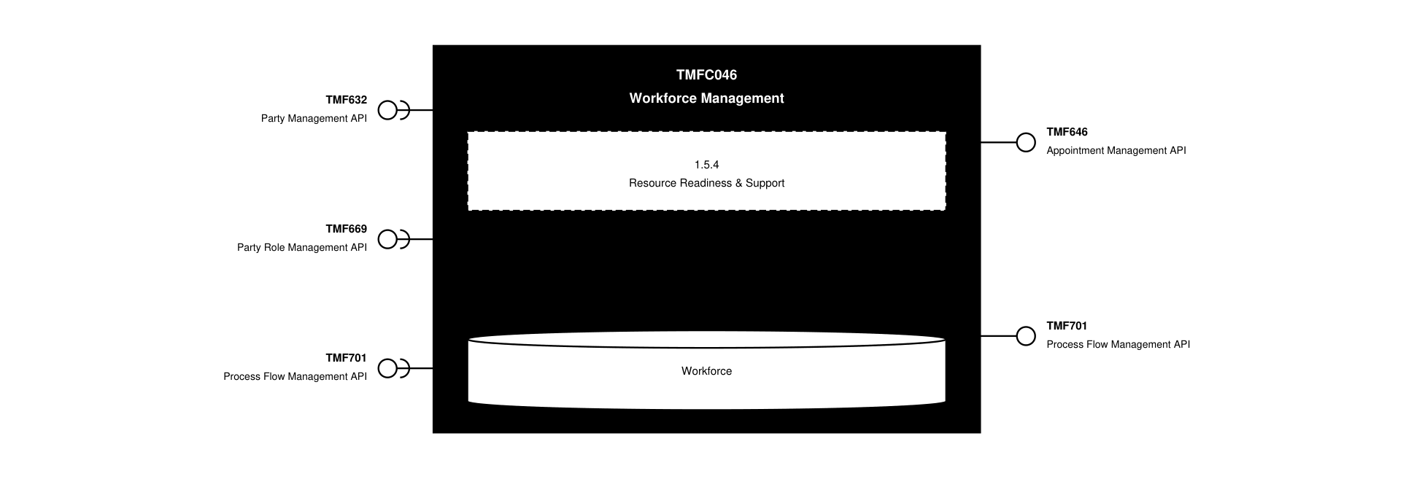
API Context diagram

Exposed APIs
API ID | API Name | Mandatory / Optional | API Version | Resource | Operations
TMF646 | Appointment Management API | Mandatory | 4 | appointment  searchTimeSlot | GET  GET /id  POST  PATCH /id  DELETE /id
TMF701 | Process Flow Management API | Optional | 4 | processFlow  taskFlow | GET  GET /id  POST  DELETE /id  PATCH /id

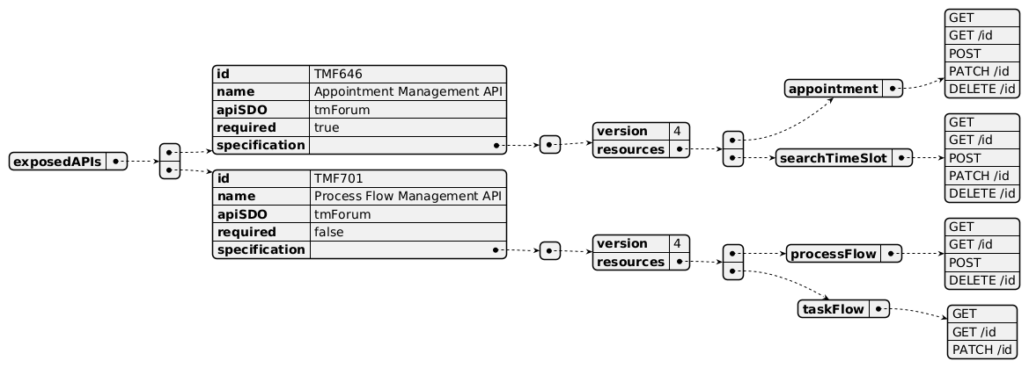
Exposed API diagram

Dependent APIs
API ID | API Name | API Version | Mandatory / Optional | Resource | Operations
TMF632 | Party Management API | 5 | Optional | individual  organization | GET  GET /id
TMF632 | Party Management API | 4 | Optional | individual  organization | GET  GET /id
TMF669 | Party Role Management API | 5 | Optional | partyRole | GET  GET /id
TMF669 | Party Role Management API | 4 | Optional | PartyRole | GET  GET /id
TMF701 | Process Flow Management API | 4 | Optional | processFlow | POST  GET  GET /id  PATCH

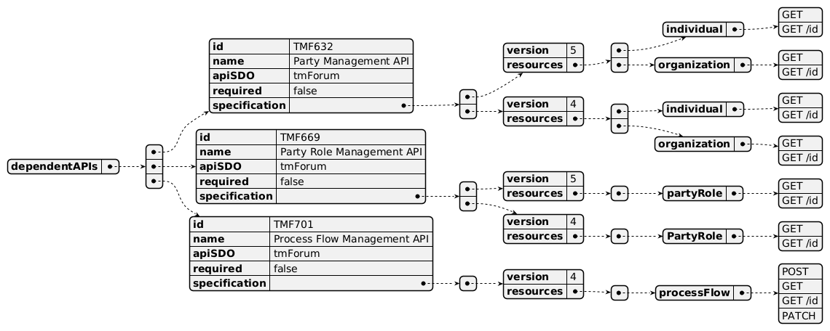
Dependent API diagram

Events
The diagram illustrates the Events which the component may publish and the Events that the component may subscribe to and then may receive. Both lists are derived from the APIs listed in the preceding sections.

Published Events
API ID | API Name | Event Resources
TMF646 | Appointment Management API | appointmentStateChange  appointmentCreateEvent  appointmentAttributeValueChangeEvent  appointmentDeleteEvent  searchTimeSlotCreateEvent  searchTimeSlotAttributeValueChangeEvent  searchTimeSlotStateChangeEvent  searchTimeSlotDeleteEvent

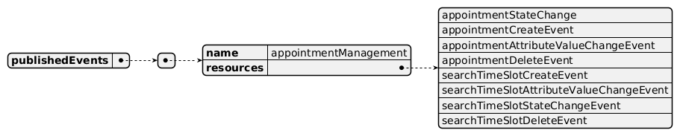
Published Events diagram

Subscribed Events
API ID | API Name | Event Resources
TMF669 | Party Role Management API | partyRoleCreateEvent  partyRoleAttributeValueChangeEvent  partyRoleStateChangeEvent  partyRoleDeleteEvent
TMF701 | Process Flow Management API | processFlowCreateEvent  processFlowStateChangeEvent  processFlowStateDeleteEvent  processFlowStateAttributeValueChangeEvent  taskFlowCreateEvent  taskFlowStateChangeEvent  taskFlowDeleteEvent  taskFlowAttributeValueChangeEvent  taskFlowInformationRequiredEvent

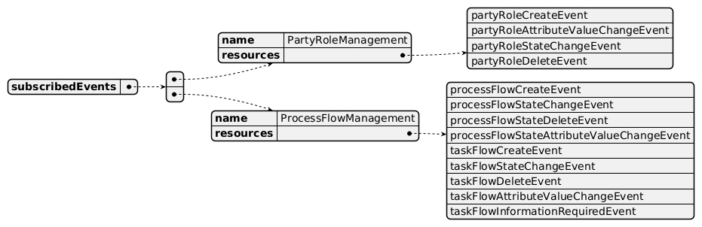
Subscribed Events diagram

Machine Readable Component Specification
Refer to the ODA Component Directory on the TM Forum website for the machine-readable component specification files for this component.

References

TMF Standards related versions
Standard | Version(s)
eTOM | v23.0.1
SID | v25.0
Functional Framework | v23.0

Jira References
none currently listed

Further resources
1. IG1228: please refer to IG1228 for defined use cases with ODA components interactions.

Administrative Appendix

Document History

Version History
Version Number | Date | Modified by | Description of changes
1.0.0 | 30-Apr-2024 | Amaia White | v1.0.0 Initial release final edits prior to publication
1.1.0 | 03-Dec-2024 | Anastasios Sarantis | Updates in v1.1.0
1.1.0 | 27-Dec-2024 | Rosie Wilson | Final administrative edits
1.1.1 | 11-Mar-2025 | Gaetano Biancardi | Maturity level corrected to General Availability
1.1.1 | 13-Mar-2025 | Rosie Wilson | Final administrative edits
1.1.2 | 09-Jul-2025 | Rosie Wilson | Updates to description per agreed YAML updated on 03 Jun 2025. Final administrative edits

Release History
Release Status | Date Modified | Modified by | Description of changes
Pre-production | 30-Apr-2024 | Amaia White | 1st version of document v1.0.0
Pre-production | 10-Jun-2024 | Adrienne Walcott | Updated to Member Evaluated status
Pre-production | 27-Dec-2024 | Rosie Wilson | Updated to release v1.1.0
Pre-production | 17-Feb-2025 | Adrienne Walcott | Updated to Member Evaluated status
Pre-production | 13-Mar-2025 | Rosie Wilson | Updated to release v1.1.1
Production | 09-May-2025 | Adrienne Walcott | Updated to reflect TM Forum Approved status
Pre-production | 09-Jul-2025 | Rosie Wilson | Updated to release v1.1.2

Acknowledgements
This document was prepared by the members of the TM Forum Component and Canvas project team.
Team Member | Company | Role
Milind Bhagwat | BT Group PLC | Author
Gaetano Biancardi | Accenture | Reviewer
Elisabeth Andersson | Matrixx | Reviewer
Abinash Vishwakarma | Netcracker | Reviewer
Jose Macaluso | Xacria | Reviewer
Kamal Maghsoudlou | Ericsson | Reviewer
Milind Bhagwat | BT | Reviewer
Ritu Arora | BT | Reviewer
Matteo Destino | Accenture | Reviewer
Rosie Wilson | TM Forum | Reviewer

