TMFC050 Product Recommendation Management v1.1.0
Components and Canvas
In this deliverable:

Overview
Component Name | ID | Description | ODA Function Block
Product Recommendation Management | TMFC050 | The Product Recommendation Management component is responsible for evaluating and providing Party recommendation offerings based on the history and real-time context of a Party. | Core Commerce

eTOM Processes, SID Data Entities and Functional Framework Functions

eTOM business activities
eTOM business activities this ODA Component is responsible for:
Identifier | Level | Business Activity Name | Description
1.12.9.4.2 | L4 | Recommend Appropriate Product Offering(s) | Recommend more appropriate product offering(s) to the customer or other party based on the results of Analyze Customer or Other Party Trends.
1.12.9.4 | L3 | Cross/Up Sell | Ensure that the value of the relationship between the customer or other party and an enterprise is maximized by selling additional, or more of the existing, product offerings.

SID ABEs
SID ABEs this ODA Component is responsible for:
SID ABE Level 1 | SID ABE Level 2 (or set of BEs) | SID ABE L1 Definition | SID ABE L2 Definition
Product Offering Specification |  | The Product Offering Specification ABE describes tangible and intangible goods made available for a certain price to the market in the form of product catalogs. This ABE is also responsible for targeting market segments based on the appropriate market strategy. | *(no description available)*

eTOM L2 - SID ABEs links
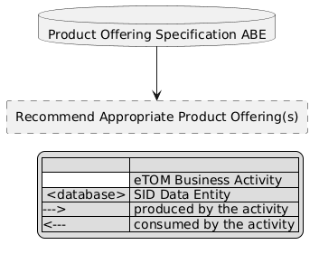
eTOM L2 - SID ABEs links diagram

Functional Framework Functions
Function ID | Function Name | Function Description | Aggregate Function Level 1 | Aggregate Function Level 2
1196 | Product Specification & Offering Simulation | Product Specification & Offering Simulation Function simulates Product Specification configuration and Product Offerings on the real traffic of the customer thanks to Tariff Calculation and Rating. | Product Operational Analysis | Pushed Offer Management
1195 | Pushed Offer Identification | Pushed Offer Identification Function identifies offers adapted to the customer needs including personalized offers. Based on a customer's individualized knowledge (Marketing one to one), the aim is to elaborate for each customer according to his needs and recent action individualized Product Specifications & Offerings. | Product Operational Analysis | Pushed Offer Management

TM Forum Open APIs & Events
The following part covers the APIs and Events; this part is split in 3:

List of Exposed APIs - This is the list of APIs available from this component.

List of Dependent APIs - In order to satisfy the provided API, the component could require the usage of this set of required APIs.

List of Events (generated & consumed) - The events which the component may generate are listed in this section along with a list of the events which it may consume. Since there is a possibility of multiple sources and receivers for each defined event.

API Context Diagram
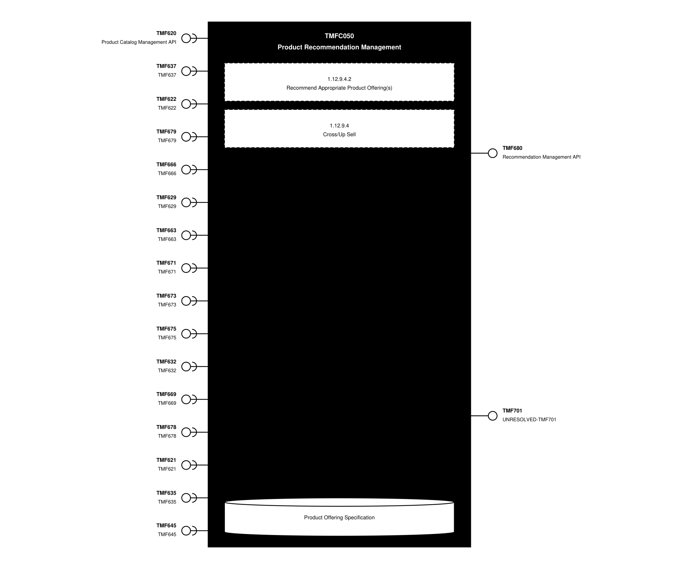
API Context diagram

Exposed APIs
API ID | API Name | Mandatory / Optional | API Version | Resource | Operations
TMF680 | Recommendation Management API | Mandatory | 4 | queryProductRecommendation | GET  GET /id  POST
TMF701 | UNRESOLVED-TMF701 | Optional | 4 | processFlow  taskFlow | GET  GET /id  POST  DELETE /id  PATCH /id

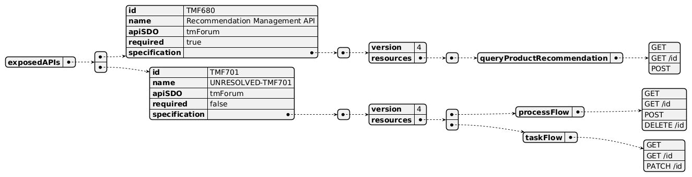
Exposed API diagram

Dependent APIs
API ID | API Name | API Version | Mandatory / Optional | Resource | Operations
TMF620 | Product Catalog Management API | 5 | Mandatory | productCatalog  category  productOffering  productOfferingPrice  productSpecification | GET  GET /id
TMF620 | Product Catalog Management API | 4 | Mandatory | catalog  category  productSpecification  productOffering  productOfferingPrice | GET  GET /id
TMF637 | TMF637 | 5 | Optional | product | GET  GET /id
TMF637 | TMF637 | 4 | Optional | product | GET  GET /id
TMF622 | TMF622 | 5 | Optional | productOrder | GET  GET /id
TMF622 | TMF622 | 4 | Optional | productOrder | GET  GET /id
TMF679 | TMF679 | 4 | Optional | productOfferingQualification | GET  GET /id
TMF666 | TMF666 | 5 | Optional | billingAccount | GET  GET /id
TMF666 | TMF666 | 4 | Optional | billingAccount | GET  GET /id
TMF629 | TMF629 | 5 | Optional | customer | GET  GET /id
TMF629 | TMF629 | 4 | Optional | customer | GET  GET /id
TMF663 | TMF663 | 5 | Optional | shoppingCart | GET  GET /id
TMF663 | TMF663 | 4 | Optional | shoppingCart | GET  GET /id
TMF671 | TMF671 | 4 | Optional | promotion | GET  GET /id
TMF673 | TMF673 | 4 | Optional | geographicAddressManagement | GET  GET /id
TMF675 | TMF675 | 4 | Optional | geographicLocationManagement | GET  GET /id
TMF632 | TMF632 | 5 | Optional | individual  organization | GET  GET /id
TMF632 | TMF632 | 4 | Optional | individual  organization | GET  GET /id
TMF669 | TMF669 | 5 | Optional | partyRole | GET  GET /id
TMF669 | TMF669 | 4 | Optional | partyRole | GET  GET /id
TMF678 | TMF678 | 5 | Optional | customerBill | GET  GET /id
TMF678 | TMF678 | 4 | Optional | customerBill | GET  GET /id
TMF621 | TMF621 | 5 | Optional | troubleTicket | GET  GET /id
TMF621 | TMF621 | 4 | Optional | troubleTicket | GET  GET /id
TMF635 | TMF635 | 4 | Optional | usage | GET  GET /id
TMF645 | TMF645 | 5 | Optional | checkServiceQualification  queryServiceQualification | GET  GET /id  POST  PATCH
TMF645 | TMF645 | 4 | Optional | checkServiceQualification  queryServiceQualification | GET  GET /id  POST  PATCH

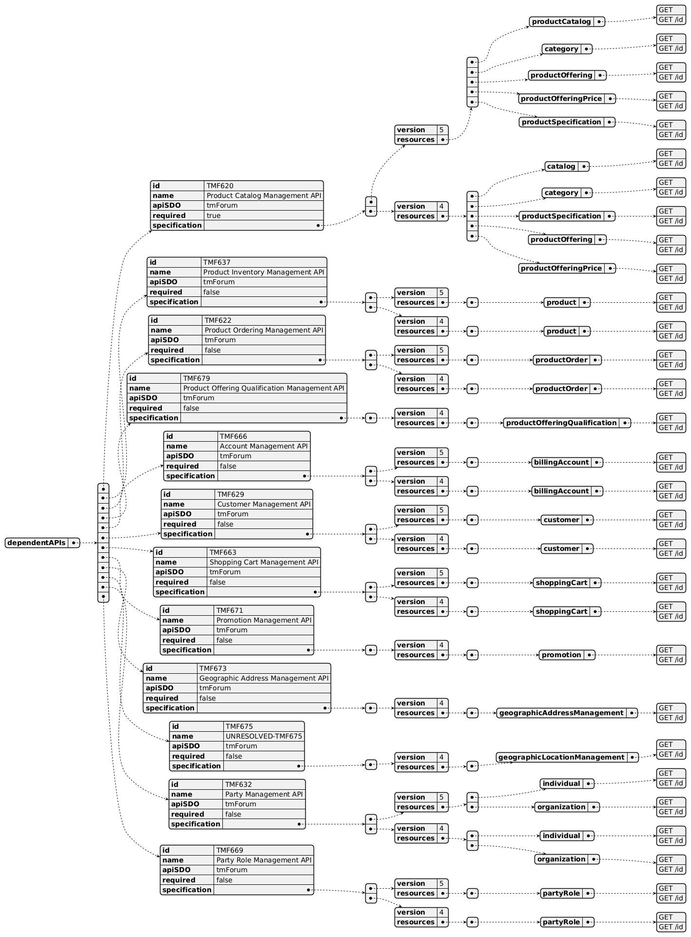
Dependent API diagram (1 of 2)
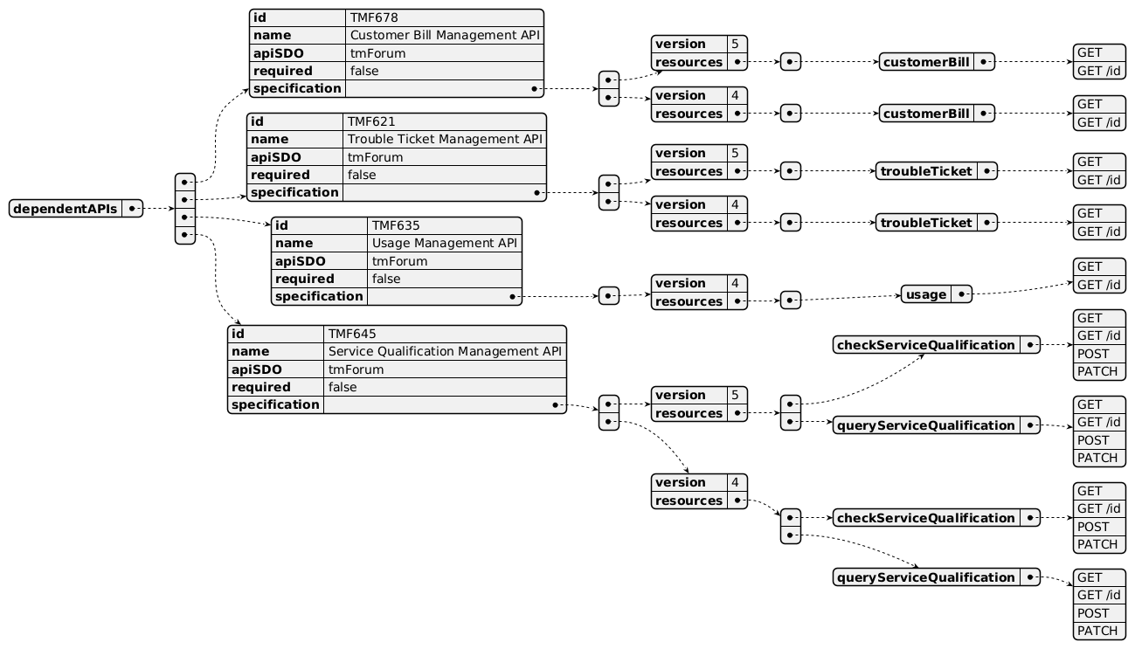
Dependent API diagram (2 of 2)

Events
The diagram illustrates the Events which the component may publish and the Events that the component may subscribe to and then may receive. Both lists are derived from the APIs listed in the preceding sections.

Published Events
API ID | API Name | Event Resources
TMF680 | Recommendation Management API | queryProductRecommendationCreateEvent  queryProductRecommendationStateChangeEvent
TMF701 | UNRESOLVED-TMF701 | processFlowCreateEvent  processFlowStateChangeEvent  processFlowStateDeleteEvent  processFlowStateAttributeValueChangeEvent  taskFlowCreateEvent  taskFlowStateChangeEvent  taskFlowDeleteEvent  taskFlowAttributeValueChangeEvent  taskFlowInformationRequiredEvent

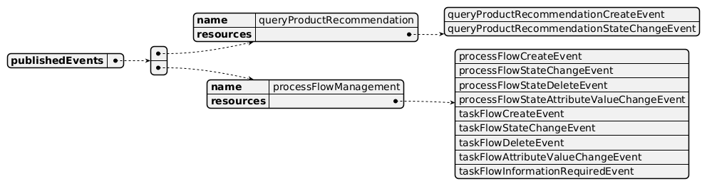
Published Events diagram

Subscribed Events
API ID | API Name | Event Resources
TMF620 | Product Catalog Management API | productSpecificationCreate  productSpecificationDeleteEvent  categoryCreateEvent  categoryDeleteEvent  productOfferingCreateEvent  productOfferingAttributeValueChangeEvent  productOfferingStateChangeEvent  productOfferingDeleteEvent  productOfferingPriceCreateEvent  productOfferingPriceAttributeValueChangeEvent  productOfferingPriceStateChangeEvent  productOfferingPriceDeleteEvent

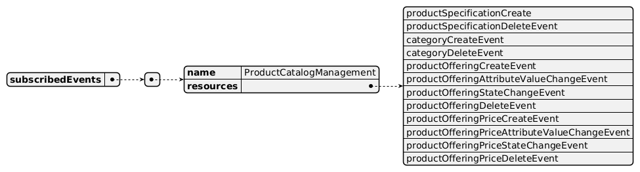
Subscribed Events diagram

Machine Readable Component Specification
Refer to the ODA Component Directory on the TM Forum website for the machine-readable component specification files for this component.

References

TMF Standards related versions
Standard | Version(s)
eTOM | v26.0
SID | v26.0
Functional Framework | v26.0

Jira References

JIRA request for creating the SID entity for queryRecommendationManagement: [ISA-1194] SID Entity for queryRecommendationManagement - TM Forum Jira

JIRA request for improving the function description of 1196: [FX-1227] Improvement of the description for function id 1196 - Product Specification & Offering Simulation - TM Forum Jira

JIRA request for improving the function description of 1195: [FX-1228] Improvement of the description for function id 1195 - Pushed Offer Identification - TM Forum JIRA

Further resources
1. IG1228: please refer to IG1228 for defined use cases with ODA components interactions.

Administrative Appendix

Document History

Version History
Version Number | Date | Modified by | Description of changes
1.0.0 | 11-Dec-2024 | Abinash Vishwakarma | First version.
1.0.0 | 07-Jan-2025 | Rosie Wilson | Final administrative edits prior to publication
1.1.0 | 10-Mar-2025 | Abinash Vishwakarma | Added Service Qualification Management
1.1.0 | 14-Mar-2025 | Rosie Wilson | Final administrative edits prior to publication
1.1.1 | 20-Jan-2026 | Rosie Wilson | Updates to description per agreed YAML updated on 03 Jun 2025. Final administrative updates prior to publication
1.2.0 | 05-Jun-2026 | Hugo Vaughan | Gen 5 API updates
1.2.0 | 25-Jun-2026 | Sannah Sibaya | Final edits prior to publication

Release History
Release Status | Date Modified | Modified by | Description of changes
Pre-production | 07-Jan-2025 | Rosie Wilson | Initial Release
Production | 07-Mar-2025 | Adrienne Walcott | Updated to reflect TM Forum Approved status
Pre-production | 14-Mar-2025 | Rosie Wilson | New version 1.1.0
Production | 09-May-2025 | Adrienne Walcott | Updated to reflect TM Forum Approved status
Pre-production | 20-Jan-2026 | Rosie Wilson | New version 1.1.1
Production | 20-Mar-2026 | Adrienne Walcott | Updated to reflect TM Forum Approved status
Pre-production | 25-Jun-2026 | Sannah Sibaya | New version 1.2.0

Acknowledgements
This document was prepared by the members of the TM Forum Component and Canvas project team.
Team Member | Company | Role
Abinash Vishwakarma | Netcracker | Editor
Gaetano Biancardi | Accenture | Reviewer
Sylvie Demarest | Orange | Reviewer
Rosie Wilson | TM Forum | Additional Input
Hugo Vaughan (TM Forum) | TM Forum | Additional Input
Elisabeth Andersson | Matrixx | Reviewer
Jose Macaluso | Xacria | Reviewer
Milind Bhagwat | BT | Reviewer
Ritu Arora | BT | Reviewer
Matteo Destino | Accenture | Reviewer

