TMFC054 Product Test Management v1.1.0
Components and Canvas
In this deliverable:

Overview
Component Name | ID | Description | ODA Function Block
Product Test Management | TMFC054 | Product Test Management component is responsible for product test specification for each Product Specification, and identification of the possible tests to be launched automatically by the delivery or assurance processes, or manually by the customer or user or by a CSR, to test that a product is functioning correctly. It utilizes tests available at the service specification level (or resource specification level for a tangible product). Product Test Management owns end-to-end execution and reporting of product tests according to the context and/or the actor. | Core Commerce

eTOM Processes, SID Data Entities and Functional Framework Functions

eTOM business activities
eTOM business activities this ODA Component is responsible for:
Identifier | Level | Business Activity Name | Description
1.2.1.5 | L3 | Product Test Strategy | Product Test Strategy develops the strategies of the enterprise for Product Test. / This process is in charge of identifying types of Product Test to be conducted according to different context (i.e. business activities) for types of products. / The different context for Product Test are: / Product Specification Development & Retirement to qualify the capacity to deliver Products before validating a new ProductSpecification, / Order Handling (Customer Order Orchestration) to test the Product before closing the CustomerOrderItem, / Product Performance Management to test Product performance, / Customer Problem Handling to test Product functioning, / Product Test Management to conduct tests not specific to a customer’s product.
1.2.4.9 | L3 | Manage Product Test | Manage Product Test processes manage the end-to-end execution of a test or test scenario for products not specific to a customer. Tests can be manual or automated. / Product Test Management processes rely on Service Test Management and Resource Test Management processes due to dependencies between product tests, service tests and resource tests. / Product Test Management includes: / - Identification of product tests needed according to fulfillment and assurance issues / - triggering of product tests in manual or automated mode / - Execution of product tests / - Verification of test authorization (role and context) and quota management / - Identification and prioritization of tests / - Setting up the test context and configuration / - Triggering appropriate service & resource Tests / - Tests can be on-demand or planned according to specific needs / - Enrichment with service and resource tests results based on applicable product test rules / - Reporting of test results
1.2.1 | L2 | Product Portfolio Strategy Management | Product Portfolio Strategy Management includes activities to make decisions about products to develop, maintain, or phase out. It also has oversight on Product Allocation to maximize growth and profitability across the entire product portfolio, and individual Product Strategy to outline how a product will operate and support the business strategy and goals. Product Portfolio Strategy Management plans, supports development, and overseeing a product from concept to market release.
1.2.4 | L2 | Product Support Management | Product Support Management processes ensure the support capability is in place to allow the CRM Fulfillment, Assurance and Billing processes to operate effectively.

SID ABEs
SID ABEs this ODA Component is responsible for:
SID ABE Level 1 | SID ABE Level 2 (or set of BEs) | SID ABE L1 Definition | SID ABE L2 Definition
Product Test |  | Product Test ABE represents all information to specify tests that will be performed on Products as well as the results in measures being produced that reflect the functioning of the product under test. | *(no description available)*

eTOM L2 - SID ABEs links
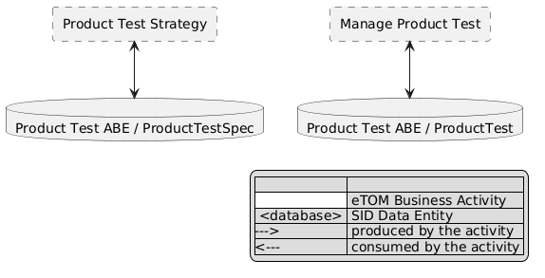
eTOM L2 - SID ABEs links diagram

Functional Framework Functions
Function ID | Function Name | Function Description | Aggregate Function Level 1 | Aggregate Function Level 2
1073 | Product Test Specification Design | Product Test Specification Design is in charge of designing Product Test Specification. It includes: / Defining the Product Test Specification, depending on the atomic product specification, based on a Service Test Specification or directly a Resource Test Specification (for example for a resource like a box, a STB) / Managing product test capabilities: the underlying service or resource tests used to define the product test have limitation that must be taken into account. Additional limitations can be enforced at the product level especially for the self-tests for the users / Managing initiator authorization: some tests are restricted to some user roles (internal or external) so the authorization are defined at the Product Test Strategy and Policy Management. | Product Specification & Offering Management | Product Test Specification Development
1074 | Product Test Configuration Design | Product Test Configuration Design Function specifies Test rules defining the strategies for setting up test configuration that are necessary for executing the service or resource test on which the product test is based. | Product Specification & Offering Management | Product Test Specification Development
1075 | Product Test Restitution Design | Product Test Restitution Design Function specifies Test rules defining the restitution of the result depending on test execution context. / For example: a test result of ok/not ok can be enough for a user whereas customer care may require more details in the result of the test. | Product Specification & Offering Management | Product Test Specification Development
1130 | Product Test Authorization Check | Product Test Authorization Check Function verifies test authorization and quota management: product test execution checks. | Product Test Management | End to End Product Test Execution
1131 | Product Test Execution | Product Test Execution Function includes: / Carrying out test priority: for example, the priority of a self-care test for a user is higher than a back-office test / Retrieval of appropriate inventory data and setting up the test context and configuration / Test execution with access to the various data required to perform product testing / A product test main actions will be to trigger service or resource tests depending on the product composition / Data collected during product test can be inventory data (for example in IS inventory) or data coming from service or resource tests / Test execution produces a test result that may contain a raw result and an enrichment of this result depending on the product test definition and associated rules. / For example: for an access product test the raw result can be the associated bandwidth and an enrichment can be done depending on the user access type (fiber, xdsl) to evaluate if the result is suitable or not. | Product Test Management | End to End Product Test Execution
1132 | Product Test Reporting | Product Test Reporting Function includes: / Test results restitution: the restitution of the raw test results may depend on the test execution context data. / - For the same test, depending on the initiator, the result restitution can be more or less detailed. The user/customer needs less technical details in self-care whereas customer care needs more and more details with higher care level. / - However test result restitution levels must always be mutually consistent through all the execution context. / Test results long term logging for offline data analyses. These analyses are done outside of Product Test Management. / Possible reporting of test results back to the initiator of the test. | Product Test Management | End to End Product Test Execution

TM Forum Open APIs & Events
The following part covers the APIs and Events; this part is split in 3:

List of Exposed APIs - This is the list of APIs available from this component.

List of Dependent APIs - In order to satisfy the provided API, the component could require the usage of this set of required APIs.

List of Events (generated & consumed) - The events which the component may generate are listed in this section along with a list of the events which it may consume. Since there is a possibility of multiple sources and receivers for each defined event.

API Context Diagram
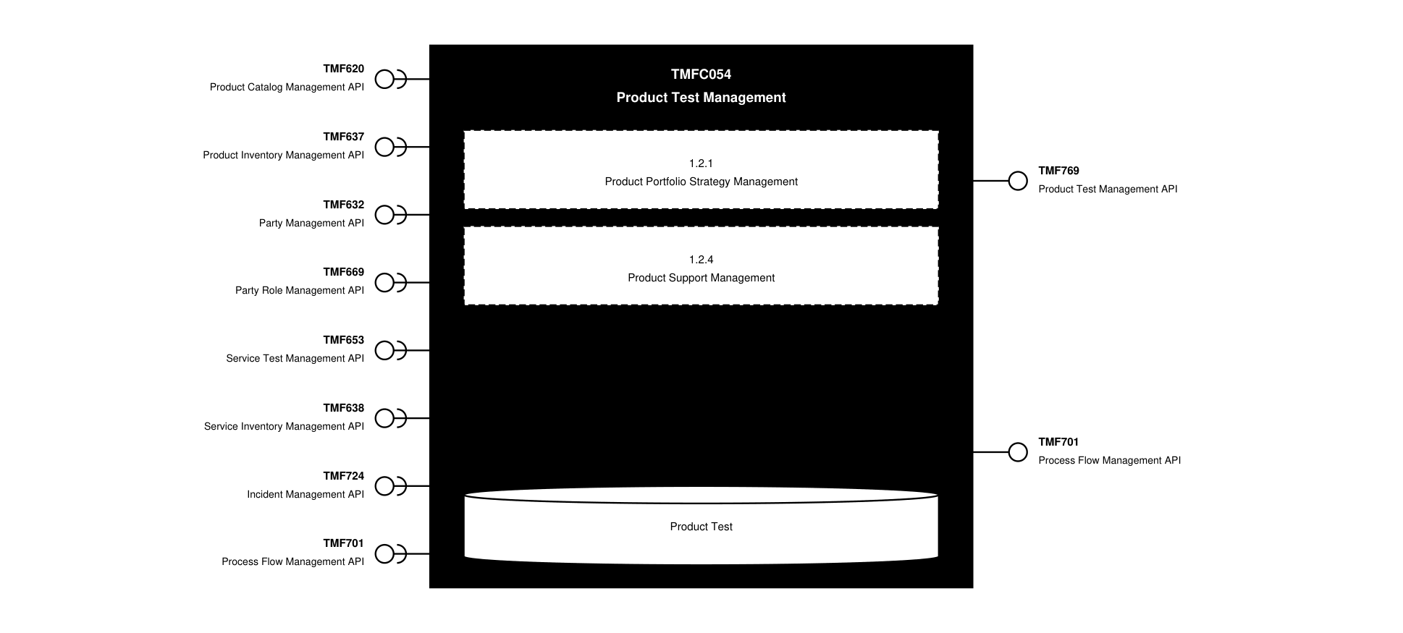
API Context diagram

Exposed APIs
API ID | API Name | Mandatory / Optional | API Version | Resource | Operations
TMF769 | Product Test Management API | Mandatory | 5 | productTestSpecification  productTest | GET  GET /id  POST  PATCH  DELETE
TMF701 | Process Flow Management API | Optional | 4 | processFlow  taskFlow | POST  GET  GET /id  DELETE  PATCH

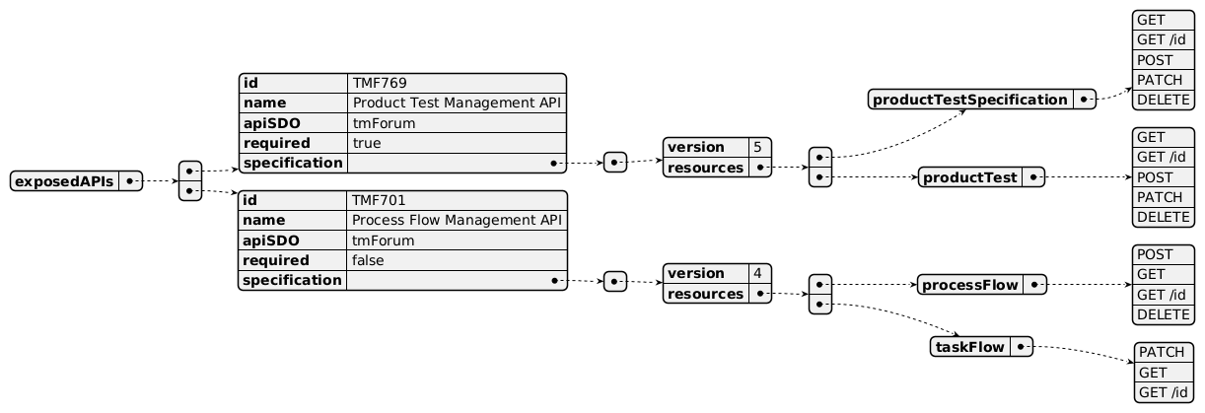
Exposed API diagram

Dependent APIs
API ID | API Name | API Version | Mandatory / Optional | Resource | Operations
TMF620 | Product Catalog Management API | 5 | Mandatory | productSpecification | GET  GET /id
TMF620 | Product Catalog Management API | 4 | Mandatory | productSpecification | GET  GET /id
TMF637 | Product Inventory Management API | 5 | Mandatory | product | GET  GET /id
TMF637 | Product Inventory Management API | 4 | Mandatory | product | GET  GET /id
TMF632 | Party Management API | 5 | Optional | individual  organization | GET  GET /id
TMF632 | Party Management API | 4 | Optional | individual  organization | GET  GET /id
TMF669 | Party Role Management API | 5 | Optional | partyRole | GET  GET /id
TMF669 | Party Role Management API | 4 | Optional | partyRole | GET  GET /id
TMF653 | Service Test Management API | 4 | Optional | serviceTestSpecification  serviceTest | GET  GET /id  POST  PATCH  DELETE
TMF638 | Service Inventory Management API | 5 | Optional | service | GET  GET /id
TMF638 | Service Inventory Management API | 4 | Optional | service | GET  GET /id
TMF724 | Incident Management API | 4 | Optional | incident | GET  GET /id
TMF701 | Process Flow Management API | 4 | Optional | processFlow  taskFlow | GET  GET /id  POST  PATCH

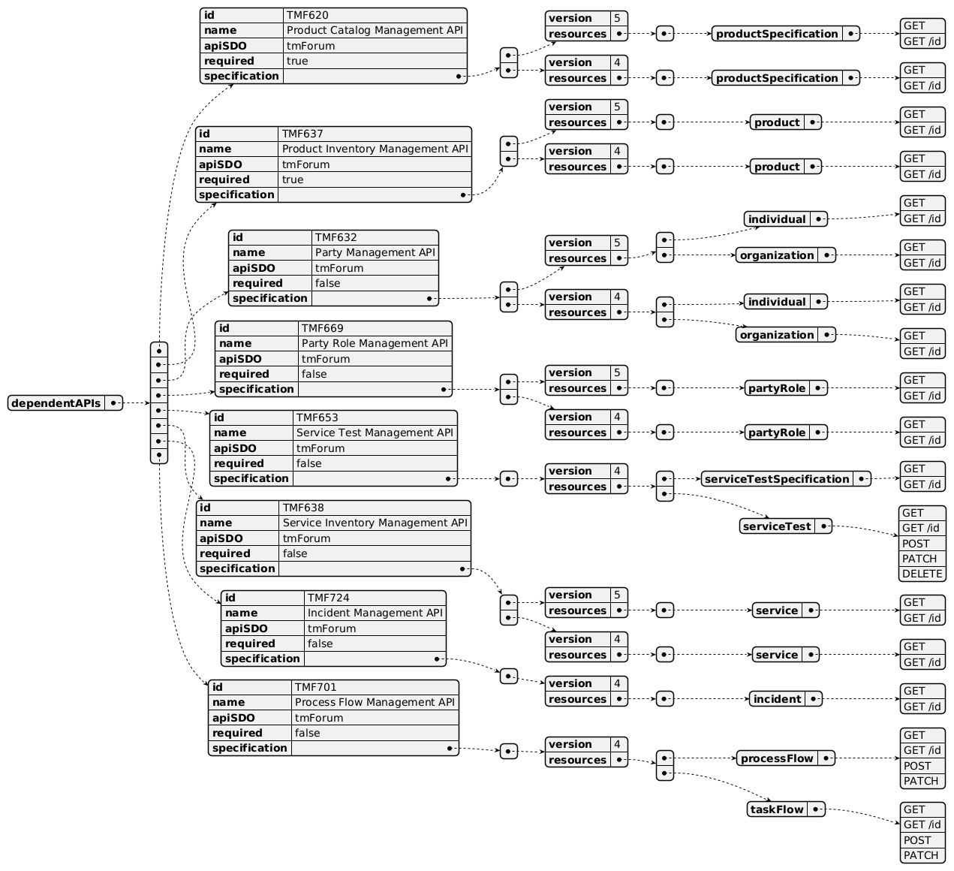
Dependent API diagram

Events
The diagram illustrates the Events which the component may publish and the Events that the component may subscribe to and then may receive. Both lists are derived from the APIs listed in the preceding sections.

Published Events
API ID | API Name | Event Resources
TMF769 | Product Test Management API | ProductTestSpecificationCreateEvent  ProductTestSpecificationDeleteEvent  ProductTestSpecificationAttributeValueChangeEvent  ProductTestSpecificationStateChangeEvent  ProductTestCreateEvent  ProductTestAttributeValueChangeEvent  ProductTestStateChangeEvent

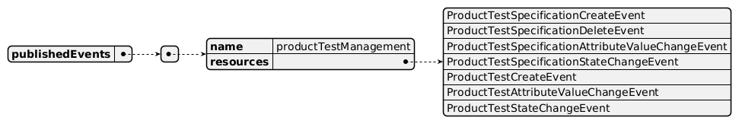
Published Events diagram

Subscribed Events
API ID | API Name | Event Resources
TMF620 | Product Catalog Management API | productSpecificationCreateEvent  productSpecificationDeleteEvent
TMF653 | Service Test Management API | serviceTestSpecificationCreateEvent  serviceTestSpecificationAttributeValueChangeEvent  serviceTestSpecificationDeleteEvent
TMF632 | Party Management API | individualDeleteEvent  organizationDeleteEvent

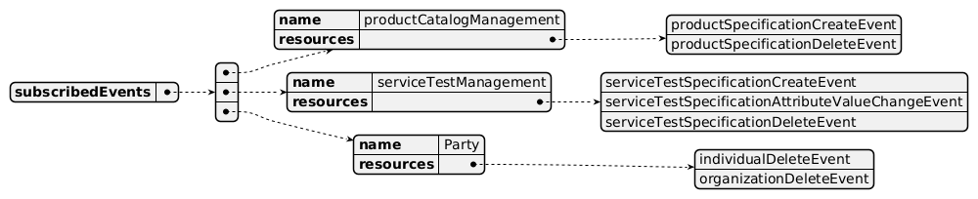
Subscribed Events diagram

Machine Readable Component Specification
Refer to the ODA Component Directory on the TM Forum website for the machine-readable component specification files for this component.

References

TMF Standards related versions
Standard | Version(s)
eTOM | v25.0
SID | v25.0
Functional Framework | v26.0

Jira References
Note: Same needs as at Service level for non-tangible products, plus addition of Resource Inventory APIs, to be consistent.
Note on the Dependent APIs table: no link to this information is currently described in the resource model of the draft TMF769 API (refer to Jira ticket below). When available, the Resource Test API should be added as a dependent API, as with the Resource Inventory Management API (refer to Jira ticket below).
SID [ISA-1251] Improve the description of Product/Service/Resource Test ABEs - TM Forum JIRA
The links between ProductTest, ServiceTest and ResourceTest need to be described, at specification and instance levels. For example:

a ProductTestSpecification related to an intangible ProductSpecification should correspond to an existing ServiceTestSpecification; a ProductTest related to an intangible Product triggers a ServiceTest on the corresponding Service.

a ProductTestSpecification related to a tangible ProductSpecification should correspond to an existing ResourceTestSpecification; a ProductTest related to a tangible Product should trigger a ResourceTest on the corresponding Resource.
APIs [AP-6690] TMF769 - add reference to ServiceTest and ResourceTest - TM Forum JIRA: TMF769 Product Test API is only available in preview, but contains no links to Service Test or Resource Test, where the real tests are done.
[AP-6691] New API: Resource Test API - TM Forum JIRA: no Resource Test Management API identified yet.

Further resources
none currently listed

Administrative Appendix

Document History

Version History
Version Number | Date | Modified by | Description of changes
1.0.0 | 04-Mar-2025 | Sylvie Demarest | Initial version
1.0.0 | 04-Mar-2025 | Rosie Wilson | Final administrative updates prior to publication
1.0.1 | 09-Sep-2025 | Rosie Wilson | Updates to description per agreed YAML updated on 03 Jun 2025
1.1.0 | 25-May-2026 | Hugo Vaughan | Final administrative updates prior to publication
1.1.0 | 25-Jun-2026 | Sannah Sibaya | Gen 5 API updates; Final edits prior to publication

Release History
Release Status | Date Modified | Modified by | Description of changes
Pre-production | 04-Mar-2025 | Rosie Wilson | Preparation for initial release
Pre-production | 21-Apr-2025 | Adrienne Walcott | Updated to Member Evaluated status
Pre-production | 09-Sep-2025 | Rosie Wilson | Version 1.0.1
Pre-production | 25-Jun-2026 | Sannah Sibaya | Version 1.1.0

Acknowledgements
This document was prepared by the members of the TM Forum Component and Canvas project team.
Team Member | Company | Role
Sylvie Demarest | Orange | Author
Gaetano Biancardi | Accenture | Reviewer
Anastasios Sarantis | Vodafone | Reviewer
Hugo Vaughan (TM Forum) | TM Forum | Additional Input
Ian Turkington | TM Forum | Additional Input
Abinash Vishwakarma | Netcracker | Reviewer
Elisabeth Andersson | MATRIXX | Reviewer
Kamal Maghsoudlou | Ericsson | Reviewer
Jose Macaluso | Xacria | Reviewer
Milind Bhagwat | BT | Reviewer
Ritu Arora | BT | Reviewer

