TMFC055 Service Test Management v1.1.0
Components and Canvas
In this deliverable:

Overview
Component Name | ID | Description | ODA Function Block
Service Test Management | TMFC055 | Service Test Management is responsible for managing the service test specification and executing tests based on this specification to ensure the service operates correctly. Service test specification involves capturing potential tests for each Service Specification that can be initiated either automatically or manually by the service user. These tests are derived from those available at the service specification or resource specification level. The scope of the component includes the end-to-end execution and reporting of tests, tailored to the specific context and actor involved. | Production

eTOM Processes, SID Data Entities and Functional Framework Functions

eTOM business activities
eTOM business activities this ODA Component is responsible for:
Identifier | Level | Business Activity Name | Description
1.4.1 | L2 | Service Strategy Management | Enable the development of a strategic view and a multi-year business plan for the enterprise’s services and service directions, and the parties who will supply the required services.
1.4.1.8 | L3 | Service Test Strategy | Service Test Strategy develops the strategies of the enterprise for Service Test. / This process is in charge of identifying types of Service Test to be conducted according to different context (i.e. business activities) for types of Services. / The different context for Service Test are: / - Service Development & Retirement to qualify the capacity to deliver Services before validating a new ServiceSpecification / - Service Configuration & Activation to test the Service before closing the ServiceOrderItem / - Service Quality Management to test Service Quality / - Service Problem Management to test Service functioning / - Service Test Management to conduct tests not specific to a customer’s product
1.4.3.8 | L3 | Service Specification Test Development & Retirement | Service Test Development & Retirement is in charge of the Service Test catalogue. / A type of Service Test aims at measuring proper functioning and capacities of a Service. / Service Test Development & Retirement includes: / - Specifying in detail each Service Test according to the different context. It includes specifying: / - the roles authorized to use the Test and quotas for each type of role / - the method to conduct the Test / - the rules that define the strategies for conducting the test (including the test plan) / - the thresholds and related actions / - the relationships with lower level tests (Resource Test) / - the report of test results with rules for enrichment of Resource Tests results according to role asking for it / - Specifying test scenarios defining sequence of Tests with rules about context and planning to trigger it. It includes roles allowed for asking test scenario and corresponding quotas.
1.4.1.9 | L3 | Analyze Service Test Quality | Analyze Service Test Quality process performs quality analysis of service testing processes, in order to continuously fine-tune and improve them. / Service Test Quality Analysis processes provide an offline analysis of the performance of service testing processes to ensure their continuous fitness for purpose, and eventually propose modifications or enhancements to the current service test specifications (including: service testing methods, quota, authorized users, recommendations and course of action if needed). / The analysis is done using statistical service test usage data to evaluate service tests performance and required improvements if needed. / Following the analysis, typical course of action can be: / - No changes needed currently, / - Creation of additional service tests, / - Improving existing service tests, / - Removing service tests that are no longer relevant.
1.4.4.6 | L3 | Manage Service Test | Manage Service Test process manages the end-to-end execution of a test or test scenario for services not specific to a customer. Tests can be manual or automated. / Service Test Management processes rely on Product and Resource Test Management processes due to dependencies between product tests and resource tests. / Service Test Management includes: / - Identification of service tests needed according to fulfillment and assurance issues / - triggering of service tests in manual or automated mode / - Execution of service tests / - Verification of test authorization (role and context) and quota management / - Identification and prioritization of tests / - Setting up the test context and configuration / - Triggering appropriate product and resource Tests / - Tests can be on-demand or planned according to specific needs / - Enrichment with product and resource tests results based on applicable service test rules / - Reporting of test results
1.4.4 | L2 | Service Support Management | Manage service infrastructure, ensuring that the appropriate service capacity is available and ready to support the SM&O Fulfillment, Assurance and Billing processes.
1.4.3 | L2 | Service Specification Lifecycle Management | Service Specification Lifecycle Management processes are project oriented in that they develop and deliver new or enhanced service types. These processes include process and procedure implementation; systems changes and customer documentation. They also undertake rollout and testing of the service type, capacity management and costing of the service type. It ensures the ability of the enterprise to deliver service types according to requirements. / / This process was renamed in 24.0. Old name was- Service Specification Development & Retirement.

SID ABEs
SID ABEs this ODA Component is responsible for:
SID ABE Level 1 | SID ABE Level 2 (or set of BEs) | SID ABE L1 Definition | SID ABE L2 Definition
Service Test | ServiceTest | The Service Test ABE defines measurement including units and values and how the values are determined. It also includes thresholds used to evaluate the measure and the consequences of violating the thresholds as well as the Service Test measures that reflect the functioning of the Service under test. | An entity that exists for a controlled test invocation on a service. The service test is executed according to a schedule. and contains service test configuration parameters that are to be applied at execution time, and service test measures that result.
Service Test | ServiceTestSpec | The Service Test ABE defines measurement including units and values and how the values are determined. It also includes thresholds used to evaluate the measure and the consequences of violating the thresholds as well as the Service Test measures that reflect the functioning of the Service under test. | The service test specification describes the service test in terms of parameters to be configured and measures to be taken.

eTOM L2 - SID ABEs links
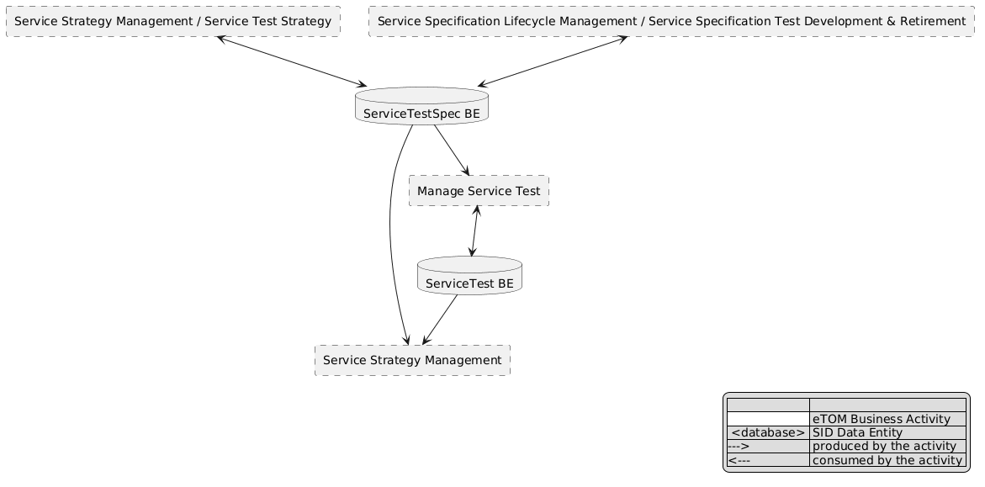
eTOM L2 - SID ABEs links diagram

Functional Framework Functions
Function ID | Function Name | Function Description | Aggregate Function Level 1 | Aggregate Function Level 2
625 | Service Test Operation Control | Service Test Operation Control function provides the necessary functionality to access, command and control the various service test devices required to perform service testing. | Service Capability Management | Service Test Resource Check
1136 | Service Test Specification and Scenario Management | Service Test Specification and Scenario Management Function includes: / / Test scenario management: for example, a home equipment self-test can trigger a test scenario that verifies the functioning of all the services associated, depending on the installed products of the user. Thus, the box could test its internal configuration and functioning and its capacity to connect to internet and VoIP services. / Managing service test capabilities: some resources used to implement services have limited capabilities for executing tests, especially for multiple parallel testing. All the constraints linked to limited resources test capabilities and depending on the execution context must be aggregated and managed at service test level. / Managing initiator authorization: some tests are restricted to some user roles (internal or external) so the authorization are defined at the Service Test Strategy and Policy Management. | Service Test Specification Development | Service Test Policy Management
566 | Service Test Result Analysis Policy Configuration | Service Test Result Analysis Policy Configuration functions provide the necessary functionality to manage how the test results should be interpreted. / Strategies can range from simple (e.g. - check the status of a router) to complex (e.g. - perform an end-to-end test on a circuit and sectionalize the problem). | Service Test Specification Development | Service Test Policy Management
573 | Service Testing Rules Management | Service Testing Rules Management provides management of service testing rules. | Service Test Specification Development | Service Test Policy Management
581 | Automated Service Test Invocation | Automated Service Test Invocation provides automated invocation of Service Test Services for test and retrieval of results from the resource testing capabilities. | Service Test Management | Service Test Conducting
1138 | Service Test Reporting Rules Management | Service Test Reporting Rules Management Function includes: / / Test rules defining the enrichment of test results. / / - For example: enrichment of internet bandwidth measure based on installed product / / Test rules defining the restitution of the result depending on test execution context / / - For example: a test result of ok/not ok can be enough for a user whereas customer care requires more details in the result of the test. | Service Test Specification Development | Service Test Policy Management
582 | Manual Service Test Invocation | Manual Service Test Invocation provides a user interface (GUI) function that provides the means to access the testing capabilities. | Service Test Management | Service Test Conducting
627 | Service Test Strategy Management | Service Test Strategy Management functions provide the necessary functionality to manage the local rules that define the strategies for conducting a test as well as how the test results should be interpreted. | Service Strategy Management | Service Strategy Design and Planning
1137 | Service Test Rules Management | Service Test Rules Management Function includes: / / Test rules defining the strategies for setting up test configuration / Test rules defining how to carry out the service test. / / - For example: to choose the next test in a scenario depending on the results of the previous tests. | Service Test Specification Development | Service Test Policy Management
575 | Service Test Results Reporting | Service Test Results Reporting provides reporting of service end-to-end test results back to the client. | Service Test Management | Service Test Reporting
626 | Service Testing Management | Service Testing Management functions provides the necessary functionality to manage the end-to-end lifecycle of a test of a service. / Including the management of scheduling, retrieval of appropriate inventory data, setting up the test configuration, acquisition and management of test resources, test results interpretation, reporting of test results and close down of the test of the service. | Service Test Management | Service Test Repository Management
577 | Service End to End Test Scheduling | Service End to End Test Scheduling provides scheduling of end-to-end testing of services. | Service Test Specification Development | Service Test Policy Management
579 | Service End to End Testing | Service End to End Testing provides test execution of the end-to-end service testing. | Service Test Management | Service Test Conducting

TM Forum Open APIs & Events
The following part covers the APIs and Events; this part is split in 3:

List of Exposed APIs - This is the list of APIs available from this component.

List of Dependent APIs - In order to satisfy the provided API, the component could require the usage of this set of required APIs.

List of Events (generated & consumed) - The events which the component may generate are listed in this section along with a list of the events which it may consume. Since there is a possibility of multiple sources and receivers for each defined event.

API Context Diagram
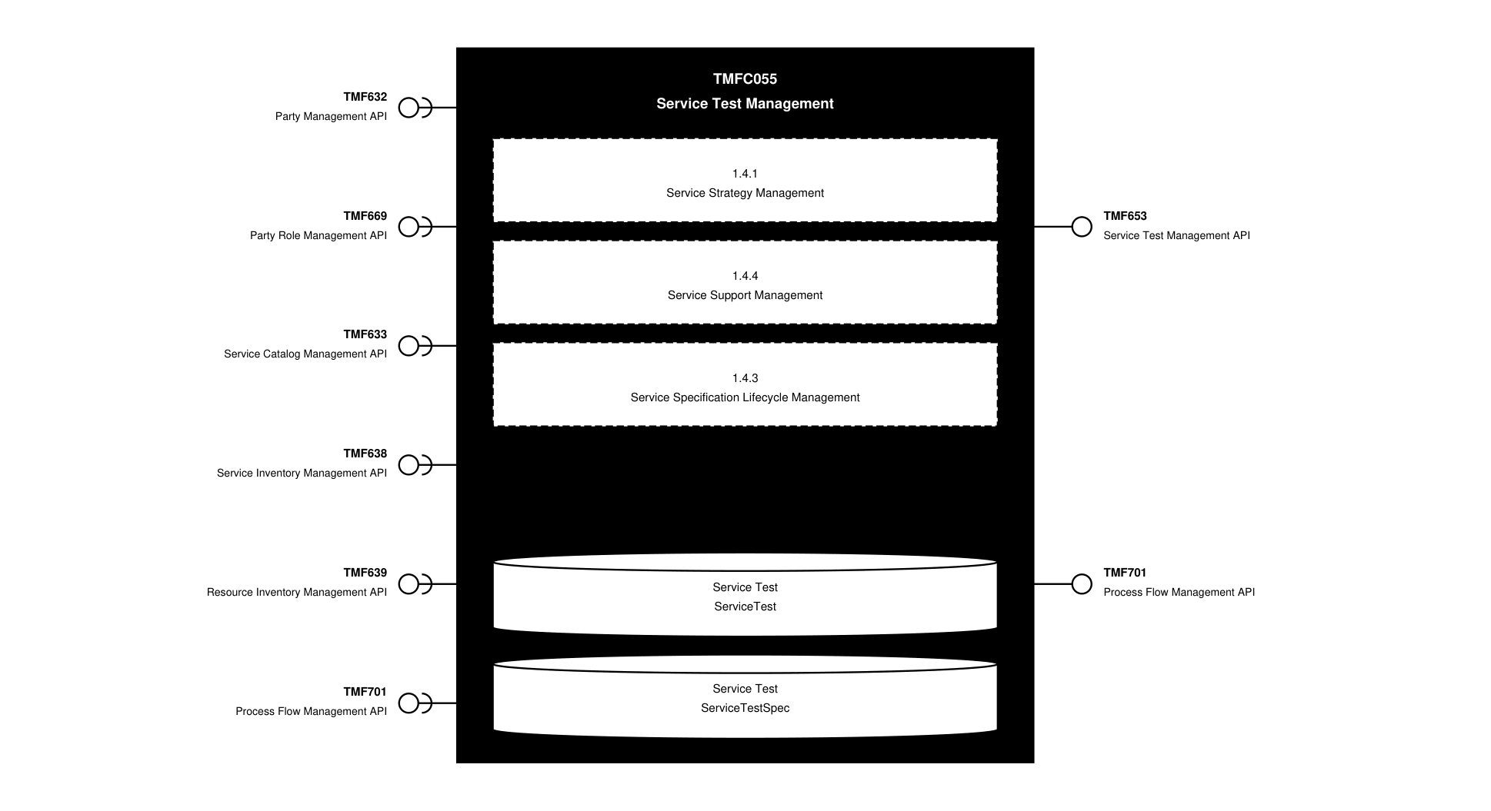
API Context diagram

Exposed APIs
API ID | API Name | Mandatory / Optional | API Version | Resource | Operations
TMF653 | Service Test Management API | Mandatory | 4 | serviceTest  serviceTestSpecification | GET  POST  GET /id  PATCH /id  DELETE /id
TMF701 | Process Flow Management API | Optional | 4 | processFlow  taskFlow | POST  GET  GET /id  DELETE  PATCH

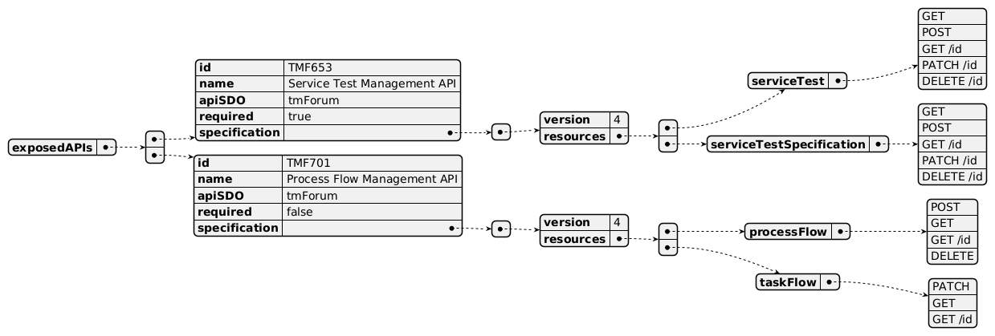
Exposed API diagram

Dependent APIs
API ID | API Name | API Version | Mandatory / Optional | Resource | Operations
TMF632 | Party Management API | 5 | Optional | individual  organization | GET  GET /id
TMF632 | Party Management API | 4 | Optional | individual  organization | GET  GET /id
TMF669 | Party Role Management API | 5 | Optional | partyRole | GET  GET /id
TMF669 | Party Role Management API | 4 | Optional | partyRole | GET  GET /id
TMF633 | Service Catalog Management API | 4 | Optional | serviceSpecification | GET  GET /id
TMF638 | Service Inventory Management API | 5 | Mandatory | service | GET  GET /id
TMF638 | Service Inventory Management API | 4 | Mandatory | service | GET  GET /id
TMF639 | Resource Inventory Management API | 4 | Optional | resource | GET  GET /id
TMF701 | Process Flow Management API | 4 | Optional | processFlow  taskFlow | GET  GET /id  POST  PATCH

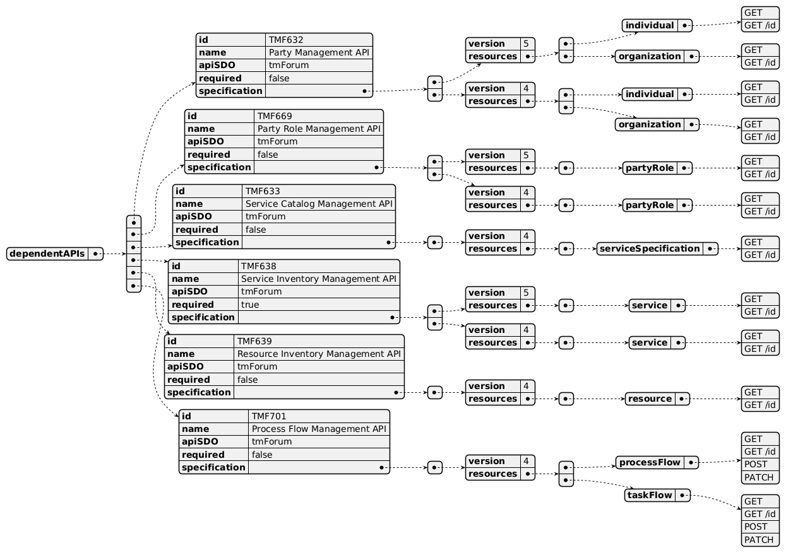
Dependent API diagram

Events
The diagram illustrates the Events which the component may publish and the Events that the component may subscribe to and then may receive. Both lists are derived from the APIs listed in the preceding sections.

Published Events
API ID | API Name | Event Resources
TMF653 | Service Test Management API | serviceTestCreateEvent  serviceTestStateChangeEvent  serviceTestSpecificationCreateEvent  serviceTestSpecificationDeleteEvent  serviceTestAttributeValueChangeEvent  serviceTestDeleteEvent  serviceTestSpecificationAttributeValueChangeEvent

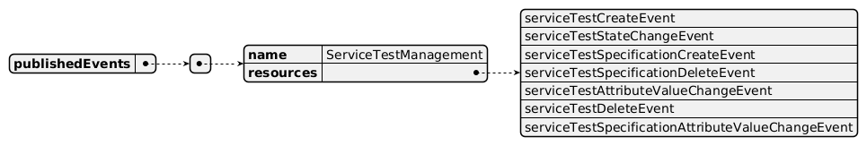
Published Events diagram

Subscribed Events
API ID | API Name | Event Resources
TMF633 | Service Catalog Management API | serviceSpecificationCreateEvent  serviceSpecificationDeleteEvent
TMF632 | Party Management API | organizationDeleteEvent  individualDeleteEvent

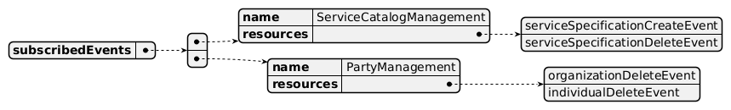
Subscribed Events diagram

Machine Readable Component Specification
Refer to the ODA Component Directory on the TM Forum website for the machine-readable component specification files for this component.

References

TMF Standards related versions
Standard | Version(s)
eTOM | v24.5
SID | v25.0
Functional Framework | v24.0

Jira References
Note: Same needs as at Service level for non-tangible products, plus addition of Resource Inventory APIs, to be consistent.
SID [ISA-1318] Verify role of Test Measure, Test Measure Definition and Test Specification in ServiceTestABE - TM Forum JIRA
Note: Jira ISA-1318 is raised for an open point - whether Test Measure, Test Measure Definition and Test Specification Role should be included in ServiceTestABE under Service, Resource, Product tabs.
[ISA-1251] Improve the description of Product/Service/Resource Test ABEs - TM Forum JIRA
The links between ServiceTest and ResourceTest need to be described, at specification and instance levels. For example:

a ServiceTestSpecification related to a Service should correspond to an existing ResourceTestSpecification

a ServiceTest related to a Service should trigger a ResourceTest on the corresponding Resource.
APIs As:

a ServiceSpecification related to a Service should correspond to an existing ResourceTestSpecification;

a ServiceTest related to a Service should trigger a ResourceTest on the corresponding Resource.
[AP-6690] TMF769 - add reference to ServiceTest and ResourceTest - TM Forum JIRA: TMF769 Product Test API is only available in preview, but contains no links to Service Test or Resource Test, where the real tests are done.
[AP-6691] New API: Resource Test API - TM Forum JIRA: no Resource Test Management API identified yet.

Further resources
1. IG1242: please refer to IG1242 for defined use cases with ODA components interactions.

Administrative Appendix

Document History

Version History
Version Number | Date | Modified by | Description of changes
Draft version 01 | 02-May-2025 | Ritu Arora | Initial draft created
Draft Version 0.2 | 13-May-2025 | Ritu Arora | Based on Review on 06th May: SID ABE table containing pattern ABE (TestMeasure, TestMeasureDefinition, TestSpecificationRole, TestSpecification, Test) has been removed and a Jira raised to request clarification for Test Measure, Test Measure Definition and Test Specification Role to be included in ServiceTestABE under Service, Resource, Product tabs. Under Functional Framework: Service Test Result Analysis Policy Configuration continues to be included; Service Test Resources Availability Management has been removed. Dependent APIs: Incident and Trouble Ticket Management APIs have been removed (ServiceOrderManagement API was suggested to be added as a dependent API but later suggested otherwise, so has not been included). All diagrams updated to incorporate these changes.
Draft Version 0.3 | 30-May-2025 | Ritu Arora | Based on Review on 13th May: eTOM entries updated to include Service Specification Test Development & Retirement; Dependent APIs Product Test and Product Inventory have been removed. All diagrams updated to incorporate these changes.
Draft Version 0.4 | 23-Jun-2025 | Ritu Arora | Changed Service Catalog API to optional in the dependent API list; respective diagram updated to reflect this change
1.0.0 | 18-Jul-2025 | Rosie Wilson | Final Administrative Updates
1.1.0 | 25-May-2026 | Hugo Vaughan | Gen 5 API updates
1.1.0 | 25-Jun-2026 | Sannah Sibaya | Final edits prior to publication

Release History
Release Status | Date Modified | Modified by | Description of changes
Pre-production | 18-Jul-2025 | Rosie Wilson | Initial release
Production | 18-Aug-2025 | Adrienne Walcott | Updated to Member Evaluated status
Pre-production | 25-Jun-2026 | Sannah Sibaya | New Release Version 1.1.0

Acknowledgements
This document was prepared by the members of the TM Forum Component and Canvas project team.
Team Member | Company | Role
Ritu Arora | British Telecom | Author
Milind Bhagwat | British Telecom | Reviewer
Marcio Sousa | Altice Labs | Additional Input
Sylvie Demarest | Orange | Reviewer
Anastasios Sarantis | City Fibre | Reviewer

