TMFC061 Work Order Management v1.1.0
Components and Canvas
In this deliverable:

Overview
Component Name | ID | Description | ODA Function Block
Work Order Management | TMFC061 | Work Order Management component is responsible of the setup and maintenance requests from initiation to completion.Work Order is a formal request that outlines essential details related to necessary setup/maintenance tasks. These details typically include Nature of the task A description of the work that needs to be done. Location Where the maintenance or repair is required. Required materials The items or resources needed for the job. Assigned personnel The technician or contractor responsible for executing the work. Timeline for completion The expected timeframe within which the task should be finished. | Production

eTOM Processes, SID Data Entities and Functional Framework Functions

eTOM business activities
eTOM business activities this ODA Component is responsible for:
Identifier | Level | Business Activity Name | Description
1.5.5 | L2 | Resource Order Management | Resource Order Management business process directs and controls ordering, scheduling, and allocation of resources (such as materials, equipment, and personnel) within the business. / Resource Order Management includes managing the capture of resource orders, sheduling works to support the resoure order, managing the fullfillment of resource orders, picking/packing, shipping, tracking and closing orders.
1.5.5.7 | L3 | Manage Resource Work Order | Manage Resource Order Work business activity directs and controls all work that are required to fulfill an aproved resource order by ensuring the work related to the order is planned, executed and closed in a timely and efficient manner. / Manage Resource Order Work business activity includes activities to "Initiate Resource Work Order", "Create Resource Work Order", "Review Resource Work Order", "Plan Resource Work Order", "Close Resource Work Order", "Analyze Resource Work Order" and "Report Resource Work Order".
1.5.19 | L2 | Resource Specification Management | [Data-quality issue: this row's Description in the source document is a verbatim copy of activity 1.5.5.7's description, not a description of "Resource Specification Management."] Manage Resource Order Work business activity directs and controls all work that are required to fulfill an aproved resource order by ensuring the work related to the order is planned, executed and closed in a timely and efficient manner. / Manage Resource Order Work business activity includes activities to "Initiate Resource Work Order", "Create Resource Work Order", "Review Resource Work Order", "Plan Resource Work Order", "Close Resource Work Order", "Analyze Resource Work Order" and "Report Resource Work Order".
1.5.19.1 | L3 | Develop Resource Specifications | Develop Resource Specification business activity define and elaborate on the conditions for meeting resource requirement for consistency, quality, functionality and fit for purpose. / This activity leverages captured resource requirements and resource preferences and builds in tolerances according to stakeholders for suppliers to adhere to.
1.5.19.2 | L3 | Master Resource Specifications | Master Resource Specifications business activity learn and understand the collection of resource specifications in order to manage improvement or evolution of standards that will used for design and construction of resource. / This business activity is used by organizations to establish a collection of standardized, pre-written specifications or guide specifications that can be used by resource designers, resource architects, and other resource construction entities.
1.5.19.3 | L3 | Analyze Resource Specifications | Analyze Resource Specifications business activity research, assess and evaluate performance criteria and factors to develop, master, control/update resource specifications for resource requirement adherence. / This business activity can include multiple analyzes of resources specifications, including standard analysis (based on empirical research) or custom analysis (based on other standards). Analysis of Resource Specification include testing Resource specifications and the ability to meet business requirements, as well as conform to operational mandates.
1.5.19.4 | L3 | Update and Version Resource Specifications | Update and Version Resource Specifications business activity update and track changes to existing resource specifications according to versioning policies to support requirement management. / This business activity manages all changes to resource specifications over their lifecycle. Resource specification versioning is an effective means to communicate changes to resource specifications, so that resource planners and consumers know what to expect. It includes communicating when changes are made to resource specification properties.

SID ABEs
SID ABEs this ODA Component is responsible for:
SID ABE Level 1 | SID ABE Level 2 (or set of BEs) | SID ABE L1 Definition | SID ABE L2 Definition
Workforce | Work Specification | The Workforce ABE models the human and other field resources with their roles, skills, calendar, and other characteristics. It also models the work description and reservation and assignment of a technician to a task. It contains Work, Work Specification, WorkforceResource, and WorkforceSchedule. | The WorkSpecification specifies a kind of work that can be performed manually by a technician. Two key entities that comprise the WorkSpecification ABE are WorkSpecification and WorkSpecFulfillmentRate.
Project | Work Order | The Project ABE represents the tools used by project managers to ensure that enterprise objectives of quality, cost and time are achieved by planning and scheduling work. It uses common industry definitions of Project, Work Breakdown Structure and Activity to provide support to project managers. | *(no description available)*

eTOM L2 - SID ABEs links
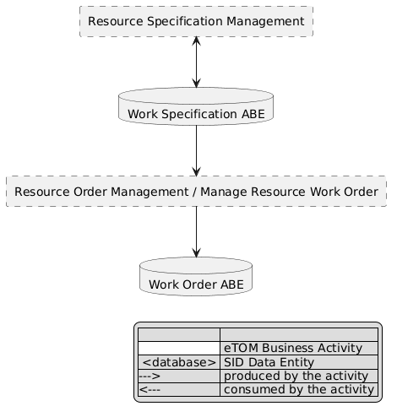
eTOM L2 - SID ABEs links diagram

Functional Framework Functions
Function ID | Function Name | Function Description | Aggregate Function Level 1 | Aggregate Function Level 2
542 | Dynamic Work Order Assigning | Dynamic Work Order Assigning takes into consideration the following criteria: / / Work order priority / Associated SLAs / Work order due date / Required skills to perform work / Dependencies between work items/orders / Job location relative to other assignments made to the dispatchable staff / Workload of staff / Staff availability hours. | Work Order Management | Work Order Assignment and Plan
543 | Periodic Bulk Work Order Assigning | Periodic Bulk Work Order Assigning takes into consideration the following criteria: / / Work order priority / Associated SLAs / Work order due date / Required skills to perform work / Dependencies between work items/orders / Job location relative to other assignments made to the dispatchable staff / Workload of staff / Staff availability hours. | Work Order Management | Work Order Assignment and Plan
545 | Work Order Coordination | Work Order Coordination function for coordinating work between dependent or related work orders for Resource dispatchable staff. | Work Order Management | Work Order Assignment and Plan
547 | Work Order Information Transferring | Work Order Information Transferring provides information transfer between the operator's workforce management system(s) and those of external third parties (when the infrastructure is owned and operated by third parties). | Work Order Management | Work Order Tracking and Business Value Development
549 | Work Order Re-assigning | Initiates re-assignments as needed based on changing priorities, technician progress on other job assignments, etc. | Work Order Management | Work Order Assignment and Plan
540 | Work Order Manual Activities Determining | Work Order Manual Activities Determining function provides the necessary functionality to analyze the work order and determine what manual activities are necessary. | Work Order Management | Work Order Establishment
544 | Work Order Closing | Work Order Closing function closes completed work orders | Work Order Management | Work Order Tracking and Business Value Development
739 | Workflow Delay Jeopardy Analyzing | Workflow Delay Jeopardy Analyzing function should be found in any process or workflow management system and warns when a delay in the due date of a task or process step will prevent subsequent tasks from starting, or affect the overall end date of the process, also including escalation function for issues as required. | Work Order Management | Work Order Tracking and Business Value Development
551 | Work Order Status Monitoring | Monitors the status and progress of the various manual activities, including the various states of the work order | Work Order Management | Work Order Tracking and Business Value Development
553 | Work Specification Classification | Work Specification Classification provides classification of different types of manual activities provide the necessary functionality to appropriately classify the working activity types and related information. | Work Specification Management | Work Specification Development
541 | Work Order Assignment Dispatching | Dispatching of work order assignments to dispatchable staff. | Work Order Management | Work Order Assignment and Plan
548 | Work Orders Initiation | Work Orders Initiation initiates workforce orders for Resource preventive and corrective maintenance and change. | Work Order Management | Work Order Establishment
552 | Work Order Updating | Work Order Updating updates the transition of the order through its various states, including in-flight changes and cancellations | Work Order Management | Work Order Tracking and Business Value Development

TM Forum Open APIs & Events
The following part covers the APIs and Events; this part is split in 3:

List of Exposed APIs - This is the list of APIs available from this component.

List of Dependent APIs - In order to satisfy the provided API, the component could require the usage of this set of required APIs.

List of Events (generated & consumed) - The events which the component may generate are listed in this section along with a list of the events which it may consume. Since there is a possibility of multiple sources and receivers for each defined event.

API Context Diagram
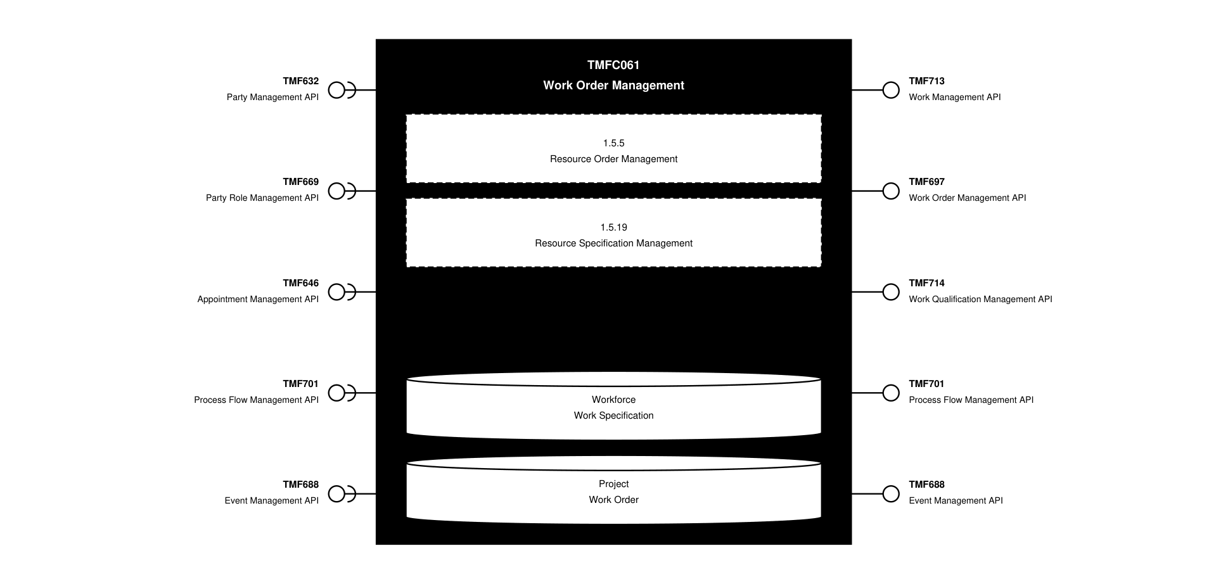
API Context diagram

Exposed APIs
API ID | API Name | Mandatory / Optional | API Version | Resource | Operations
TMF713 | Work Management API | Mandatory | 4 | work  workSpecification | GET  GET /id  POST  PATCH  DELETE
TMF697 | Work Order Management API | Mandatory | 4 | workOrder  cancelWorkOrder | GET  GET /id  POST  PATCH /id  DELETE /id
TMF714 | Work Qualification Management API | Mandatory | 4 | checkWorkQualification  queryWorkQualification | GET  GET /id  POST  PATCH /id  DELETE  DELETE /id
TMF701 | Process Flow Management API | Mandatory | 4 | processFlow  taskFlow | GET  GET /id  POST  DELETE  PATCH /id
TMF688 | Event Management API | Mandatory | 4 | listener  hub | POST  DELETE

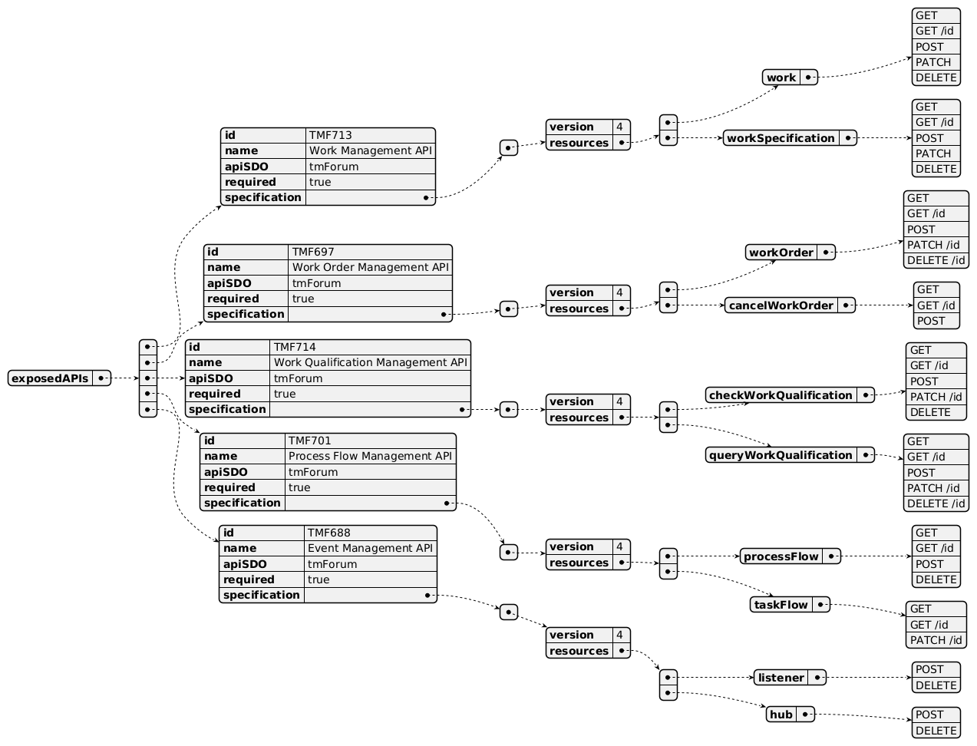
Exposed API diagram

Dependent APIs
API ID | API Name | API Version | Mandatory / Optional | Resource | Operations
TMF632 | Party Management API | 5 | Optional | individual  organization | GET  GET /id
TMF632 | Party Management API | 4 | Optional | individual  organization | GET  GET /id
TMF669 | Party Role Management API | 5 | Optional | partyRole | GET  GET /id
TMF669 | Party Role Management API | 4 | Optional | partyRole | GET  GET /id
TMF646 | Appointment Management API | 4 | Mandatory | appointment  searchTimeSlot | GET  GET /id  POST  PATCH /id  DELETE /id
TMF701 | Process Flow Management API | 4 | Optional | processFlow  taskFlow | GET  GET /id  POST  DELETE  PATCH
TMF688 | Event Management API | 4 | Optional | event | GET  GET /id

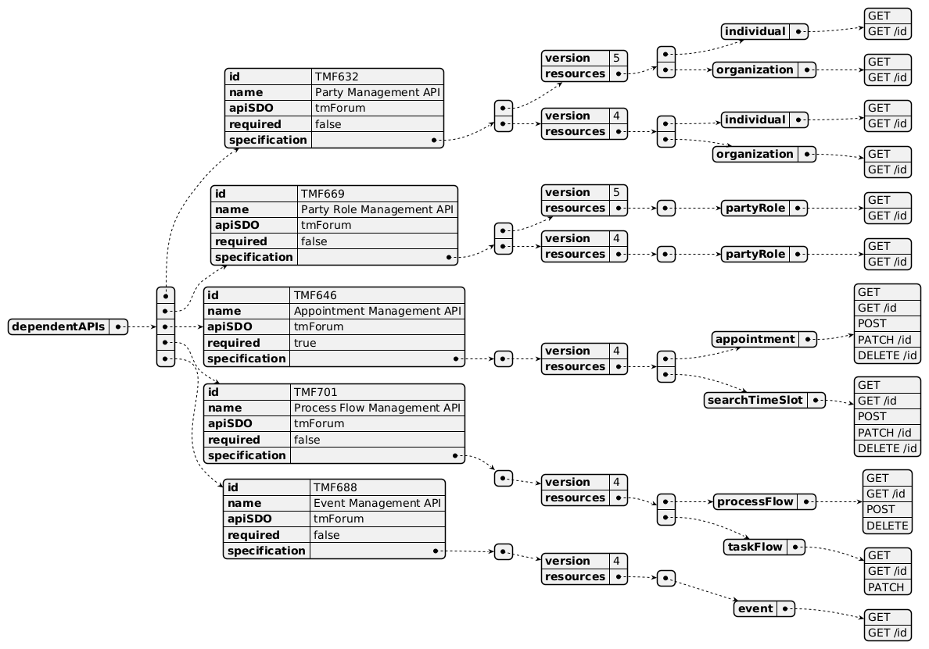
Dependent API diagram

Events
The diagram illustrates the Events which the component may publish and the Events that the component may subscribe to and then may receive. Both lists are derived from the APIs listed in the preceding sections.

Published Events
API ID | API Name | Event Resources
TMF713 | Work Management API | workStateChange  workCreateEvent  workAttributeValueChangeEvent  workDeleteEvent  workSpecificationsearchTimeSlotCreateEvent  workSpecificationAttributeValueChangeEvent  workSpecificationStateChangeEvent  workSpecificationDeleteEvent
TMF697 | Work Order Management API | workOrderStateChange  workOrderCreateEvent  workOrderAttributeValueChangeEvent  workOrderDeleteEvent  workOrderInformationRequiredEvent  cancelWorkOrderCreateEvent  cancelWorkOrderStateChangeEvent  cancelWorkOrderDeleteEvent
TMF714 | Work Qualification Management API | checkWorkQualificationStateChange  checkWorkQualificationCreateEvent  checkWorkQualificationAttributeValueChangeEvent  checkWorkQualificationtDeleteEvent  checkWorkQualificationInformationRequiredEvent  queryWorkQualificationStateChangeEvent  queryWorkQualificationDeleteEvent
TMF701 | Process Flow Management API | processFlowCreateEvent  processFlowStateChangeEvent  processFlowStateDeleteEvent  processFlowStateAttributeValueChangeEvent  taskFlowCreateEvent  taskFlowStateChangeEvent  taskFlowDeleteEvent  taskFlowAttributeValueChangeEvent  taskFlowInformationRequiredEvent

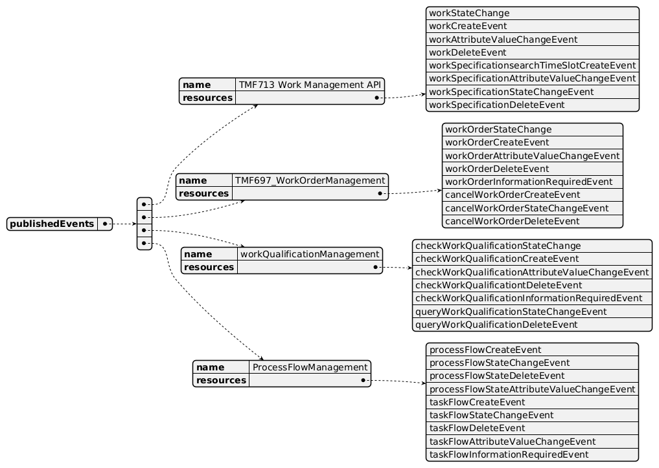
Published Events diagram

Subscribed Events
API ID | API Name | Event Resources
TMF632 | Party Management API | IndividualCreateEvent  IndividualAttributeValueChangeEvent  IndividualStateChangeEvent  IndividualDeleteEvent  OrganizationCreateEvent  OrganizationAttributeValueChangeEvent  OrganizationStateChangeEvent  OrganizationDeleteEvent
TMF632 | Party Management API | partyRoleCreateEvent  partyRoleAttributeValueChangeEvent  partyRoleStateChangeEvent  partyRoleDeleteEvent
TMF701 | Process Flow Management API | processFlowCreateEvent  processFlowStateChangeEvent  processFlowStateDeleteEvent  processFlowStateAttributeValueChangeEvent  taskFlowCreateEvent  taskFlowStateChangeEvent  taskFlowDeleteEvent  taskFlowAttributeValueChangeEvent  taskFlowInformationRequiredEvent
TMF646 | Appointment Management API | appointmentStateChange  appointmentCreateEvent  appointmentAttributeValueChangeEvent  appointmentDeleteEvent  searchTimeSlotCreateEvent  searchTimeSlotAttributeValueChangeEvent  searchTimeSlotStateChangeEvent  searchTimeSlotDeleteEvent

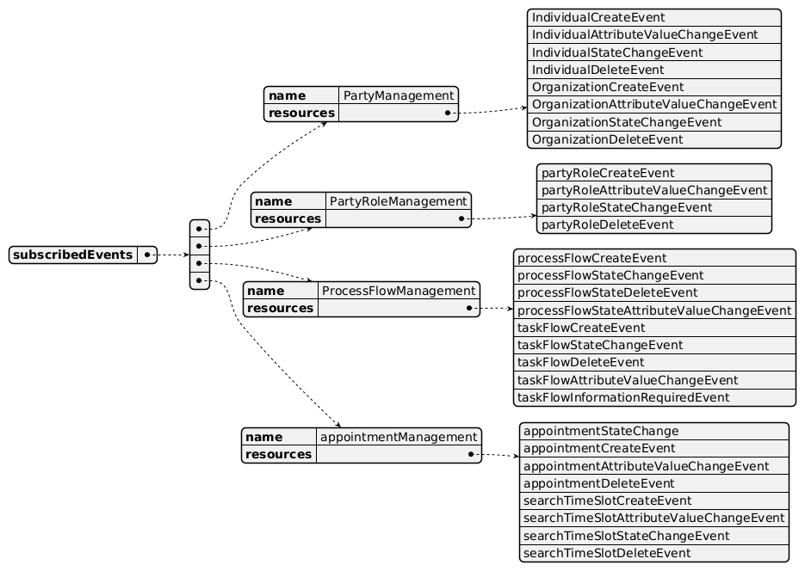
Subscribed Events diagram

Machine Readable Component Specification
Refer to the ODA Component Directory on the TM Forum website for the machine-readable component specification files for this component.

References

TMF Standards related versions
Standard | Version(s)
eTOM | v23.5
SID | v25.0
Functional Framework | v23.5

Jira References
none currently listed

Further resources
1. IG1228: please refer to IG1228 for defined use cases with ODA components interactions.

Administrative Appendix

Document History

Version History
Version Number | Date | Modified by | Description of changes
0.1.0.0 | 12-Jun-2024 | Milind Bhagwat | First draft for team review
1.0.0 | 02-Jul-2024 | Amaia White | Initial release

Release History
Release Status | Date Modified | Modified by | Description of changes
Pre-production | 02-Jul-2024 | Amaia White | Initial release.
Production | 30-Aug-2024 | Adrienne Walcott | Updated to reflect TM Forum Approved status

Acknowledgements
This document was prepared by the members of the TM Forum Component and Canvas project team.
Team Member | Company | Role
Milind Bhagwat | BT | Editor

