TMFC062 Resource Configuration and Activation v1.1.0
Components and Canvas
In this deliverable:

Overview
Component Name | ID | Description | ODA Function Block
Resource Configuration and Activation | TMFC062 | The Resource Configuration and Activation component configures and activates resource instances and enables querying of resource instances to acquire the resource activation states and attributes. | Production

eTOM Processes, SID Data Entities and Functional Framework Functions

eTOM business activities
eTOM business activities this ODA Component is responsible for:
Identifier | Level | Business Activity Name | Description
1.5.8.2.1 | L4 | Verify Resource Configuration | This process verifies whether the resource configuration matches the appropriate service features.

SID ABEs
SID ABEs this ODA Component is responsible for:
SID ABE Level 1 | SID ABE Level 2 (or set of BEs) | SID ABE L1 Definition | SID ABE L2 Definition
Resource Configuration |  | The Resource Configuration ABE represents the specification of the different possible Resource configurations as well as the Resource Configurations instantiated for a Resource. | *(no description available)*

eTOM L2 - SID ABEs links
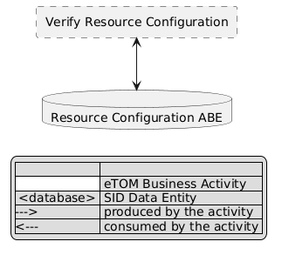
eTOM L2 - SID ABEs links diagram

Functional Framework Functions
none listed in the component YAML

TM Forum Open APIs & Events
The following part covers the APIs and Events; this part is split in 3:

List of Exposed APIs - This is the list of APIs available from this component.

List of Dependent APIs - In order to satisfy the provided API, the component could require the usage of this set of required APIs.

List of Events (generated & consumed) - The events which the component may generate are listed in this section along with a list of the events which it may consume. Since there is a possibility of multiple sources and receivers for each defined event.

API Context Diagram
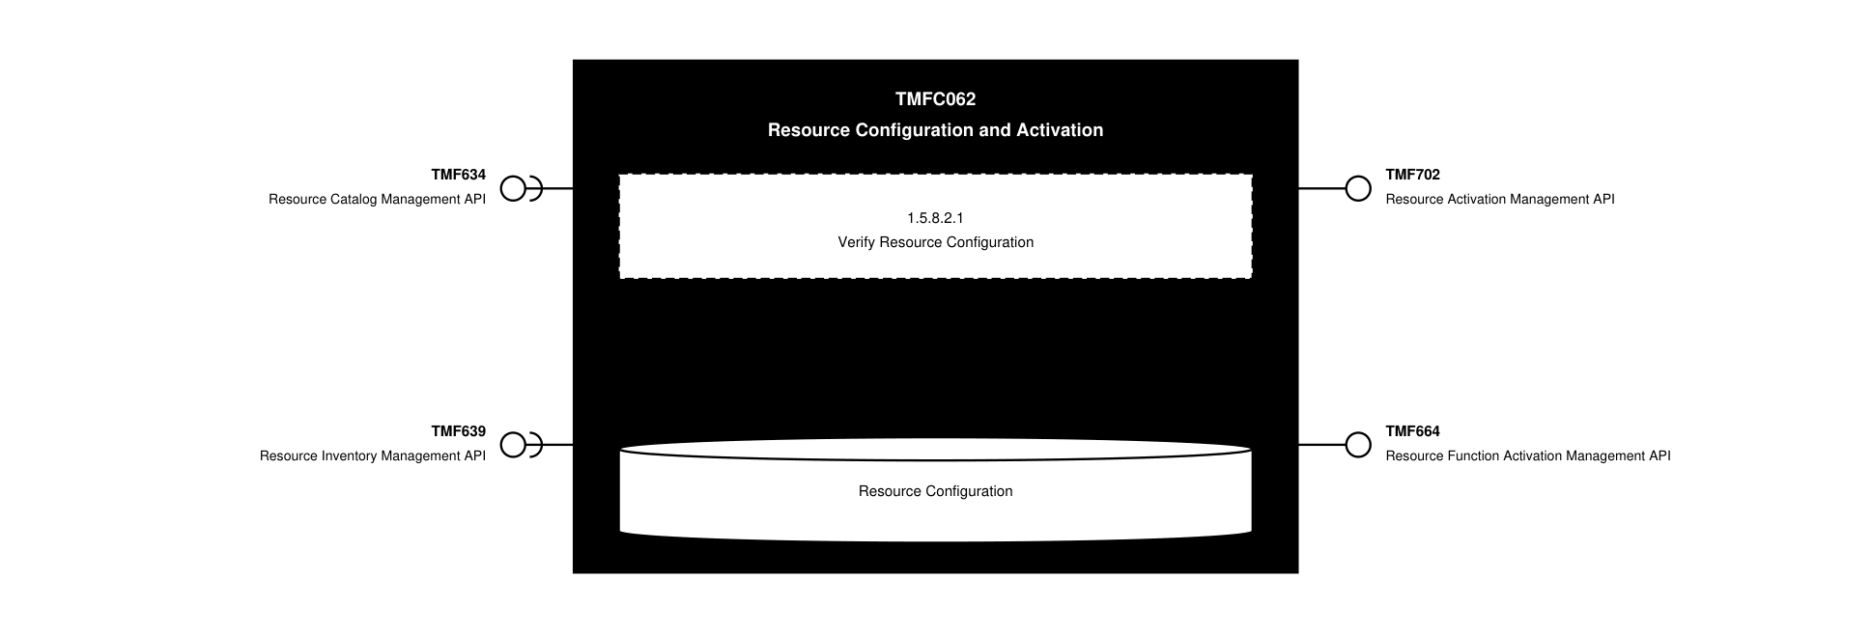
API Context diagram

Exposed APIs
API ID | API Name | Mandatory / Optional | API Version | Resource | Operations
TMF702 | Resource Activation Management API | Mandatory | 4 | resource | GET  GET /id  POST /id  PATCH  DELETE /id
TMF664 | Resource Function Activation Management API | Optional | 4 | resourceFunction  heal  scale  migrate | GET  GET /id  POST  PATCH /id  DELETE /id

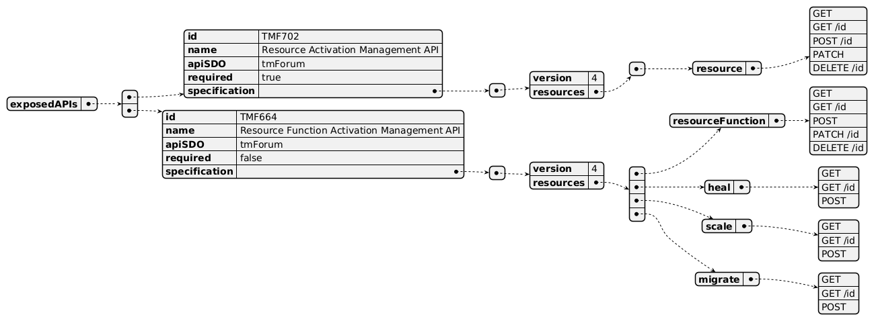
Exposed API diagram

Dependent APIs
API ID | API Name | API Version | Mandatory / Optional | Resource | Operations
TMF634 | Resource Catalog Management API | 5 | Mandatory | resourceSpecification | GET  GET /id
TMF634 | Resource Catalog Management API | 4 | Mandatory | resourceSpecification | GET  GET /id
TMF639 | Resource Inventory Management API | 4 | Mandatory | resource | GET  GET /id  POST  PATCH /id  DELETE /id

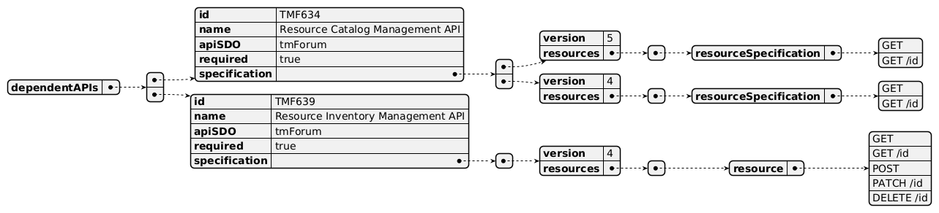
Dependent API diagram

Events
The diagram illustrates the Events which the component may publish and the Events that the component may subscribe to and then may receive. Both lists are derived from the APIs listed in the preceding sections.

Published Events
API ID | API Name | Event Resources
TMF702 | Resource Activation Management API | ResourceCreateEvent  ResourceAttributeValueChangeEvent  ResourceStateChangeEvent  ResourceDeleteEvent
TMF664 | Resource Function Activation Management API | ResourceFunctionCreateEvent  ResourceFunctionAttributeValueChangeEvent  ResourceFunctionChangeEvent  ResourceFunctionDeleteEvent  HealCreateEvent  HealAttributeValueChangeEvent  HealChangeEvent  HealDeleteEvent  ScaleCreateEvent  ScaleAttributeValueChangeEvent  ScaleChangeEvent  ScaleDeleteEvent  MigrateCreateEvent  MigrateAttributeValueChangeEvent  MigrateChangeEvent  MigrateDeleteEvent

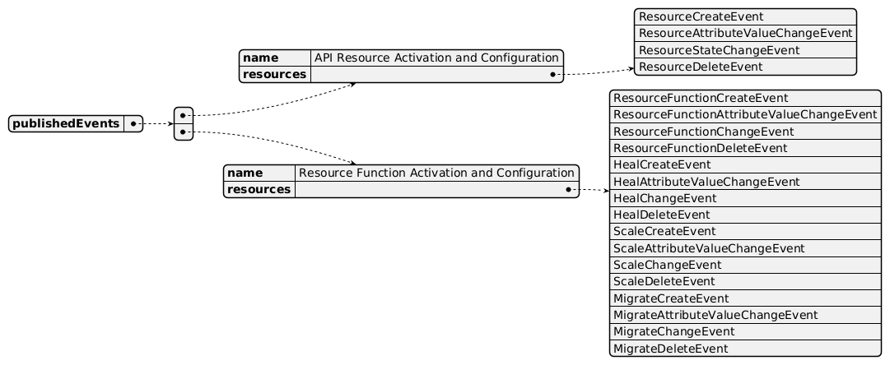
Published Events diagram

Subscribed Events
API ID | API Name | Event Resources
TMF634 | Resource Catalog Management API | ResourceSpecificationCreateEvent  ResourceSpecificationChangeEvent  ResourceSpecificationDeleteEvent

Subscribed Events diagram

Machine Readable Component Specification
Refer to the ODA Component Directory on the TM Forum website for the machine-readable component specification files for this component.

References

TMF Standards related versions
Standard | Version(s)
eTOM | v25.0
SID | v25.0
Functional Framework | *(none)*

Jira References
none currently listed

Further resources
none currently listed

Administrative Appendix

Document History

Version History
Version Number | Date | Modified by | Description of changes
1.1.0 | 02-Jun-2026 | Author Name | Initial publication

Release History
Release Status | Date Modified | Modified by | Description of changes
Pre-production | 02-Jun-2026 | Author Name | Initial release

Acknowledgements
This document was prepared by the members of the TM Forum ODA Components & Canvas team.
Team Member | Company | Role
Author Name | Company | Editor

