Sprint 2 Milestone – Terraform Infrastructure Provisioning
AWS Services screenshots
S3 Bucket
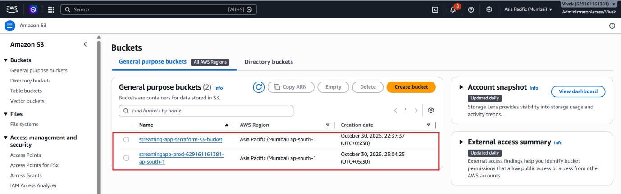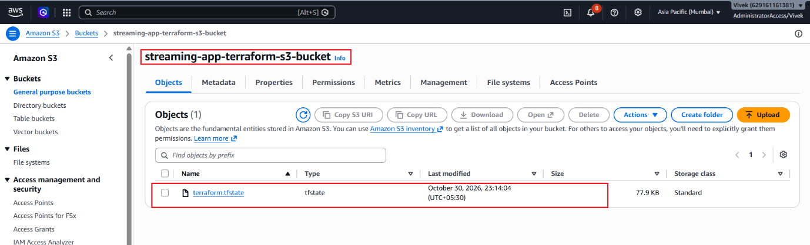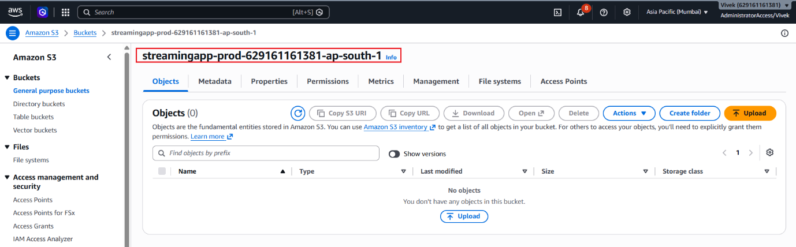
Elastic Container Registry (ECR)
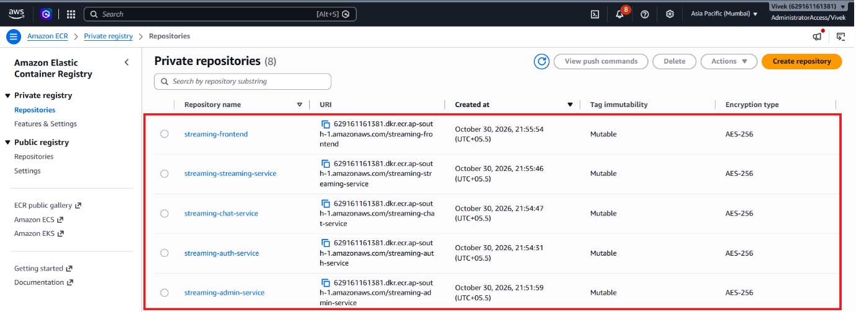
Virtual Private Cloud (VPC)
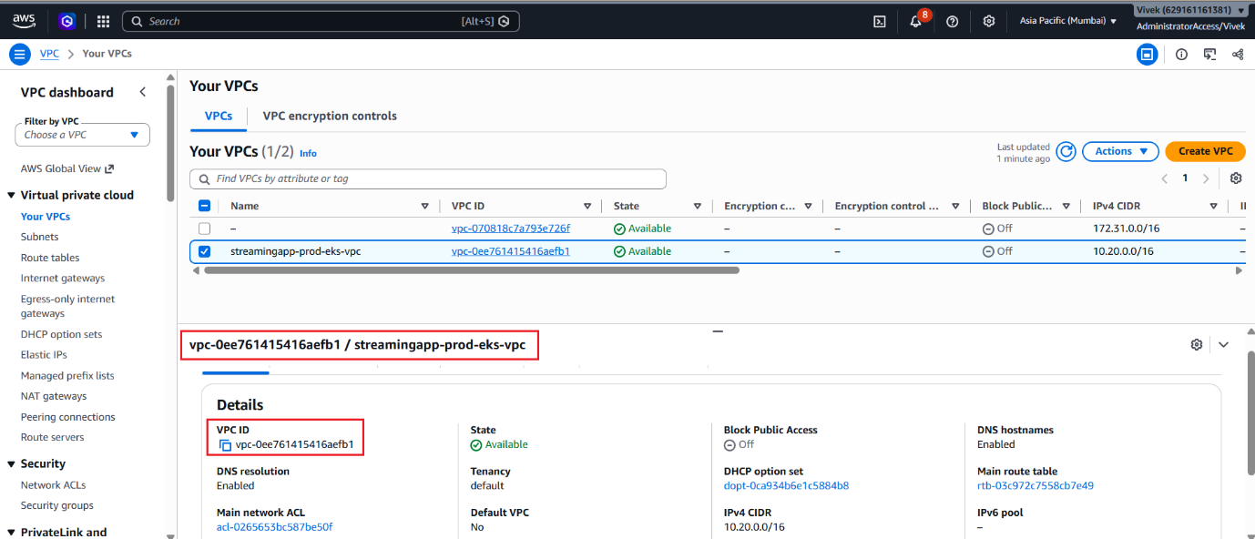
Elastic Kubernetes Service (EKS)
