Sprint 1 Milestone – Docker Containerization
Docker Desktop Images
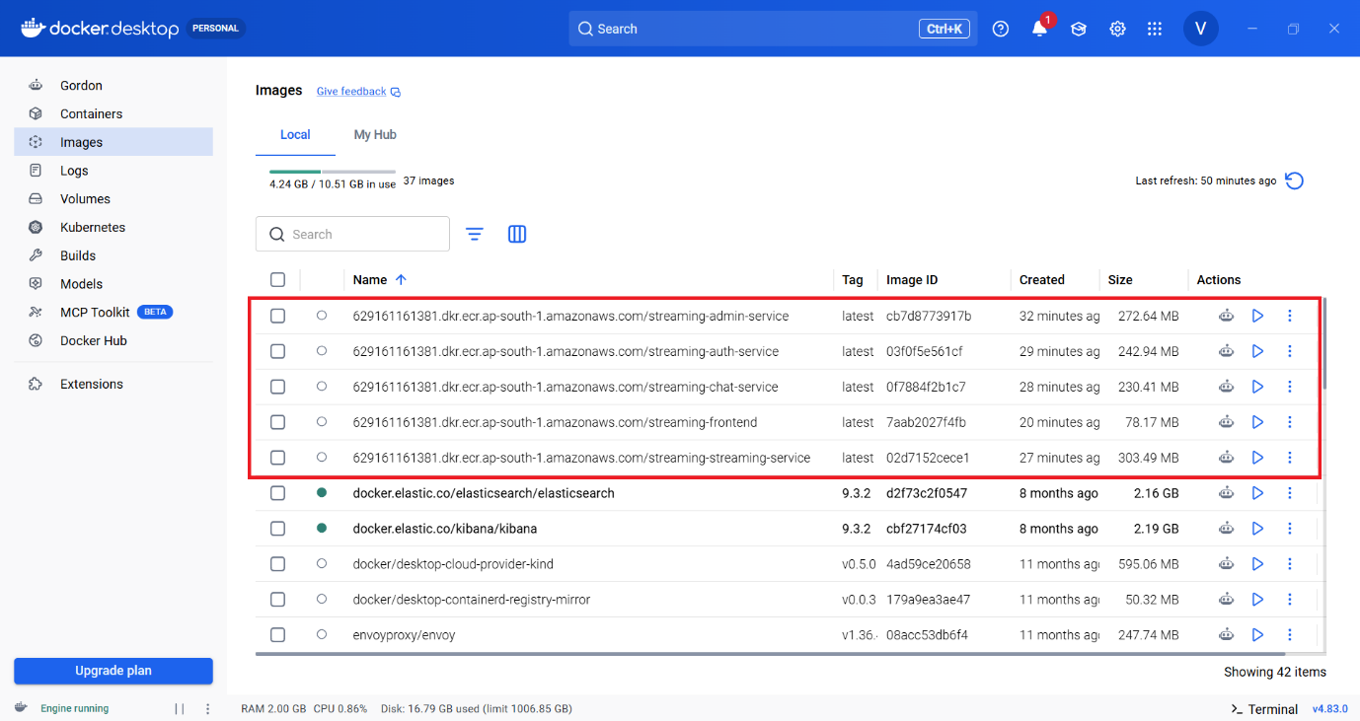

AWS Elastic Container Registry (ECR) – Docker Images
