Sprint 2 Milestone – Terraform Infrastructure Provisioning
Terraform commands execution
terraform apply, fmt and validate
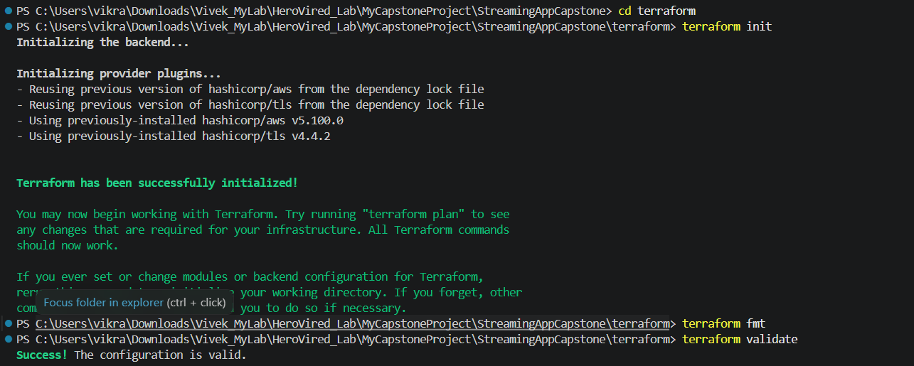
terraform plan
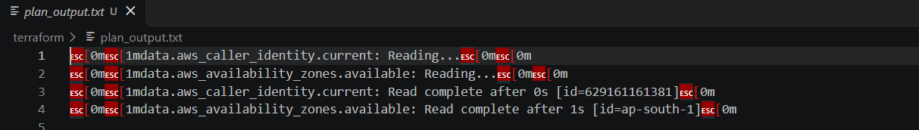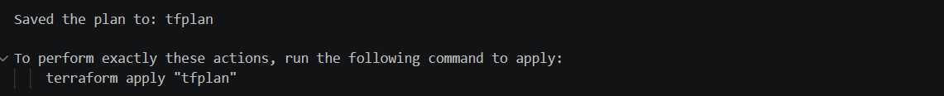

terraform apply
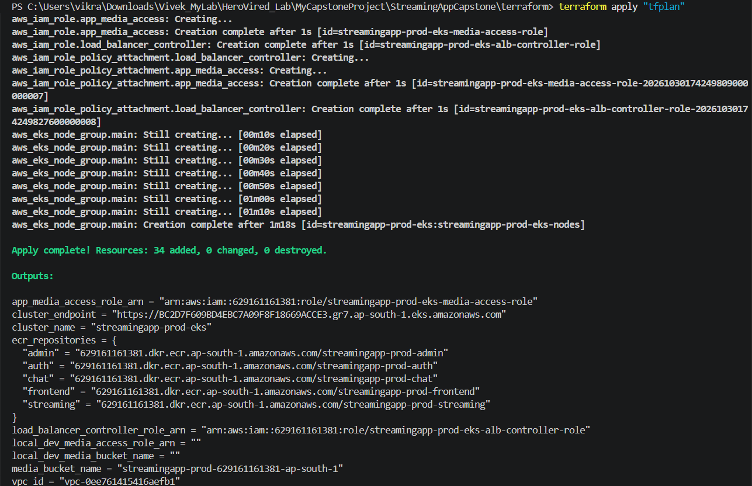
terraform destroy

