Cuong Hoang

CSC 3320 System Level Programming

Lab Assignment 9 – Post Lab

**Part 1:**

Output:

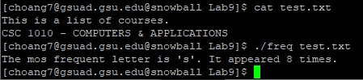

Source Code:

#include <stdio.h>

#include <string.h>

#include <stdlib.h>

int main(int argc, char *argv[])

{

char character;

int pos = 0, maxFreq = 0, f = 0, tf = 0;

int equalFreq[27];

int freq[27];

memset(freq, 0, sizeof(freq));

memset(freq, 0, sizeof(equalFreq));

FILE *filePointer;

if (argc >= 2) {

filePointer = fopen(argv[1], "r");

}

else {

filePointer = fopen("test.txt", "r");

}

while ((character = fgetc(filePointer)) != EOF) {

if (character >= 'a' && character <= 'z') {

pos = character - 'a';

freq[pos]++;

}

else if (character >= 'A' && character <= 'Z') {

pos = character - 'A';

freq[pos]++;

}

}

for (f = 0; f < 26; f++) {

if (freq[f] > maxFreq) {

pos = f;

maxFreq = freq[f];

tf = 0;

}

if (maxFreq == freq[f] && freq[f] > 0) {

equalFreq[tf] = f;

tf++;

}

}

printf("The mos frequent letter is ");

for (f = 0; f < tf; f++) {

printf("'%c'", equalFreq[f] + 'a');

printf(". It appeared %d times.\n", maxFreq);

}

fclose(filePointer);

return 0;

}

**Part 2:**

1) Output:

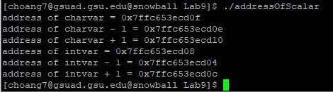

2) Source Code:

#include <stdio.h>

int main() {

// intialize a char variable, print its address and the next address

char charvar = '\0';

printf("address of charvar = %p\n", (void *)(&charvar));

printf("address of charvar - 1 = %p\n", (void *)(&charvar - 1));

printf("address of charvar + 1 = %p\n", (void *)(&charvar + 1));

// intialize an int variable, print its address and the next address

int intvar = 1;

printf("address of intvar = %p\n", (void *)(&intvar));

printf("address of intvar - 1 = %p\n", (void *)(&intvar - 1));

printf("address of intvar + 1 = %p\n", (void *)(&intvar + 1));

}

3)

The address after **intvar** is incremented by 4 bytes instead of 1 byte because the variable is of the data type integer, which takes 4 bytes memory in a 32-bit or 64-bit C compiler.

**Part 3:**

1) Output:

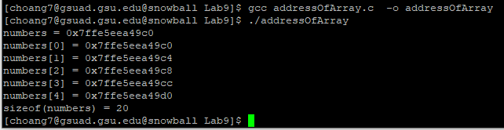

2) The address of the array and the address of the first element in the array **are the same**.

3) Statement to print out the length of the array using **sizeof** operator:

int length = sizeof(numbers) / sizeof numbers[0];

printf("the length of the array: %u \n", length);

Output:

