Cuong Hoang

CSC3320

Lab 2

1. /home/choang7
2. In Step (3), there was no file in my home directory (/home/choang7), so the result returned empty when I used the command “ls” to list all the content in my current working directory. In step (4), I created a new folder “csc3320” in that working directory. Therefore, when I used “ls” to list all the content, it shows “csc3320”, which is the file I have created from that home directory.
3. pwd
4. mkdir lab2
5. cd lab2
6. the special character “>” between “cat” and “myLab2.txt” indicates that we will create a new file named myLab2 with type “txt” and redirect us to that newly created file “myLab2.txt” and wait for input from user. After user’s input, we press “CTRL -D” to indicate that this is the end of the file.
7. 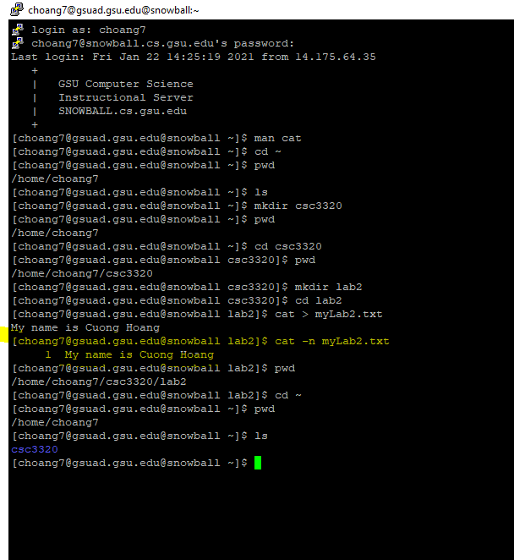
8. 