Cuong Hoang

CSC3320

Lab Assignment 3 (Post-Lab)

**Part 1:**

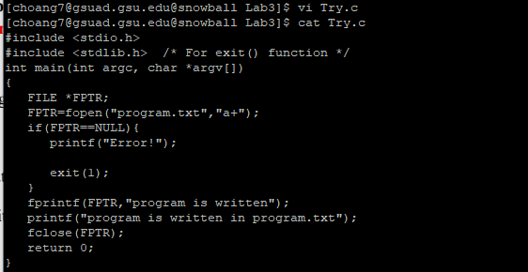

**Part 2:**

1. vi RealEstate.csv
2. in Command mode (ESC), use ‘G’ to move to the beginning of the last line, then use ‘$’ to move the cursor to the end of the last line.
3. in Command mode (ESC), type ‘:set number’.
4. in Command mode (ESC), type ‘:/111 EAST/’.

This string located at line 896. Type ‘dd’ and hit enter to delete the current line.

1. In Command mode (ESC), type ‘:50’.
2. In Command mode (ESC), type ‘:50,54s/,/:/g’.
3. In command mode (ESC)
   1. Copy line 50 to 54: ‘:50,54y’.
   2. Move the cursor to the end of the file like in question 4.
   3. Press p.
4. In Command mode (ESC), type ‘:50,54d’.
5. In Command mode (ESC), type ‘:1’ and press ‘$’ to move to the cursor to the end of line 1.

Press ‘i’ to enter insert/text mode.

Move the cursor with arrow key, press enter to insert a new line.

Type in “Recorded in year 2008”.

1. Press ESC to switch back to command mode.
2. Type ‘:wq’ to save and quit vi.

**Part 3:**

10)

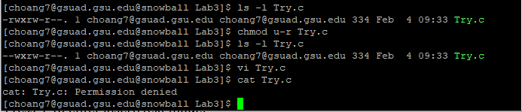

12)



the first character ‘-‘ means this is a regular file.

the next 3 character ‘r--’ means that the owner of file can only read the file.

the next 3 character ‘r--' means that the other users in the same group as the owner can only read the file.

The last 3 character ‘r--’ means that the other users in the other groups different from owner can only read the file.

15) the error message: “E45: ‘readonly’ option is set (add ! to override)”.

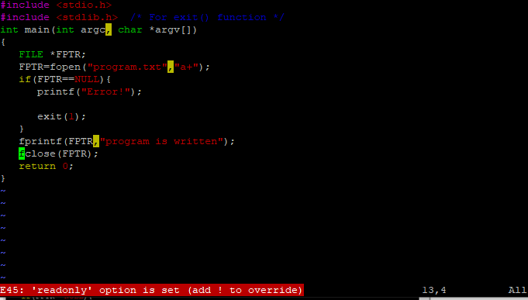

In command mode (ESC), type ‘:q!’ to quit the vi editor without saving the modification.

16) add write permission to all the users for file “Try.c” with the following command:

$ chmod ugo+w Try.c

17) check the file permission for file “Try.c” with the following command

$ ls -l Try.c



The first character ‘-‘ indicates this is a regular file

The next 3 characters ‘rw-‘ means the owner of the file can only read and write the file.

The next 3 characters ‘rw-‘ means the other users in the same group as the owner can only read and write the file.

The last 3 characters ‘rw-‘ means the other users in the other groups different from the owner can only read and write the file.

**Part 4:**

|  |  |  |  |  |  |  |
| --- | --- | --- | --- | --- | --- | --- |
| **Owner’s permissions** | **ls** | **mkdir** | **cat >** | **rm** | **cp** | **cd** |
|  | A. Read contents | B. Create sub-dictionary | C. Create file | D. Remove contents | E. Copy contents from | F. Enter into dictionary |
| --- | **N** | **N** | **N** | **N/A** | **N/A** | **N** |
| --x | **N** | **N** | **N** | **N/A** | **N/A** | **Y** |
| -w- | **N** | **N** | **N** | **N/A** | **N/A** | **N** |
| -wx | **N** | **Y** | **Y** | **Y** | **Y** | **Y** |
| r-- | **Y** | **N** | **N** | **N/A** | **N/A** | **N** |
| r-x | **Y** | **N** | **Y** | **N/A** | **Y** | **Y** |
| rw- | **Y** | **N** | **N** | **N/A** | **N/A** | **N** |
| rwx | **Y** | **Y** | **Y** | **Y** | **Y** | **Y** |