Cuong Hoang

CSC3320 System Level Programming

Lab Assignment 4 – Part 2 (Out of lab)

1) grep -E ‘Towns|Union’ mountainList.txt

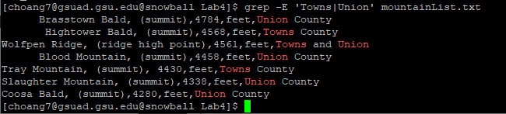

2) grep ‘Rabun’ mountainList.txt | wc -l



3) grep -c ‘Rabun’ mountainList.txt



4)

A.

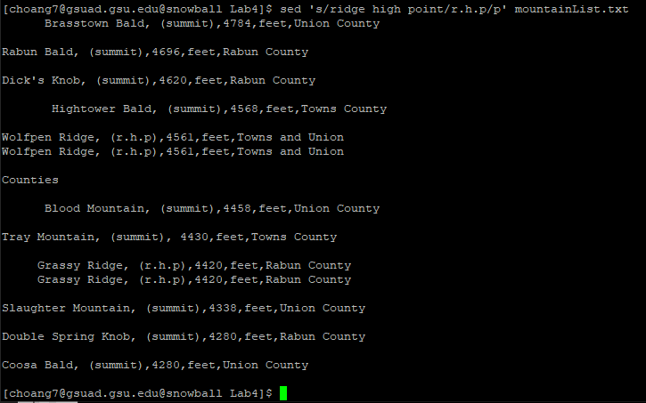

B.



C. By default, sed prints all processed input except input that has been modified/deleted by commands. We use -n to suppress the automatic printing of pattern space.

D. sed -n ‘s/ridge high point/r.h.p./p’ mountainList.txt

This command replaces ‘ridge high point’ in the file ‘mountainList.txt’ with ‘r.h.p’ and prints out the processed lines.

5) sed -n ‘s/^ \*//p’ mountainList.txt

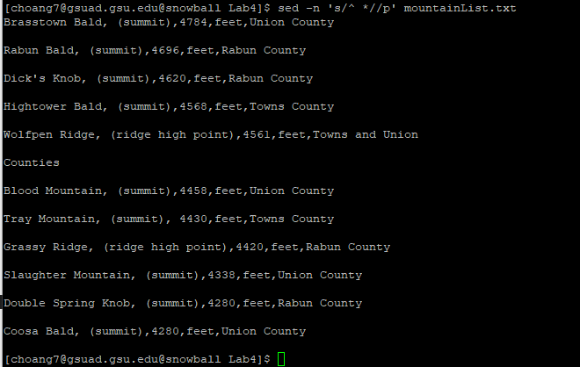

6) sed ‘s/^ \*//g’ < mountainList.txt > newList.txt

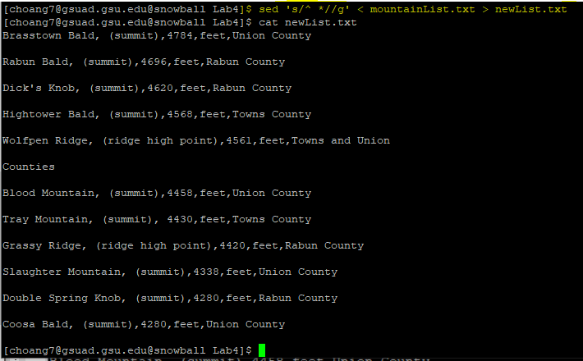

7) sed -n ‘/^\s/p’ mountainList.txt

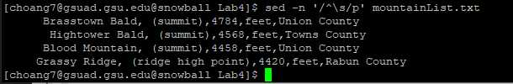

8) sed ‘/Union County/d’ mountainList.txt

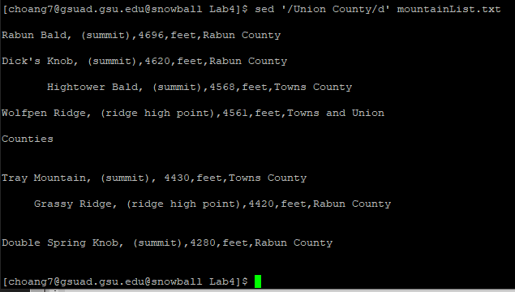

9) the provided command only removes the second and fourth field, so I modified the command a bit like the picture below:

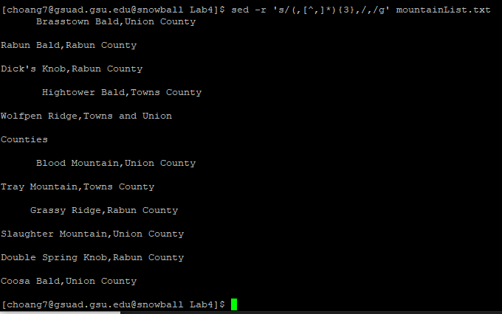

10) awk ‘{sub(/(,[^,]\*){3},/,”,”)}1’ mountainList.txt

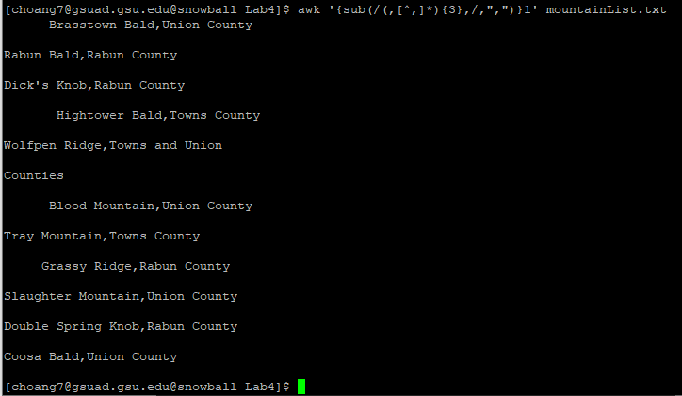

11) sed ‘1 I Table: Eleven highest mountains in Georgia’ mountainList.txt

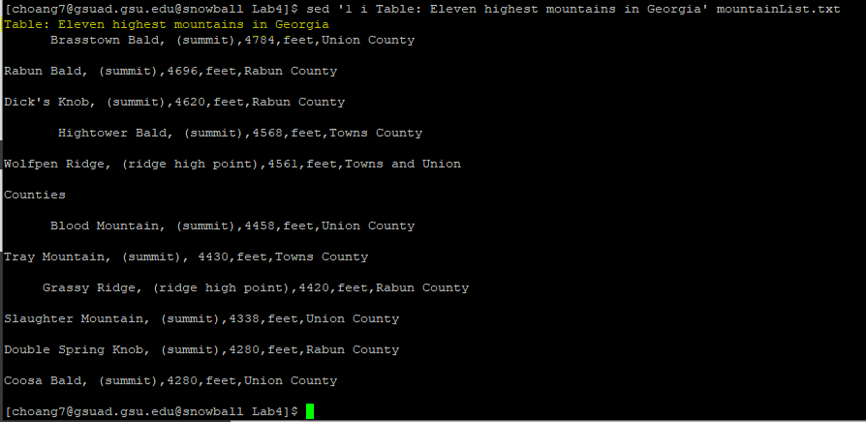

12) sort -b mountainList.txt

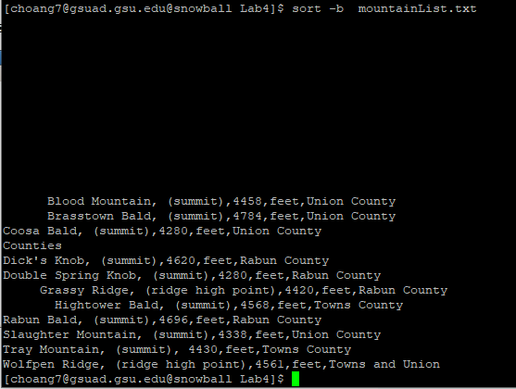

13) sort -s -n -k 3,4 mountainList.txt

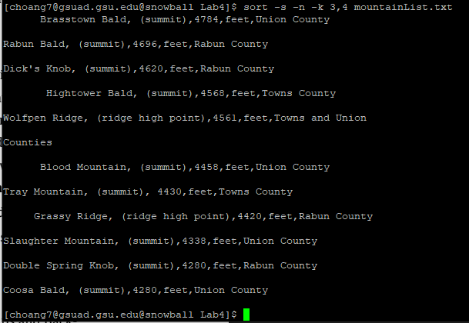

14) 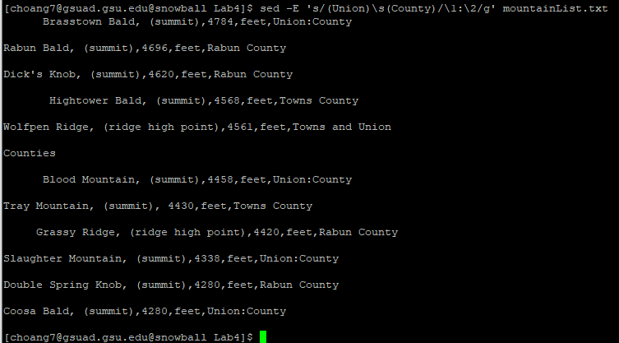

15) sed -r ‘s/([^,]\*){1}(,[^,]\*){3},([^,]\*)/\1,\3/g’ mountainList.txt

