Cuong Hoang

CSC3320 System Level Programming

Lab Assignment 5 – In-Lab

**Part 1:**

Question 1)



Question 2)



Question 3)

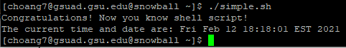

Question 4)

-n option means do not print the trailing newline character.

Question 5)

“Simple Script” is a comment because it has a pound sign (#) before on 1st column and is not the first line of the script.

Question 6)

“#!/bin/bash” is not a comment. It is placed in the first line of the script to notify which shell is used to interpret the script.

**Part 2:**

Question 7)

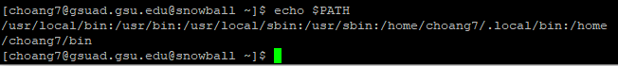

I can find 6 directories in the output.

Question 8)

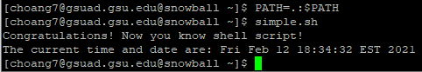

I do not see any error. This is because the PATH variable is an environment variable that contains a list of paths that Unix uses to search for executables when running a command. After inserting the current working directory into the PATH variable, Unix now knows the path to execute the shell script stored in my current working directory and no longer need me to explicitly state the path before the file name.

Question 9)

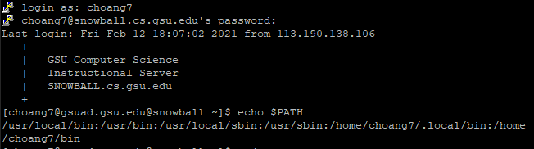

I cannot find the current working directory . in the PATH variable anymore.

Question 10)



There is a “Command not found” error. This is because the shell script is created is in my current working directory, and since the current working directory is no longer stored in the PATH variable after ending the session, Unix doesn’t know where to find the path that has the script ‘simple.sh’ in order to execute it.

**Part 3:**

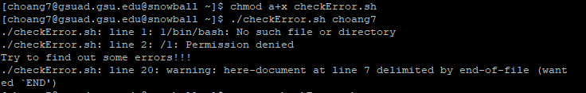

There are 3 errors at line 1, 2, and 20.

For the first line, if there is a pound sign then it is likely used to indicate the appropriate shell to interpret the script. We can fix this problem by removing the sign “$” to make the “#” place at first.

For the error in line 2, I think that the creator is mistaking the multipleline comment is available in shell script, but actually the slash-star is not supported. In fact, there is no multi-line comment mechanism in shell. We can fix this problem by removing the slash-star and put the single-line comment sign “#” before it.

For the last error, the here-document << END construction is incorrectly formed. To fix this, we need to remove the whitespace before END in line 7 and replace “-ENDHERE” with “END” to finish the document.

Here is the file after fixing all the error and the output:

