Cuong Hoang

CSC3320 System Level Programming

Lab Assignment 6 – Part 1 – In-Lab

Part 1:

Line 1: $#/bin/bash

Error: No such file or directory

Correction: #/bin/bash

Line 2: /\* Check Error Script \*/

Error: bash: /1:: No such file or directory

Multi-line comment is not supported in shell script.

Correction: # Check Error Script

Line 13: -ENDHERE

Error: here-document END started at line 7 is incorrectly formed, need another END.

Correction: END

Line 17: ls mail $1 < Result

Error: ls: cannot access mail: No such file or directory

Command ‘ls’ interrupt the ‘mail’ command. Separate them into different lines.

Correction:

ls;

mail ${1}@student.gsu.edu < Result

Result:

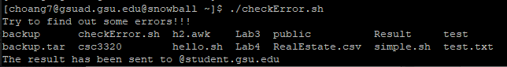

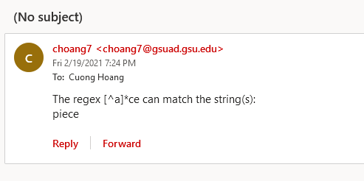

Part 2:

Content:

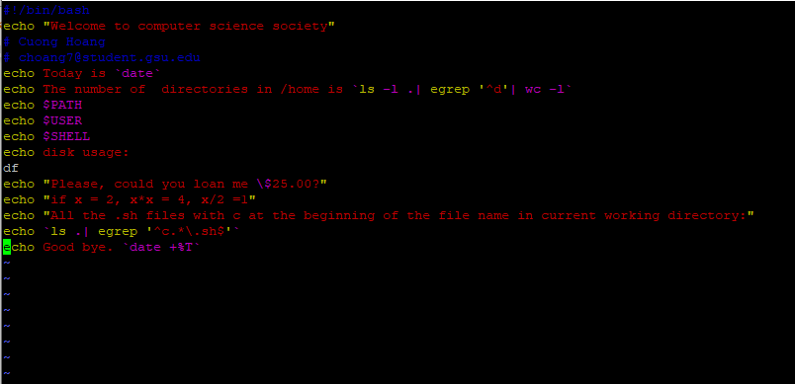

Result:

