Cuong Hoang

CSC3320 System Level Programming

Lab Assignment 6 – Part 2 – Post Lab

Part A:

Question 1:



Question 2:

In the while loop,

The first iteration i = 1:

s = 1 \* 1 = 1

x = 1 + 0 = 1

i increment by 1 -> i = 2

The second iteration i = 2:

s = 2 \* 2 = 4

x = 4 + 1 = 5

i increment by 1 -> i = 3

The third and final iteration i = 3:

s = 3 \* 3 = 9

x = 9 + 5 = 14

i increment by 1 -> I = 4

i = 4 does not satisfy the condition in the while loop -> exit the loop

echo the variable x, which is 14.

Part B:

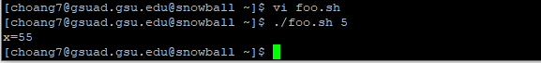

Part C:

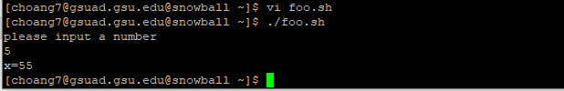

Part D:

Source code of foo.java:

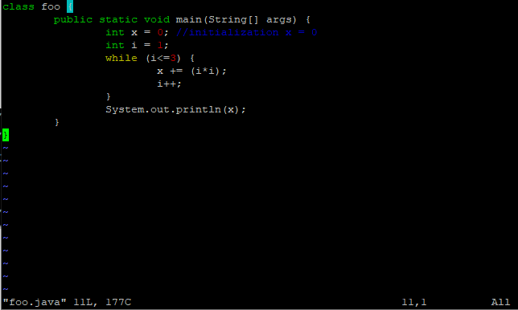

Output:

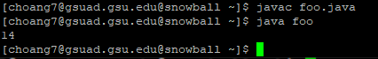

Part E:

Question 1:



Question 2:

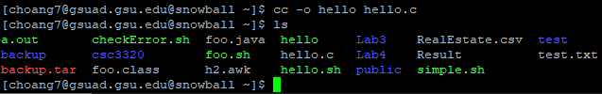

The new file is ‘hello’.

Question 3:



Question 4:

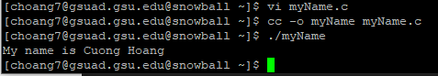

The source code:

