Cuong Hoang

CSC3320 System Level Programming

Lab Assignment 7 – Post-Lab

**Part 1:**

Question 1:

Execute and output:

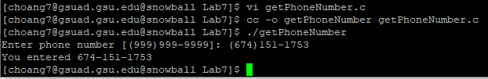

Source Code:

#include <stdio.h>

int main()

{

char phoneNumber[12];

printf("Enter phone number [(999)999-9999]: ");

scanf("%s", phoneNumber);

printf("You entered %.*s", 3, phoneNumber+1);

printf("-%.*s\n", 8, phoneNumber+5);

return 0;

}

Question 2:

Execute and output:

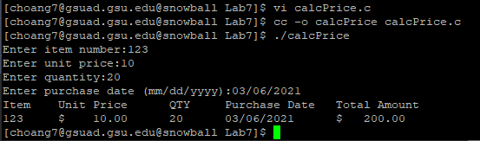

Source Code:

#include <stdio.h>

int main() {

int itemNum;

int qty;

double unitPrice;

char purchaseDate[10];

printf("Enter item number:");

scanf("%d", &itemNum);

printf("Enter unit price:");

scanf("%lf", &unitPrice);

printf("Enter quantity:");

scanf("%d", &qty);

printf("Enter purchase date (mm/dd/yyyy):");

scanf("%s", &purchaseDate);

double totalAmt = qty * unitPrice;

printf("Item\tUnit Price\tQTY\tPurchase Date\tTotal Amount\n");

printf("%d\t$%9.2lf\t%d\t%s\t$%9.2lf\n",itemNum, unitPrice, qty, purchaseDate, totalAmt);

return 0;

}

Part 2:

Execute and Output:

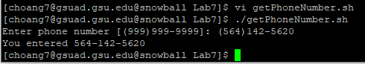

Source Script:

#!/bin/bash

echo -n "Enter phone number [(999)999-9999]: "

read num

echo -n "You entered "

output=$(echo "$num" | sed "s/(//g"| sed "s/)/-/g"); echo "$output"

General Idea: Use sed to substitute character “(“ with nothing and “)” with “-“.