|  |  |  |  |  |  |  |  |  |  |  |  |  |  |
| --- | --- | --- | --- | --- | --- | --- | --- | --- | --- | --- | --- | --- | --- |
|  | **MAD Project Evaluation 2 – June Intake 2020** | | | | | | | | | | | | |
| **Project Name:** | **Science Guider** | | **Batch:** | **2020_Y2S2** | | | |  | **Group ID:** | **G1.4** | | |
| Student ID | Student Name | Integrated system using a repository (Out of 5) | Marketing the app using a video clip published in a social media account (eg: LinkedIn) (Out of 20) | Function completeness (Out of 25) | Database connectivity (Out of 5) | Usability (Out of 5) | Validations (Out of 5) | Good coding practice (Out of 5) | Out of box features (Out of 5) | Report (Out of 5) | Q & A (Out of 20) | Total (Out of 100) |
| IT18216974 | Jayawardana J.T.H |  |  |  |  |  |  |  |  |  |  |  |
| IT18218190 | Didulantha U.M |  |  |  |  |  |  |  |  |  |
| IT18217100 | Dilshan H.V.V |  |  |  |  |  |  |  |  |  |
| IT18203554 | Dilshani W.D.C |  |  |  |  |  |  |  |  |  |
|  |  |  |  |  |  |  |  |  |  |  |

Git Repository Link: https://github.com/Team-abhiru/MAD-project.git

Link for the video in social media: https://www.facebook.com/tiran.jayawardana.35/videos/158613725624865/

(All group members should be tagged)

----------------------------------------------------------------------------------------------------------For Evaluators---------------------------------------------------------------------------------------------------------

Evaluator’s name:

Comments:

**Contribution**

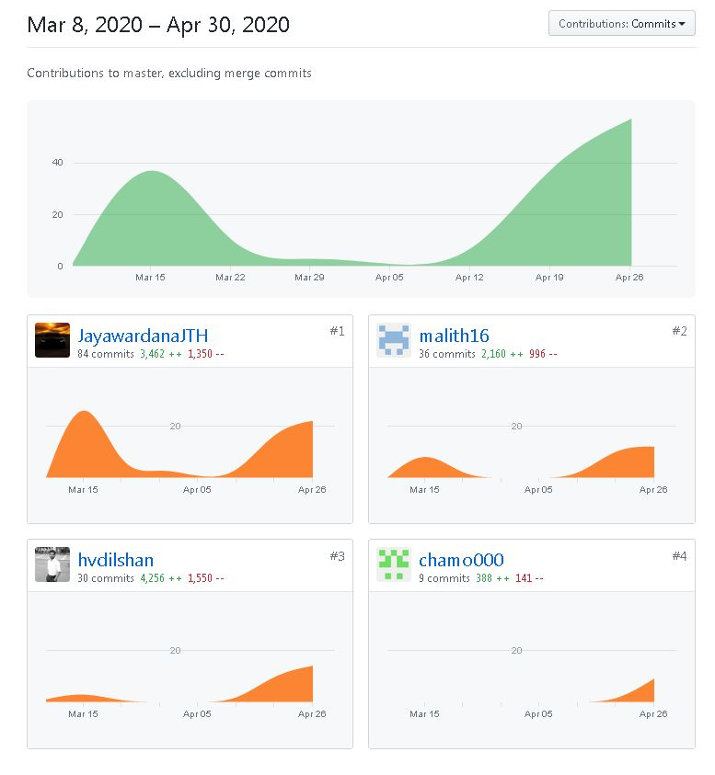

**Quiz Management** (IT18216974)

* The Question management function is providing quizzes to users. Users can attend the quizzes to grow up their skills on the subjects.
* In the user view users can see questions, answers and the check button. We provide three answers and users have to select correct answer. Using the check button users can check whether the provided answer is correct or not and also they can see solution for it.
* As admin can add questions to related subjects and topics. If there are unwanted or unrelated questions admin can delete them.
* The function linked with the subject content pages.
* There used string.xml to add names to the buttons, text views and spinners. Color.xml used to add colors to the buttons.

**Add New Quiz**

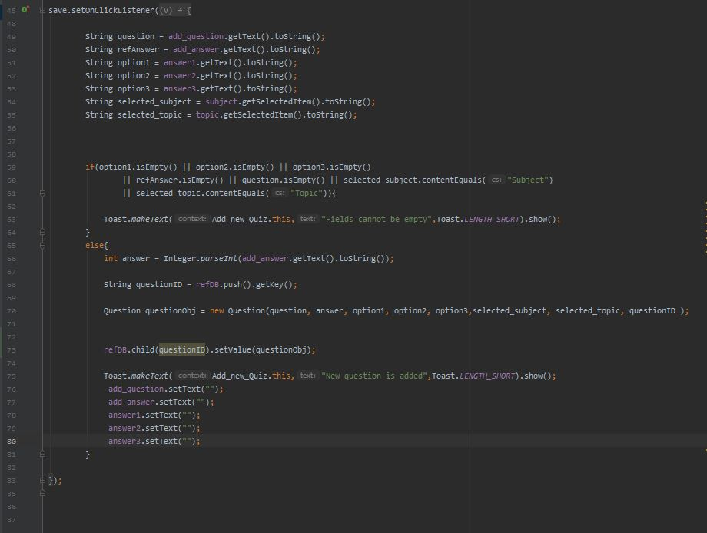

**Attempt Quiz**

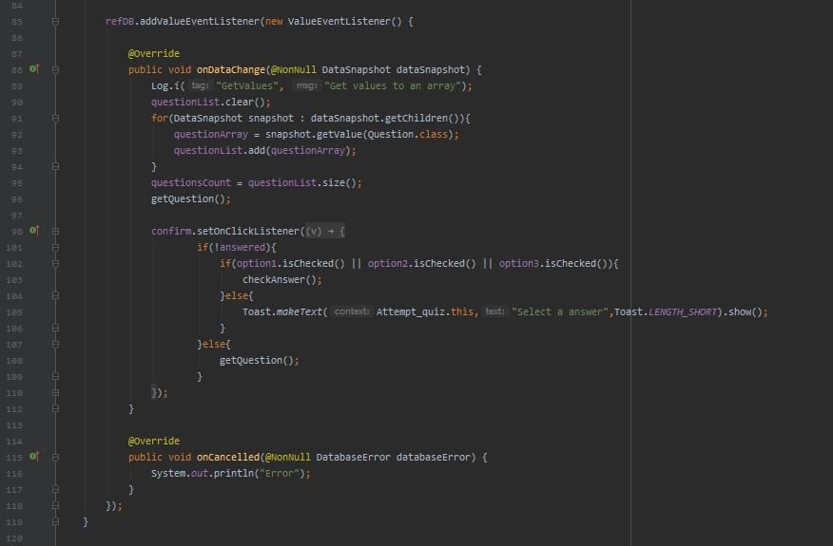

**Update Quiz**

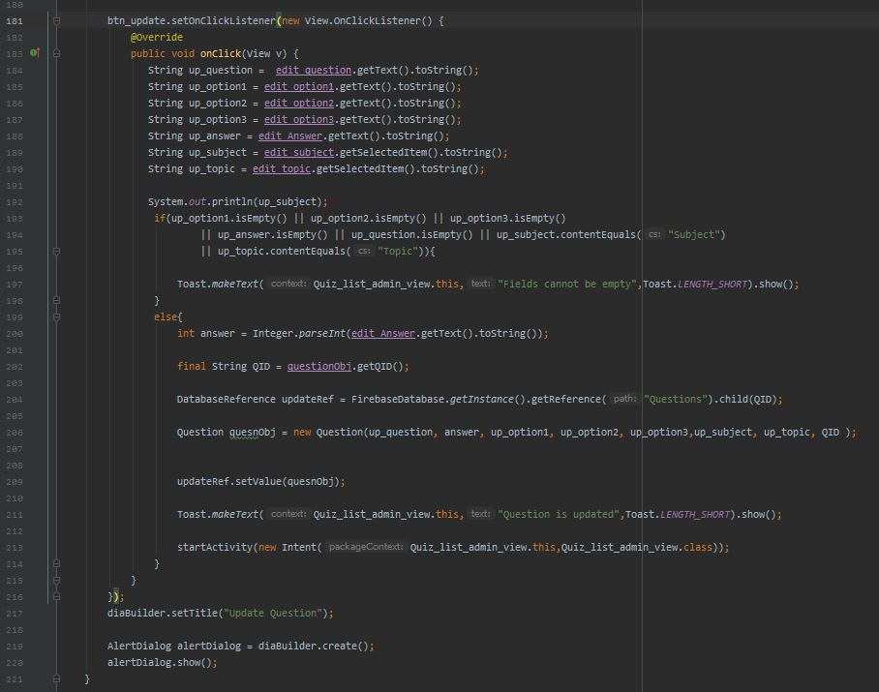

**Delete Quiz**

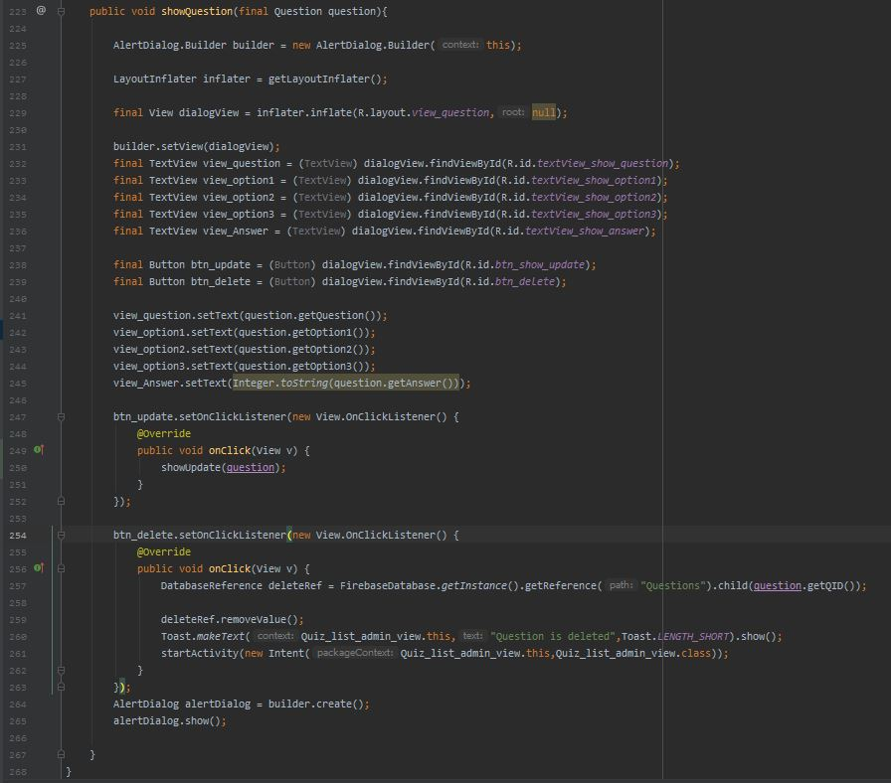

**User Management** (IT18218190)

* Users can register to the app by providing their username, full name, email, school and password. Their user ID are auto generated. After the registration they can login to the system by providing their username and password. App provide them to password changing facility and also they have ability delete their profile from the database.

**UploadPDF.java**

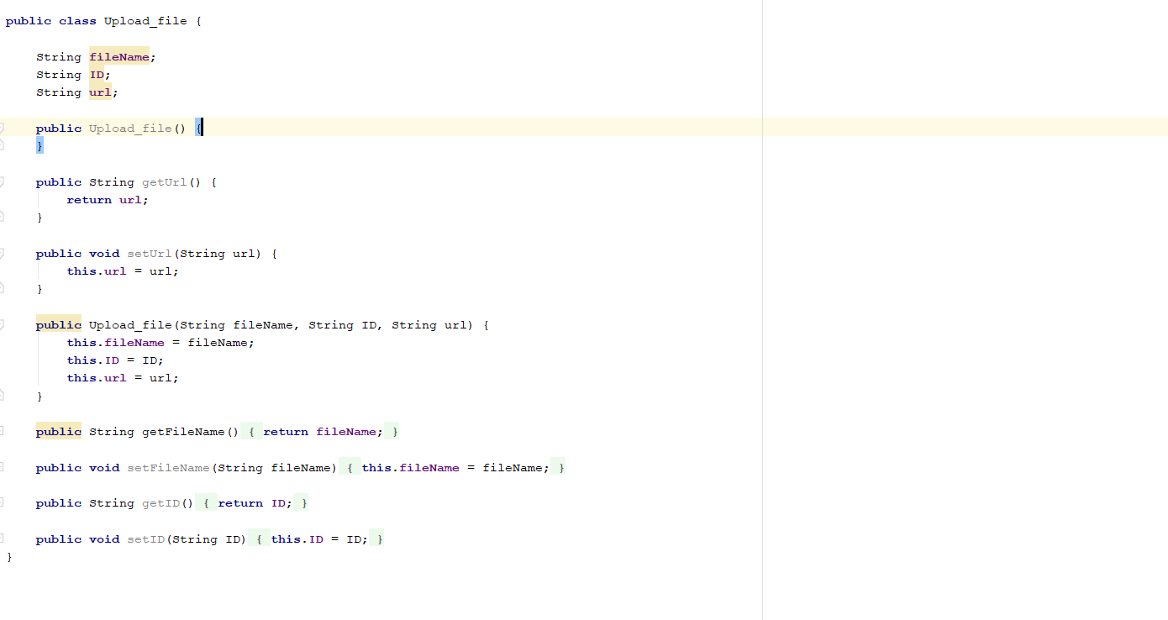

**Register New User**

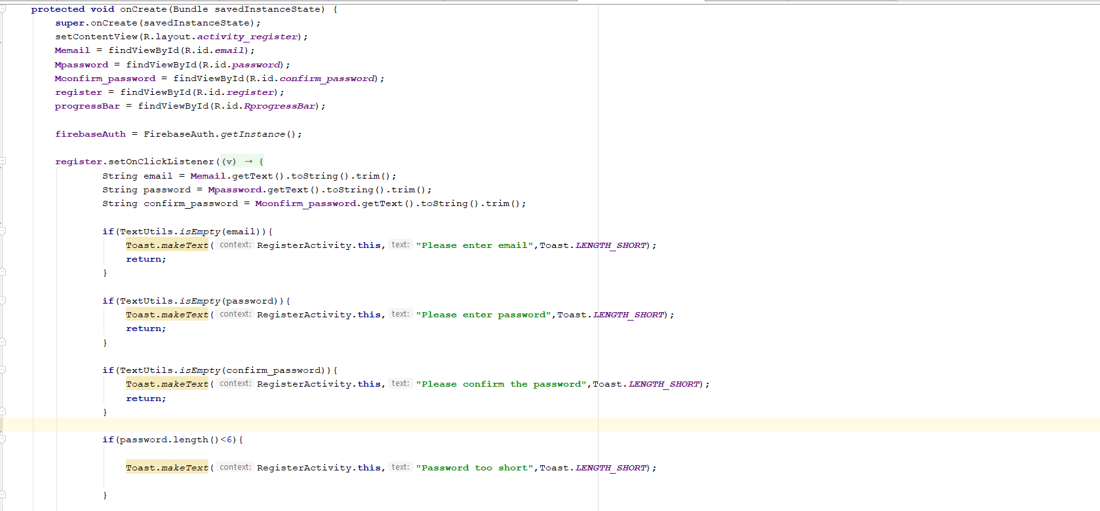

**Check Existing User or Not**

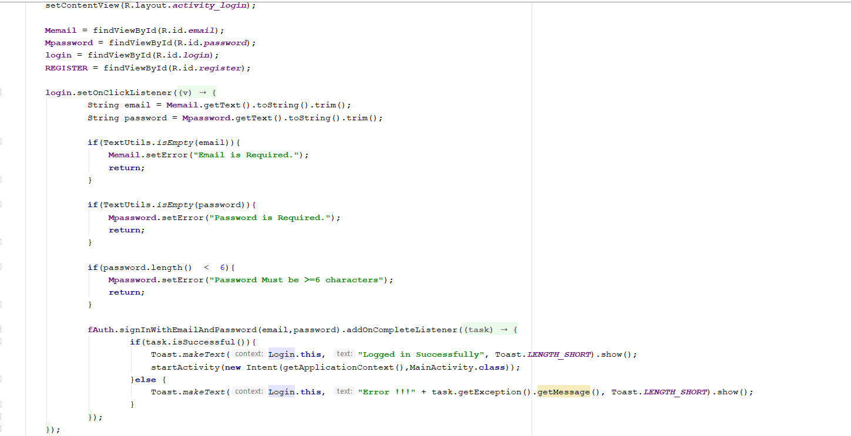

**Select New PDF**

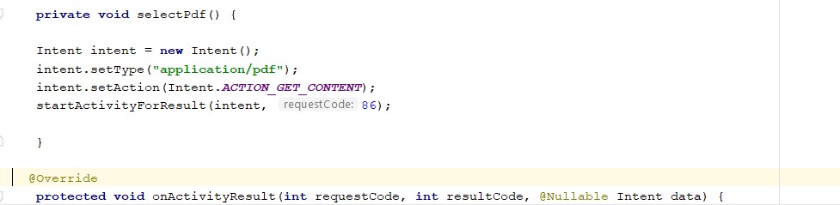

**Upload New PDF**

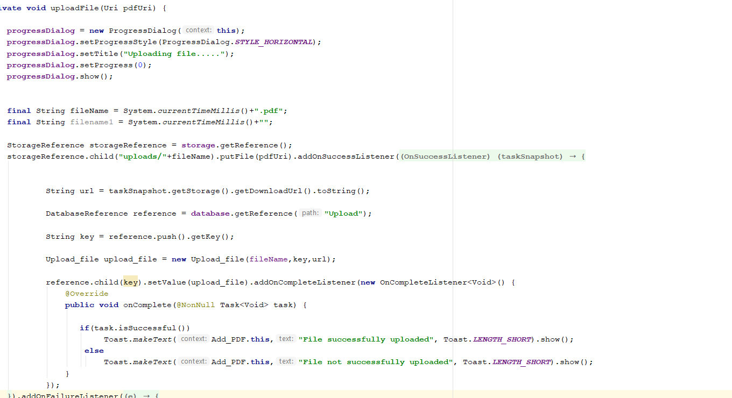

**View PDF List**

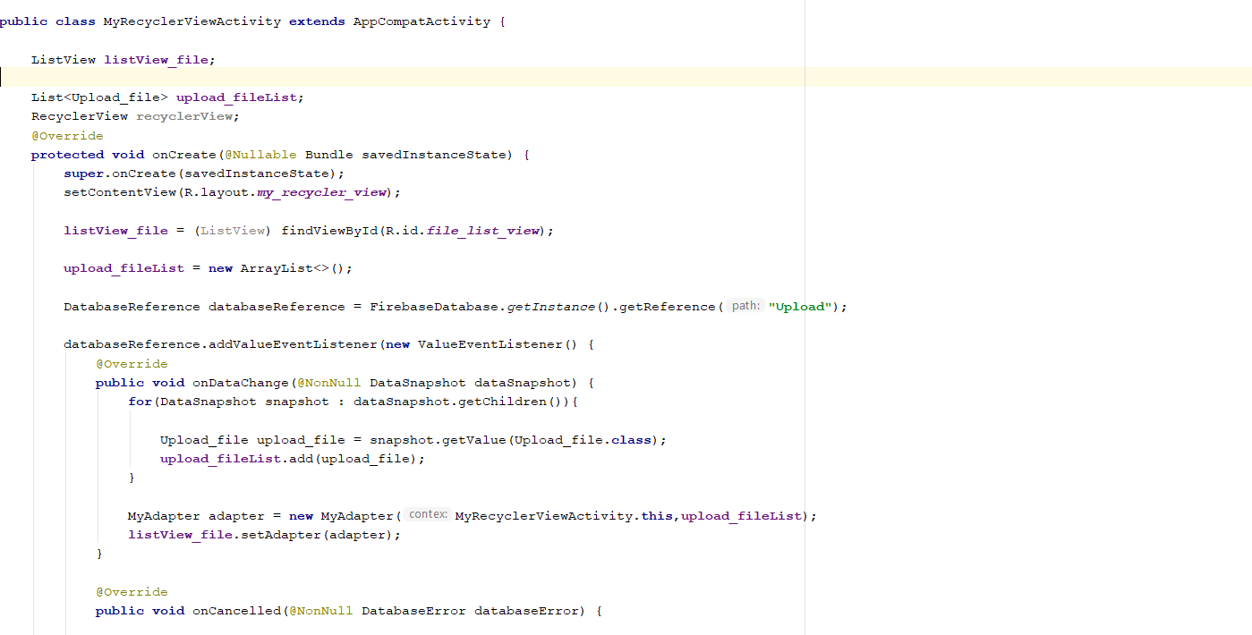

**Subject Management** (IT18217100)

* In this mobile application this is a function call Subject management. Purpose of this function add subject materials and manage it. Admin can add, delete and update materials information. Users can choose subject and also they can refer contents related the subject.

**PDF_Uploader.java**

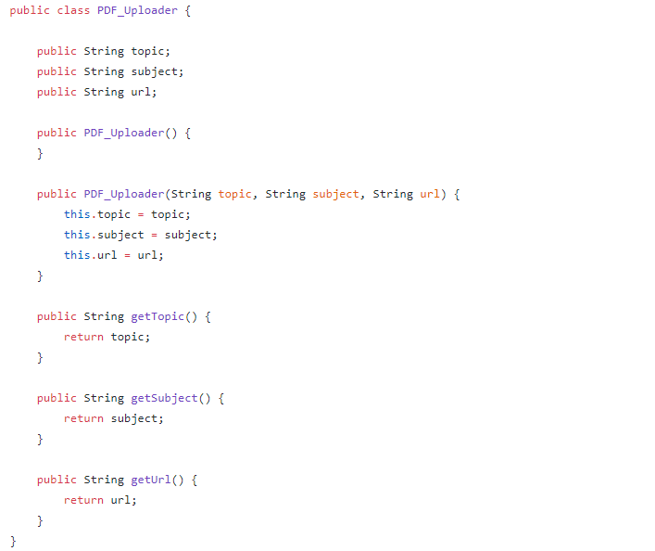

**Add New Material**

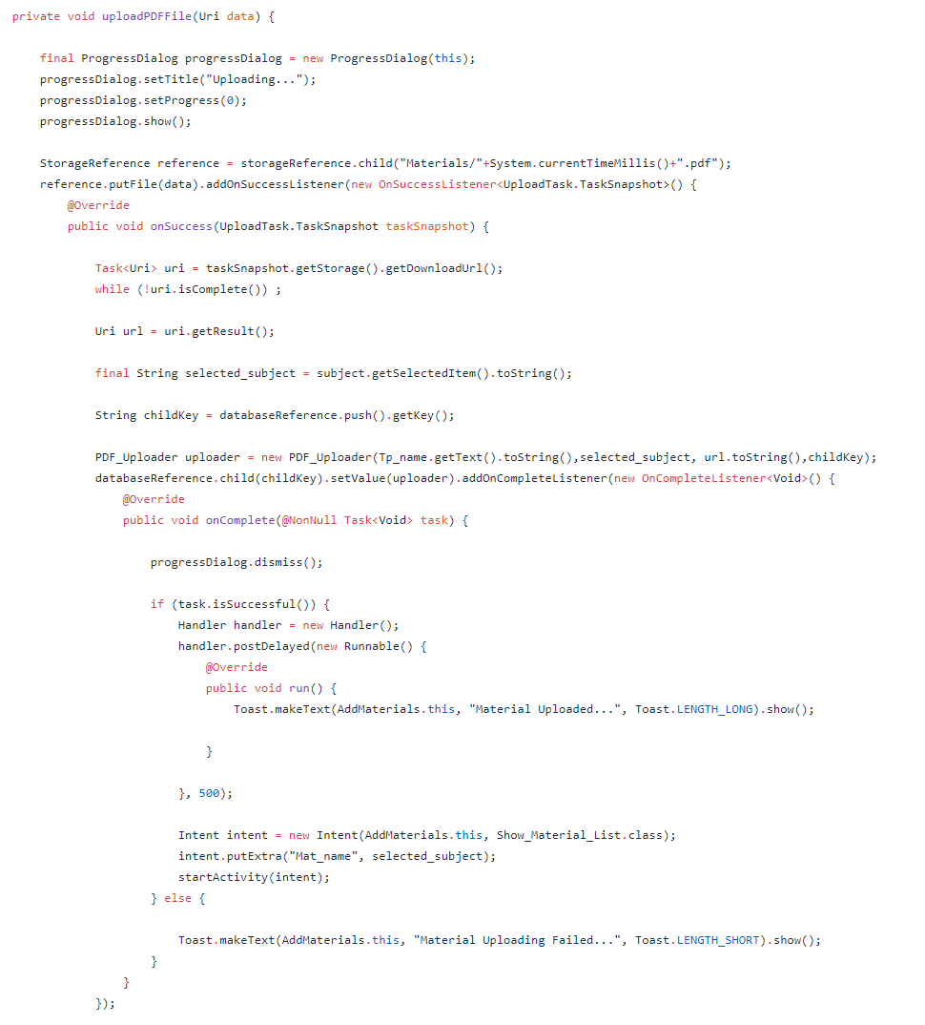

**Select PDF Upload**

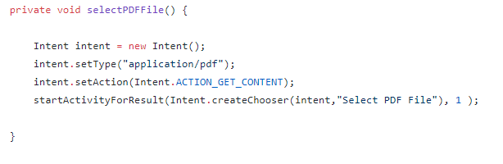

**List of Materials**

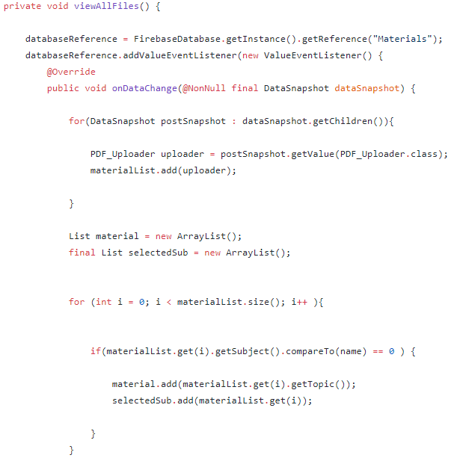

**Update Material Details**

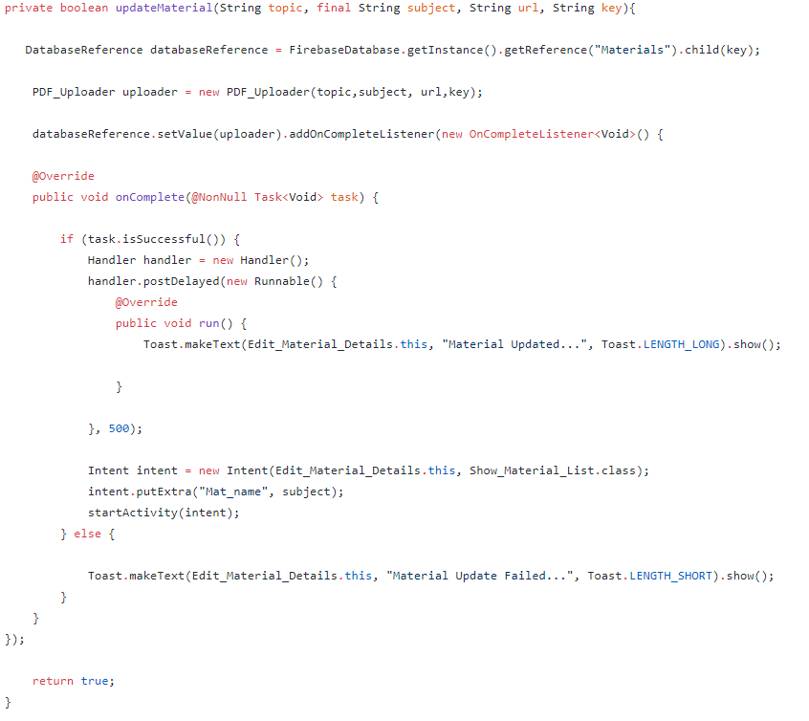

**Delete Material Details**

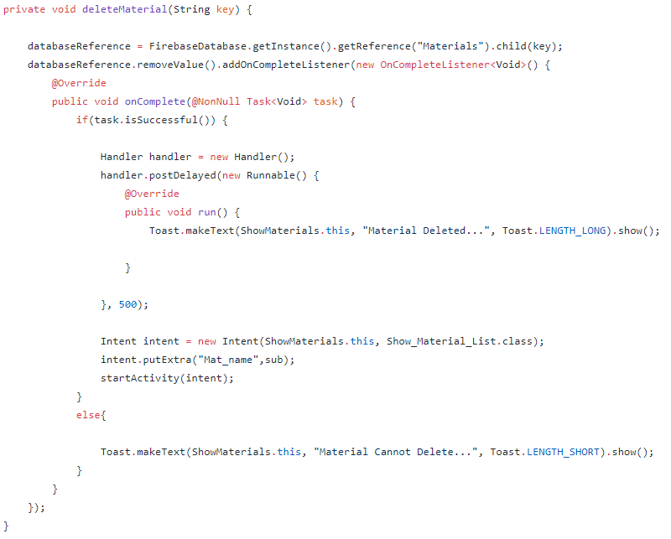

**View Selected Material**

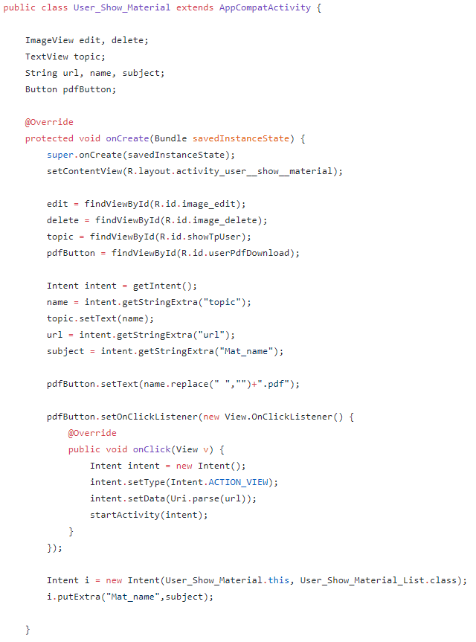

**Feedback Management** (IT18203554)

* In this mobile application there is a function call feedback management. Purpose of this function is collect users’ feedbacks. Users can share their experience on this mobile application and give suggestions. Users can send their feedbacks, view feedbacks, edit feedbacks and delete feedbacks which they gave us.

**Write New Feedback**

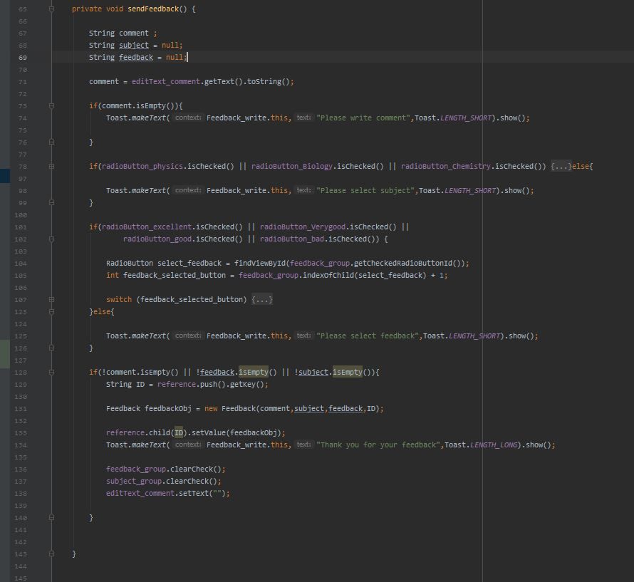

**View Feedback**

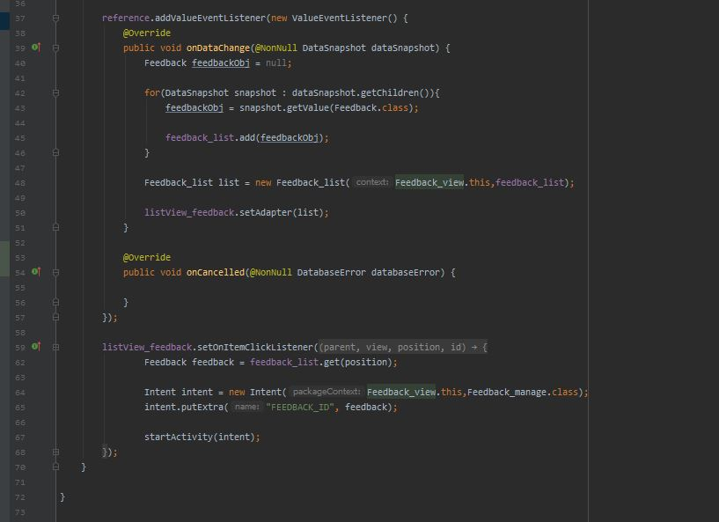

**Update Feedback**

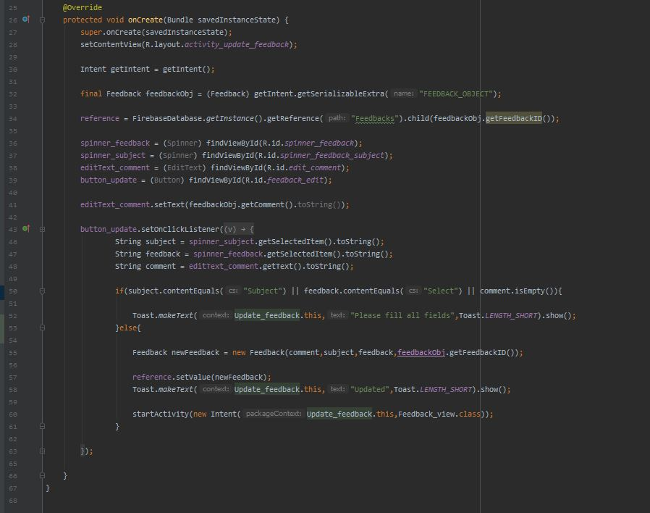

**Delete Feedback**

