Reg Number – IT18216974

Group – Year 2 semesters 2 Group 1.2

1. Quick short algorithm
2. Because the question mentioned compares the cards with first one, there for the first card should be a key.
3. Advantages : -
   1. Easy implementation,
   2. Cache performance is higher than other sorting algorithms

Disadvantages:-

1. Very slow on high big O values

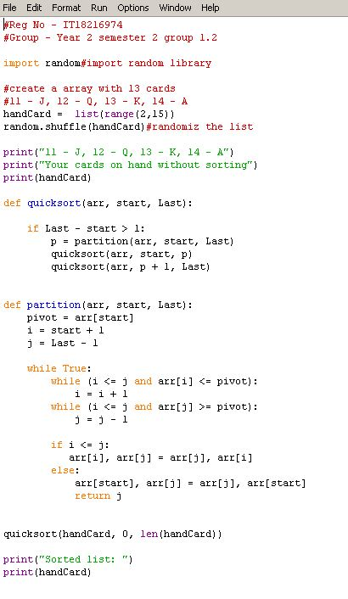5)

