**Contents**

Setting up your Google Sheets from Excel

VBA Codes:

* Y LSF
* XY LSF

Google Apps Scripts:

* Y LSF
* XY LSF

**Setting up your Google Sheets from Excel!**

1. Download your .xls or .xlsx file onto your local device
2. Drag and drop your local file into your Google Drive

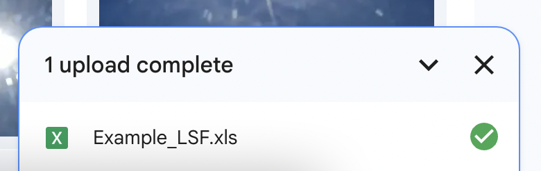

1. Open the file in Google Sheets by double-clicking on it
2. Click on **Insert > Drawing**

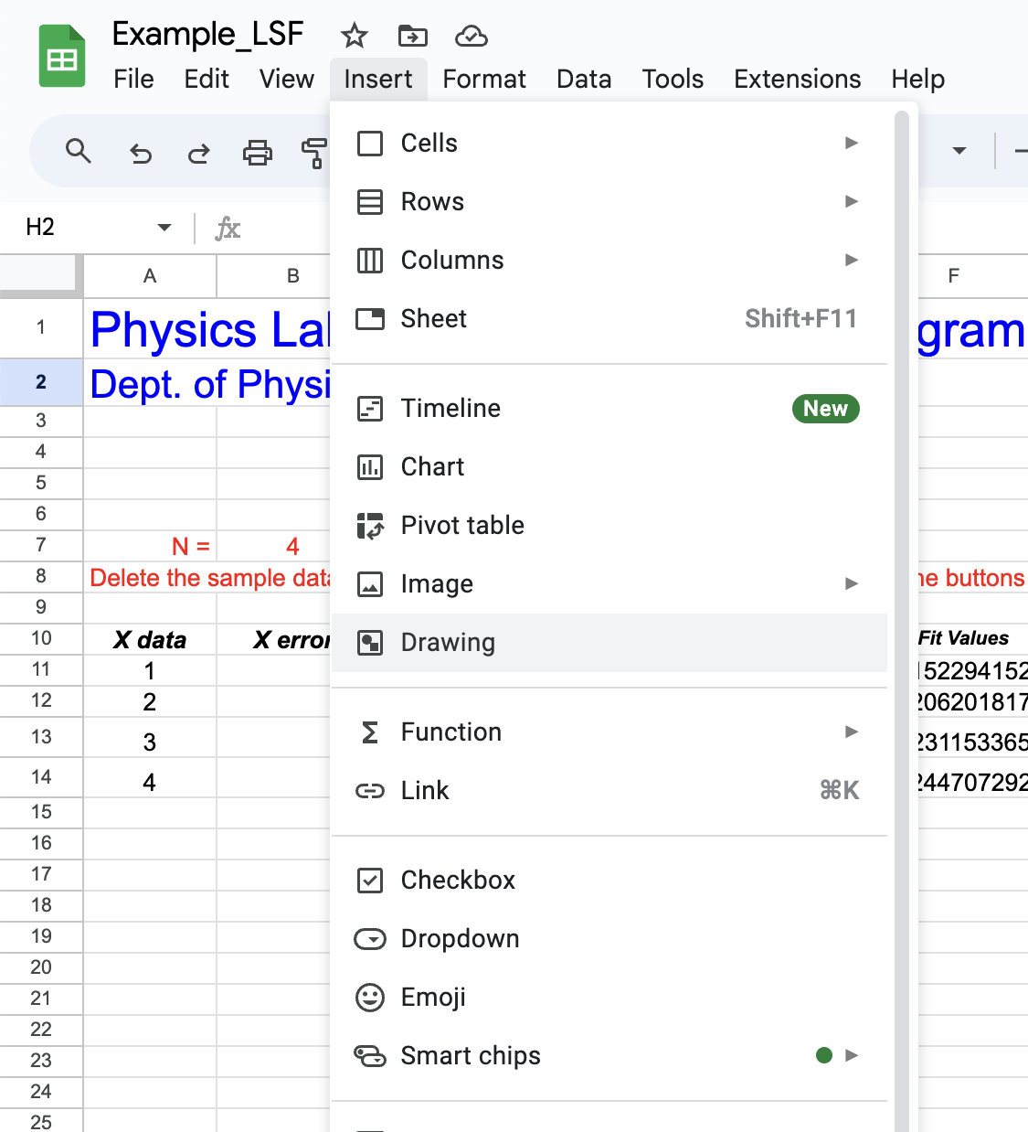

1. Add a drawing, by choosing a box and typing ‘Y errors only’. Repeat this for ‘X & Y error bars’.

**> Shapes > Rectangle**

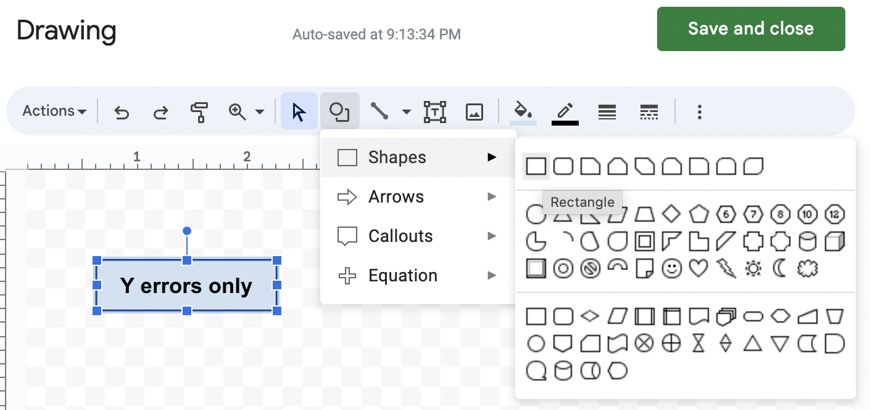

1. Go to **Extensions > Apps Script**

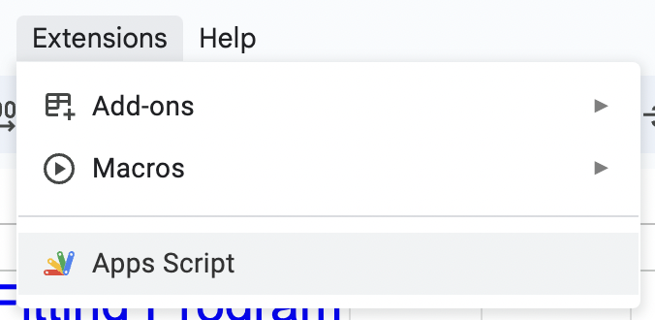

1. Create two files: ‘ylsf.gs’ and ‘xylsf.gs’ by clicking on **+ > Script**. You should also name your project. Note: apps script automatically adds .gs after the file name. You may delete the ‘Code.gs’ file if you aren’t using it.

|  |  |
| --- | --- |

1. Copy paste the following code in the following files and save:
   1. Y LSF code in the file ylsf.gs
   2. XY LSF code in the file xylsf.gs
2. Go back to the google sheet. Now, click on the three dots > Assign script. Type in ‘ylsf’ for the ‘Y errors only’ button. Do the same for the ‘X & Y error bars’ button, and type in ‘xylsf’.

|  |  |
| --- | --- |

1. Set the ‘N=’ to be ‘=COUNTA(A11:A99999999)’ in cell B7

**To Run**

The first time you click a button, it will require you to authorize the script you have added to the document.

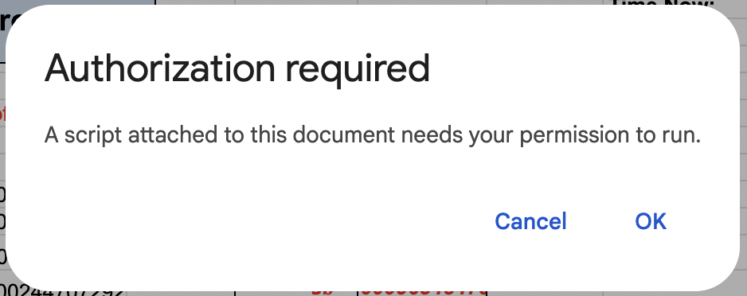

Clicking ok will prompt a log-in to the attached account. Log in and click Allow.



**VBA Code for Y-LSF**

| Sub xlsf()  Dim i, N, col, row As Integer  Dim x(1100), y(1100), yerr(1100) As Double  Dim a, b, aerr, berr, ChiSqr As Double  Dim S, Sx, Sy, Sxx, Sxy, D As Double  N = Cells(7, 2).Value  row = 10: col = 9 ' Cells(11, col - 1).Value = "a =" ' Cells(12, col - 1).Value = "b =" ' Cells(13, col - 1).Value = "a err=" ' Cells(14, col - 1).Value = "b err=" ' Cells(15, col - 1).Value = "ChiSqr/d.o.f."  For i = 1 To N  x(i) = Cells(10 + i, 1)  y(i) = Cells(10 + i, 3)  yerr(i) = Cells(10 + i, 4)  Next i  S = 0: Sx = 0: Sy = 0: Sxx = 0: Sxy = 0  For i = 1 To N  S = S + 1 / yerr(i) ^ 2  Sx = Sx + x(i) / yerr(i) ^ 2  Sy = Sy + y(i) / yerr(i) ^ 2  Sxx = Sxx + (x(i) / yerr(i)) ^ 2  Sxy = Sxy + x(i) * y(i) / yerr(i) ^ 2  Next i  D = S * Sxx - Sx ^ 2 ' Cells(row + 6, col) = S ' Cells(row + 7, col) = Sx ' Cells(row + 8, col) = Sy ' Cells(row + 9, col) = Sxx ' Cells(row + 10, col) = Sxy ' Cells(row + 11, col) = D ' Cells(row + 12, col) = N  a = (Sxx * Sy - Sx * Sxy) / D  b = (S * Sxy - Sx * Sy) / D  aerr = Sqr(Sxx / D)  berr = Sqr(S / D)  ChiSqr = 0  For i = 1 To N  ChiSqr = ChiSqr + ((y(i) - a - b * x(i)) / yerr(i)) ^ 2  Next i  Cells(row + 1, col) = a  Cells(row + 2, col) = b  Cells(row + 3, col) = aerr  Cells(row + 4, col) = berr  Cells(row + 5, col) = ChiSqr / (N - 2)  Cells(3, 12) = Now()  Cells(4, 12) = Time()  For i = 1 To N  yfit = a + b * x(i)  Cells(10 + i, 6) = yfit  Cells(10 + i, 5) = (y(i) - yfit) / yerr(i)  Next i End Sub |
| --- |

**VBA Code for XY-LSF**

| Sub xylsf()  Dim i, N, col, row As Integer  Dim x(1100), y(1100), yerr(1100), xerr(1100) As Double  Dim a, b, aerr, berr, ChiSqr As Double  Dim S, Sx, Sy, Sxx, Sxy, D As Double  row = 10: col = 9  N = Cells(7, 2).Value ' Cells(11, col - 1).Value = "a =" ' Cells(12, col - 1).Value = "b =" ' Cells(13, col - 1).Value = "a err=" ' Cells(14, col - 1).Value = "b err=" ' Cells(15, col - 1).Value = "ChiSqr/d.o.f."  For i = 1 To N  x(i) = Cells(10 + i, 1)  y(i) = Cells(10 + i, 3)  xerr(i) = Cells(10 + i, 2)  yerr(i) = Cells(10 + i, 4)  Next i  b = 0  For iter = 1 To 5 'Iterate 5 times for find best slope...  S = 0: Sx = 0: Sy = 0: Sxx = 0: Sxy = 0  For i = 1 To N  S = S + 1 / (yerr(i) ^ 2 + (b * xerr(i)) ^ 2)  Sx = Sx + x(i) / (yerr(i) ^ 2 + (b * xerr(i)) ^ 2)  Sy = Sy + y(i) / (yerr(i) ^ 2 + (b * xerr(i)) ^ 2)  Sxx = Sxx + x(i) * x(i) / (yerr(i) ^ 2 + (b * xerr(i)) ^ 2)  Sxy = Sxy + x(i) * y(i) / (yerr(i) ^ 2 + (b * xerr(i)) ^ 2)  Next i  D = S * Sxx - Sx ^ 2  b = (S * Sxy - Sx * Sy) / D  Next iter ' Cells(row + 6, col) = S ' Cells(row + 7, col) = Sx ' Cells(row + 8, col) = Sy ' Cells(row + 9, col) = Sxx ' Cells(row + 10, col) = Sxy ' Cells(row + 11, col) = D ' Cells(row + 12, col) = N  a = (Sxx * Sy - Sx * Sxy) / D  b = (S * Sxy - Sx * Sy) / D  aerr = Sqr(Sxx / D)  berr = Sqr(S / D)  ChiSqr = 0  For i = 1 To N  ChiSqr = ChiSqr + (y(i) - a - b * x(i)) ^ 2 / ((yerr(i)) ^ 2 + (b * xerr(i)) ^ 2)  Next i  Cells(row + 1, col) = a  Cells(row + 2, col) = b  Cells(row + 3, col) = aerr  Cells(row + 4, col) = berr  Cells(row + 5, col) = ChiSqr / (N - 2)  Cells(3, 12) = Now()  Cells(4, 12) = Time()  For i = 1 To N  yfit = a + b * x(i)  Cells(10 + i, 6) = yfit  Cells(10 + i, 5) = (y(i) - yfit) / yerr(i)  Next i End Sub |
| --- |

**Google Apps Script for Y-LSF**

| function ylsf() {  var sheet = SpreadsheetApp.getActiveSpreadsheet().getActiveSheet();  var N = sheet.getRange("B7").getValue();  var row = 10;  var col = 9;  var x = [];  var y = [];  var yerr = [];  var a, b, aerr, berr, ChiSqr;  var S = 0, Sx = 0, Sy = 0, Sxx = 0, Sxy = 0, D = 0;    for (var i = 1; i <= N+11; i++) {  var cell1 = sheet.getRange(row+i,1).getValue(); // x.push  var cell2 = sheet.getRange(row+i,3).getValue(); // y.push  var cell3 = sheet.getRange(row+i,4).getValue(); // xerr.push  var number1 = parseFloat(cell1);  var number2 = parseFloat(cell2);  var number3 = parseFloat(cell3);  x.push(number1);  y.push(number2);  yerr.push(number3);  }   for (var i = 0; i < N; i++) {  S += 1 / Math.pow(yerr[i], 2);  Sx += x[i] / Math.pow(yerr[i], 2);  Sy += y[i] / Math.pow(yerr[i], 2);  Sxx += Math.pow(x[i] / yerr[i], 2);  Sxy += x[i] * y[i] / Math.pow(yerr[i], 2);  }   D = S * Sxx - Math.pow(Sx, 2);    a = (Sxx * Sy - Sx * Sxy) / D;  b = (S * Sxy - Sx * Sy) / D;  aerr = Math.sqrt(Sxx / D);  berr = Math.sqrt(S / D);  ChiSqr = 0;   for (var i = 0; i < N; i++) {  ChiSqr += Math.pow((y[i] - a - b * x[i]) / yerr[i], 2);  }   sheet.getRange(row + 1, col).setValue(a);  sheet.getRange(row + 2, col).setValue(b);  sheet.getRange(row + 3, col).setValue(aerr);  sheet.getRange(row + 4, col).setValue(berr);  sheet.getRange(row + 5, col).setValue(ChiSqr / (N - 2));  sheet.getRange("L3").setValue(new Date());  var estTimeZone = Session.getScriptTimeZone();   var estDate = Utilities.formatDate(new Date(), estTimeZone, "HH:mm:ss");   sheet.getRange("L4").setValue(estDate);    for (var i = 0; i < N; i++) {  var yfit = a + b * x[i];  sheet.getRange(row + i + 1, 6).setValue(yfit);  sheet.getRange(row + i + 1, 5).setValue((y[i] - yfit) / yerr[i]);  } } |
| --- |

**Google Apps Script for XY-LSF**

| function xylsf() {  var sheet = SpreadsheetApp.getActiveSpreadsheet().getActiveSheet();  var N = sheet.getRange("B7").getValue();  var row = 10;  var col = 9;  var x = [];  var y = [];  var yerr = [];  var xerr = [];  var a, b, aerr, berr, ChiSqr;  var S, Sx, Sy, Sxx, Sxy, D;    for (var i = 1; i <= N+11; i++) {  var cell1 = sheet.getRange(row+i,1).getValue(); // x.push  var cell2 = sheet.getRange(row+i,3).getValue(); // y.push  var cell3 = sheet.getRange(row+i,2).getValue(); // xerr.push  var cell4 = sheet.getRange(row+i,4).getValue(); // yerr.push  var number1 = parseFloat(cell1);  var number2 = parseFloat(cell2);  var number3 = parseFloat(cell3);  var number4 = parseFloat(cell4);  x.push(number1);  y.push(number2);  xerr.push(number3);  yerr.push(number4);  }   var b = 0;  for (var iter = 1; iter <= 5; iter++) {  S = 0; Sx = 0; Sy = 0; Sxx = 0; Sxy = 0;  for (var i = 0; i < N; i++) {  var errSq = Math.pow(yerr[i], 2) + Math.pow(b * xerr[i], 2);  S += 1 / errSq;  Sx += x[i] / errSq;  Sy += y[i] / errSq;  Sxx += Math.pow(x[i], 2) / errSq;  Sxy += x[i] * y[i] / errSq;  }  D = S * Sxx - Math.pow(Sx, 2);  b = (S * Sxy - Sx * Sy) / D;  }   a = (Sxx * Sy - Sx * Sxy) / D;  b = (S * Sxy - Sx * Sy) / D;  aerr = Math.sqrt(Sxx / D);  berr = Math.sqrt(S / D);  ChiSqr = 0;   for (var i = 0; i < N; i++) {  var errSq = Math.pow(yerr[i], 2) + Math.pow(b * xerr[i], 2);  ChiSqr += Math.pow((y[i] - a - b * x[i]), 2) / errSq;  }   sheet.getRange(11, 9).setValue(a);  sheet.getRange(12, 9).setValue(b);  sheet.getRange(13, 9).setValue(aerr);  sheet.getRange(14, 9).setValue(berr);  sheet.getRange(15, 9).setValue(ChiSqr / (N - 2));  sheet.getRange("L3").setValue(new Date());  var estTimeZone = Session.getScriptTimeZone();   var estDate = Utilities.formatDate(new Date(), estTimeZone, "HH:mm:ss");   sheet.getRange("L4").setValue(estDate);  //sheet.getRange("L4").setValue(new Date());    for (var i = 0; i < N; i++) {  var yfit = a + b * x[i];  sheet.getRange(row + i + 1, 6).setValue(yfit);  sheet.getRange(row + i + 1, 5).setValue((y[i] - yfit) / yerr[i]);  } } |
| --- |