Stat/CS 187: Final Project

Huaye Yang, Halina Vercessi, and Matthew Mccarthy

Spring 2022

Table of Contents

1. Introduction 1

2. Data Visualizations 6

2.1 Length of Relationship and Age (Graph 1): 6

2.1.1 Graph 1 –> Halina 6

2.1.2 Summarizing Paragraph: 9

2.2 Occupation and Income (Graph 2 and Graph 3) 10

2.2.1 Graph 2 10

2.2.2 Summarizing Paragraph: 18

2.2.3 Graph 3 18

2.2.4 Summarizing Paragraph: 25

2.3 Reasons for Sleeping Separately (Graph 4) –> Matthew 25

2.3.1 Graph 4 26

2.3.2 Summarizing Paragraph: 32

3 Conclusions: 33

4 Limitations / Recommendations: 33

knitr::opts_chunk$set(echo = TRUE,  
 fig.width=12,   
 fig.height=10)  
  
# Load the packages  
pacman::p_load(gapminder, tidyverse, skimr, socviz, grid, stringr,  
 usmap, maps, statebins, viridis, leaflet, cowplot, gridExtra)

# 1. Introduction

Before this survey, the most detailed data and reports on this subject were gathered and made in 2004 by the National Sleep Foundation. The data from the National Sleep Foundation provided the numbers on how many couples slept separately but did not gather data that could offer insight as to the reasons couples sleep apart and why couples sleep in separate beds. This data is interesting because it is the kind of data that could be useful to psychologists and social workers. This data can be used to examine stereotypes we have about why couples sleep separately and which age ranges of couples sleep separately along with being useful for examining why couples sleep separately.The data comes from a survey created in 2014 by Mona Chalabi as research for an article for Five Thirty Eight (from ABC News). The population from which this sample was drawn includes 1,057 American adults who were married, in a domestic partnership, in civil union or cohabiting with a significant other. The sample was selected with the help of SurveyMonkey, which gathered all 1,057 responses.

The participants only need to check boxes that they think best describes their situation. Bias can easily occur in this survey because:

1. It may be hard for participants to find a certain categorical box within each question to best describe their situation. In this circumstances, samples that are considered as outlier will fall into one of the categorical values. Also, we are only able to do a rough analysis based on designed categorical values. It can’t provide detailed information or quantitative analysis for accurate numerical values.
2. Participants may overly/underly describe their situation due to the form of survey. What we have in dataset is subjective, not objective.
3. We are not sure whether this survey is voluntary. If this is forced or hard for participants to refuse, the data can be messed because participants may randomly select the boxes instead of actually looking into the questions and participate. Also, we can’t guarantee how reliable the data is. From the recorded time (EndDate - StartDate),participants only spent around 3 minutes for answering 29 questions (Some of them only use less than 1 minute). There might be part of the data that are not meaningful. If this survey is voluntary (or maybe taken at a counselling institution,etc), participants who are willing to answer these questions may already have issues or at least went through the situation that were asked in the survey. This means we are not getting randomly distributed samples.

The cleaning that was done on the data was to rename the columns because the original column names were built from the survey questions (separated by periods) and they were very long and tedious to work with. Additionally, during the building of the following graphs, responses that were left blank were omitted to focus on relevant responses. We also removed the first row as it served as almost a second title row but was being counted in the rows of data. We considered labeling the blank / no answer spaces as N/A but N/A means something in this data as it is a valid response to specific check boxes.

# Read in data  
sleeping_alone_data1 <- read.csv("R_sleeping_alone.csv", stringsAsFactors = T)  
  
# Take a look at the relationship status column, 7 categories  
#summary(sleeping_alone_data1)  
  
# Rename columns to simpler names based on survey questions  
sleeping_alone_data <- sleeping_alone_data1 %>%  
   
 rename( Relationship_Status = Which.of.the.following.best.describes.your.current.relationship.status.,   
 Relationship_Length = How.long.have.you.been.in.your.current.relationship..If.you.are.not.currently.in.a.relationship..please.answer.according.to.your.last.relationship.,  
 How_Often_Sep_Beds = When.both.you.and.your.partner.are.at.home..how.often.do.you.sleep.in.separate.beds.,   
 Diff_Bed_Where_You_Sleep = When.you.re.not.sleeping.in.the.same.bed.as.your.partner..where.do.you.typically.sleep.,   
 Diff_Bed_Where_Partner_Sleep = When.you.re.not.sleeping.in.the.same.bed..where.does.your.partner.typically.sleep.,   
 Sep_Beds_Reasons = What.are.the.reasons.that.you.sleep.in.separate.beds..Please.select.all.that.apply.,   
 When_First_Time_Sep_Beds = When.was.the.first.time.you.slept.in.separate.beds.,   
 Statement_Help_Stay_Together = To.what.extent.do.you.agree.with.the.following.statement...sleeping.in.separate.beds.helps.us.to.stay.together..,   
 Statement_Better_Sleep = To.what.extent.do.you.agree.with.the.following.statement...we.sleep.better.when.we.sleep.in.separate.beds..,  
 Statement_Improved_Sex_Life = To.what.extent.do.you.agree.with.the.following.statement.ë_.our.sex.life.has.improved.as.a.result.of.sleeping.in.separate.beds..ë_,   
 Current_Occupation = Which.of.the.following.best.describes.your.current.occupation.,  
 Household_Income = Household.Income,   
 Location_Census_Region = Location..Census.Region.)  
   
  
sleeping_alone_data <- sleeping_alone_data %>% slice(-c(1))  
  
head(sleeping_alone_data)

## StartDate EndDate Relationship_Status  
## 1 7/10/14 18:37 7/10/14 18:39 Single, but cohabiting with a significant other  
## 2 7/10/14 15:54 7/10/14 15:56 Single, but cohabiting with a significant other  
## 3 7/10/14 15:44 7/10/14 15:49 Married  
## 4 7/10/14 13:47 7/10/14 13:47 Married  
## 5 7/10/14 13:13 7/10/14 13:14 Married  
## 6 7/10/14 4:29 7/10/14 4:30 Single, but cohabiting with a significant other  
## Relationship_Length How_Often_Sep_Beds  
## 1 1-5 years Once a year or less  
## 2 1-5 years A few times per month  
## 3 1-5 years Never  
## 4 1-5 years Never  
## 5 1-5 years Never  
## 6 1-5 years Never  
## Diff_Bed_Where_You_Sleep X  
## 1 On the couch/chair   
## 2 I sleep in our shared bed, my partner is the one who sleeps somewhere else   
## 3   
## 4   
## 5   
## 6   
## Diff_Bed_Where_Partner_Sleep  
## 1 My partner sleeps in our shared bed, I'm the one who sleeps somewhere else  
## 2 Separate bedroom  
## 3   
## 4   
## 5   
## 6   
## X.1 Sep_Beds_Reasons X.2  
## 1   
## 2 One of us snores One of us makes frequent bathroom trips in the night  
## 3   
## 4   
## 5   
## 6   
## X.3 X.4 X.5 X.6 X.7  
## 1 One of us is sick   
## 2 One of us is sick We've had an argument or fight   
## 3   
## 4   
## 5   
## 6   
## X.8 X.9 X.10 X.11  
## 1 Other (please specify)  
## 2 Do not want to share the covers   
## 3   
## 4   
## 5   
## 6   
## When_First_Time_Sep_Beds Statement_Help_Stay_Together  
## 1 Within the first 1-5 years of our relationship Strongly disagree  
## 2 Immediately/ We've always slept in separate beds Somewhat agree  
## 3   
## 4   
## 5   
## 6   
## Statement_Better_Sleep Statement_Improved_Sex_Life  
## 1 Somewhat agree Strongly disagree  
## 2 Strongly agree Strongly disagree  
## 3   
## 4   
## 5   
## 6   
## Current_Occupation X.12 Gender  
## 1 Other (please specify) Student Male  
## 2 Healthcare Support Occupations Male  
## 3 Legal Occupations Male  
## 4 Life, Physical, and Social Science Occupations Male  
## 5 Office and Administrative Support Occupations Male  
## 6 Arts, Design, Entertainment, Sports, and Media Occupations Male  
## Age Household_Income Education  
## 1 18-29 $0 - $24,999 Some college or Associate degree  
## 2 18-29 Bachelor degree  
## 3 18-29 $150,000+ Graduate degree  
## 4 18-29 $25,000 - $49,999 Bachelor degree  
## 5 18-29 $100,000 - $149,999 Graduate degree  
## 6 18-29 $0 - $24,999 High school degree  
## Location_Census_Region  
## 1 Pacific  
## 2 South Atlantic  
## 3 South Atlantic  
## 4 Middle Atlantic  
## 5 South Atlantic  
## 6 East North Central

# 2. Data Visualizations

## 2.1 Length of Relationship and Age (Graph 1):

**The following figures aim to elate the length of relationships, bed status (separate beds vs same bed), and age.** **Additionally, the start of sleeping separately in looked at.** **Is it more likely that couples who have been together longer will sleep in separate beds more often?**

### 2.1.1 Graph 1 –> Halina

sleeping_alone_data2 <- sleeping_alone_data %>%  
   
 filter(Relationship_Length != "", How_Often_Sep_Beds != "") %>%  
   
 group_by(Relationship_Length, How_Often_Sep_Beds) %>%  
   
 summarise(count_freq = n()) %>%  
   
 mutate(Proportion = round(count_freq/sum(count_freq), digits = 5)) %>%  
   
 select(Relationship_Length, How_Often_Sep_Beds, Proportion) %>%   
   
 slice(-c(1)) %>%  
   
 ungroup()

## `summarise()` has grouped output by 'Relationship_Length'. You can override using the `.groups` argument.

rel_length_bar <- ggplot(data = sleeping_alone_data2,  
 mapping = aes(x = Relationship_Length,  
 y = Proportion,   
 fill = How_Often_Sep_Beds)) +  
   
 geom_col(position = "dodge") +   
   
 labs(x = "Relationship Length",  
 fill = "How Often Couples Sleep Separately",   
 title = "Frequency Sleeping Separately and Relationship Length (proportions)")+  
   
 scale_y_continuous(labels = scales::percent) +  
 scale_x_discrete(name = "Relationship Length (years)", labels = c("1-5", "11-15", "16-20", "6-10","< 1", "> 20" )) +  
 facet_wrap(~How_Often_Sep_Beds) +  
 theme(legend.position = "NA",   
 title = element_text(size = 9)) +  
 coord_flip()

sleeping_alone_data3 <- sleeping_alone_data %>%  
   
 filter(Age != "", How_Often_Sep_Beds != "") %>%  
   
 group_by(Age, How_Often_Sep_Beds) %>%  
   
 summarise(count_freq = n()) %>%  
   
 mutate(Proportion = round(count_freq/sum(count_freq), digits = 5)) %>%  
   
 select(Age, How_Often_Sep_Beds, Proportion) %>%   
   
 slice(-c(1)) %>%  
   
 ungroup()

## `summarise()` has grouped output by 'Age'. You can override using the `.groups` argument.

prop_age_bar <- ggplot(data = sleeping_alone_data3,  
 mapping = aes(x = Age,  
 y = Proportion,   
 fill = How_Often_Sep_Beds)) +  
   
 geom_col(position = "dodge") +   
   
 labs(x = "Age",  
 fill = "How Often Couples Sleep Separately",   
 title = "Frequency Sleeping Separately and Age (proportions)")+  
   
 scale_y_continuous(labels = scales::percent)+   
 scale_x_discrete(name = "Age Range", labels = c("60-Up", "18-29", "30-44", "45-60")) +  
 facet_wrap(~How_Often_Sep_Beds) +  
 theme(legend.position = "NA",   
 title = element_text(size = 9)) +  
 coord_flip()  
  
  
plot_grid(rel_length_bar, prop_age_bar, nrows = 2, ncols = 1)

## Warning in as_grob.default(plot): Cannot convert object of class numeric into a  
## grob.  
  
## Warning in as_grob.default(plot): Cannot convert object of class numeric into a  
## grob.

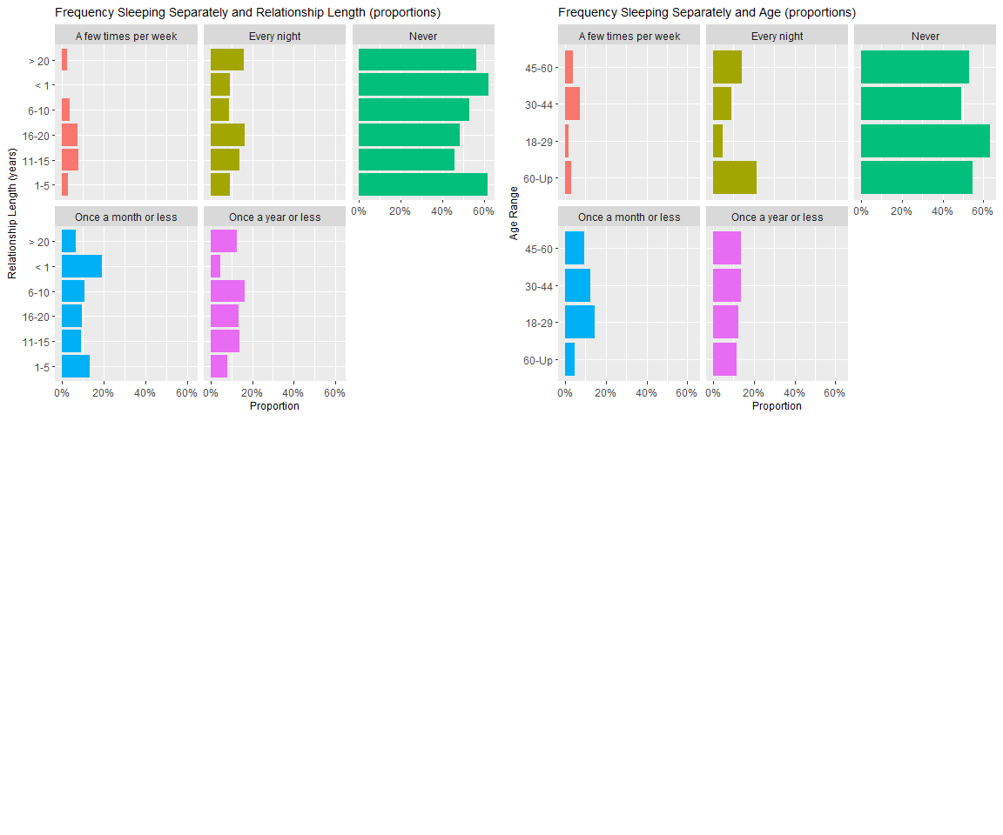

# Thinking about omitting this graph but we think it would be interesting to still examine the starting   
# point of sleeping separately within the relationship span.   
  
length_and_start_graph <- sleeping_alone_data %>%  
 filter(Age != "", How_Often_Sep_Beds != "", When_First_Time_Sep_Beds != "") %>%  
 ggplot(mapping = aes(x = Relationship_Length,  
 y = How_Often_Sep_Beds)) +  
  
 geom_jitter(mapping = aes(color = When_First_Time_Sep_Beds)) +  
  
 facet_wrap(facets = ~When_First_Time_Sep_Beds) +  
  
 scale_x_discrete(name = "Relationship Length (years)", labels = c("1-5", "11-15", "16-20", "6-10","< 1", "> 20" )) +  
  
 scale_y_discrete(name = "How Often Couple Sleeps in Separate Beds", labels = c("Few Times Per Month", "Few Times Per Week", "Every Night", "Never", "Once a Month or Less","Once a Year or Less")) +  
  
 theme(legend.position = "NA") +  
  
 labs(title = "Relationship Length, Frequency Sleeping in Separate Beds, and When it Started")  
  
length_and_start_graph

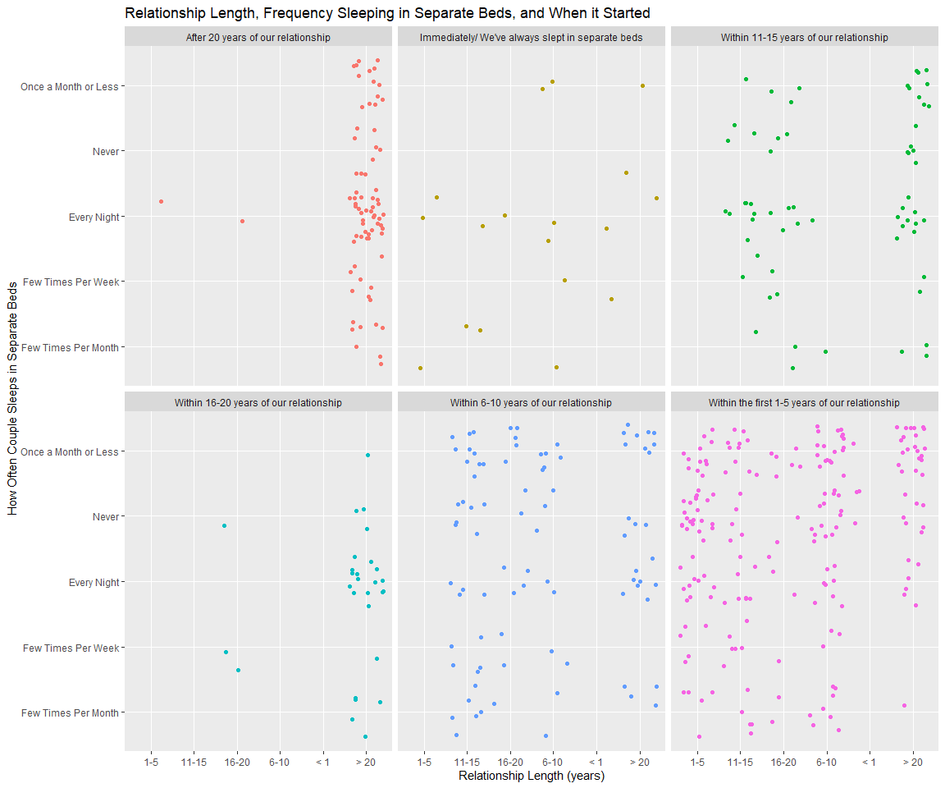

### 2.1.2 Summarizing Paragraph:

From the first two graphs, it is clear that the majority of couples who took the survey do not sleep separately. From the first graph, around 18% of couples who have been in a relationship for 16-20 years and more than 20 years do sleep in separate beds. These percentages are on the higher end for proportions of couples that have slept or do sleep separately. This aspect of the data fits our society’s stereotyping that couples who have been together longer are more likely to sleep separately. Another notable percentage is that almost 20% of couples who have been together for less than a year reported sleeping separately once a month or less.

From the last graph, which aims to show patterns in when sleeping separately starts, it appears that the majority of couples who do sleep in separate beds every night started sleeping separately earlier on in the relationship (within 1-5 years of the relationship) as can be seen in the last figure (bottom left pink), but also note that the relationship lengths that follow this pattern are mainly under 20 years in length and greater than 1 year. Another interesting pattern that can be noted is that for those who have been in a very long-term relationship (greater than 20 years), the majority of those couples sleeping in separate beds every night or a few times per week started this sleeping situation within 16 to 20 year or more than 20 years into their relationship. So, the couples with long relationships actually did not sleep separately until many years together had passed.

The first two graphs do fit what the public might expect to see from a survey like this, however, it does not give any indication as to the reasons couples who have been together longer might be sleeping separately. The following sections and figures will aim to further examine this aspect of the population sample. More specifically, could occupation and income (which are often tied to how busy or occupied a person might be in their daily activities) be related to couple sleeping separately? Additionally, what are the reasons for certain categories of couples (older, younger, etc) sleeping separately and have they noticed changes in their relationship from sleeping separately?

## 2.2 Occupation and Income (Graph 2 and Graph 3)

**Relate occupation, income, and bed status with how often they sleep separately.**

**Do occupational demands affect sleeping status? Is someone with a more demanding job more likely to sleep separately?** **(Could call for inclusion or examination of another data-set that has information on occupational categories and average hours worked per day or week.)**

### 2.2.1 Graph 2

# GRAPH 2  
  
# change the default theme below:  
theme_set(theme_bw())  
# set levels in order to give a better visisualization in color  
#summary(sleeping_alone_data$How_Often_Sep_Beds)  
  
rank<-as.factor(sleeping_alone_data$How_Often_Sep_Beds)  
sleeping_alone_data4 <- sleeping_alone_data %>%  
 mutate(How_Often_Sep_Beds = factor(rank, ordered = TRUE,   
 levels = c("Never",  
 "Once a year or less",  
 "Once a month or less",  
 "A few times per month",  
 "A few times per week",  
 "Every night")))  
# Relate occupation to bed status (and how often they sleep)  
# Overall plot  
sleeping_alone_data4 %>%  
 group_by(Current_Occupation)%>%  
 ggplot(data = sleeping_alone_data4,  
 mapping = aes(x = Current_Occupation,  
 fill = How_Often_Sep_Beds)) +  
 geom_bar(position="dodge")+  
   
 theme(axis.text.x = element_text(angle = 90,  
 hjust = 1,  
 vjust = 0.25,  
 size = 7),  
 legend.position = "top",  
 legend.text = element_text(size = 7),  
 legend.key.size = unit(0.25,'cm'),  
 legend.title = element_text(size= 8),  
 axis.title.x = element_blank(),  
 axis.title.y = element_blank())

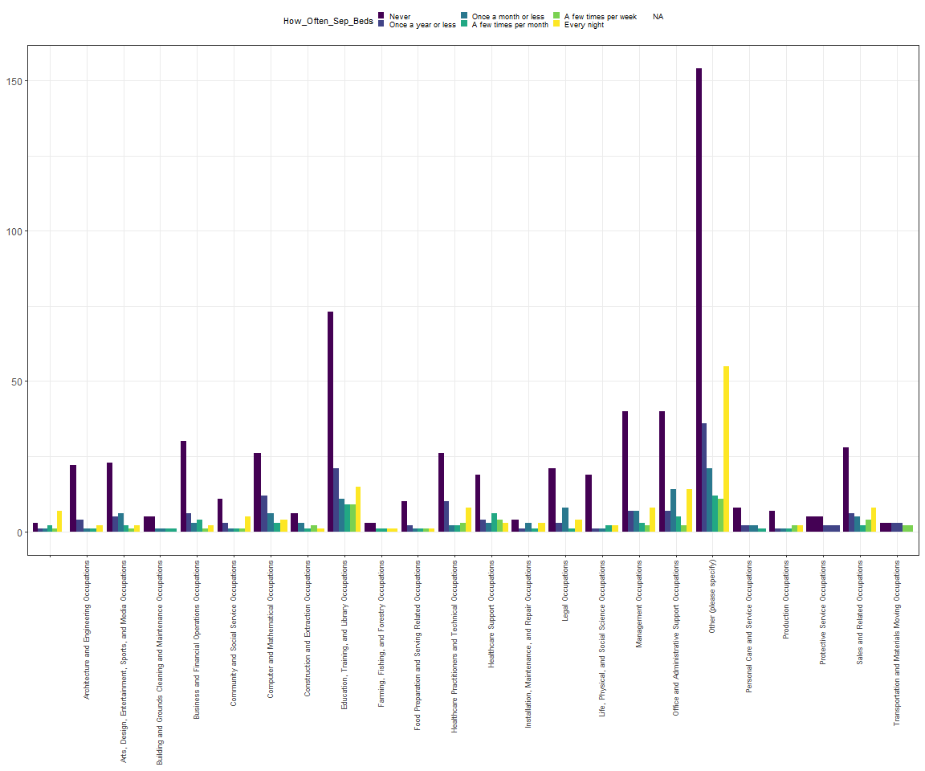

# summary() to see each category name and ready to draw plots for each of   
# the categories. facet_wrap or facet_grid provide too little information  
#summary(sleeping_alone_data$How_Often_Sep_Beds)  
#### for each bed status below:  
# Never  
sleeping_alone_data4 %>%  
 select(Current_Occupation,How_Often_Sep_Beds) %>%  
 filter(How_Often_Sep_Beds == "Never") %>%  
 ggplot(aes(y = Current_Occupation,  
 color = How_Often_Sep_Beds))+  
 geom_bar(fill = "purple4")+  
 theme(axis.title.x = element_blank(),  
 axis.title.y = element_blank())

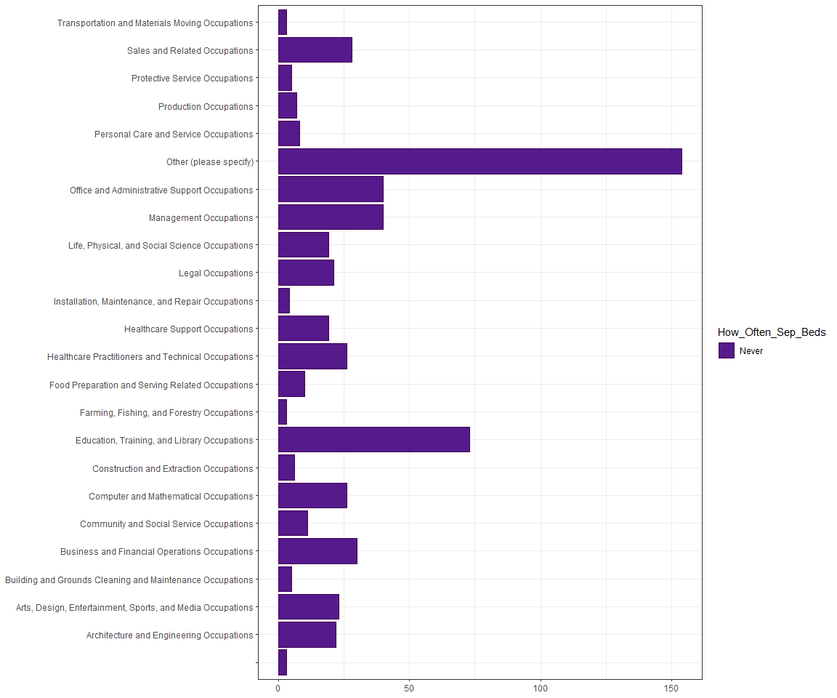

# Once a year or less   
sleeping_alone_data4 %>%  
 select(Current_Occupation,How_Often_Sep_Beds) %>%  
 filter(How_Often_Sep_Beds == "Once a year or less") %>%  
 ggplot(aes(y = Current_Occupation,  
 color = How_Often_Sep_Beds))+  
 geom_bar(fill = "darkslateblue")+  
 theme(axis.title.x = element_blank(),  
 axis.title.y = element_blank())

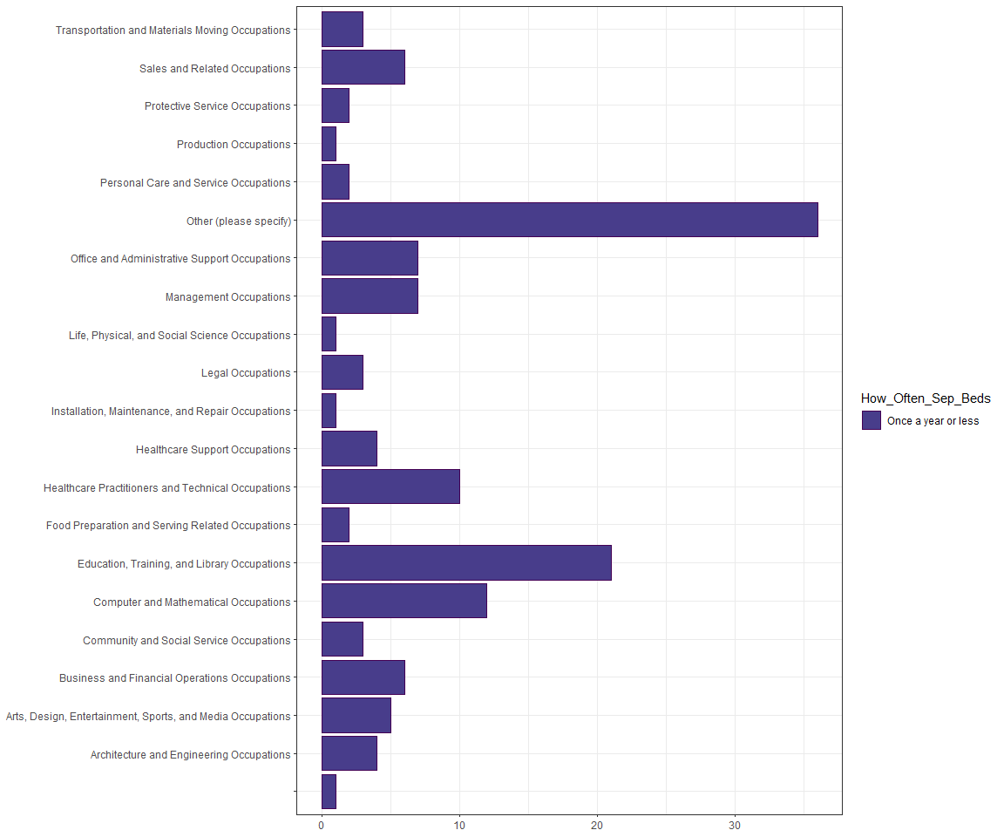

# Once a month or less  
sleeping_alone_data4 %>%  
 select(Current_Occupation,How_Often_Sep_Beds) %>%  
 filter(How_Often_Sep_Beds == "Once a month or less") %>%  
 ggplot(aes(y = Current_Occupation,  
 color = How_Often_Sep_Beds))+  
 geom_bar(fill = "cadetblue4")+  
 theme(axis.title.x = element_blank(),  
 axis.title.y = element_blank())

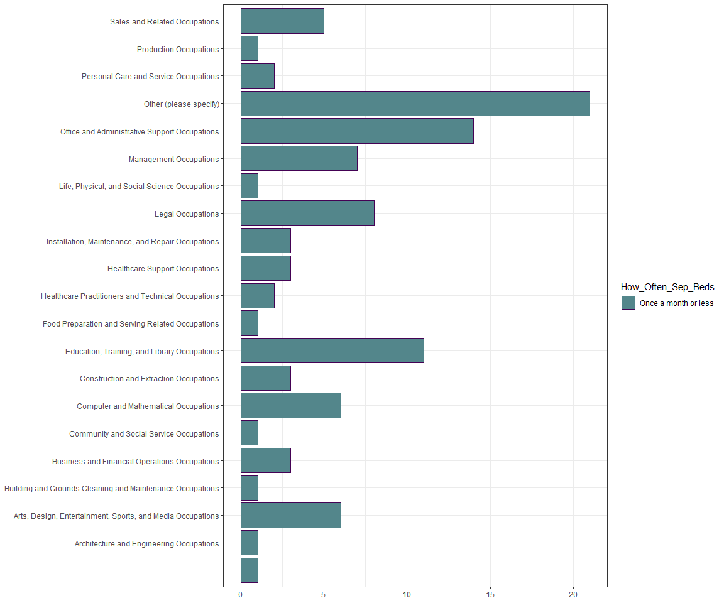

# A few times per month   
sleeping_alone_data4 %>%  
 select(Current_Occupation,How_Often_Sep_Beds) %>%  
 filter(How_Often_Sep_Beds == "A few times per month") %>%  
 ggplot(aes(y = Current_Occupation,  
 color = How_Often_Sep_Beds))+  
 geom_bar(fill = "lightseagreen")+  
 theme(axis.title.x = element_blank(),  
 axis.title.y = element_blank())

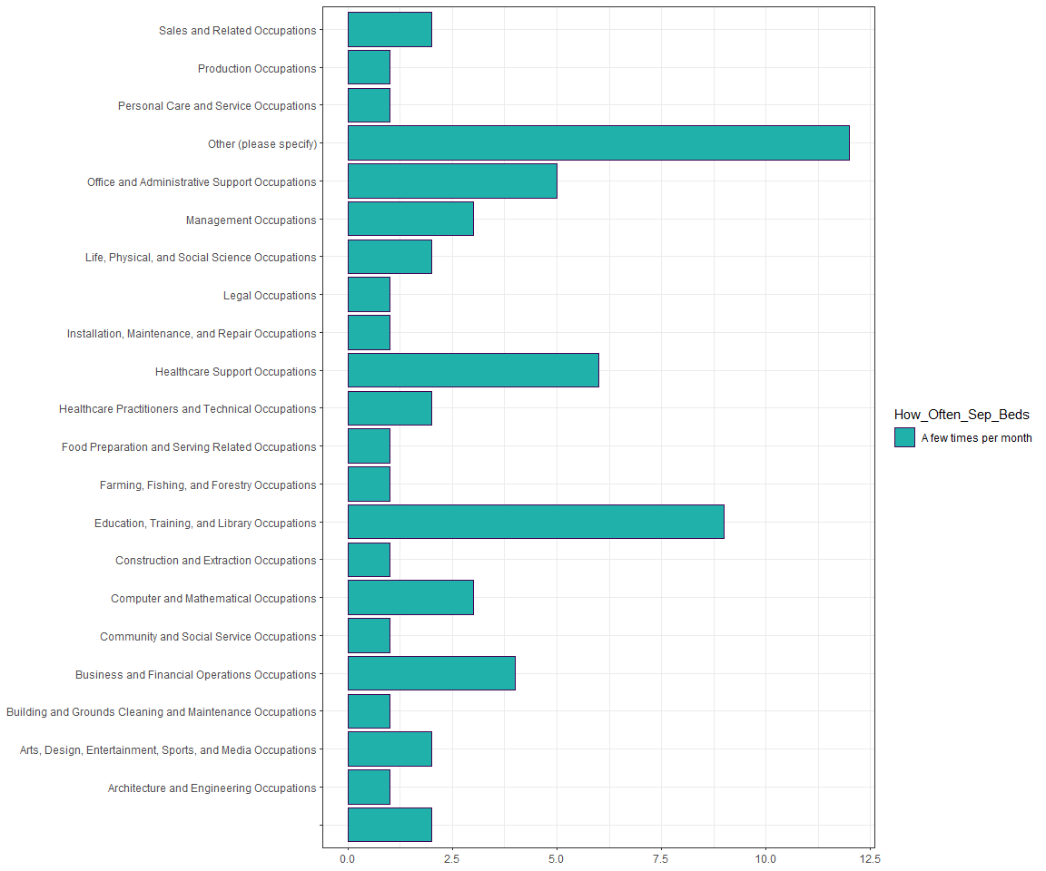

# A few times per week  
sleeping_alone_data4 %>%  
 select(Current_Occupation,How_Often_Sep_Beds) %>%  
 filter(How_Often_Sep_Beds == "A few times per week") %>%  
 ggplot(aes(y = Current_Occupation,  
 color = How_Often_Sep_Beds))+  
 geom_bar(fill = "palegreen3")+  
 theme(axis.title.x = element_blank(),  
 axis.title.y = element_blank())

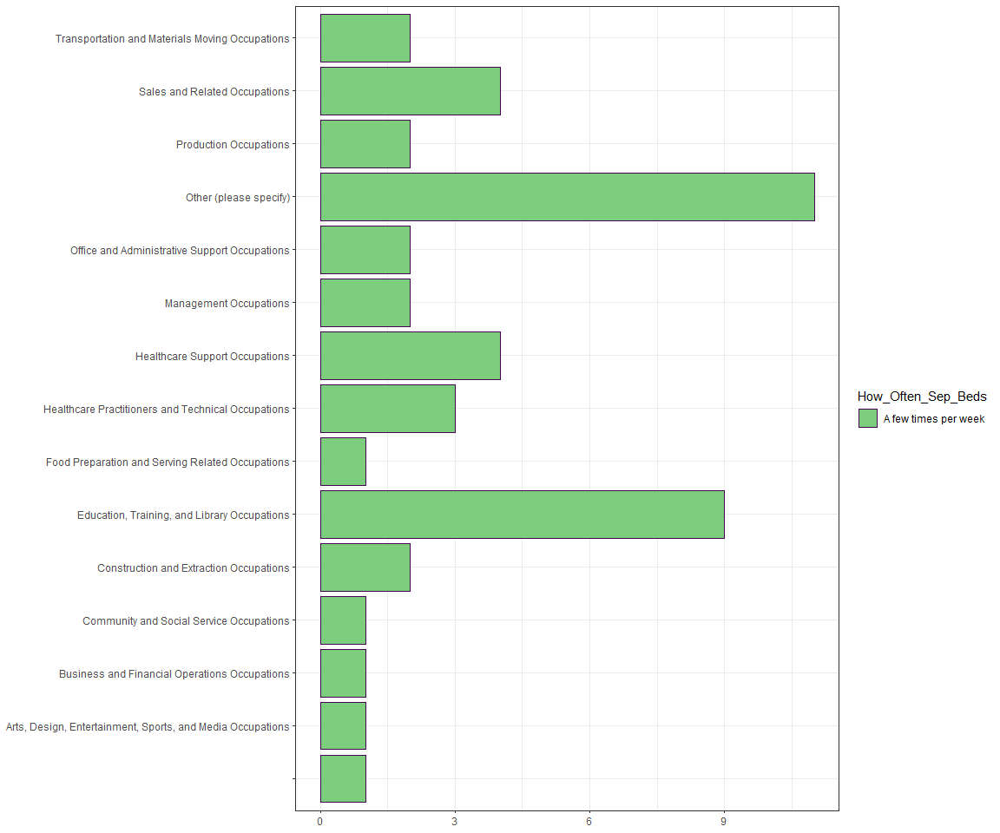

# Every night  
sleeping_alone_data4 %>%  
 select(Current_Occupation,How_Often_Sep_Beds) %>%  
 filter(How_Often_Sep_Beds == "Every night") %>%  
 ggplot(aes(y = Current_Occupation,  
 color= How_Often_Sep_Beds))+  
 geom_bar(fill = "khaki1")+  
 theme(axis.title.x = element_blank(),  
 axis.title.y = element_blank())

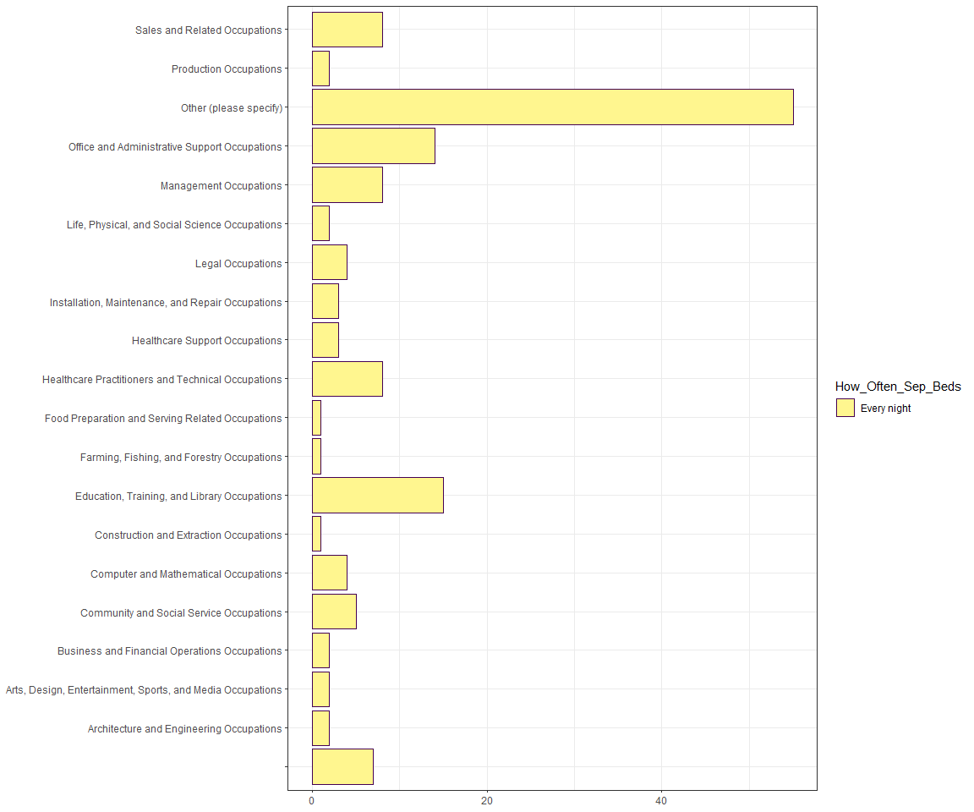

## for people who have further response instead of checking boxes  
## (choose to plot those who answered "retired" or "Retired)  
sleeping_alone_data4 %>%  
 filter(X.12 == "retired" | X.12 == "Retired")%>%  
 mutate(X.12 ="retired") %>%  
   
 ggplot(aes(x = X.12, fill= How_Often_Sep_Beds)) +  
   
 geom_bar(color="white",position = "dodge")+  
   
 theme(axis.text.x = element_text(),  
 axis.title.x = element_blank(),  
 axis.title.y = element_blank())

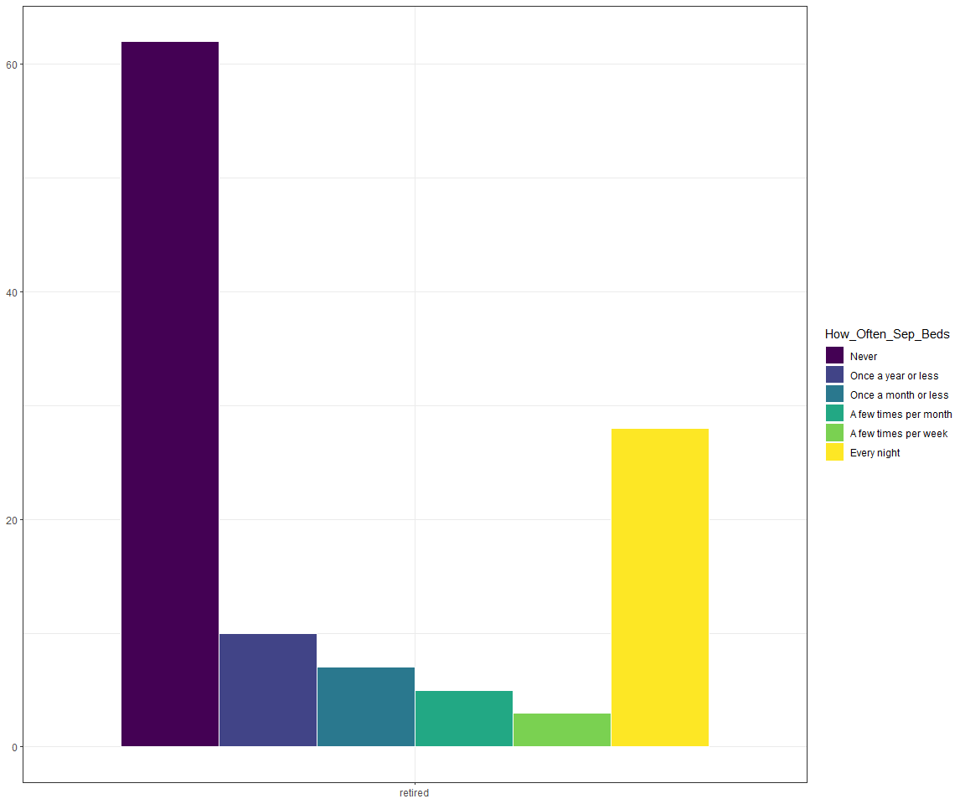

### 2.2.2 Summarizing Paragraph:

People who are in Education, Training, and Library Occupations seems to have more response of “Never” sleeping separately. Regardless of the occupation, The number of people who sleep separately is bigger than other frequencies.

For people who checked the box of “Other(please specify)”, we select retired samples to draw a bar graph. Distribution of people who retired have heavy tails on both side(Never & Every night), but the number of people who never sleeping separately is almost twice as large as those who sleeping separately every night.

### 2.2.3 Graph 3

# GRAPH 3  
  
ggplot(data = sleeping_alone_data4,  
 mapping = aes(x = Current_Occupation,  
 fill = How_Often_Sep_Beds)) +  
 geom_bar()+  
 scale_fill_viridis_d(option = "cividis")+  
   
 theme(axis.text.x = element_text(angle = 90,  
 hjust = 1,  
 vjust = 0.25,  
 size = 7),  
 legend.position = "top",  
 legend.text = element_text(size = 7),  
 legend.key.size = unit(0.25,'cm'),  
 legend.title = element_text(size= 8),  
 axis.title.x = element_blank(),  
 axis.title.y = element_blank())+  
 facet_grid(~Gender)

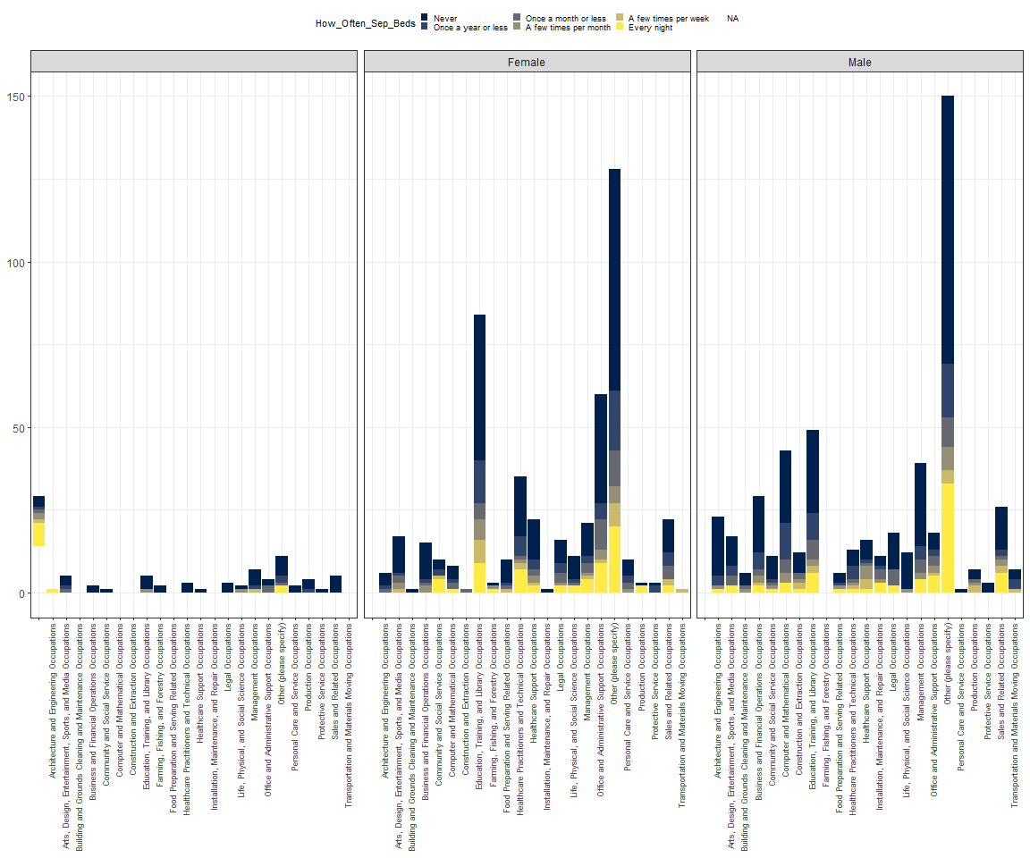

## for each bed status below:  
# Never  
sleeping_alone_data4 %>%  
 select(Current_Occupation,How_Often_Sep_Beds,Gender) %>%  
 filter(How_Often_Sep_Beds == "Never") %>%  
 ggplot(aes(x= Current_Occupation,  
 color = How_Often_Sep_Beds,  
 fill = Gender))+  
 geom_bar()+  
 theme(axis.text.x = element_text(angle = 90,  
 hjust = 1,  
 vjust = 0.25,  
 size = 7),  
 axis.title.x = element_blank(),  
 axis.title.y = element_blank())+  
 facet_grid(~Gender)

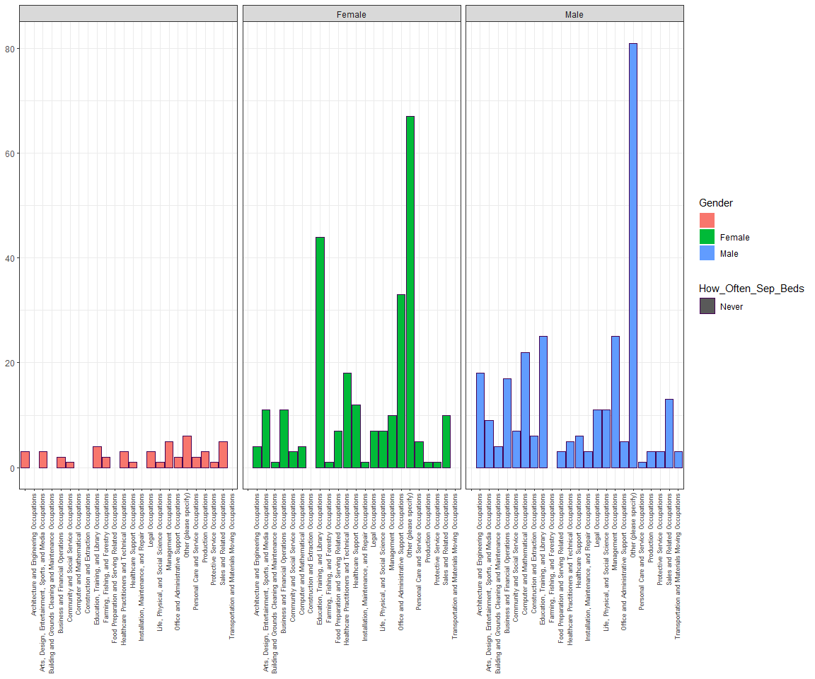

# Once a year or less   
sleeping_alone_data4 %>%  
 select(Current_Occupation,How_Often_Sep_Beds,Gender) %>%  
 filter(How_Often_Sep_Beds == "Once a year or less") %>%  
 ggplot(aes(x= Current_Occupation,  
 color = How_Often_Sep_Beds,  
 fill = Gender))+  
 geom_bar()+  
 theme(axis.text.x = element_text(angle = 90,  
 hjust = 1,  
 vjust = 0.25,  
 size = 7),  
 axis.title.x = element_blank(),  
 axis.title.y = element_blank())+  
 facet_grid(~Gender)

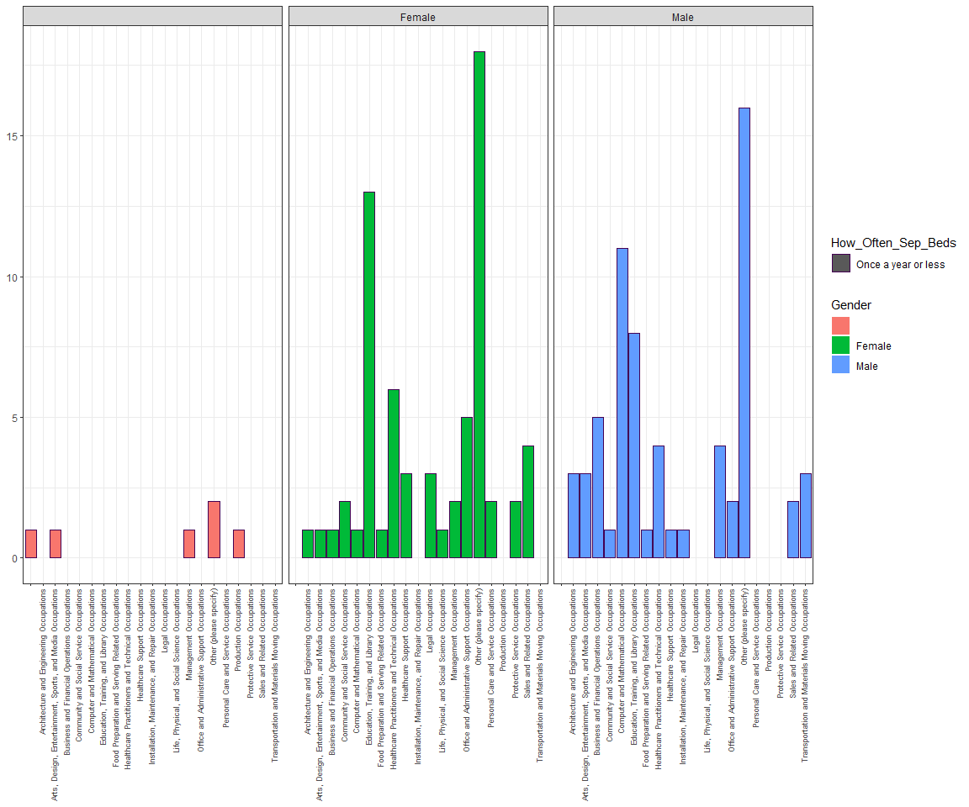

# Once a month or less  
sleeping_alone_data4 %>% filter(Gender != "") %>%  
 select(Current_Occupation,How_Often_Sep_Beds,Gender) %>%  
 filter(How_Often_Sep_Beds == "Once a month or less") %>%  
 ggplot(aes(x= Current_Occupation,  
 color = How_Often_Sep_Beds,  
 fill = Gender))+  
 geom_bar()+  
 theme(axis.text.x = element_text(angle = 90,  
 hjust = 1,  
 vjust = 0.25,  
 size = 7),  
 axis.title.x = element_blank(),  
 axis.title.y = element_blank())+  
 facet_grid(~Gender)

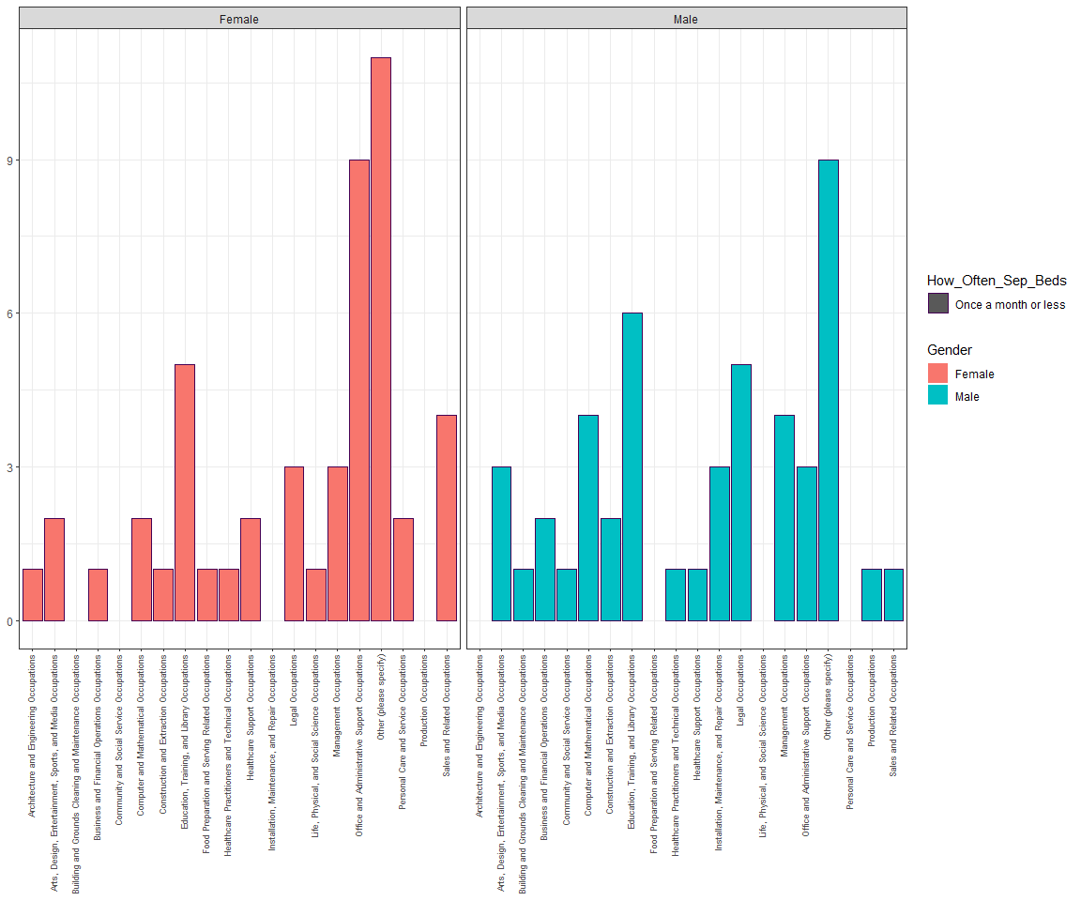

# A few times per month   
sleeping_alone_data4 %>% filter(Gender != "") %>%  
 select(Current_Occupation,How_Often_Sep_Beds,Gender) %>%  
 filter(How_Often_Sep_Beds == "A few times per month") %>%  
 ggplot(aes(x= Current_Occupation,  
 color = How_Often_Sep_Beds,  
 fill = Gender))+  
 geom_bar()+  
 theme(axis.text.x = element_text(angle = 90,  
 hjust = 1,  
 vjust = 0.25,  
 size = 7),  
 axis.title.x = element_blank(),  
 axis.title.y = element_blank())+  
 facet_grid(~Gender)

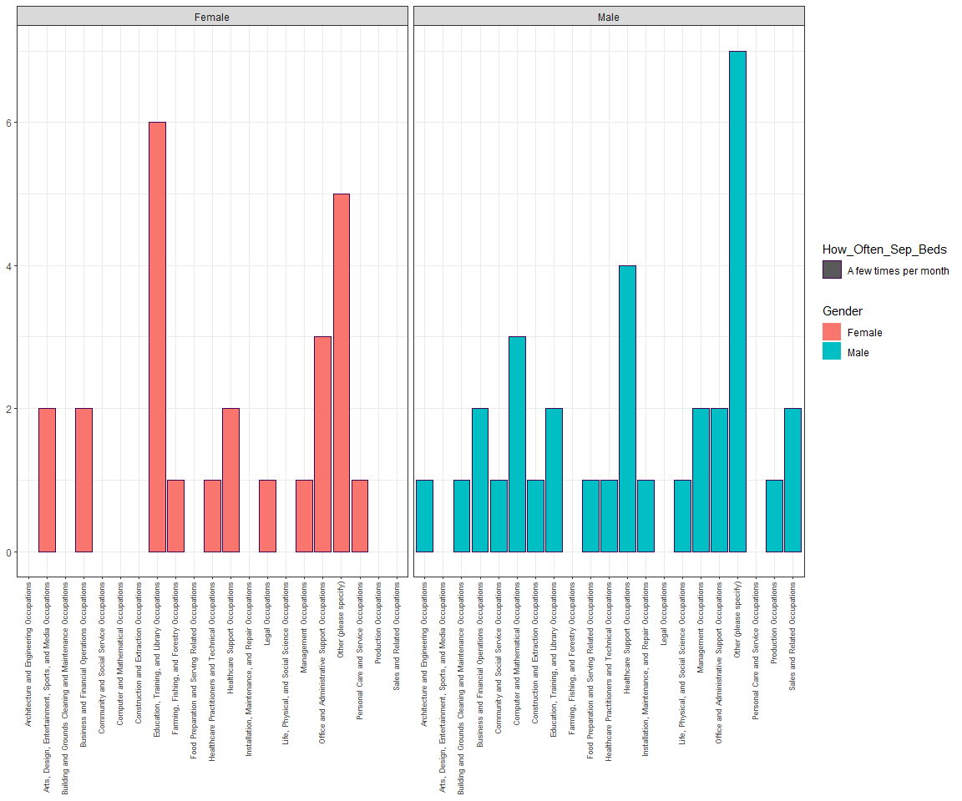

# A few times per week  
sleeping_alone_data4 %>% filter(Gender != "") %>%  
 select(Current_Occupation,How_Often_Sep_Beds,Gender) %>%  
 filter(How_Often_Sep_Beds == "A few times per week") %>%  
 ggplot(aes(x= Current_Occupation,  
 color = How_Often_Sep_Beds,  
 fill = Gender))+  
 geom_bar()+  
 theme(axis.text.x = element_text(angle = 90,  
 hjust = 1,  
 vjust = 0.25,  
 size = 7),  
 axis.title.x = element_blank(),  
 axis.title.y = element_blank())+  
 facet_grid(~Gender)

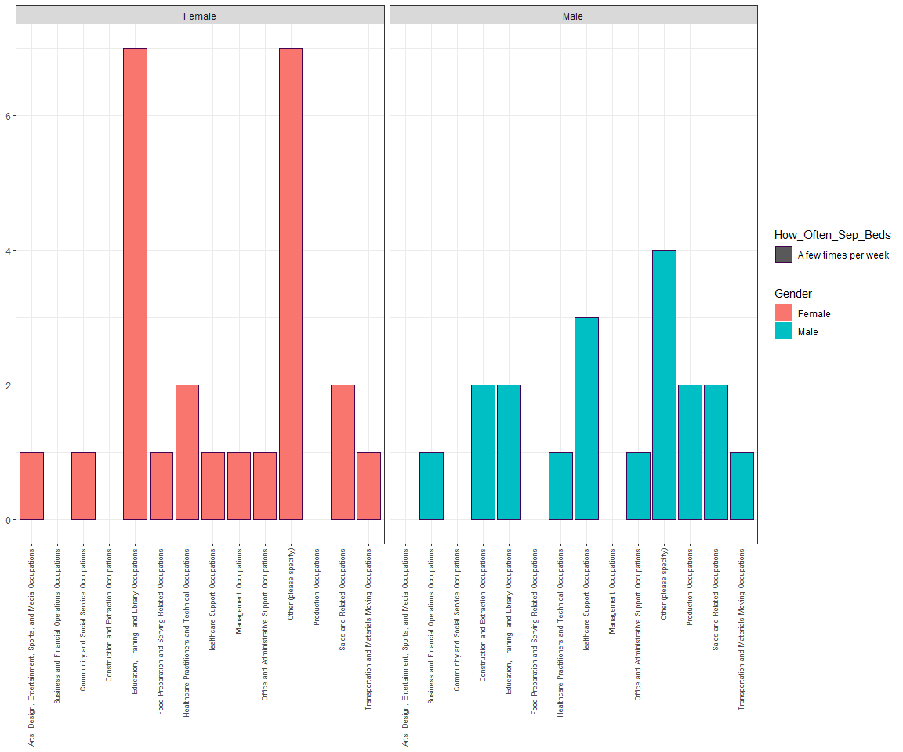

# Every night  
sleeping_alone_data4 %>% filter(Gender != "") %>%  
 select(Current_Occupation,How_Often_Sep_Beds,Gender) %>%  
 filter(How_Often_Sep_Beds == "Every night") %>%  
 ggplot(aes(x= Current_Occupation,  
 color = How_Often_Sep_Beds,  
 fill = Gender))+  
 geom_bar()+  
 theme(axis.text.x = element_text(angle = 90,  
 hjust = 1,  
 vjust = 0.25,  
 size = 7),  
 axis.title.x = element_blank(),  
 axis.title.y = element_blank())+  
 facet_grid(~Gender)

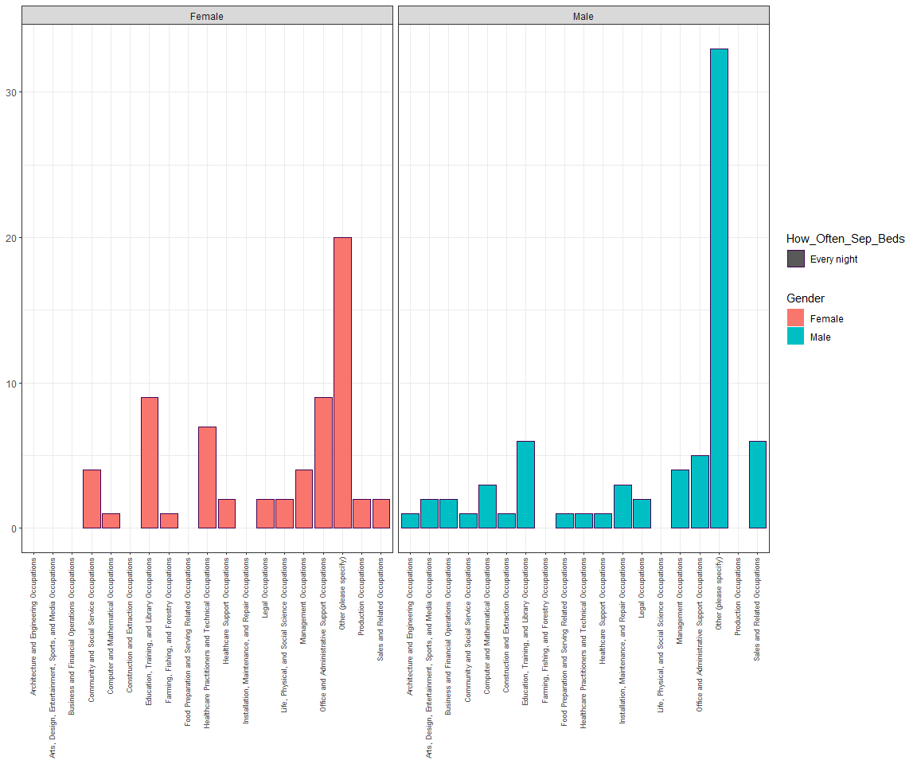

### 2.2.4 Summarizing Paragraph:

When we add gender as another consideration of our plots, it seems that there are more male participants for this study. For each frequencies of how often they sleep separately, there is a significant difference in number for the response of Never & Every night(males more than females). For other response of this question, the number in difference is not significant. People who does not specify their gender has a large proportion of responding to “Never”.

## 2.3 Reasons for Sleeping Separately (Graph 4) –> Matthew

**Relate how often couples sleep in different beds with the reason they sleep separately.**

**How correlated are the reasons they sleep in separate beds with the frequency they sleep together?** **Reasons include snoring, frequent bathroom trips, sickness, intimacy issues, etc.**

### 2.3.1 Graph 4

# GRAPH 4  
  
#Horizontal Bar Chart for Reason 1  
sleeping_alone_data5 <- sleeping_alone_data %>%   
   
 group_by(Sep_Beds_Reasons, How_Often_Sep_Beds) %>%   
   
 summarise(freq = n()) %>%   
   
 mutate(Prop = round(freq/sum(freq), digits = 5)) %>%   
   
 select(Sep_Beds_Reasons, How_Often_Sep_Beds, Prop) %>%   
   
 slice(-c(1)) %>%   
   
 ungroup()

## `summarise()` has grouped output by 'Sep_Beds_Reasons'. You can override using the `.groups` argument.

BarOftenVsReason1 <- ggplot(data = sleeping_alone_data5,  
 mapping = aes(y = Prop,  
 x = How_Often_Sep_Beds,  
 fill = How_Often_Sep_Beds)) +  
   
 geom_bar(stat = "identity",  
 show.legend = F) +   
 coord_flip() +   
 labs(title = "One of Us Snores",  
 x = "",  
 y = "") +  
 scale_y_continuous(labels = scales::percent) +  
   
 theme(plot.title = element_text(size = 15, hjust = 0.5))  
#Horizontal Bar Chart for Reason 2  
sleeping_alone_data6 <- sleeping_alone_data %>%   
   
 group_by(X.2, How_Often_Sep_Beds) %>%   
   
 summarise(freq = n()) %>%   
   
 mutate(Prop = round(freq/sum(freq), digits = 5)) %>%   
   
 select(X.2, How_Often_Sep_Beds, Prop) %>%   
   
 slice(-c(1)) %>%   
   
 ungroup()

## `summarise()` has grouped output by 'X.2'. You can override using the `.groups` argument.

BarOftenVsReason2 <- ggplot(data = sleeping_alone_data6,  
 mapping = aes(y = Prop,  
 x = How_Often_Sep_Beds,  
 fill = How_Often_Sep_Beds)) +  
   
 geom_bar(stat = "identity",  
 show.legend = F) +   
 coord_flip() +   
 labs(title = "Frequent Bathroom Trips",  
 x = "",  
 y = "") +  
   
 scale_y_continuous(labels = scales::percent) +  
   
 theme(plot.title = element_text(size = 15, hjust = 0.5))  
#Horizontal Bar Chart for Reason 3  
sleeping_alone_data7 <- sleeping_alone_data %>%   
   
 group_by(X.4, How_Often_Sep_Beds) %>%   
   
 summarise(freq = n()) %>%   
   
 mutate(Prop = round(freq/sum(freq), digits = 5)) %>%   
   
 select(X.4, How_Often_Sep_Beds, Prop) %>%   
   
 slice(-c(1)) %>%   
   
 ungroup()

## `summarise()` has grouped output by 'X.4'. You can override using the `.groups` argument.

BarOftenVsReason3 <- ggplot(data = sleeping_alone_data7,  
 mapping = aes(y = Prop,  
 x = How_Often_Sep_Beds,  
 fill = How_Often_Sep_Beds)) +  
   
 geom_bar(stat = "identity",  
 show.legend = F) +   
 coord_flip() +   
 labs(title = "No Longer Physically Intimate",  
 x = "",  
 y = "") +  
   
 scale_y_continuous(labels = scales::percent) +  
   
 theme(plot.title = element_text(size = 15, hjust = 0.5))  
#Horizontal Bar Chart for Reason 4  
sleeping_alone_data8 <- sleeping_alone_data %>%   
   
 group_by(X.5, How_Often_Sep_Beds) %>%   
   
 summarise(freq = n()) %>%   
   
 mutate(Prop = round(freq/sum(freq), digits = 5)) %>%   
   
 select(X.5, How_Often_Sep_Beds, Prop) %>%   
   
 slice(-c(1)) %>%   
   
 ungroup()

## `summarise()` has grouped output by 'X.5'. You can override using the `.groups` argument.

BarOftenVsReason4 <- ggplot(data = sleeping_alone_data8,  
 mapping = aes(y = Prop,  
 x = How_Often_Sep_Beds,  
 fill = How_Often_Sep_Beds)) +  
   
 geom_bar(stat = "identity",  
 show.legend = F) +   
 coord_flip() +   
 labs(title = "Different Temperature Preferences",  
 x = "",  
 y = "") +  
   
 scale_y_continuous(labels = scales::percent) +  
   
 theme(plot.title = element_text(size = 15, hjust = 0.5))  
#Horizontal Bar Chart for Reason 5  
sleeping_alone_data9 <- sleeping_alone_data %>%   
   
 group_by(X.6, How_Often_Sep_Beds) %>%   
   
 summarise(freq = n()) %>%   
   
 mutate(Prop = round(freq/sum(freq), digits = 5)) %>%   
   
 select(X.6, How_Often_Sep_Beds, Prop) %>%   
   
 slice(-c(1)) %>%   
   
 ungroup()

## `summarise()` has grouped output by 'X.6'. You can override using the `.groups` argument.

BarOftenVsReason5 <- ggplot(data = sleeping_alone_data9,  
 mapping = aes(y = Prop,  
 x = How_Often_Sep_Beds,  
 fill = How_Often_Sep_Beds)) +  
   
 geom_bar(stat = "identity",  
 show.legend = F) +   
 coord_flip() +   
 labs(title = "Arguments / Fights",  
 x = "",  
 y = "") +  
   
 scale_y_continuous(labels = scales::percent) +  
   
 theme(plot.title = element_text(size = 15, hjust = 0.5))  
#Horizontal Bar Chart for Reason 6  
sleeping_alone_data10 <- sleeping_alone_data %>%   
   
 group_by(X.8, How_Often_Sep_Beds) %>%   
   
 summarise(freq = n()) %>%   
   
 mutate(Prop = round(freq/sum(freq), digits = 5)) %>%   
   
 select(X.8, How_Often_Sep_Beds, Prop) %>%   
   
 slice(-c(1)) %>%   
   
 ungroup()

## `summarise()` has grouped output by 'X.8'. You can override using the `.groups` argument.

BarOftenVsReason6 <- ggplot(data = sleeping_alone_data10,  
 mapping = aes(y = Prop,  
 x = How_Often_Sep_Beds,  
 fill = How_Often_Sep_Beds)) +  
   
 geom_bar(stat = "identity",  
 show.legend = F) +   
 coord_flip() +   
 labs(title = "Not Wanting to Share Covers",  
 x = "",  
 y = "") +  
   
 scale_y_continuous(labels = scales::percent) +  
   
 theme(plot.title = element_text(size = 8, hjust = 0.5))  
grid.arrange(BarOftenVsReason1, BarOftenVsReason2, BarOftenVsReason3, BarOftenVsReason4, BarOftenVsReason5, BarOftenVsReason6,nrow = 2,  
 top=textGrob("Comparing How Often Couples Sleep In Different Beds With Reasons They Sleep Separately",   
 gp=gpar (fontsize=10, fontface = "bold")))

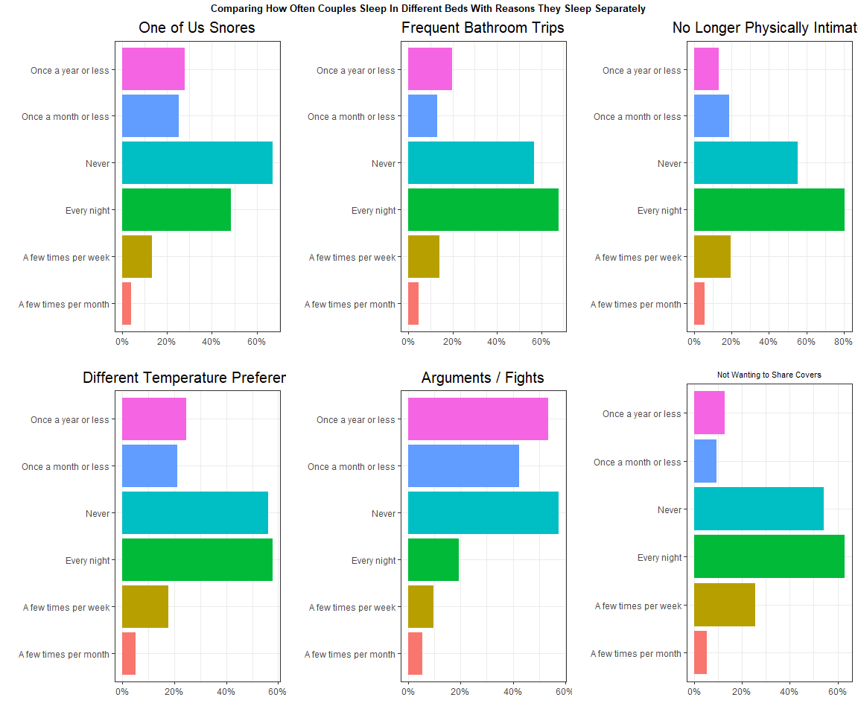

# GRAPH 5  
  
help_stay_together <- sleeping_alone_data %>% filter(Statement_Help_Stay_Together != "") %>%  
 ggplot(mapping = aes(x = Statement_Help_Stay_Together,  
 fill = How_Often_Sep_Beds)) +  
 geom_bar(position = "dodge") +   
 labs(x = "Helped Us Stay Together",  
 fill = "How Often Couples Sleep Separately",  
 title = "Frequency Sleeping Separately and Improvements") +  
 theme(legend.position = "NA",   
 title = element_text(size = 9)) +  
 coord_flip()  
  
better_sleep <- sleeping_alone_data %>% filter(Statement_Better_Sleep != "") %>%  
 ggplot(mapping = aes(x = Statement_Better_Sleep,  
 fill = How_Often_Sep_Beds)) +  
 geom_bar(position = "dodge") +   
 labs(x = "Helped Improve Sleep",  
 fill = "How Often Couples Sleep Separately") +  
 theme(legend.position = "NA" ) +  
 coord_flip()  
  
improved_sex_life <- sleeping_alone_data %>% filter(Statement_Improved_Sex_Life != "") %>%  
 ggplot(mapping = aes(x = Statement_Improved_Sex_Life,  
 fill = How_Often_Sep_Beds)) +  
 geom_bar(position = "dodge") +   
 labs(x = "Helped Improve Sex Life",  
 fill = "How Often Couples Sleep Separately") +  
 theme(legend.position = "bottom",  
 legend.key.size = unit(0.25, 'cm'),   
 legend.title = element_blank(),   
 legend.text = element_text(size=9)) +  
 coord_flip()  
  
  
  
plot_grid(help_stay_together, better_sleep, improved_sex_life, ncol = 2, nrow = 2, label_size = 9)

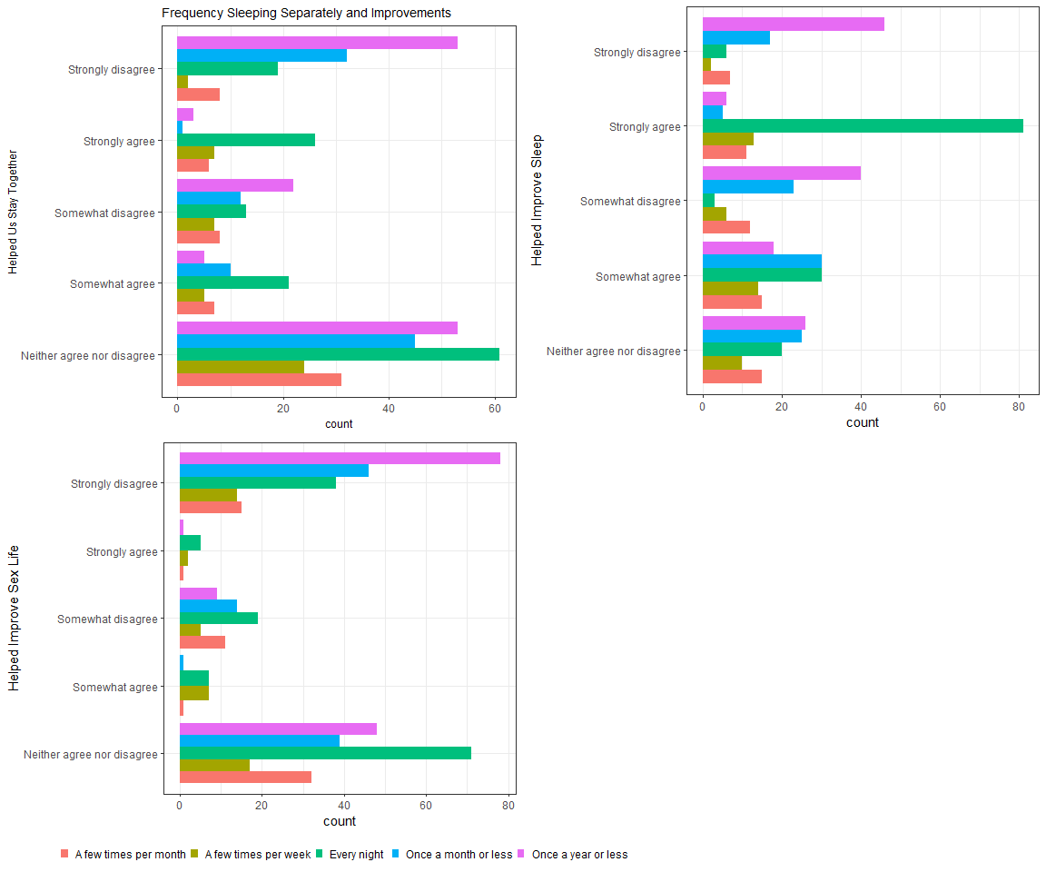

?plot_grid

## starting httpd help server ... done

### 2.3.2 Summarizing Paragraph:

These graphs compare how often couples sleep in different beds with some reasons why they sleep separately. The reason that the percentages add up to over 100% is because this part of the survey involved selecting all that applied. One specific pattern that I notice is that sleeping separately “a few times per month” is clearly the least common response among all reasons. Most of the reasons have the highest percentage of sleeping separately “every night”, except for arguments and fights which has by far the lowest percentage. This makes sense to think about because couples do not usually have arguments or fights every night. They generally happen on occasion, which is why the arguments/fights graph has the highest percentage of sleeping separately “once a year or less” and “once a month or less”. Besides arguments and fights, the graphs have similar distributions.

In terms of imrpovements, majority of couples who sleep in separate beds every night who did not anser neutrally, reported strongly agreeing with the statement “it helped save our relationship”. Most notably, the vast majority of couples sleeping separately every night stated that sleeping separately improved their sleep. When it comes to improvements in sex life, the results are less descriptive and there seems to be less unanimous improvements in this category. Overall, the reasons that couples chose to sleep apart every night were practical sleep reasons relating to sleeping habits such as temperature differences, middle-of-the-night disturbances, snoring, and cover-sharing.

# 3 Conclusions:

This data does illustrate a tendancy toward stereotypical patterns in our society regarding age / relationship length and sleeping situation. That being that couples who are older (or have one partner who is older) are more likely to sleep in separate beds. Additionally couples who have been together for at least a decade are much more likely to sleep in separate beds. That being said, the purpose of this data was to help shed light on the factors involved in sleeping separately and allow us to examine the reasons why couples choose ot sleep separately. It seems that the reasons are highly related to comfort and to getting the best quality of sleep. The stereotype of age / relationship length and separate sleeping usually has to do with stereotypes about “romance fading away” or things of the kind. However, the most popular reasons in general are far more specific and practical. It is understandable that couples who have been together longer (say 16-20) years may be at the point where they can comfortably communicate that it would be best to have separate beds.

# 4 Limitations / Recommendations:

There are several limitations to this data. The aspect of gender identity is neglected in this survey, only male and female options are given and there is no indication of which gender identity the partner or the person taking the survey is. It would be an interesting aspect to consider the patterns among different types of couples in the US (in terms of gender and sexual identity and how that varies depending on age/generation).