Optimal syndrome timing on trapped-ion hardware

Problem statement
Surface-code memories usually run syndrome extraction back-to-back. Measuring less often lets idle errors build up; measuring more often adds gate and readout faults. Haug et al. predict an optimal interval $Δt^{*}$ that minimises logical error per unit time.

We test whether it survives native-gate and coherent idle noise, and whether it helps on Quantinuum H2.

Approach
We run two simulation pipelines.
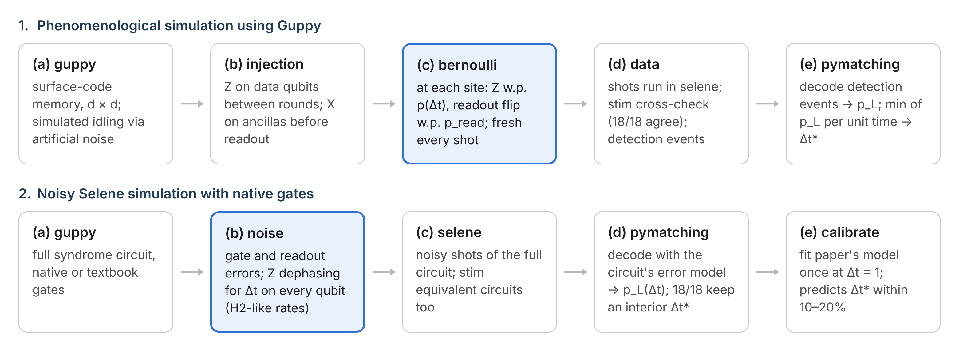
Simulation pipelines.
(1) Phenomenological simulation
(2) Noisy Selene simulation with native gates.
- d: code distance
- $Δt$: simulated interval between syndrome extractions,
- $p\left(Δt\right)$: Z-error probability per data qubit for $Δt$
- $p_{\text{read}}$ (pipeline 1): readout-flip probability
- Native Gates: the hardware’s own gate set, as opposed to textbook gates
- $p_{\text{data}}$, $p_{\text{read}}$ (pipeline 2): the paper’s data and readout error rates, measured once from detection events at Δt = 1
- $p_{\text{L}}$: logical error probability
- $Δt^{*}$: interval that minimises logical error per unit time.

Dephasing applies Z to each data qubit over the simulated interval $Δt$ under one of two idle models: Markovian at incoherent rate γ, or coherent phase drift at rate c. γ and c are free parameters fitted to the simulated detection events; their H2 values are unmeasured and set $Δt^{*}$:
$$p_{\text{Markov}}(Δt)=1/2 \left(1 - e^{-γΔt}\right), p_{\text{coherent}}(Δt)=\sin^{2}(cΔt/2).$$
The work runs in three stages:
- Phenomenological. Errors are drawn per shot by Bernoulli trials in Guppy, then decoded by PyMatching. This leads to a non-trivial syndrome extraction interval.
- Circuit-level. Gate and readout errors plus Z dephasing in Selene, with Stim-equivalent circuits too. The paper’s model is fitted once at $Δt=1$ and predicts $Δt^{*}$.
- Hardware map. Map $Δt^{*}$ over the $(γ,c)$ plane and place H2-1E idle rates on it as a function of $t_{R}$.

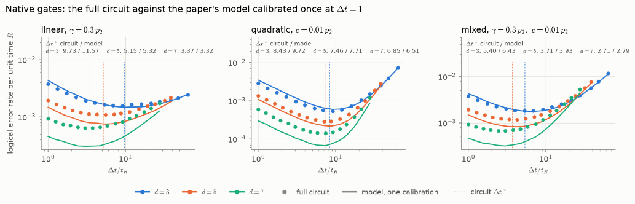
Key results and relevance to quantum computing
Fig 1
1. The optimum survives full circuit noise. In Fig. 1 (native gates; idle models linear 0.3, quadratic 0.01 and mixed), the full-circuit logical error per unit time falls and then rises with at $d=3, 5, 7$.
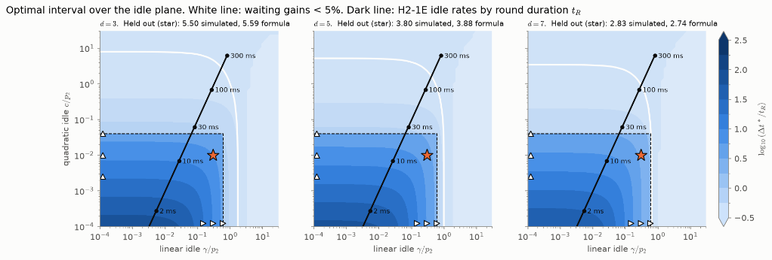
2. The paper’s model predicts it from one calibration. Calibrated once from detection events at $Δt=1$, the model predicts $Δt^{*}$ within ±15–20% at $d=3$, and ±10% at $d=5, 7$. Held-out points (stars in Fig. 2): 5.50 simulated vs 5.59 formula at $d=3$, 3.80 vs 3.88 at $d=5$, 2.83 vs 2.74 at $d=7$.
Fig 2
3. Expected tradeoff on H2. Fig. 2 maps the optimal interval $Δt^{*}/t_R$ over the idle plane at $d=3,5,7$: linear idle strength $γ/p_{2}$ against quadratic idle strength $c/p_{2}$, both relative to the two-qubit gate error $p_{2}$. Beyond the white line, waiting gains less than 5% over $Δt=1$. The dark line places H2-1E idle rates by round duration $t_{R}$; it stays inside the gain region up to $t_{R}$ ≈ 100–300 ms, where it crosses the white line.

Potential impact
Algorithms leave most logical qubits idle: sequential workloads spend 84–87% (adder) and 41–51% (QFT) of their qubit-time waiting, so how an idle memory is protected governs most of a computation’s space-time volume.
Time can stand in for space. For idling qubits a longer syndrome interval lowers logical error per unit time: waiting at distance d can beat back-to-back extraction at d + 2, saving 16–24 data qubits per logical qubit at short round durations. [SEE FIG IN SAVED??!?!]
Generalised across noise models. $Δt^{*}$is mapped over linear and quadratic idle noise $(γ,c)$ with gate noise, not one fixed phenomenological model.
Linked to hardware feasibility. Placing H2-1E idle rates on that map ties the gain to the round duration: waiting helps up to $t_{R}$ ≈ 100–300 ms, and one calibration at $Δt=1$ predicts $Δt^{*}$ within 10–20%.

Next steps
All 16 programs pass the H2-1SC syntax check. Runs on the full H2 emulators via aqora, which include noise sources our Stim and Selene models leave out, will fix where H2 sits on the map.
Reference. T. Haug, K. Bharti, L. Aolita, Exponential logical-error reduction in quantum memories via optimal syndrome-measurement timing, arXiv:2608.06242 (2026).

