**Landing page:**

Navigation Bar:

Logo (navigate to landing page) Works About Contact (change

color to white when clicking or scrolling the mouse on)

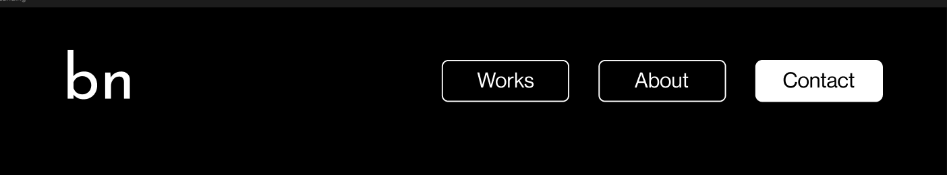

“I am a multi-disciplinary artist with a deep interest in the materiality of technology. My practice involves researching and experimenting with new and emerging technologies, pushing the boundaries of traditional art materials.”

* Trần Nguyên Bảo Ngọc