Landing page:
Navigation Bar:
Logo (navigate to landing page) Works About Contact (change
color to white when clicking or scrolling the mouse on)
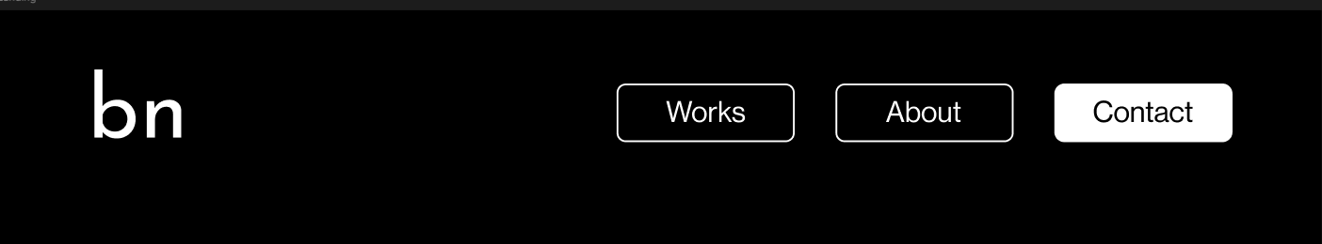

“I am a multi-disciplinary artist with a deep interest in the materiality of technology. My practice involves researching and experimenting with new and emerging technologies, pushing the boundaries of traditional art materials.”
- Trần Nguyên Bảo Ngọc

