新建项目并运行
2021年10月14日
23:23

- vscode启动和调试flutter
  - Vscode
  - 安装vscode插件Dart,flutter,flutter-materials
  - 手动下载flutter（flutter中集成了dart）
  - Android Studio中配置flutter
  - 设置flutter环境变量
  - 设置变量(是否要配置待定) PUB_HOSTED_URL”和“FLUTTER_STORAGE_BASE_URL
PUB_HOSTED_URL=https://pub.flutter-io.cn
FLUTTER_STORAGE_BASE_URL=https://storage.flutter-io.cn
- 安装andriod studio
- 输入flutter doctor检查运行环境是否正常
- 创建工程: ctrl+shift+p, 输入 flutter: new project
- 选择设备
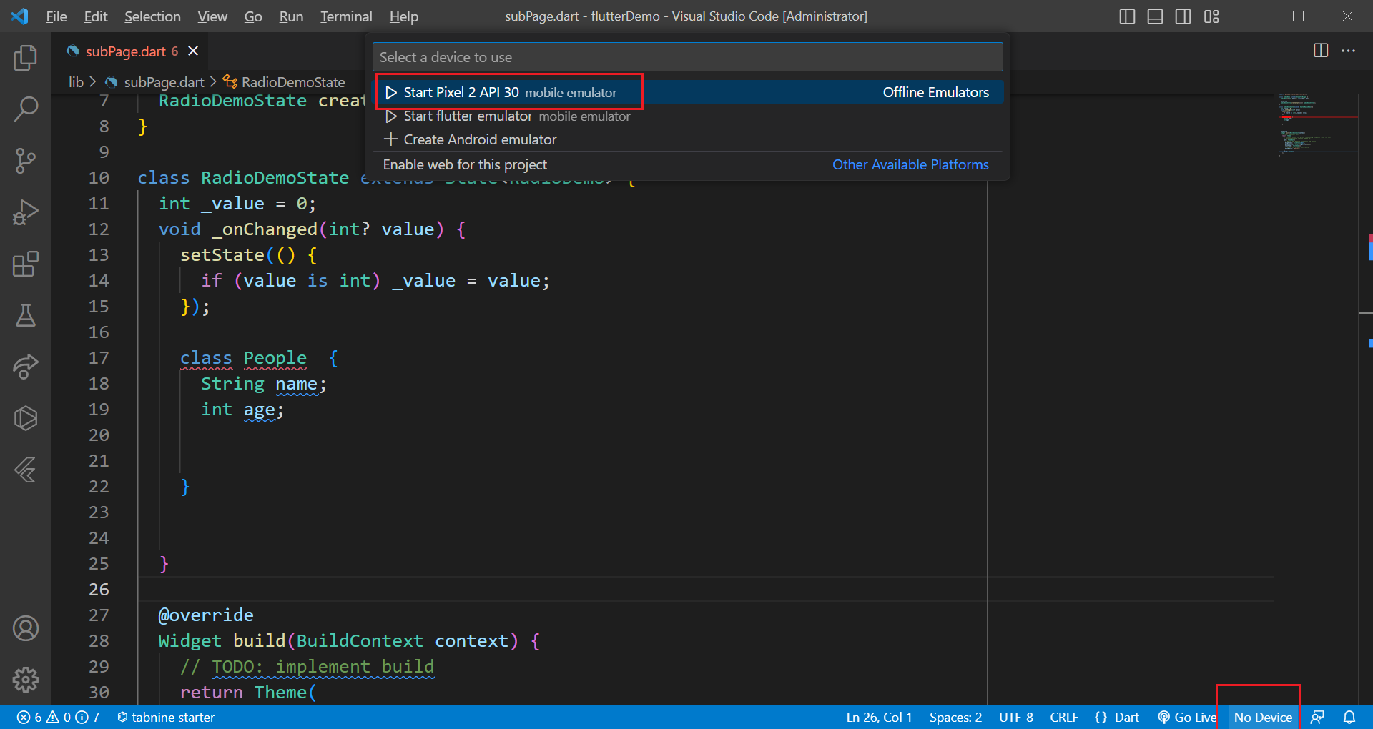

- 启动项目 flutter run
- 调试配置
{
"version": "0.2.0",
"configurations": [
{
"type": "dart",
"name": "Flutter",
"request": "launch"
}
]
}
- 打印
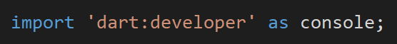

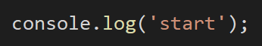

- 容器描线

