常见报错

2024年12月22日

12:45

1. **Exception in thread "main" java.net.ConnectException: Connection timed out: connect**

**或者 Running Gradle task 'assembleDebug'卡住**

下载gradle网络异常，可以下载gradle-XX-all.zip，放到本地目录，修改gradle-wrapper.properties文件

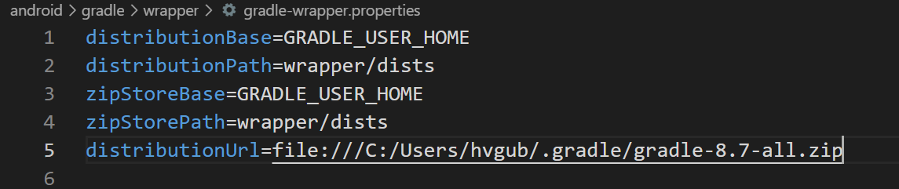

1. **You are applying Flutter's main Gradle plugin imperatively using the apply script method**

**更新项目**

备份重要修改

AndroidManifest.xml 的更改、Gradle 配置更改、本地依赖等

将flutter升级到最新版本

删除flutter项目中的android文件夹

运行flutter create .命令重新生成android项目

手动删除不需要的平台 $ rm -rf web/

重新打开flutter项目flutter run

同步gradle时若网络中断，会导致缓存文件损坏或下载不完整，需要执行如下命令清理gradle缓存后重新运行。 $ rm -rf ~/.gradle/wrapper/dists/

从备份项目中将自定义配置转移到新生成的android项目

1. **Connect to repo1.maven.org:443 [repo1.maven.org/146.75.92.209] failed: Connection timed out**

更改Android Studio配置 Setting/Remote Jar Respositories/Maven Jar Respositories

1. **PKIX path building failed: sun.security.provider.certpath.SunCertPathBuilderException: unable to find valid certification path to requested target**

解决方法: 添加证书到JAVA SDK

1. 到对应网站下载证书

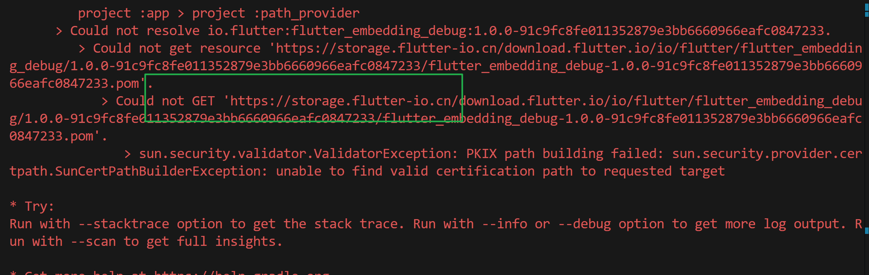

1. 导入证书

keytool -import -keystore "%JAVA_HOME%\jre\lib\security\cacerts" -file <证书位置: D:\_.aliyun.crt -alias> <证书别名:aliyun>

注意: 需要修改文件地址及证书别名; 需要事先在环境变量中配置JAVA_HOME

1. maven文件下载不动

替换maven配置，找到项目名称/android/build.gradle, 运行./gradlew

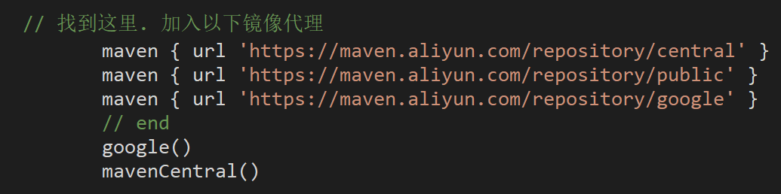

1. BUG! exception in phase 'semantic analysis' in source unit '_BuildScript_' Unsupported class file major version 65

JAVA版本与gradle版本不对应

查看对应关系[GRADLE文档](https://docs.gradle.org/current/userguide/compatibility.html" \l "compatibility)

1. No signature of method: org.gradle.api.tasks.bundling.Jar.destinationDir() is applicable for argument types: (File) values: [D:\workspace\flutter\flutterwhatsappdemo\build\app\intermediates\flutter\debug]

flutter版本与gradlew版本不对应

查看对应关系

1. The method 'setMockMessageHandler' isn't defined for the class 'BasicMessageChannel<dynamic>'.

flutter clean

flutter pub upgrade --major-versions

flutter pub get

Flutter run

1. Flutter 运行新项目时报错 Build failed due to use of deprecated Android v1 embedding.

第一步先/android/app/src/main下的找到AndroidManifest.xml文件

修改application标签删除name字段值，添加meta-data标签

